UNITED STATES

SECURITIES AND EXCHANGE COMMISSION
Washington, D.C. 20549

SCHEDULE 14A

Proxy Statement Pursuant to Section 14(a) of the

Securities Exchange Act of 1934

Filed by the Registrant ☒ Filed by a Party other than the Registrant ☐

Check the appropriate box:

- Preliminary Proxy Statement

- Confidential, for Use of the Commission Only (as permitted by Rule 14a-6(e)(2))

- Definitive Proxy Statement

- Definitive Additional Materials

- Soliciting Material Pursuant to §240.14a-12

Crown Holdings, Inc.

(Name of Registrant as Specified in its Charter)

N/A

(Name of Person(s) Filing Proxy Statement, if Other Than the Registrant)

Payment of Filing Fee (Check the appropriate box):

- No fee required.

- Fee computed on table below per Exchange Act Rules 14a-6(i)(1) and 0-11.

  - Title of each class of securities to which transaction applies:

  - Aggregate number of securities to which transaction applies:

  - Per unit price or other underlying value of transaction computed pursuant to Exchange Act Rule 0-11 (set forth the amount on which the filing fee is calculated and state how it was determined):

  - Proposed maximum aggregate value of transaction:

  - Total fee paid:

- Fee paid previously with preliminary materials.

- Check box if any part of the fee is offset as provided by Exchange Act Rule 0-11(a)(2) and identify the filing for which the offsetting fee was paid previously. Identify the previous filing by registration statement number, or the Form or Schedule and the date of its filing.

  - Amount Previously Paid:

  - Form, Schedule or Registration Statement No.:

- Filing Party:

- Date Filed:


Crown Holdings, Inc.

770 Township Line Road

Yardley, Pennsylvania 19067

IMPORTANT NOTICE

CHANGE OF LOCATION AND VOTING METHOD FOR THE

2020 ANNUAL MEETING OF SHAREHOLDERS

The following Notice of Annual Meeting of Shareholders (the “Notice”) amends and restates the original notice included in the Proxy Statement (the “Proxy Statement”) of CROWN HOLDINGS, INC. (the “Company”), dated March 16, 2020, furnished to Shareholders of the Company in connection with the solicitation of proxies by the Board of Directors of the Company for use at the Annual Meeting of Shareholders to be held on April 23, 2020 (the “Annual Meeting”). The purpose of this Notice is to announce a change in the location of the Annual Meeting to a virtual meeting format only, via webcast.

This Notice is being filed with the Securities and Exchange Commission and is being made available to Shareholders on or about March 30, 2020.

By Order of the Board of Directors

ADAM J. DICKSTEIN

Corporate Secretary

Yardley, Pennsylvania

March 30, 2020

THIS NOTICE SHOULD BE READ IN CONJUNCTION WITH THE PROXY STATEMENT

NOTICE OF ANNUAL MEETING OF SHAREHOLDERS

To the Shareholders of Crown Holdings, Inc.:

Due to the emerging public health impact of the coronavirus pandemic (COVID-19) and to support the health and well-being of our Shareholders, employees and their families, NOTICE IS HEREBY GIVEN that the location of the 2020 Annual Meeting of Shareholders (the “Annual Meeting”) of CROWN HOLDINGS, INC. (the “Company”) has been changed. As previously announced, the Annual Meeting will be held on Thursday, April 23, 2020 at 9:30 a.m. Eastern Time. In light of public health concerns, the Annual Meeting will be held in a virtual meeting format only, via webcast. You will not be able to attend the Annual Meeting in person.

Record Owners

If your shares are registered directly in your name with EQ Shareowner Services, the Company’s stock transfer agent, you are considered the “Shareholder of record” or “record owner” with respect to those shares. An updated proxy card for the virtual Annual Meeting should be included with this Notice. If you are a participant in our Employee Stock Purchase Plan or any other applicable Company employee benefit plan, your updated proxy card also serves as voting instructions for the number of shares for which you are entitled to direct the vote under each plan. You must enter the 16-digit control number found on your updated proxy card to vote in advance of or during the Annual Meeting and/or participate in the Annual Meeting. If you have already voted using the original proxy card, you must cast your vote again with the updated proxy card for the virtual Annual Meeting for your vote to be counted.

Beneficial Owners

If your shares are held in an account at a brokerage firm, bank or trust as custodian on your behalf, you are considered the “beneficial owner” of those shares. Your shares are registered on the Company’s books in the name of the brokerage firm, bank or trust, or its nominee. Shares held in this manner are commonly referred to as being held in “street name.” You must enter the 16-digit control number found on your voting instruction form previously sent to you in order to vote in advance of or during the Annual Meeting and/or to participate in the Annual Meeting. In the event you previously requested a legal proxy from your broker, bank or other similar organization, you may also use such legal proxy to vote at and/or participate in the Annual Meeting. If you have already voted, you do not need to vote again.

Additional Information

As described in the proxy materials for the Annual Meeting previously distributed, you are entitled to participate in the Annual Meeting if you were a Shareholder at the close of business on March 3, 2020, the record date. If you are eligible, you will participate in the Annual Meeting by going to the following web address: www.virtualshareholdermeeting.com/CCK2020. You will enter the 16-digit control number found on your updated proxy card or your voting instruction form. Whether or not you plan to attend the virtual Annual Meeting, we urge you to vote in advance of the Annual Meeting by one of the methods described below.

Annual Meeting Information

Date: April 23, 2020

Time: 9:30 a.m. EDT

Place: Online at www.virtualshareholdermeeting.com/CCK2020

Record date: March 3, 2020

Agenda

- To elect the 12 director nominees named in the Proxy Statement to serve as Directors for the ensuing year or until their successors shall be elected;

- Ratification of the appointment of independent auditors for the fiscal year ending December 31, 2020;

- Approval by advisory vote of the resolution on executive compensation as described in the Proxy Statement; and

- To consider and act upon a Shareholder’s proposal requesting the Board of Directors to adopt a policy for an independent Board Chairman.

Admission to the Meeting

You are entitled to participate in the Annual Meeting only if you were a Shareholder of the Company at the close of business on March 3, 2020.

Please refer to the “Additional Information About the Virtual Annual Meeting” section on the next page for further information.

ADAM J. DICKSTEIN

Corporate Secretary

March 30, 2020

Your vote is important


Shareholders at the close of business on March 3, 2020, the record date for the Annual Meeting, are the only Shareholders entitled to notice of, and to vote at, the Annual Meeting.

Even if you plan to participate in the Annual Meeting, we ask that you please promptly vote on the Internet, by phone or by mail. Voting early will help avoid additional solicitation costs and will not prevent you from voting electronically during the Annual Meeting if you wish to do so.

How to Vote:

Online: Vote online at

www.proxyvote.com.

Phone: Vote by calling

1-800-690-6903.

Mail: If you have received a printed version of the proxy materials, you may vote by mail.

During Meeting: You may vote online during the Annual Meeting at www.virtualshareholder meeting.com/CCK2020.

Important Notice Regarding the Availability of Proxy Materials for the

Shareholder Meeting to Be Held on April 23, 2020:

The Proxy Statement and Proxy Card relating to the Annual Meeting of Shareholders

and the Annual Report to Shareholders are available at

https://www.crowncork.com/investors/proxy-online

ADDITIONAL INFORMATION ABOUT THE VIRTUAL ANNUAL MEETING

Attendance and Participation

Our virtual Annual Meeting will be conducted on the Internet via webcast. You will be able to participate online and submit your questions during the Annual Meeting by visiting www.virtualshareholdermeeting.com/CCK2020. Shareholders will be able to vote their shares electronically during the Annual Meeting.

To participate in the Annual Meeting, you will need the 16-digit control number included on your updated proxy card or your voting instruction form. The Annual Meeting will begin promptly at 9:30 a.m. EDT. We encourage you to access the Annual Meeting prior to the start time. Online access will begin at 9:15 a.m. EDT.

The virtual Annual Meeting platform is fully supported across browsers (Internet Explorer, Firefox, Chrome, and Safari) and devices (desktops, laptops, tablets, and cell phones) running the most updated version of applicable software and plugins. Participants should ensure they have a strong Internet connection wherever they intend to participate in the Annual Meeting. Participants should also allow plenty of time to log in and ensure that they can hear streaming audio prior to the start of the Annual Meeting.

Questions

Shareholders may submit questions during the Annual Meeting. If you wish to submit a question, you may do so by logging into the virtual meeting platform at www.virtualshareholdermeeting.com/CCK2020, typing your question into the “Ask a Question” field, and clicking “Submit.”

Questions pertinent to the Annual Meeting will be answered during the Annual Meeting, subject to time constraints.

Technical Difficulties

If you encounter any difficulties accessing the virtual Annual Meeting during the check-in or meeting time, please call 800-586-1548 (Toll Free) or 303-562-9288 for assistance. Technical support will be available beginning at 9:15 a.m. EDT on April 23, 2020 through the conclusion of the Annual Meeting.

Additional information regarding matters addressing technical and logistical issues, including technical support during the Annual Meeting, will be available at www.virtualshareholdermeeting.com/CCK2020.

Tabulation

In light of the change in format for the Annual Meeting, Broadridge Financial Solutions, Inc., rather than EQ Shareowner Services, will tabulate the votes at the Annual Meeting.

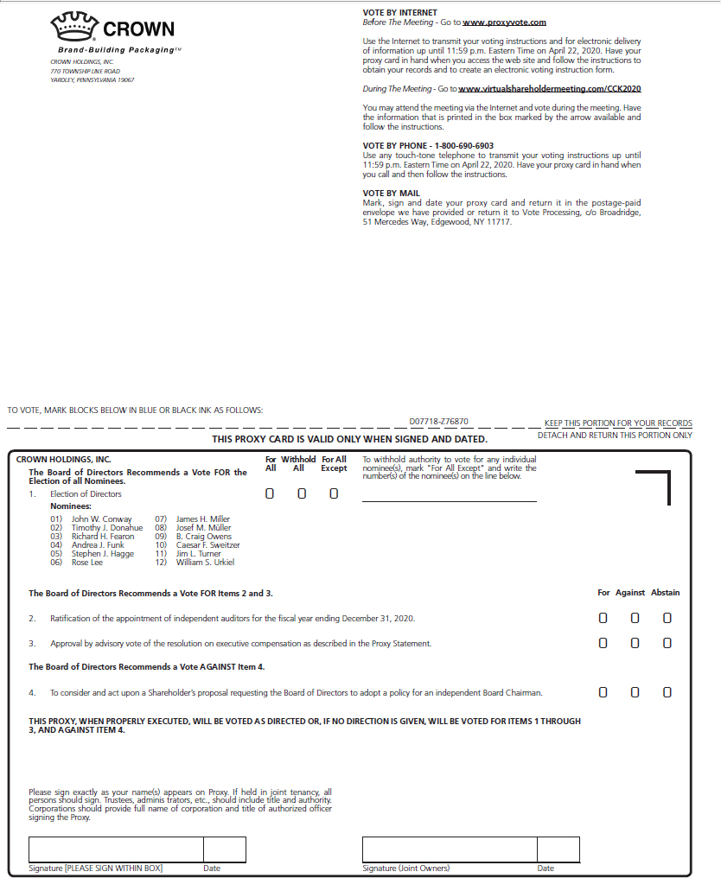

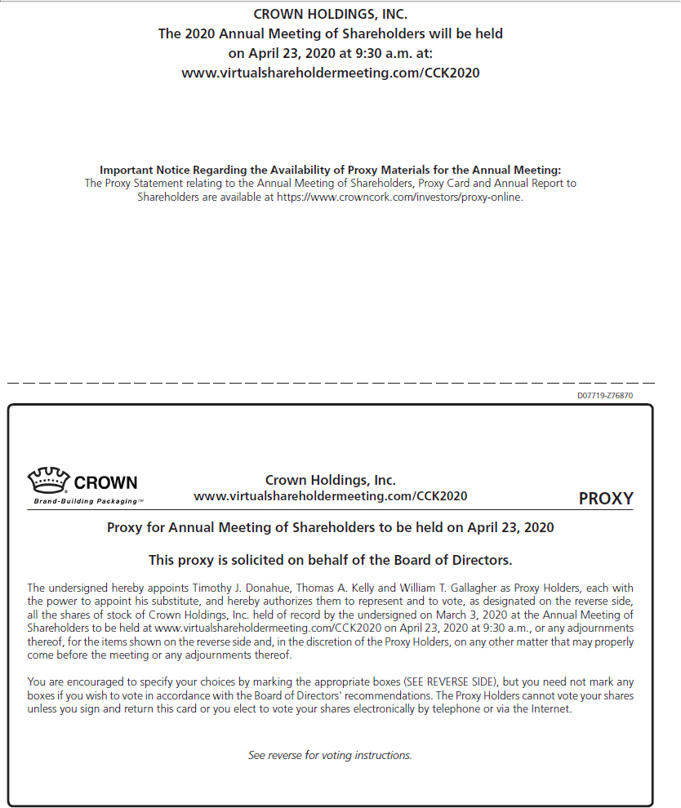

News Release


Corporate Headquarters

770 Township Line Road

Yardley, PA 19067

CROWN HOLDINGS ANNOUNCES LOCATION AND VOTING METHOD CHANGE

FOR ANNUAL MEETING OF SHAREHOLDERS TO BE HELD ON APRIL 23, 2020

Yardley, PA – March 30, 2020. Crown Holdings, Inc. (NYSE: CCK) today announced notice of a change in the location of and voting method for its Annual Meeting of Shareholders to be held on April 23, 2020 at 9:30 AM, Eastern Time. Due to the ongoing public health impact of the coronavirus pandemic and the travel and public gathering restrictions being imposed throughout Pennsylvania as a result thereof, the Annual Meeting has been changed to be held in a virtual meeting format to support the health and well-being of the Company’s shareholders, employees and their families. Shareholders will not be able to attend the Annual Meeting in person this year.

Shareholders as of the close of business on March 3, 2020, the record date for the Annual Meeting, who desire to vote electronically before the day of the virtual Annual Meeting must go to www.proxyvote.com and enter the 16-digit control number found on their updated proxy card to be distributed beginning today, or their voting instruction form previously distributed. If you are a record owner of Company shares who has already voted using the original proxy card, you must cast your vote again with the updated proxy card for the virtual Annual Meeting for your vote to be counted. Beneficial owners who have already voted do not need to vote again.

Shareholders as of the close of business on March 3, 2020, the record date for the Annual Meeting, can attend the virtual meeting. To participate in the virtual Annual Meeting and/or vote during the Annual Meeting, shareholders must enter the 16-digit control number found on their updated proxy card to be distributed beginning today, or their voting instruction form previously distributed, at www.virtualshareholdermeeting.com/CCK2020 on the day of the meeting.

For additional information regarding how shareholders may access, vote and participate in the virtual Annual Meeting, please refer to the Company’s Notice of Change of Location and Voting Method for the 2020 Annual Meeting of Shareholders filed with the U.S. Securities and Exchange Commission on March 30, 2020.

About Crown Holdings, Inc.

Crown Holdings, Inc., through its subsidiaries, is a leading global supplier of rigid packaging products to consumer marketing companies, as well as transit and protective packaging products, equipment and services to a broad range of end markets. World headquarters are located in Yardley, Pennsylvania. For more information, visit www.crowncork.com.

For more information, contact:

Thomas A. Kelly, Senior Vice President and Chief Financial Officer, (215) 698-5341, or Thomas T. Fischer, Vice President, Investor Relations and Corporate Affairs, (215) 552-3720

