Table of Contents

As filed with the Securities and Exchange Commission on November 14, 2022

Registration No. 333-

SECURITIES AND EXCHANGE COMMISSION

Washington, DC 20549

FORM S-4

REGISTRATION STATEMENT

UNDER

THE SECURITIES ACT OF 1933

CROWN HOLDINGS, INC.

(Exact name of Registrants as specified in their charter)

Pennsylvania | 3411 | 75-3099507
(State or Other Jurisdiction of | (Primary Standard Industrial | (I.R.S. Employer
Incorporation or Organization) | Classification Code Number) | Identification No.)

770 Township Line Road
Yardley, PA 19067 USA
(215) 698-5100
(Address, Including Zip Code, and Telephone Number, Including Area Code, of Registrant’s Principal Executive Offices)

CROWN AMERICAS LLC

Pennsylvania | 3411 | 23-1526444
(State or Other Jurisdiction of | (Primary Standard Industrial | (I.R.S. Employer
Incorporation or Organization) | Classification Code Number) | Identification No.)

c/o Crown Holdings, Inc.
770 Township Line Road
Yardley, PA 19067 USA
(215) 698-5100
(Address, Including Zip Code, and Telephone Number, Including Area Code, of Registrant’s Principal Executive Offices)

Adam J. Dickstein, Esquire
Senior Vice President, General Counsel and Secretary
Crown Holdings, Inc.
770 Township Line Road
Yardley, PA 19067 USA
(215) 698-5100

(Name, Address, Including Zip Code, and Telephone Number, Including Area Code, of Agent for Service)

See Table of Additional Registrants Below

Copies to:

Ian A. Hartman, Esquire
Dechert LLP
Cira Centre
2929 Arch Street
Philadelphia, Pennsylvania 19104
(215) 994-4000

Approximate date of commencement of proposed sale to public: As soon as practicable after this Registration Statement becomes effective.

If the securities being registered on this Form are being offered in connection with the formation of a holding company and there is compliance with General Instruction G, check the following box. ☐

If this Form is filed to register additional securities for an offering pursuant to Rule 462(b) under the Securities Act, please check the following box and list the Securities Act registration statement number of the earlier effective registration statement for the same offering. ☐

If this Form is a post effective amendment filed pursuant to Rule 462(d) under the Securities Act, check the following box and list the Securities Act registration statement number of the earlier effective registration statement for the same offering. ☐

Indicate by check mark whether the registrant is a large accelerated filer, an accelerated filer, a non-accelerated filer, a smaller reporting company, or an emerging growth company. See the definitions of “large accelerated filer,” “accelerated filer,” “smaller reporting company,” and “emerging growth company” in Rule 12b-2 of the Exchange Act.

Large accelerated filer ☒ Accelerated filer

Non-accelerated filer ☐ Smaller reporting company

Emerging growth company

If an emerging growth company, indicate by check mark if the registrant has elected not to use the extended transition period for complying with any new or revised financial accounting standards pursuant to Section 7(a)(2)(B) of the Securities Act. ☐

If applicable, place an X in the box to designate the appropriate rule provision relied upon in conducting this transaction:

Exchange Act Rule 13e-4(i) (Cross-Border Issuer Tender Offer) ☐

Exchange Act Rule 14d-1(d) (Cross-Border Third-Party Tender Offer) ☐

☐

☐

☐

The Registrant hereby amends this Registration Statement on such date or dates as may be necessary to delay its effective date until the Registrant shall file a further amendment which specifically states that this Registration Statement shall thereafter become effective in accordance with Section 8(a) of the Securities Act or until this Registration Statement shall become effective on such date as the Securities and Exchange Commission, acting pursuant to said Section 8(a), may determine.

Table of Contents

Table of Additional Registrants

 |  | Jurisdiction of |  | I.R.S. Employer
Exact Name of Additional Registrants |  |  |  | Identification
Exact Name of Additional Registrants |  | Incorporation |  | Number
CROWN Beverage Packaging Puerto Rico, Inc. |  | Delaware |  | Not Applicable
Crown Consultants, Inc. | Pennsylvania |  |  | 23-2846356
Crown Cork & Seal Company (DE), LLC | Delaware |  |  | Not Applicable
Crown Cork & Seal Company, Inc. | Pennsylvania |  |  | 23-1526444
Crown Financial Corporation | Pennsylvania |  |  | 23-1603914
Crown International Holdings, Inc. | Delaware |  |  | 75-3099512
CROWN Packaging Technology, Inc. | Delaware |  |  | 52-2006645
Foreign Manufacturers Finance Corporation | Delaware |  |  | 51-0099971
CROWN Cork & Seal USA, Inc. | Delaware |  |  | 52-2006645
CR USA, Inc. | Delaware |  |  | 23-2162641
Crown Beverage Packaging, LLC | Delaware |  |  | 13-2853410
Crown Beverage Holdings, Inc. | Delaware |  |  | 87-1855354
Signode Industrial Group LLC | Delaware |  |  | 80-0935607
Signode Pickling Holding LLC | Delaware |  |  | Not Applicable
Signode US IP Holdings LLC | Delaware |  |  | 46-5417288
Signode Industrial Group US Inc. | Delaware |  |  | 46-5152538
Signode Industrial Group Holdings US Inc. | Delaware |  |  | 46-5152404
Signode International IP Holdings LLC | Delaware |  |  | 32-0453191
Simplimatic Engineering Holdings, LLC | Ohio |  |  | 34-1933983
Simplimatic Automation LLC | Ohio |  |  | 27-4464512
SEH Real Estate Holdings LLC | Virginia |  |  | 46-4557904
SE International Holdings LLC | Ohio |  |  | 86-1198810
SE International Holdings II LLC | Ohio |  |  | 86-1304089

The address for service of each of the additional registrants is c/o Crown Holdings, Inc., 770 Township Line Road, Yardley, Pennsylvania 19067, telephone (215) 698-5100. The primary industrial classifications number for each of the additional registrants is 3411.

Table of Contents

The information in this prospectus is not complete and may be changed. We may not sell these securities until the registration statement filed with the Securities and Exchange Commission is effective. This preliminary prospectus is not an offer to sell these securities and it is not soliciting an offer to buy these securities in any state where the offer or sale is not permitted.

SUBJECT TO COMPLETION, DATED | , 2022

PRELIMINARY PROSPECTUS


Crown Americas LLC

OFFER TO EXCHANGE

$500,000,000 5.250% Senior Notes due 2030 and related Guarantees for all outstanding

5.250% Senior Notes due 2030

The exchange offer expires at 5:00 p.m., New York City time, on , 2022, unless extended. Crown Americas LLC (“Crown Americas” and the “Issuer”) will exchange all old notes that are validly tendered and not validly withdrawn prior to the expiration of the exchange offer. You may withdraw tenders of old notes at any time before the exchange offer expires.

The form and terms of the new notes will be identical in all material respects to the form and terms of the old notes, except that the new notes:

- will have been registered under the Securities Act;

- will not bear restrictive legends restricting their transfer under the Securities Act;

- will not be entitled to the registration rights that apply to the old notes; and

- will not contain provisions relating to increased interest rates in connection with the old notes under circumstances related to the timing of the exchange offer.

The new notes will be senior obligations of the Issuer and initially will be guaranteed on a senior basis by its indirect parent, Crown Holdings, Inc. (“we” or “Crown”), and by each of Crown’s U.S. subsidiaries (other than the Issuer, Crown Americas Capital Corp., Crown Americas Capital Corp. II, Crown Americas Capital Corp. III, Crown Americas Capital Corp. IV, Crown Americas Capital Corp. V and Crown Americas Capital Corp. VI) that guarantees obligations under Crown’s senior secured credit facilities, subject to customary release provisions. The entities providing such guarantees are referred to collectively as the guarantors. The notes will not be guaranteed by Crown’s foreign subsidiaries. The new notes and new note guarantees will be effectively junior in right of payment to all existing and future secured indebtedness of the Issuer and the guarantors to the extent of the value of the assets securing such indebtedness and will be junior in right of payment to all indebtedness of Crown’s non-guarantor subsidiaries.

Each broker-dealer that receives new notes for its own account pursuant to the exchange offer must acknowledge that it will deliver a prospectus in connection with any resale of such new notes. The letter of transmittal states that by so acknowledging and by delivering a prospectus, a broker-dealer will not be deemed to admit that it is an “underwriter” within the meaning of the Securities Act. This prospectus, as it may be amended or supplemented from time to time, may be used by a broker-dealer in connection with resales of new notes received in exchange for old notes where such old notes were acquired by such broker-dealer as a result of market-making activities or other trading activities. Crown has agreed that, starting on the expiration date of the exchange offer and ending on the close of business one year after the expiration date, it will make this prospectus available to any broker-dealer for use in connection with any such resale. See “Plan of Distribution.”

See “Risk Factors” beginning on page 7 for a discussion of risks that should be considered by holders prior to tendering their old notes.

Neither the Securities and Exchange Commission nor any state securities commission has approved or disapproved of these securities or determined if this prospectus is truthful or complete. Any representation to the contrary is a criminal offense.

The date of this prospectus is | , 2022.

Table of Contents

 |  |  |  |  |  |  |  |  |  |  |  | TABLE OF CONTENTS
Summary |  |  |  |  |  |  |  |  |  |  |  |  | Page
 |  |  |  |  |  |  |  |  |  |  |  |  | 1
Risk Factors |  |  |  |  |  |  |  |  |  |  |  | 7
Forward-Looking Statements |  |  |  |  |  |  |  |  |  |  |  | 11
Use of Proceeds |  |  |  |  |  |  |  |  |  |  |  | 14
The Exchange Offer |  |  |  |  |  |  |  |  |  |  |  | 15
Description of the Notes |  |  |  |  |  |  |  |  |  |  |  | 25
Certain U.S. Federal Income Tax Considerations |  |  |  |  |  |  |  |  |  |  |  | 51
Plan of Distribution |  |  |  |  |  |  |  |  |  |  |  | 56
Legal Matters |  |  |  |  |  |  |  |  |  |  |  | 57
Experts |  |  |  |  |  |  |  |  |  |  |  | 57
Where You Can Find Additional Information |  |  |  |  |  |  |  |  |  |  |  | 57
Incorporation of Documents by Reference |  |  |  |  |  |  |  |  |  |  |  | 57

This prospectus incorporates important business and financial information that is not included in or delivered with this document. This information is available without charge upon written or oral request. To obtain timely delivery, note holders must request the information no

later than five business days before the expiration date. The expiration date is , 2022. See “Incorporation of Documents by Reference.”

You should rely only on the information contained in this document and any supplement, including the periodic reports and other information we file with the Securities and Exchange Commission or to which we have referred you. See “Where You Can Find Additional Information.” Neither the Issuer nor Crown has authorized anyone to provide you with information that is different. If anyone provides you with different or inconsistent information, you should not rely on it. Neither the Issuer nor Crown is making an offer to sell these securities in any jurisdiction where the offer or sale is not permitted, where the person making the offer is not qualified to do so, or to any person who cannot legally be offered the securities.

The distribution of this prospectus and the offer or sale of the new notes may be restricted by law in certain jurisdictions. Persons who possess this prospectus must inform themselves about, and observe, any such restrictions. See “Plan of Distribution.” Neither the Issuer, nor Crown nor any of their respective representatives is making any representation to any offeree or purchaser under applicable legal investment or similar laws or regulations. Each prospective investor must comply with all applicable laws and regulations in force in any jurisdiction in which it purchases, offers or sells notes or possesses or distributes this prospectus and must obtain any consent, approval or permission required by it for the purchase, offer or sale by it of notes under the laws and regulations in force in any jurisdiction to which it is subject or in which it makes such purchases, offers or sales, and neither the Issuer, nor Crown nor any of their respective representatives shall have any responsibility therefor.

This prospectus does not constitute an offer to sell or a solicitation of an offer to buy securities to any person in any jurisdiction where it is unlawful to make such an offer or solicitation.

i

Table of Contents

MARKETS, RANKING AND OTHER DATA

The data included in this prospectus regarding markets and ranking, including the position of Crown and its competitors within these markets, are based on independent industry publications, reports of government agencies or other published industry sources and the estimates of Crown based on its management’s knowledge and experience in the markets in which it operates. We believe these data are accurate in all material respects as of the date of this prospectus. Crown’s estimates have been based on information obtained from customers, suppliers, trade and business organizations and other contacts in the markets in which it operates. This information may prove to be inaccurate because of the method by which Crown obtained some of the data for these estimates or because this information cannot always be independently verified with complete certainty due to the limits on the availability and reliability of raw data, the voluntary nature of the data gathering process and other inherent limitations and uncertainties. Furthermore, facts, statistics and estimates upon which these publications and data are based and to which Crown cites in this prospectus may become outdated, obsolete or inaccurate as underlying facts or markets or industry conditions change.

ii

Table of Contents


SUMMARY

The following summary should be read in connection with, and is qualified in its entirety by, the more detailed information and financial statements (including the accompanying notes) appearing elsewhere in, or incorporated by reference in, this prospectus. See “Risk Factors” for a discussion of certain factors that should be considered in connection with this offering. Unless the context otherwise requires: (i) “Crown” refers to Crown Holdings, Inc. and its subsidiaries on a consolidated basis; (ii) “Crown Cork” refers to Crown Cork & Seal Company, Inc. and not its subsidiaries; (iii) “Crown European Holdings” refers to Crown European Holdings S.A. and not its subsidiaries; (iv) “Crown Americas” refers to Crown Americas LLC and not its subsidiaries; (v) “old notes” refers to the $500 million aggregate principal amount of 5.250% Senior Notes due 2030 issued on March 17, 2022; (vi) “new notes” refers to the $500 million aggregate principal amount of 5.250% Senior Notes due 2030 offered in exchange for the old notes pursuant to this prospectus; and (vii) “notes” refers collectively to the old notes and the new notes.

Crown Holdings, Inc.

Crown is a worldwide leader in the design, manufacture and sale of packaging products for consumer goods and industrial products. Crown’s consumer packaging solutions primarily support the beverage and food industries through the sale of aluminum and steel cans. Crown’s packaging for industrial products includes steel and plastic consumables and equipment, paper-based protective packaging, and plastic film consumables and equipment, which are sold into the metals, food and beverage, construction, agricultural, corrugated and general industries.

These products are manufactured in Crown’s plants both within and outside the United States and are sold through Crown’s sales organization to the soft drink, food, citrus, brewing, household products, personal care and various other industries. As of December 31, 2021, the Company operated 200 plants along with sales and service facilities throughout 40 countries and had approximately 26,000 employees. In 2021, consolidated net sales for the Company were $11.4 billion with 63% derived from operations outside the United States.

Crown is a Pennsylvania corporation. Crown’s principal executive offices are located at 770 Township Line Road, Yardley, Pennsylvania, 19067, and its telephone number is (215) 698-5100. Crown Cork is a Pennsylvania corporation. Crown Americas (formerly known as Crown Americas, Inc.) is a Pennsylvania limited liability company. Crown European Holdings (formerly known as CarnaudMetalbox SA) is a société anonyme organized under the laws of France. Each of Crown Americas and Crown European Holdings is an indirect, wholly-owned subsidiary of Crown, and Crown Cork is a direct, wholly-owned subsidiary of Crown.

1

Table of Contents


The Exchange Offer

The summary below describes the principal terms of the exchange offer and is not intended to be complete. Certain of the terms and conditions described below are subject to important limitations and exceptions. The section of this prospectus entitled “The Exchange Offer” contains a more detailed description of the terms and conditions of the exchange offer.

On March 17, 2022, we issued and sold $500,000,000 of 5.250% Senior Notes due 2030. In connection with this sale, we entered into a separate registration rights agreement with the initial purchasers of the old notes in which we agreed to deliver this prospectus to you and to complete an exchange offer for the old notes.

Notes Offered | $500,000,000 of 5.250% Senior Notes due 2030.
 | The issuance of the new notes will be registered under the Securities Act. The terms of the
 | new notes and old notes are identical in all material respects, except for transfer
 | restrictions, registration rights relating to the old notes and certain provisions relating to
 | increased interest rates in connection with the old notes under circumstances related to the
 | timing of the exchange offer. You are urged to read the discussions under the heading “The
 | New Notes” in this Summary for further information regarding the new notes.
The Exchange Offer | We are offering to exchange the new notes for up to $500 million aggregate principal
 | amount of the old notes.
 | Old notes may be exchanged only in denominations of $2,000 and any integral multiple of
 | $1,000 in excess thereof. In this prospectus, the term “exchange offer” means this offer to
 | exchange new notes for old notes in accordance with the terms set forth in this prospectus
 | and the accompanying letter of transmittal. You are entitled to exchange your old notes for
 | new notes.
Expiration Date; Withdrawal of Tender | The exchange offer will expire at 5:00 p.m., New York City time, on | , 2022, or
 | such later date and time to which it may be extended by us. The tender of old notes
 | pursuant to the exchange offer may be withdrawn at any time prior to the expiration date of
 | the exchange offer. Any old notes not accepted for exchange for any reason will be
 | returned without expense to the tendering holder thereof promptly after the expiration or
 | termination of the exchange offer.
Conditions to the Exchange Offer | Our obligation to accept for exchange, or to issue new notes in exchange for, any old notes
 | is subject to customary conditions relating to compliance with any applicable law or any
applicable interpretation by the staff of the Securities and Exchange Commission, the receipt of any applicable governmental approvals and the absence of any actions or proceedings of any governmental agency or court which could materially impair the Issuer’s or Crown’s ability to consummate the exchange offer. See “The Exchange Offer— Conditions to the Exchange Offer.”

2

Table of Contents

Procedures for Tendering Old Notes | If you wish to accept the exchange offer and tender your old notes, you must either:
 | • complete, sign and date the Letter of Transmittal, or a facsimile of the Letter of
 | Transmittal, in accordance with its instructions and the instructions in this
 | prospectus, and mail or otherwise deliver such Letter of Transmittal, or the
 | facsimile, together with the old notes and any other required documentation, to the
 | exchange agent at the address set forth herein; or
 | • if old notes are tendered pursuant to book-entry procedures, the tendering holder
 | must arrange with the Depository Trust Company, or DTC, to cause an agent’s
 | message to be transmitted through DTC’s Automated Tender Offer Program System
 | with the required information (including a book-entry confirmation) to the exchange
 | agent.
Broker-Dealers | Each broker-dealer that receives new notes for its own account in exchange for old notes,
 | where such old notes were acquired by such broker-dealer as a result of market-making
 | activities or other trading activities, must acknowledge that it will deliver a prospectus in
 | connection with any resale of such new notes. See “Plan of Distribution.”
Use of Proceeds | We will not receive any proceeds from the exchange offer. See “Use of Proceeds.”
Exchange Agent | U.S. Bank Trust Company, National Association (as successor to U.S. Bank National
 | Association) is serving as the exchange agent in connection with the exchange offer.
U.S. Federal Income Tax Consequences | The exchange of old notes for new notes pursuant to the exchange offer should not be a
 | taxable event for U.S. federal income tax purposes. See “Certain U.S. Federal Income Tax
 | Considerations.”
 | 3

Table of Contents


Consequences of Exchanging Old Notes Pursuant to the Exchange Offer

Based on certain interpretive letters issued by the staff of the Securities and Exchange Commission to third parties in unrelated transactions, the Issuer is of the view that holders of old notes (other than any holder who is an “affiliate” of the Issuer within the meaning of Rule 405 under the Securities Act) who exchange their old notes for new notes pursuant to the exchange offer generally may offer the new notes for resale, resell such new notes and otherwise transfer the new notes without compliance with the registration and prospectus delivery provisions of the Securities Act, provided that:

- the new notes are acquired in the ordinary course of the holders’ business;

- the holders have no arrangement or understanding with any person to participate in a distribution of the new notes; and

- neither the holder nor any other person is engaging in or intends to engage in a distribution of the new notes.

Each broker-dealer that receives new notes for its own account in exchange for old notes that were acquired as a result of market-making or other trading activity must acknowledge that it will deliver a prospectus in connection with any resale of the new notes. See “Plan of Distribution.” If a holder of old notes does not exchange the old notes for new notes according to the terms of the exchange offer, the old notes will continue to be subject to the restrictions on transfer contained in the legend printed on the old notes. In general, the old notes may not be offered or sold, unless registered under the Securities Act, except under an exemption from, or in a transaction not subject to, the Securities Act and applicable state securities laws. Holders of old notes do not have any appraisal or dissenters’ rights in connection with the exchange offer. See “The Exchange Offer —Resales of New Notes.”

Additionally, if you do not participate in the exchange offer, you will not be able to require us to register your old notes under the Securities Act except in limited circumstances. These circumstances are:

- the exchange offer is not permitted by applicable law or SEC policy,

- the exchange offer is not completed within 360 days of the issue date of the old notes, or

- prior to the 20th day following consummation of the exchange offer:

  - any initial purchaser of the old notes requests that we register old notes that were not eligible to be exchanged for new notes in the exchange offer and that are held by it following consummation of the exchange offer; or

  - any holder of old notes notifies us that it is not eligible to participate in the exchange offer; or

  - any initial purchaser of the old notes notifies us that it will not receive freely tradable new notes in exchange for old notes constituting any portion of an unsold allotment.

In these cases, the registration rights agreement requires us to file a registration statement for a continuous offering in accordance with Rule 415 under the Securities Act for the benefit of the holders of the old notes. We do not currently anticipate that we will register under the Securities Act any old notes that remain outstanding after completion of the exchange offer.

4

Table of Contents


The New Notes

The summary below describes the principal terms of the new notes and is not intended to be complete. Many of the terms and conditions described below are subject to important limitations and exceptions. The “Description of the Notes” section of this prospectus contains a more detailed description of the terms and conditions of the new notes.

Issuer | Crown Americas LLC, a Pennsylvania limited liability company.
Notes Offered | $500,000,000 principal amount of 5.250% of Senior Notes due 2030.
Maturity | April 1, 2030.
Interest | Interest on the new notes will accrue from and including the issue date of the old notes and
 | will be payable semi-annually on April 1 and October 1 of each year, commencing on
 | October 1, 2022.
Ranking and Guarantees | The new notes will be senior obligations of the Issuer, ranking senior in right of payment to
 | all its subordinated indebtedness, and will be unconditionally guaranteed on an unsecured
 | senior basis by Crown and each of Crown’s present and future U.S. subsidiaries (other than
 | the Issuer, Crown Americas Capital Corp., Crown Americas Capital Corp. II, Crown
 | Americas Capital Corp. III, Crown Americas Capital Corp. IV, Crown Americas Capital
 | Corp. V and Crown Americas Capital Corp. VI) that from time to time are obligors under
 | or guarantee Crown’s senior secured credit facilities.
 | The new notes and new note guarantees will be senior unsecured obligations of the Issuer
 | and the guarantors,
 | • effectively subordinated to all existing and future secured indebtedness of the Issuer
 | and the guarantors to the extent of the value of the assets securing such
 | indebtedness, including any borrowings under Crown’s senior secured credit
 | facilities, to the extent of the value of the assets securing such indebtedness;
 | • structurally subordinated to all indebtedness of subsidiaries of Crown that do not
 | guarantee the notes offered hereby which include all of Crown’s foreign
 | subsidiaries, and any U.S. subsidiaries that are neither obligors nor guarantors of
 | Crown’s senior secured credit facilities;
 | • ranking equal in right of payment to any existing or future senior indebtedness of
 | the Issuer and the guarantors; and
 | • ranking senior in right of payment to all existing and future subordinated
 | indebtedness of the Issuer and the guarantors.
 | Upon the release of any new note guarantor from its obligations under Crown’s senior
 | secured credit facilities, unless there is a default or event of default existing or continuing
 | under the indenture governing the new notes, the guarantee of such new notes by such new
 | note guarantor will also be released.
 | 5

Table of Contents


Additional Indebtedness

Crown and the Issuer may be able to incur additional debt in the future. Although Crown’s senior secured credit facilities contain restrictions on Crown’s ability to incur indebtedness, those restrictions are subject to a number of exceptions.

Optional Redemption

The Issuer may redeem some or all of the new notes at any time prior to January 1, 2030 at a price equal to 100% of the principal amount of the notes redeemed, plus accrued and unpaid interest, if any, to, but excluding, the redemption date and a “make whole” premium, as described in this prospectus. Thereafter, the Issuer may redeem all or some of the notes at the redemption prices set forth in this prospectus. In addition, at any time on or after January 1, 2030, the notes will be redeemable at a redemption price equal to 100% of the principal amount of the notes redeemed, plus accrued and unpaid interest, if any, to, but excluding, the redemption date. See “Description of the Notes—Optional Redemption.”

Change of Control

Upon a “change of control repurchase event” of Crown or the Issuer, as defined under the caption “Description of the Notes—Repurchase at the Option of Holders,” you will have the right, as a holder of new notes, to require the Issuer to repurchase all or part of your new notes at a repurchase price equal to 101% of their principal amount, plus accrued and unpaid interest, if any, to, but excluding, the repurchase date. Crown will comply, to the extent applicable, with requirements of Section 14(e) of the Securities Exchange Act of 1934, as amended, and any other securities laws or regulations in connection with the repurchase of notes in the event of a change of control repurchase event.

Restrictive Covenants

The indenture governing the new notes will limit, among other things, Crown’s ability and the ability of certain of its subsidiaries (including the Issuer) to incur secured indebtedness and engage in certain sale and leaseback transactions.

These covenants are subject to a number of important exceptions and limitations that are described under the caption “Description of the Notes—Certain Covenants.”

Risk Factors

Participation in the exchange offer involves risks. You should carefully consider all of the information in this prospectus. In particular, you should evaluate the specific risk factors set forth under the caption “Risk Factors” in this prospectus.

6

Table of Contents

RISK FACTORS

You should carefully consider the risks described below, as well as the other information contained in this prospectus, before deciding whether to participate in the exchange offer. The risks described below are not the only ones that we face. Additional risks not presently known to us may also impair our business operations. The actual occurrence of any of these risks could materially adversely affect our business, financial condition and results of operations. In that case, the value of the new notes could decline substantially, and you may lose part or all of your investment.

Risks Related to the Exchange Offer

If you fail to exchange your old notes for new notes your old notes will continue to be subject to restrictions on transfer and may become less liquid.

We did not register the old notes under the Securities Act or any state securities laws, nor do we intend to do so after the exchange offer. In general, you may only offer or sell the old notes if they are registered under the Securities Act and applicable state securities laws, or offered and sold under an exemption from these requirements. If you do not exchange your old notes in the exchange offer, you will lose your right to have the old notes registered under the Securities Act, subject to certain limitations. If you continue to hold old notes after the exchange offer, you may be unable to sell the old notes.

Because we anticipate that most holders of old notes will elect to exchange their old notes, we expect that the liquidity of the market for any old notes remaining after the completion of the exchange offer will be substantially limited. Any old notes tendered and exchanged in the exchange offer will reduce the aggregate principal amount of the old notes outstanding. Following the exchange offer, if you do not tender your old notes you generally will not have any further registration rights, and your old notes will continue to be subject to certain transfer restrictions. Accordingly, the liquidity of the market for the old notes could be adversely affected.

If an active trading market for the new notes does not develop, the liquidity and value of the new notes could be harmed.

There is no existing market for the new notes. An active public market for the new notes may not develop or, if developed, may not continue. If an active public market does not develop or is not maintained, you may not be able to sell your new notes at their fair market value or at all.

Even if a public market for the new notes develops, trading prices of the new notes will depend on many factors, including, among other things, prevailing interest rates, the Issuer’s and Crown’s financial performance or prospects or the prospects of the companies in their industry, operating results and the market for similar securities. Historically, the market for non-investment grade debt has been subject to disruptions that have caused substantial volatility in the prices of securities similar to the new notes. Declines in the market for debt securities generally may also materially and adversely affect the liquidity of the new notes, independent of Crown’s financial performance.

You must comply with the exchange offer procedures in order to receive new notes.

The new notes will be issued in exchange for the old notes only after timely receipt by the exchange agent of the old notes or a book-entry confirmation related thereto, a properly completed and executed letter of transmittal or an agent’s message and all other required documentation. If you want to tender your old notes in exchange for new notes, you should allow sufficient time to ensure timely delivery. None of us, Crown nor the exchange agent, are under any duty to give you notification of defects or irregularities with respect to tenders of old notes for exchange. Old notes that are not tendered or are tendered but not accepted will, following the exchange offer, continue to be subject to the existing transfer restrictions. In addition, if you tender the old notes in the exchange

7

Table of Contents

offer to participate in a distribution of the new notes, you will be required to comply with the registration and prospectus delivery requirements of the Securities Act in connection with any resale transaction. For additional information, please refer to the sections entitled “The Exchange Offer” and “Plan of Distribution” later in this prospectus.

Some persons who participate in the exchange offer must deliver a prospectus in connection with resales of the new notes.

Based on interpretations of the staff of the SEC contained in Exxon Capital Holdings Corp., SEC no-action letter (April 13, 1988), Morgan Stanley & Co. Inc., SEC no-action letter (June 5, 1991) and Shearman & Sterling, SEC no-action letter (July 2, 1983), we believe that you may offer for resale, resell or otherwise transfer the new notes without compliance with the registration and prospectus delivery requirements of the Securities Act. However, in some instances described in this prospectus under “Plan of Distribution,” you will remain obligated to comply with the registration and prospectus delivery requirements of the Securities Act to transfer your new notes. In these cases, if you transfer any new note without delivering a prospectus meeting the requirements of the Securities Act or without an exemption from registration of your exchange under the Securities Act, you may incur liability under the Securities Act. We do not and will not assume, or indemnify you against, this liability. Furthermore, we will not seek our own interpretive letter. As a result, we cannot assure you that the staff will take the same position on this exchange offer as it did in interpretive letters to other parties in similar transactions.

Risks Related to the New Notes

Crown and the Issuer are holding companies with no direct operations and the new notes will be structurally subordinated to all indebtedness of Crown’s subsidiaries that are not guarantors of the new notes.

Crown and the Issuer are holding companies with no direct operations. The principal assets of Crown and the Issuer are the equity interests and investments they hold in their subsidiaries. As a result, they depend on dividends and other payments from their subsidiaries to generate the funds necessary to meet their financial obligations, including the payment of principal of and interest on their outstanding debt. Their subsidiaries are legally distinct from them and have no obligation to pay amounts due on their debt or to make funds available to them for such payment except as provided in the note guarantees or pursuant to intercompany notes. Not all of Crown’s or the Issuer’s subsidiaries will guarantee the new notes. Specifically, none of Crown’s or the Issuer’s foreign subsidiaries are expected to guarantee the new notes. A holder of new notes will not have any claim as a creditor against subsidiaries of Crown or the Issuer that are not guarantors of the new notes, and the indebtedness and other liabilities, including trade payables, whether secured or unsecured, of those non-guarantor subsidiaries will be effectively senior to your claims.

Your right to receive payments on the new notes is effectively subordinated to Crown’s existing secured indebtedness, including Crown’s existing senior secured credit facilities, and possible future secured borrowings.

The new notes and the new note guarantees will be effectively subordinated to the prior payment in full of Crown’s, the Issuer’s and the guarantors’ current and future secured indebtedness to the extent of the value of the assets securing such indebtedness. Such secured indebtedness may increase if Crown incurs secured indebtedness, including under Crown’s senior secured revolving credit facilities, to finance an acquisition or otherwise. Because of the liens on the assets securing the senior secured credit facilities, in the event of the bankruptcy, wind-up, reorganization, liquidation or dissolution of the borrowers or any guarantor of such indebtedness, the assets of the borrowers or guarantors would be available to pay obligations under the new notes offered to be exchanged hereby and other unsecured obligations only after payments had been made on the borrowers’ or the guarantors’ secured indebtedness. Sufficient assets may not remain after these payments have been made to make any payments on the new notes offered to be exchanged hereby and Crown’s other unsecured

8

Table of Contents

obligations, including payments of interest when due. Holders of the new notes offered to be exchanged hereby will participate ratably with all holders of other unsecured obligations that are deemed to be of the same class as the new notes offered to be exchanged hereby, and potentially with all of Crown’s other general creditors, based upon the respective amounts owed to each holder or creditor, in Crown’s remaining assets. As a result, holders of the new notes offered to be exchanged hereby may receive less ratably than holders of secured indebtedness. In addition, all payments on the notes and the note guarantees will be prohibited in the event of a payment default on Crown’s secured indebtedness (including borrowings under the senior secured credit facilities) and, for limited periods, upon the occurrence of other defaults under the existing senior secured credit facilities.

Crown may not be able to generate sufficient cash to service all of its indebtedness, including the new notes offered to be exchanged hereby, and may be forced to take other actions to satisfy its obligations under its indebtedness, which may not be successful.

Crown’s ability to make scheduled payments on and to refinance its indebtedness, including the new notes offered to be exchanged hereby, and to fund planned capital expenditures and research and development efforts, will depend on Crown’s ability to generate cash in the future. This is subject to general economic, financial, competitive, legislative, regulatory and other factors that may be beyond Crown’s control.

We cannot assure you that Crown’s business will generate sufficient cash flow from operations or that future borrowings will be available in an amount sufficient to enable Crown to pay its indebtedness, including the new notes offered to be exchanged hereby, or to fund its other liquidity needs. If Crown’s cash flows and capital resources are insufficient to fund its debt service obligations, Crown may be forced to reduce or delay capital expenditures, sell assets or operations, seek additional capital or restructure or refinance its indebtedness, including the new notes offered to be exchanged hereby. We cannot assure you that Crown would be able to take any of these actions, that these actions would be successful and permitted under the terms of Crown’s existing or future debt agreements or that Crown could release from these actions sufficient proceeds to meet any debt service obligations then due.

The new note guarantee of a subsidiary guarantor will be released if such subsidiary guarantor no longer guarantees or is otherwise an obligor of indebtedness under any Crown credit facility.

Any subsidiary guarantee of the new notes may be released without action by, or consent of, any holder of the new notes or the trustee under the indenture if the subsidiary guarantor is no longer a guarantor or an obligor of any Crown credit facility or other indebtedness as described under “Description of the Notes—Ranking and Guarantees.” The lenders under Crown’s senior secured credit facilities will have the discretion to release the subsidiary guarantees under the senior secured credit facilities in a variety of circumstances. You will not have a claim as a creditor against any subsidiary that is no longer a subsidiary guarantor of the new notes, and the indebtedness and other liabilities, including trade payables, whether secured or unsecured, of those subsidiaries will effectively be senior to your claims.

The new notes and the new note guarantees may be voidable, subordinated or limited in scope under insolvency, fraudulent transfer, corporate or other laws.

Fraudulent transfer and insolvency laws may void, subordinate or limit the new notes and the new note guarantees. See “Description of the Notes— Certain Bankruptcy and Fraudulent Transfer Limitations.”

Under U.S. federal bankruptcy laws or comparable provisions of state fraudulent transfer laws, the issuance of the new note guarantees by Crown and the subsidiary guarantors could be voided, or claims in respect of such obligations could be subordinated to all of their other debts and other liabilities, if, among other things, at the time Crown and/or the subsidiary guarantors issued the related new note guarantees, or, potentially, the old note guarantees, Crown or the applicable subsidiary guarantor intended to hinder, delay or defraud any present or

9

Table of Contents

future creditor, or received less than reasonably equivalent value or fair consideration for the incurrence of such indebtedness and either:

- was insolvent or rendered insolvent by reason of such incurrence;

- was engaged in a business or transaction for which Crown’s or such subsidiary guarantor’s remaining assets constituted unreasonably small capital; or

- intended to incur, or believed that it would incur, debts beyond its ability to pay such debts as they mature.

By its terms, the new note guarantee of each guarantor will limit the liability of each such guarantor to the maximum amount it can pay without the new note guarantee being deemed a fraudulent transfer.

Crown’s senior secured credit facilities, the notes and other indebtedness provide that certain change of control events constitute an event of default. In the event of a change of control, Crown, Crown Americas and the guarantors may not be able to satisfy all of their obligations under the senior secured credit facilities, the new notes or other indebtedness.

Crown, the Issuer and the guarantors may not have sufficient assets or be able to obtain sufficient third-party financing on favorable terms to satisfy all of their obligations under Crown’s senior secured credit facilities, the new notes or other indebtedness in the event of a change of control. If Crown or the Issuer experiences a change of control repurchase event, the Issuer will be required to offer to repurchase all outstanding new notes. However, Crown’s senior secured credit facilities provide that certain change of control events constitute an event of default under the senior secured credit facilities. Such an event of default entitles the lenders thereunder to, among other things, cause all outstanding debt obligations under the senior secured credit facilities to become due and payable and to proceed against the collateral securing the senior secured credit facilities. Any event of default or acceleration of the senior secured credit facilities will likely also cause a default under the terms of other indebtedness of Crown.

In addition, Crown’s senior secured credit facilities contain, and any future credit facilities or other agreements to which Crown becomes a party may contain, restrictions on its ability to offer to repurchase the new notes in connection with a change of control. In the event a change of control repurchase event occurs at a time when it is prohibited from offering to purchase the new notes, the Issuer could seek consent to offer to purchase the new notes or attempt to refinance the borrowings that contain such a prohibition. If it does not obtain the consent or refinance the borrowings, the Issuer would remain prohibited from offering to purchase the new notes. In such case, the failure by the Issuer to offer to purchase the new notes would constitute a default under the indenture governing the new notes, which, in turn, could result in amounts outstanding under any future credit facility or other agreement relating to indebtedness being declared due and payable. Any such declaration could have adverse consequences to Crown, the Issuer and the holders of the new notes.

Any decline in the ratings of Crown’s corporate credit could adversely affect the trading price of the new notes.

Any decline in the ratings of our corporate credit or any indications from the rating agencies that their ratings on Crown’s corporate credit are under surveillance or review with possible negative implications could adversely affect the value of the new notes. In addition, a ratings downgrade could adversely affect our ability to access capital.

Risks Related to Crown’s Business

For a discussion of certain risks applicable to our business and operations, see “Risk Factors” in our Annual Report on Form 10-K for the year ended December 31, 2021, as updated by our subsequently filed Quarterly Reports on Form 10-Q and Current Reports on Form 8-K.

10

Table of Contents

FORWARD-LOOKING STATEMENTS

Statements included in this prospectus that are not historical facts (including any statements concerning plans and objectives of management for future operations or economic performance, or assumptions related thereto), are “forward-looking statements” within the meaning of the U.S. federal securities laws. Forward-looking statements can be identified by words, such as “believes,” “estimates,” “anticipates,” “expects” and other words of similar meaning in connection with a discussion of future operating or financial performance. These may include, among others, statements relating to:

- Crown’s plans or objectives for future operations, products or financial performance;

- Crown’s indebtedness and other contractual obligations;

- the impact of an economic downturn or growth in particular regions;

- anticipated uses of cash;

- cost reduction efforts and expected savings;

- Crown’s policies with respect to executive compensation; and

- the expected outcome of contingencies, including with respect to asbestos-related litigation and pension and postretirement liabilities.

These forward-looking statements are made based upon Crown’s expectations and beliefs concerning future events impacting it and, therefore, involve a number of risks and uncertainties. Crown cautions that forward-looking statements are not guarantees and that actual results could differ materially from those expressed or implied in the forward-looking statements.

Important factors that could cause the actual results of operations or financial condition of Crown to differ include, but are not necessarily limited to:

- the ability of Crown to expand successfully in international and emerging markets;

- the ability of Crown to repay, refinance or restructure its short and long-term indebtedness on adequate terms and to comply with the terms of its agreements relating to debt;

- long term impact of U.K.’s withdrawal from the European Union;

- Crown’s ability to generate significant cash to meet its obligations and invest in its business and to maintain appropriate debt levels;

- restrictions on Crown’s use of available cash under its debt agreements;

- changes or differences in U.S. or international economic or political conditions, such as the effects of Brexit, inflation or fluctuations in interest or foreign exchange rates (and the effectiveness of any currency or interest rate hedges), tax rates and tax laws (including with respect to taxation of unrepatriated non-U.S. earnings or as a result of the depletion of net loss or foreign tax credit carryforwards);

- the impact of foreign trade laws and practices;

- the collectability of receivables;

- war (including the military conflict between Russia and Ukraine) or acts of terrorism that may disrupt Crown’s production or the supply or pricing of raw materials, including in Crown’s Middle East and European operations, impact the financial condition of customers or adversely affect Crown’s ability to refinance or restructure its remaining indebtedness;

11

Table of Contents

- changes in the availability and pricing of raw materials (including aluminum can sheet, steel tinplate, energy, water, inks and coatings) and Crown’s ability to pass raw material, energy and freight price increases and surcharges through to its customers or to otherwise manage these commodity pricing risks;

- Crown’s ability to obtain and maintain adequate pricing for its products, including the impact on Crown’s revenue, margins and market share and the ongoing impact of price increases;

- energy and natural resource costs;

- the cost and other effects of legal and administrative cases and proceedings, settlements and investigations;

- the outcome of asbestos-related litigation (including the number and size of future claims and the terms of settlements, and the impact of bankruptcy filings by other companies with asbestos-related liabilities, any of which could increase the asbestos-related costs of Crown Cork over time, the adequacy of reserves established for asbestos-related liabilities, Crown Cork’s ability to obtain resolution without payment of asbestos-related claims by persons alleging first exposure to asbestos after 1964, and the impact of state legislation dealing with asbestos liabilities and any litigation challenging that legislation and any future state or federal legislation dealing with asbestos liabilities);

- Crown’s ability to realize deferred tax benefits;

- changes in Crown’s critical or other accounting policies or the assumptions underlying those policies;

- labor relations and workforce and social costs, including Crown’s pension and postretirement obligations and other employee or retiree costs;

- investment performance of Crown’s pension plans;

- the impact of any potential dispositions, acquisitions or other strategic realignments, which may impact Crown’s operations, financial profile, investments or levels of indebtedness;

- Crown’s ability to realize efficient capacity utilization and inventory levels and to innovate new designs and technologies for its products in a cost-effective manner;

- competitive pressures, including new product developments, industry overcapacity, or changes in competitors’ pricing for products;

- Crown’s ability to achieve high capacity utilization rates for its equipment;

- Crown’s ability to maintain, develop and capitalize on competitive technologies for the design and manufacture of products and to withstand competitive and legal challenges to the proprietary nature of such technology;

- Crown’s ability to protect its information technology systems from attacks or catastrophic failure;

- the strength of Crown’s cyber-security;

- Crown’s ability to generate sufficient production capacity;

- Crown’s ability to improve and expand its existing products and product lines;

- the impact of overcapacity on the end-markets Crown serves;

- loss of customers, including the loss of any significant customers;

- changes in consumer preferences for different packaging products;

- the financial condition of Crown’s vendors and customers;

- weather conditions, including their effect on demand for beverages and on crop yields for fruits and vegetables stored in food containers; 12

Table of Contents

- the impact of natural disasters, including in emerging markets;

- the impact of the COVID-19 pandemic and various strains of pandemic disease on Crown’s business and operations.

- changes in governmental regulations or enforcement practices, including with respect to environmental, health and safety matters and restrictions as to foreign investment or operation;

- the impact of increased governmental regulation on Crown and its products, including the regulation or restriction of the use of bisphenol-A;

- the impact of Crown’s initiatives to generate additional cash, including the reduction of working capital levels and capital spending;

- the ability of Crown to realize cost savings from its restructuring programs;

- Crown’s ability to maintain adequate sources of capital and liquidity;

- costs and payments to certain of Crown’s executive officers in connection with any termination of such executive officers or a change in control of Crown;

- the impact of existing and future legislation regarding refundable mandatory deposit laws in Europe for non-refillable beverage containers and the implementation of an effective return system; and

- changes in Crown’s strategic areas of focus, which may impact Crown’s operations, financial profile or levels of indebtedness.

Some of the factors noted above are discussed elsewhere in this prospectus and in prior Crown filings with the Securities and Exchange Commission (the “SEC”), including within “Risk Factors” in this prospectus. In addition, other factors have been or may be discussed from time to time in Crown’s filings with the SEC.

While Crown periodically reassesses material trends and uncertainties affecting its results of operations and financial condition in connection with the preparation of “Management’s Discussion and Analysis of Financial Condition and Results of Operations” and certain other sections contained in Crown’s quarterly, annual or other reports filed with the SEC, Crown does not intend to review or revise any particular forward-looking statement in light of future events.

13

Table of Contents

USE OF PROCEEDS

We will not receive any proceeds from this exchange offer. Because we are exchanging the new notes for the old notes, which have substantially identical terms, the issuance of the new notes will not result in any increase in our indebtedness. The exchange offer is intended to satisfy our obligations under the registration rights agreement.

Net proceeds from the offering of the old notes were approximately $492 million, before deducting the initial purchasers’ discount. These net proceeds were used, together with other available funds, to pay for general corporate purposes.

14

Table of Contents

THE EXCHANGE OFFER

Purpose and Effect of the Exchange Offer

On March 17, 2022, we issued and sold the old notes to the initial purchasers without registration under the Securities Act pursuant to the exception set forth in Section 4(a)(2) of the Securities Act. The initial purchasers subsequently sold the old notes to qualified institutional buyers in reliance on Rule 144A and Regulation S under the Securities Act. Because the old notes are subject to transfer restrictions, we entered into a registration rights agreement under which we agreed to use our reasonable best efforts to:

- prepare and file with the SEC the registration statement of which this prospectus is a part;

- cause the registration statement to become effective;

- complete the exchange offer by 360 days from the issue date of the old notes (or if such 360th day is not a Business Day, the next succeeding Business Day); and

- file a shelf registration statement for the resale of the old notes if we cannot effect an exchange offer within the time period listed above and in certain other circumstances.

The registration statement is intended to satisfy our exchange offer obligations under the registration rights agreement.

Under existing interpretations of the SEC, we believe that the new notes will be freely transferable by holders other than our affiliates after the exchange offer without further registration under the Securities Act if the holder of the new notes represents that:

- it is acquiring the new notes in the ordinary course of its business;

- it has no arrangement or understanding with any person to participate in the distribution of the new notes and is not participating in, and does not intend to participate in, the distribution of such new notes;

- it is not an affiliate of us, as that term is interpreted by the SEC; and

- it is not engaged in, and does not intend to engage in, a distribution of the new notes.

However, each broker-dealer that receives new notes for its own account in exchange for old notes, where such old notes were acquired by such broker-dealer as a result of market-making or other trading activities (a “participating broker dealer”) will have a prospectus delivery requirement with respect to resales of such new notes. The SEC has taken the position that participating broker-dealers may fulfill their prospectus delivery requirements with respect to the new notes (other than a resale of an unsold allotment from the original sale of the old notes) with this prospectus. Under the registration rights agreement, we are required to allow participating broker-dealers and other persons, if any, with similar prospectus delivery requirements to use this prospectus in connection with the resale of the new notes. See “Plan of Distribution.”

The form and terms of the new notes are substantially the same as the form and terms of the old notes, except that the new notes will be registered under the Securities Act; will not bear restrictive legends restricting their transfer under the Securities Act; will not be entitled to the registration rights that apply to the old notes; and will not contain provisions relating to increased interest rates in connection with the old notes under circumstances related to the timing of the exchange offer.

The new notes will evidence the same debt as the old notes. The new notes will be issued under and entitled to the benefits of the same indenture that authorized the issuance of the old notes. For a description of the indenture, see “Description of the Notes.”

If we and the guarantors fail to meet certain specified deadlines under the registration rights agreement, we will be obligated to pay an increased interest rate on the old notes.

15

Table of Contents

A copy of the registration rights agreement has been filed with the SEC as Exhibit 4.2 of the Registrant’s Current Report on Form 8-K, dated March 17, 2022, and is incorporated by reference as an exhibit to the registration statement of which this prospectus is a part.

Terms of the Exchange Offer

We are offering to exchange an aggregate principal amount of up to $500 million of our new notes for a like amount of our old notes. The old notes must be tendered properly in accordance with the conditions set forth in this prospectus and the accompanying letter of transmittal on or prior to the expiration date and not withdrawn as permitted below. The exchange offer is not conditioned upon holders tendering a minimum principal amount of old notes. As of the date of this prospectus, all of the old notes are outstanding.

Old notes tendered in the exchange offer must be in denominations of the principal amount of $2,000 and any integral multiple of $1,000 in excess thereof.

Holders of the old notes do not have any appraisal or dissenters’ rights in connection with the exchange offer. If you do not tender your old notes or if you tender old notes that we do not accept, your old notes will remain outstanding and continue to accrue interest and you will be entitled to the rights and benefits holders have under the indenture relating to the old notes and the new notes (as applicable). Existing transfer restrictions would continue to apply to such old notes. See “Risk Factors—If you fail to exchange your old notes for new notes your old notes will continue to be subject to restrictions on transfer and may become less liquid” for more information regarding old notes outstanding after the exchange offer.

Neither Crown, the Issuer, any of the guarantors, nor any of their respective boards of directors or management, recommends that you tender or not tender old notes in the exchange offer or has authorized anyone to make any recommendation. You must decide whether to tender in the exchange offer and, if you decide to tender, the aggregate amount of old notes to tender.

The expiration date is 5:00 p.m., New York City time, on , 2022, or such later date and time to which the exchange offer is extended.

We have the right, in accordance with applicable law, at any time:

- to delay the acceptance of the old notes;

- to terminate the exchange offer and not accept any old notes for exchange if we determine that any of the conditions to the exchange offer have not occurred or have not been satisfied;

- to extend the expiration date of the exchange offer and retain all old notes tendered in the exchange offer other than those notes properly withdrawn; and

- to waive any condition or amend the terms of the exchange offer in any manner.

If we materially amend the exchange offer, we will as promptly as practicable distribute a prospectus supplement to the holders of the old notes disclosing the change and extend the exchange offer for a period of five (5) to ten (10) business days, depending upon the significance of the amendment and the manner of disclosure to the registered holders, if the exchange offer would otherwise expire during the five (5) to ten (10) business day period.

If we exercise any of the rights listed above, we will as promptly as practicable give oral or written notice of the action to the exchange agent and will make a public announcement of such action. In the case of an extension, an announcement will be made no later than 9:00 a.m., New York City time on the next business day after the previously scheduled expiration date. Without limiting the manner in which we may choose to make public

16

Table of Contents

announcements of any delay in acceptance, extension, termination or amendment of the exchange offer, we will have no obligation to publish, advertise, or otherwise communicate any public announcement, other than by making a timely release to a financial news service.

During an extension, all old notes previously tendered will remain subject to the exchange offer and may be accepted for exchange by us. Any old notes not accepted for exchange for any reason will be returned without cost to the holder that tendered them promptly after the expiration or termination of the exchange offer.

We will accept all old notes validly tendered and not withdrawn. Promptly after the expiration date, we will issue new notes registered under the Securities Act to the exchange agent.

The exchange agent might not deliver the new notes to all tendering holders at the same time. The timing of delivery depends upon when the exchange agent receives and processes the required documents.

We will be deemed to have exchanged old notes validly tendered and not withdrawn when we give oral or written notice to the exchange agent of our acceptance of the tendered old notes, with written confirmation of any oral notice to be given promptly thereafter. The exchange agent is our agent for receiving tenders of old notes, letters of transmittal and related documents.

In tendering old notes, you must warrant in the letter of transmittal or in an agent’s message (described below) that:

- you have full power and authority to tender, exchange, sell, assign and transfer old notes;

- we will acquire good, marketable and unencumbered title to the tendered old notes, free and clear of all liens, restrictions, charges and other encumbrances; and

- the old notes tendered for exchange are not subject to any adverse claims or proxies.

You also must warrant and agree that you will, upon request, execute and deliver any additional documents requested by us or the exchange agent to complete the exchange, sale, assignment and transfer of the old notes.

Additionally, each broker-dealer that receives new notes for its own account in exchange for old notes, where such old notes were acquired by such broker-dealer as a result of market-making activities or other trading activities, must acknowledge that it will deliver a prospectus in connection with any resale of such new notes. See “Plan of Distribution.”

Procedures for Tendering Old Notes

Valid Tender

We have forwarded to you, along with this prospectus, a letter of transmittal relating to this exchange offer. The letter of transmittal is to be completed by a holder of old notes either if (1) a tender of old notes is to be made by delivering physical certificates for such old notes to the exchange agent or (2) a tender of old notes is to be made by book-entry transfer to the account of the exchange agent at DTC.

Only a holder of record of old notes may tender old notes in the exchange offer. To tender in the exchange offer, a holder must comply with the procedures of DTC and:

- complete, sign and date the letter of transmittal, or a facsimile of the letter of transmittal; have the signature on the letter of transmittal guaranteed if the letter of transmittal so requires; and deliver the letter of transmittal or facsimile to the exchange agent prior to the expiration date; or

- in lieu of delivering a letter of transmittal, instruct DTC to transmit on behalf of the holder a computer-generated message to the exchange agent in which the holder of the old notes acknowledges and agrees

17

Table of Contents

to be bound by the terms of, and to make all of the representations contained in, the letter of transmittal, which computer-generated message shall be received by the exchange agent prior to 5:00 p.m., New York City time, on the expiration date or such other internal deadline set by DTC as the case may be.

In addition, either:

- the exchange agent must receive old notes along with the letter of transmittal; or

- the exchange agent must receive, before expiration of the exchange offer, timely confirmation of book-entry transfer of such old notes into the exchange agent’s account at DTC, according to the procedure for book-entry transfer described below.

To be tendered effectively, the exchange agent must receive any physical delivery of the letter of transmittal and other required documents at the address set forth below under the caption “—Exchange Agent” before expiration of the exchange offer. To receive confirmation of valid tender of old notes, a holder should contact the exchange agent at the telephone number listed under the caption “—Exchange Agent.”

A tender by a holder that is accepted by us and not withdrawn before expiration of the exchange offer will constitute a binding agreement between that holder and us in accordance with the terms and subject to the conditions set forth in this prospectus and in the letter of transmittal. Only a registered holder of old notes may tender the old notes in the exchange offer. If you tender fewer than all of your old notes, you should fill in the amount of notes tendered in the appropriate box on the letter of transmittal. The amount of old notes delivered to the exchange agent will be deemed to have been tendered unless otherwise indicated.

The method of delivery of the certificates for the old notes, the letter of transmittal and all other required documents is at the election and sole risk of the holders. If delivery is by mail, we recommend registered mail with return receipt requested, properly insured, or overnight delivery service. In all cases, you should allow sufficient time to assure timely delivery. No letters of transmittal or old notes should be sent directly to Crown. Delivery is complete when the exchange agent actually receives the items to be delivered. Delivery of documents to DTC in accordance with its procedures does not constitute delivery to the exchange agent.

If you beneficially own old notes and those notes are registered in the name of a broker, dealer, commercial bank, trust company or other nominee or custodian and you wish to tender your old notes in the exchange offer, you should contact the registered holder as soon as possible and instruct it to tender the old notes on your behalf and comply with the instructions set forth in this prospectus and the letter of transmittal.

If the applicable letter of transmittal is signed by the record holder(s) of the old notes tendered, the signature must correspond with the name(s) written on the face of the old note without alteration, enlargement or any change whatsoever. If the applicable letter of transmittal is signed by a participant in DTC, the signature must correspond with the name as it appears on the security position listing as the holder of the old notes.

If any letter of transmittal, endorsement, bond power, power of attorney, or any other document required by the letter of transmittal is signed by a trustee, executor, administrator, guardian, attorney-in-fact, officer of a corporation or other person acting in a fiduciary or representative capacity, that person must indicate such capacity when signing. In addition, unless waived by us, the person must submit proper evidence satisfactory to us, in our sole discretion, of his or her authority to so act.

Holders should receive copies of the letter of transmittal with the prospectus. A holder may obtain additional copies of the letter of transmittal for the old notes from the exchange agent at its offices listed under the caption “—Exchange Agent.”

18

Table of Contents

Signature Guarantees

Signatures on a letter of transmittal or a notice of withdrawal, as the case may be, must be guaranteed by an eligible institution unless the old notes surrendered for exchange are tendered:

- by a registered holder of old notes who has not completed the box entitled “Special Issuance Instructions” or “Special Delivery Instructions” on the letter of transmittal; or

- for the account of an eligible institution.

An “eligible institution” is a firm or other entity which is identified as an “Eligible Guarantor Institution” in Rule 17Ad-15 under the Exchange Act, including:

- a bank;

- a broker, dealer, municipal securities broker or dealer or government securities broker or dealer;

- a credit union;

- a national securities exchange, registered securities association or clearing agency; or

- a savings association.

If old notes are registered in the name of a person other than the signer of the letter of transmittal, the old notes surrendered for exchange must be endorsed or accompanied by a written instrument or instruments of transfer or exchange, in satisfactory form as determined by us in our sole discretion, duly executed by the registered holder with the holder’s signature guaranteed by an eligible institution.

DTC Book-Entry Transfers

For tenders by book-entry transfer of old notes cleared through DTC, the exchange agent will make a request to establish an account at DTC for purposes of the exchange offer. Any financial institution that is a DTC participant may make book-entry delivery of old notes by causing DTC to transfer the old notes into the exchange agent’s account at DTC in accordance with DTC’s procedures for transfer. The exchange agent and DTC have confirmed that any financial institution that is a participant in DTC may use the Automated Tender Offer Program, or ATOP, procedures to tender old notes. Accordingly, any participant in DTC may make book-entry delivery of old notes by causing DTC to transfer those old notes into the exchange agent’s account in accordance with its ATOP procedures for transfer.

Notwithstanding the ability of holders of old notes to effect delivery of old notes through book-entry transfer at DTC, the letter of transmittal or a facsimile thereof, or an agent’s message in lieu of the letter of transmittal, with any required signature guarantees and any other required documents must be transmitted to and received by the exchange agent prior to the expiration date at the address given below under “—Exchange Agent.” In this context, the term “agent’s message” means a message, transmitted by DTC and received by the exchange agent and forming part of a book-entry confirmation, which states that DTC has received an express acknowledgment from a participant tendering old notes that are the subject of the book-entry confirmation that the participant has received and agrees to be bound by the terms of the letter of transmittal, and that we may enforce that agreement against the participant.

Determination of Validity

We will resolve all questions regarding the form of documents, validity, eligibility, including time of receipt, and acceptance for exchange and withdrawal of any tendered old notes. Our determination of these questions as well as our interpretation of the terms and conditions of the exchange offer, including the letter of transmittal, will be final and binding on all parties. A tender of old notes is invalid until all defects and irregularities have been cured or waived. Holders must cure any defects and irregularities in connection with tenders of old notes for exchange

19

Table of Contents

within such reasonable period of time as we will determine, unless we waive the defects or irregularities. Neither us, any of our affiliates or assigns, the exchange agent nor any other person is under any obligation to give notice of any defects or irregularities in tenders nor will we or they be liable for failing to give any such notice.

We reserve the absolute right, in our sole and absolute discretion:

- to reject any tenders determined to be in improper form or unlawful;

- to waive any of the conditions of the exchange offer; and

- to waive any condition or irregularity in the tender of old notes by any holder.

Any waiver to the exchange offer will apply to all old notes tendered.

Resales of New Notes

Based on existing SEC interpretations issued to third parties in unrelated transactions, we believe that the new notes will be freely transferable by holders (other than affiliates of us) after the registered exchange offer without further registration under the Securities Act if the holder of the exchange notes is acquiring the new notes in the ordinary course of its business, has no arrangement or understanding with any person to participate in the distribution of the new notes and is not an affiliate of us, as such terms are interpreted by the SEC; provided that broker-dealers receiving new notes in the exchange offer will have a prospectus delivery requirement with respect to resales of such new notes. While the SEC has not taken a position with respect to this particular transaction, under existing SEC interpretations relating to transactions structured substantially like the exchange offer, participating broker-dealers may fulfill their prospectus delivery requirements with respect to exchange notes (other than a resale of an unsold allotment of the notes) with the prospectus contained in the exchange offer registration statement. We will not seek our own interpretive letter. As a result, we cannot assure you that the staff will take the same position on this exchange offer as it did in interpretive letters to other parties in similar transactions.

By tendering old notes, the holder, other than participating broker-dealers, as defined below, of those old notes will represent to us that, among other things:

- the new notes acquired in the exchange offer are being obtained in the ordinary course of business of the person receiving the new notes, whether or not that person is the holder;

- neither the holder nor any other person receiving the new notes is engaged in, intends to engage in or has an arrangement or understanding with any person to participate in a “distribution” (as defined under the Securities Act) of the new notes; and

- neither the holder nor any other person receiving the new notes is an “affiliate” (as defined under the Securities Act) of us.

If any holder or any such other person is an “affiliate” of us or is engaged in, intends to engage in or has an arrangement or understanding with any person to participate in a “distribution” of the new notes, such holder or other person:

- may not rely on the applicable interpretations of the staff of the SEC referred to above; and

- must comply with the registration and prospectus delivery requirements of the Securities Act in connection with any resale transaction.

Each broker-dealer that receives new notes for its own account in exchange for old notes must represent that the old notes to be exchanged for the new notes were acquired by it as a result of market-making activities or other trading activities and acknowledge that it will deliver a prospectus meeting the requirements of the Securities Act

20

Table of Contents

in connection with any offer to resell, resale or other retransfer of the new notes. Any such broker-dealer is referred to as a “participating broker-dealer.” However, by so acknowledging and by delivering a prospectus, the participating broker-dealer will not be deemed to admit that it is an “underwriter” (as defined under the Securities Act). If a broker-dealer acquired old notes as a result of market-making or other trading activities, it may use this prospectus, as amended or supplemented, in connection with offers to resell, resales or retransfers of new notes received in exchange for the old notes pursuant to the exchange offer. We have agreed that, starting on the expiration date of the exchange offer and ending on the close of business one year after the expiration date, we will make this prospectus available to any broker-dealer for use in connection with any such resale. See “Plan of Distribution” for a discussion of the exchange and resale obligations of broker-dealers in connection with the exchange offer.

Withdrawal Rights

You can withdraw tenders of old notes at any time prior to 5:00 p.m., New York City time, on the expiration date.

For a withdrawal to be effective, you must deliver a written notice of withdrawal to the exchange agent. The notice of withdrawal must:

- specify the name of the person tendering the old notes to be withdrawn;

- identify the old notes to be withdrawn, including the total principal amount of old notes to be withdrawn; and

- where certificates for old notes are transmitted, the name of the registered holder of the old notes if different from the person withdrawing the old notes.

If you delivered or otherwise identified old notes to the exchange agent, you must submit the serial numbers of the old notes to be withdrawn and the signature on the notice of withdrawal must be guaranteed by an eligible institution, except in the case of old notes tendered for the account of an eligible institution. If you tendered old notes as a book-entry transfer, the notice of withdrawal must specify the name and number of the account at DTC to be credited with the withdrawn old notes and you must deliver the notice of withdrawal to the exchange agent and otherwise comply with the procedures of the facility. You may not rescind withdrawals of tender; however, properly withdrawn old notes may again be tendered by following one of the procedures described under “—Procedures for Tendering Old Notes” above at any time prior to 5:00 p.m., New York City time, on the expiration date.

We will determine all questions regarding the form of withdrawal, validity, eligibility, including time of receipt, and acceptance of withdrawal notices. Our determination of these questions as well as our interpretation of the terms and conditions of the exchange offer (including the letter of transmittal) will be final and binding on all parties. Neither us, any of our affiliates or assigns, the exchange agent nor any other person is under any obligation to give notice of any irregularities in any notice of withdrawal, nor will we be liable for failing to give any such notice.

Withdrawn old notes will be returned to the holder after withdrawal. In the case of old notes tendered by book-entry transfer through DTC, the old notes withdrawn or not exchanged will be credited to an account maintained with DTC. Any old notes which have been tendered for exchange but which are not exchanged for any reason will be returned to the holder thereof without cost to the holder.

21

Table of Contents

Conditions to the Exchange Offer

Notwithstanding any other provision of the exchange offer, we are not required to accept for exchange, or to issue new notes in exchange for, any old notes, and we may terminate or amend the exchange offer, if at any time prior to 5:00 p.m., New York City time, on the expiration date, we determine that:

- the new notes to be received will not be tradable by the holder without restriction under the Securities Act and the Exchange Act;

- we have not received all applicable governmental approvals;

- the exchange offer, or the making of any exchange by a holder of old notes, would violate applicable law or any applicable interpretation or policy of the staff of the SEC; or

- any action or proceeding has been instituted or threatened in any court or by or before any governmental agency with respect to the exchange offer that would reasonably be expected to impair our ability to proceed with the exchange offer.

The foregoing conditions are for our sole benefit, and we may assert them regardless of the circumstances giving rise to any such condition, or we may waive the conditions, completely or partially, whenever or as many times as we choose, in our reasonable discretion. The foregoing rights are not deemed waived because we fail to exercise them, but continue in effect, and we may still assert them whenever or as many times as we choose. However, any such condition, other than any involving government approval, must be satisfied or waived before the expiration of the offer. If we determine that a waiver of conditions materially changes the exchange offer, the prospectus will be amended or supplemented, and the exchange offer extended, if appropriate, as described under “—Terms of the Exchange Offer.”

In addition, at a time when any stop order is threatened or in effect with respect to the registration statement of which this prospectus constitutes a part or with respect to the qualification of the indenture under the Trust Indenture Act of 1939, as amended, we will not accept for exchange any old notes tendered, and no new notes will be issued in exchange for any such old notes.

If we terminate or suspend the exchange offer based on a determination that the exchange offer violates applicable law or SEC policy, the registration rights agreement requires that we, as promptly as practicable after such determination (but in no event more than 60 days after so required or requested pursuant to the registration rights agreement), file a shelf registration statement covering the resale of the old notes, and thereafter use our reasonable best efforts to cause such shelf registration statement to be declared effective by the SEC within 60 days after the filing thereof. See “—Registration Rights and Additional Interest on the Old Notes.”

Exchange Agent

We have appointed U.S. Bank Trust Company, National Association (as successor to U.S. Bank National Association) as exchange agent for the exchange offer. You should direct questions and requests for assistance and for additional copies of this prospectus or of the letter of transmittal to the exchange agent by telephone at (800) 934-6802 or the following address:

By Mail, Overnight Courier or Hand:

U.S. Bank Trust Company, National Association

111 Fillmore Avenue

St. Paul, MN 55107-1402

Attn: Specialized Finance

Fax: (651) 466-7367

If you deliver letters of transmittal and any other required documents to an address or facsimile number other than those listed above, your tender is invalid.

22

Table of Contents

Fees and Expenses

The registration rights agreement provides that we will bear all expenses in connection with the performance of our obligations relating to the registration of the new notes and the conduct of the exchange offer. These expenses include registration and filing fees, accounting and legal fees and printing costs, among others. We will pay the exchange agent reasonable and customary fees for its services and reasonable out-of-pocket expenses. We will also reimburse brokerage houses and other custodians, nominees and fiduciaries for customary mailing and handling expenses incurred by them in forwarding this prospectus and related documents to their clients that are holders of old notes and for handling or tendering for such clients.

We have not retained any dealer-manager in connection with the exchange offer and will not pay any fee or commission to any broker, dealer, nominee or other person, other than the exchange agent, for soliciting tenders of old notes pursuant to the exchange offer.

Transfer Taxes

Holders who tender their old notes for exchange will not be obligated to pay any transfer taxes in connection with the exchange. If, however, new notes issued in the exchange offer are to be delivered to, or are to be issued in the name of, any person other than the holder of the old notes tendered, or if a transfer tax is imposed for any reason other than the exchange of old notes in connection with the exchange offer, then the holder must pay any such transfer taxes, whether imposed on the registered holder or on any other person.

Accounting Treatment

The new notes will be recorded at the same carrying value as the old notes. Accordingly, Crown will not recognize any gain or loss for accounting purposes for the exchange transaction. Crown intends to amortize the expenses of the exchange offer and issuance of the old notes over the term of the new notes.

Registration Rights and Additional Interest on the Old Notes

If:

- applicable interpretations of the staff of the SEC do not permit us to effect the exchange offer contemplated by this prospectus; or

- for any other reason this exchange offer is not completed within 360 days from the issue date of the old notes; or

- prior to the 20th day following consummation of this exchange offer:

  - any initial purchaser so requests with respect to old notes not eligible to be exchanged for new notes in this exchange offer and that are held by it following consummation of this exchange offer;

  - any holder of old notes notifies us that it is not eligible to participate in this exchange offer; or

  - an initial purchaser notifies us that it will not or did not receive freely tradable new notes in exchange for old notes constituting any portion of an unsold allotment,

we will, subject to certain conditions, at our cost:

- as promptly as practicable but no later than the deadline provided for in the registration rights agreement, file a shelf registration statement covering resales of the old notes or the new notes, as the case may be;

- use our reasonable best efforts to cause the shelf registration statement to be declared effective under the Securities Act no later than the deadline provided for in the registration rights agreement; and

23

Table of Contents

- keep the shelf registration statement effective until the earliest of (1) one year from the effective date of the shelf registration statement and

(2) the date on which all notes registered thereunder have been sold in accordance therewith.

If:

- within 360 days from the issue date of the old notes, this exchange offer has not been completed; or

- the shelf registration statement (if required) has not been filed by the deadline provided for in the registration rights agreement or has not been declared effective by the deadline provided for in the registration rights agreement; or

- after the shelf registration statement has been declared effective, such registration statement thereafter ceases to be effective at any time prior to the one year anniversary of its effective date before all notes covered by the shelf registration statement have been sold (each such event is referred to as a registration default),

then additional interest will accrue on the old notes (in addition to the stated interest on the old notes) from and including the date on which any such registration default has occurred to but excluding the date on which all registration defaults have been cured. Additional interest will accrue at a rate of 0.25% per annum during the 90-day period immediately following the occurrence of any registration default and will increase by 0.25% per annum at the end of each subsequent 90-day period, but in no event will such rate exceed 1.00% per annum in the aggregate regardless of the number of registration defaults.

24

Table of Contents

DESCRIPTION OF THE NOTES

General

Crown Americas LLC (“Crown Americas” and the “Issuer”) issued the old notes and will issue the new notes (collectively, the “Notes”) under an indenture (the “Indenture”), dated as of March 17, 2022, among the Issuer, the Guarantors (as defined below) and U.S. Bank Trust Company, National Association (as successor to U.S. Bank National Association) as trustee (the “Trustee”).

For purposes of this “Description of the Notes,” references to “Crown Americas” are references to Crown Americas LLC and not any of its Subsidiaries. The definitions of certain other terms used in the following summary are set forth below under “—Certain Definitions.”

The terms of the new notes are the same as the terms of the old notes, except that:

- the new notes will be registered under the Securities Act of 1933, as amended;

- the new notes will not bear restrictive legends restricting their transfer under the Securities Act;

- holders of the new notes are not entitled to certain rights under the registration rights agreement; and

- the new notes will not contain provisions relating to increased interest rates in connection with the old notes under circumstances related to timing of the exchange offer.

The following is a summary of certain material provisions of the Indenture. This summary is not necessarily complete and is qualified in its entirety by reference to the Indenture, including the definitions therein of certain terms used below. You should read the Indenture because it, and not this summary, will define your rights as a Holder of the Notes. A copy of the Indenture has been filed with the SEC as Exhibit 4.1 of the Registrant’s Current Report on Form 8-K, dated March 17, 2022, and is incorporated by reference as an exhibit to the registration statement of which this prospectus is a part.

Principal, Maturity and Interest

In the exchange offer contemplated by this prospectus (the “Offering”), the Issuer will issue up to $500 million aggregate principal amount of Notes under the Indenture. The Issuer may issue additional Notes in an unlimited amount (the “Additional Notes”) from time to time under the Indenture. However, no offering of any Additional Notes is being or shall in any manner be deemed to be made by this prospectus. The Notes and any Additional Notes of the same series issued under the same Indenture will be treated as a single class for all purposes under the Indenture.

The Notes will mature on April 1, 2030. Interest on the Notes will accrue at the rate of 5.250% per annum. Interest on the Notes will be payable in cash semi-annually in arrears on April 1 and October 1 of each year, commencing on October 1, 2022, to Holders of record on the immediately preceding March 15 and September 15. Interest on the Notes will accrue from the most recent date to which interest has been paid or, if no interest has been paid, from the issue date of the old notes. Interest will be computed on the basis of a 360-day year comprising twelve 30-day months, and in the case of an incomplete month, the number of days elapsed. The redemption price at final maturity for the Notes will be 100% of their principal amount.

Principal of and premium, if any, and interest on the Notes will be payable at the office or agency of the Issuer maintained for such purpose in the Borough of Manhattan, The City of New York, the State of New York (the “Paying Agent”) or in the city in the United States in which the Trustee’s Corporate Trust Office is located or, at the option of the Issuer, payment of interest may be made by check mailed to the Holders of the Notes at their respective addresses set forth in the register of Holders of Notes; provided that if any Holder has given wire transfer instructions to the Issuer or the Paying Agent at least 15 days prior to the payment date, all payments of

25

Table of Contents

principal, premium, if any, and interest with respect to the Notes held by such Holder will be made by wire transfer of immediately available funds to the account specified by such Holder. Corporate Trust Office of the Trustee, or its Agent, in the Borough of Manhattan, The City of New York, is designated as such office or agency of the Issuer. The Issuer may change the Paying Agent or registrar without prior notice to the Holders, and Parent or any of the Subsidiaries may act as a Paying Agent or registrar.

The Notes will be issued in denominations of $2,000 and any integral multiple of $1,000 in excess thereof.

Ranking and Guarantees

The Notes will be the senior obligations of the Issuer, ranking pari passu in right of payment with all other existing and future senior obligations of the Issuer, including obligations under other unsubordinated Indebtedness. The Notes will be effectively subordinated to all existing and future obligations of the Issuer that are secured by Liens on any property or assets of the Issuer, to the extent of the value of the collateral securing such obligations, and will rank senior in right of payment to all existing and future obligations of the Issuer that are, by their terms, subordinated in right of payment to the Notes.

The Issuer’s obligations under the Notes and the Indenture will be unconditionally Guaranteed, jointly and severally, by Parent and each of Parent’s present and future Domestic Subsidiaries (other than the Issuer and the Subsidiaries identified in the following paragraph) that from time to time are obligors under or Guarantee any Credit Facility including, without limitation, the Existing Credit Facility.

The old notes are, and the new notes will be, Guaranteed by Parent and each of Parent’s Domestic Subsidiaries, (other than the Issuer, Crown Americas Capital Corp., Crown Americas Capital Corp. II, Crown Americas Capital Corp. III, Crown Americas Capital Corp. IV, Crown Americas Capital Corp. V and Crown Americas Capital Corp. VI). The Notes will not be Guaranteed by any of Parent’s Foreign Subsidiaries.

Each Note Guarantee will be a senior obligation of the respective Guarantor, ranking pari passu in right of payment with all other senior obligations of such Guarantor, including obligations under other unsubordinated Indebtedness. Each Note Guarantee will be effectively subordinated to all existing and future obligations of such Guarantor secured by Liens on any property or assets of such Guarantor, to the extent of the value of the collateral securing such obligations, and will rank senior in right of payment to all existing and future obligations of such Guarantor that are, by their terms, subordinated in right of payment to the Note Guarantee of such Guarantor.

The Notes will be effectively subordinated to the obligations of non-Guarantor Subsidiaries.

The Guarantors will Guarantee the Notes on the terms and conditions set forth in the Indenture.

A Note Guarantee of a Guarantor (other than Parent) will be unconditionally released and discharged upon any of the following:

- any Transfer (including, without limitation, by way of consolidation or merger) by Parent or any Subsidiary to any Person that is not Parent or a Subsidiary of Parent of all of the Equity Interests of, or all or substantially all of the properties and assets of, such Guarantor;

- any Transfer directly or indirectly (including, without limitation, by way of consolidation or merger) by Parent or any Subsidiary to any Person that is not Parent or a Subsidiary of Parent of Equity Interests of such Guarantor or any issuance by such Guarantor of its Equity Interests, such that such Guarantor ceases to be a Subsidiary of Parent; provided that such Guarantor is also released from all of its obligations in respect of Indebtedness under each Credit Facility;

- the release of such Guarantor from all obligations of such Guarantor in respect of Indebtedness under each Credit Facility, except to the extent such Guarantor is otherwise required to provide a Guarantee pursuant to the covenant described under “—Certain Covenants— Additional Note Guarantees”; or

26

Table of Contents

- upon the contemporaneous release or discharge of all Guarantees by such Guarantor which would have required such Guarantor to guarantee the Notes pursuant to the covenant described under “—Certain Covenants—Additional Note Guarantees”.

Except as provided under “—Certain Covenants—Merger, Consolidation or Sale of Assets,” a Note Guarantee of Parent may be released and discharged only with the consent of each Holder of Notes to which such Note Guarantee relates.

No such release or discharge of a Note Guarantee of a Guarantor shall be effective against the Trustee or the Holders of Notes to which such Note Guarantee relates (i) if a Default or Event of Default shall have occurred and be continuing under the Indenture as of the time of such proposed release until such time as such Default or Event of Default is cured or waived (unless such release is in connection with the sale of the Equity Interests in such Guarantor constituting collateral for a Credit Facility in connection with the exercise of remedies against such Equity Interests or in connection with a Transfer permitted by the Indenture if, but for the existence of such Default or Event of Default, such Subsidiary would otherwise be entitled to be released from its Note Guarantee following the sale of such Equity Interests) and (ii) until the Issuer shall have delivered to the Trustee an officers’ certificate, upon which the Trustee shall be entitled but not obligated to rely, stating that all conditions precedent provided for in the Indenture relating to such transactions have been complied with and that such release and discharge is authorized and permitted under the Indenture. At the request of the Issuer, the Trustee shall execute and deliver an instrument evidencing such release.

By its terms, the Guarantee of each Subsidiary Guarantor will limit the liability of each such Guarantor to the maximum amount it can pay without its Note Guarantee being deemed a fraudulent transfer. See “Risk Factors—Risks Related to the New Notes—The new notes and the new note guarantees may be voidable, subordinated or limited in scope under insolvency, fraudulent transfer, corporate or other laws.”

Optional Redemption

On or after January 1, 2030, the Issuer may redeem the Notes, at its option, in whole at any time or in part from time to time, at a redemption price equal to 100% of the principal amount thereof, plus accrued and unpaid interest, if any, to but excluding the applicable redemption date.

Prior to January 1, 2030, the Issuer may redeem the Notes, at its option, in whole at any time or in part from time to time, at a redemption price equal to 100% of the principal amount thereof, plus accrued and unpaid interest, if any, to but excluding the applicable Make-Whole Redemption Date, plus the Make-Whole Premium (a “Make-Whole Redemption”). The Indenture will provide that with respect to any such redemption the Issuer will notify the Trustee of the Make-Whole Premium with respect to the Notes on or before the applicable Make-Whole Redemption Date, and the Trustee will not be responsible, for verifying or otherwise, for such calculation.

Any such redemption or notice may, at the Issuer’s discretion, be subject to one or more conditions precedent.

In addition, the Issuer may acquire Notes by means other than a redemption, whether by tender offer, open market purchases, negotiated transactions or otherwise, in accordance with applicable securities laws, so long as such acquisition does not otherwise violate the terms of the Indenture.

Selection and Notice Regarding Notes

If less than all of the Notes are to be redeemed at any time, selection of such Notes for redemption will be made by the Trustee in compliance with the requirements of the principal national securities exchange, if any, on which the Notes to be redeemed are listed or, if the Notes are not so listed, on a pro rata basis (or if the Notes are held through DTC and if the procedures of DTC at such time do not permit pro rata redemptions, then by lot or by such other method consistent with the procedures of DTC that the Trustee in its sole discretion deems fair and

27

Table of Contents

reasonable); provided that no Notes with a principal amount of $2,000 or less shall be redeemed in part. Notice of redemption shall be mailed electronically or by first class mail at least 30 but not more than 60 days before the redemption date to each Holder of Notes to be redeemed at its registered address. If any Note is to be redeemed in part only, the notice of redemption that relates to such Note shall state the portion of the principal amount thereof to be redeemed. A new Note in principal amount equal to the unredeemed portion thereof will be issued in the name of the Holder thereof upon cancellation of the original Note. On and after the redemption date, interest will cease to accrue on such Notes or portions thereof called for redemption. Redemption amounts shall only be paid upon presentation and surrender of any such Notes to be redeemed.

Any redemption and notice thereof pursuant to the Indenture may, in the Issuer’s discretion, be subject to the satisfaction of one or more conditions precedent.

Mandatory Redemption

Except as set forth below under “—Repurchase at the Option of Holders,” the Issuer are not required to make any mandatory redemption or sinking fund payments with respect to the Notes.

Repurchase at the Option of Holders

Change of Control Repurchase Events

Upon the occurrence of a Change of Control Repurchase Event, each Holder of Notes will have the right to require the Issuer to repurchase all or any part (equal to $2,000 or an integral multiple of $1,000 in excess thereof) of such Holder’s Notes pursuant to the offer described below (the “Change of Control Offer”) at an offer price in cash equal to 101% of their aggregate principal amount, plus accrued and unpaid interest, if any, thereon to but excluding the purchase date (the “Change of Control Payment”). Within 30 days following any Change of Control Repurchase Event or, at the Issuer’s option, prior to the consummation of such Change of Control Repurchase Event but after the public announcement thereof, the Issuer will mail a notice to each Holder describing the transaction or transactions that constitute the Change of Control Repurchase Event and offering to repurchase Notes on the purchase date specified in such notice (which must be no earlier than 30 days nor later than 60 days from the date such notice is mailed, other than as required by law) (the “Change of Control Payment Date”) pursuant to the procedures required by the Indenture and described in such notice. Such obligation will not continue after a discharge of the Issuer or defeasance from their obligations with respect to the Notes. See “—Legal Defeasance and Covenant Defeasance.”

On the Change of Control Payment Date, the Issuer will, to the extent lawful:

- accept for payment all Notes or portions thereof (in minimum amounts of $2,000 or an integral multiple of $1,000 in excess thereof) validly tendered and not validly withdrawn pursuant to the Change of Control Offer;

- deposit with the Paying Agent an amount in U.S. Dollars equal to the Change of Control Payment in respect of all Notes or portions thereof properly tendered; and

- deliver or cause to be delivered to the Trustee all Notes so accepted together with an officers’ certificate stating the aggregate principal amount of Notes (or portions thereof) being purchased by the Issuer.

The Paying Agent will promptly remit to each Holder of Notes so tendered the Change of Control Payment for such Notes, and the Trustee will promptly authenticate and deliver (or cause to be transferred by book entry) to each Holder of Notes a new Note equal in principal amount to any unpurchased portion of the Notes surrendered, if any; provided that each such new Note will be in a principal amount of $2,000 or an integral multiple of $1,000 in excess thereof. The Issuer will publicly announce the results of the Change of Control Offer on or as soon as practicable after the Change of Control Payment Date.

28

Table of Contents

The Issuer will comply with the requirements of Rule 14e-1 under the Exchange Act and any other securities laws and regulations thereunder to the extent such laws and regulations are applicable in connection with the repurchase of the Notes as a result of a Change of Control Repurchase Event. To the extent that the provisions of any securities laws or regulations conflict with provisions of this covenant, the Issuer will comply with the applicable securities laws and regulations and will not be deemed to have breached their obligations under this covenant by virtue thereof.

Except as described above with respect to a Change of Control Repurchase Event, the Indenture will not contain provisions that permit the Holders of the Notes to require that the Issuer repurchase or redeem the Notes in the event of a takeover, recapitalization or similar transaction with respect to Parent or the Issuer.

The Issuer will not be required to make a Change of Control Offer upon a Change of Control Repurchase Event if (1) a third party makes the Change of Control Offer in the manner, at the times and otherwise in compliance with the requirements set forth in the Indenture with respect to a Change of Control Offer made by the Issuer and purchases all Notes validly tendered and not withdrawn under such Change of Control Offer or (2) notice of redemption has been given pursuant to the Indenture as described above under the caption “—Optional Redemption,” unless and until there is a default in payment of the applicable redemption price. Notwithstanding anything to the contrary contained herein, a Change of Control Offer may be made in advance of a Change of Control Repurchase Event, conditioned upon the consummation of such Change of Control Repurchase Event, if a definitive agreement is in place for the Change of Control Repurchase Event at the time the Change of Control Offer is made and such Change of Control Offer is otherwise made in compliance with the provisions of this covenant.

The Existing Credit Facility and other existing Indebtedness of Parent and its Subsidiaries contain, and their future Indebtedness may contain, prohibitions on the occurrence of certain events that would constitute a Change of Control Repurchase Event or require the repayment or repurchase of such Indebtedness upon a Change of Control Repurchase Event. Moreover, the exercise by the Holders of their right to require the Issuer to repurchase the Notes could cause a default under the Existing Credit Facility and/or such Indebtedness, even if the Change of Control Repurchase Event itself does not. Finally, the Issuer’s ability to pay cash to the Holders of Notes following the occurrence of a Change of Control Repurchase Event may be limited by their then-existing financial resources. There can be no assurance that sufficient funds will be available when necessary to make any required repurchases and there can be no assurance that the Issuer would be able to obtain financing to make such repurchases. The Issuer’s failure to purchase the Notes in connection with a Change of Control Repurchase Event would result in a Default under the Indenture which could, in turn, constitute a default under such other Indebtedness.

The existence of a Holder’s right to require the Issuer to make a Change of Control Offer upon a Change of Control Repurchase Event may deter a third party from acquiring Parent or the Issuer in a transaction that constitutes a Change of Control Repurchase Event. The definition of “Change of Control” includes a phrase relating to the transfer of “all or substantially all” of the assets of Parent and its Subsidiaries taken as a whole. Although there is a limited body of case law interpreting the phrase “substantially all,” there is no precise established definition of the phrase under applicable law. Accordingly, the ability of a Holder of Notes to require the Issuer to repurchase its Notes as a result of a transfer of less than all of the assets of Parent and its Subsidiaries taken as a whole to another Person may be uncertain.

Certain Covenants

Set forth below are summaries of certain covenants contained in the Indenture:

Limitation on Liens

The Indenture provides that Parent will not, nor will it permit any of its Restricted Subsidiaries to, create, incur or assume any Lien (other than Permitted Liens) upon any Principal Property or upon the Capital Stock or

29

Table of Contents

Indebtedness of any of its Principal Property Subsidiaries, in each case to secure Indebtedness of Parent, any Subsidiary of Parent or any other Person, without securing the Notes (together with, at the option of Parent, any other Indebtedness of Parent or any Subsidiary of Parent ranking equally in right of payment with the Notes) equally and ratably with or, at the option of Parent, prior to, such other Indebtedness for so long as such other Indebtedness is so secured. Any Lien that is granted to secure the Notes under this covenant shall be automatically released and discharged at the same time as the release of the Lien that gave rise to the obligation to secure the Notes under this covenant.

“Permitted Liens” means

- Liens securing Indebtedness on any Principal Property existing at the time of its acquisition and Liens created contemporaneously with or within 360 days after (or created pursuant to firm commitment financing arrangements obtained within that period) the later of (a) the acquisition or completion of construction or completion of substantial reconstruction, renovation, remodeling, expansion or improvement (each, a “substantial improvement”) of such Principal Property or (b) the placing in operation of such Principal Property after the acquisition or completion of any such construction or substantial improvement;

- Liens on property or assets or shares of Capital Stock or Indebtedness of a Person existing at the time it is merged, combined or amalgamated with or into or consolidated with, or its assets or Capital Stock are acquired by, Parent or any of its Subsidiaries or it otherwise becomes a Subsidiary of Parent, provided, however, that in each case (a) the Indebtedness secured by such Lien was not incurred in contemplation of such merger, combination, amalgamation, consolidation, acquisition or transaction in which Person becomes a Subsidiary of Parent and (b) such Lien extends only to the Capital Stock and assets of such Person (and Subsidiaries of such Person) and/or to property other than Principal Property or the Capital Stock or Indebtedness of any Subsidiary of Parent;

- Liens securing Indebtedness in favor of Parent and/or one or more of its Subsidiaries;

- Liens in favor of or required by a governmental unit in any relevant jurisdiction, including any departments or instrumentality thereof, to secure payments under any contract or statute, or to secure debts incurred in financing the acquisition or construction of or improvements or alterations to property subject thereto;

- Liens in favor of any customer arising in respect of and not exceeding the amount of performance deposits and partial, progress, advance or other payments by that customer for goods produced or services rendered to that customer in the ordinary course of business and consignment arrangements (whether as consignor or as consignee) or similar arrangements for the sale or purchase of goods in the ordinary course of business;

- Liens existing on the date of the Indenture;

- Liens to secure any extension, renewal, refinancing, refunding or replacement (or successive extensions, renewals, refinancings, refundings or replacements), in whole or in part, of any Indebtedness secured by Liens referred to in clauses (1) through (6) above or clauses (10) or (12) below or Liens created in connection with any amendment, consent or waiver relating to such Indebtedness, so long as (a) such Lien is limited to (i) all or part of substantially the same property which secured the Lien extended, renewed, refinanced, refunded or replaced and/or (ii) property other than Principal Property or the Capital Stock or Indebtedness of any Principal Property Subsidiary of Parent and (b) the amount of Indebtedness secured is not increased (other than by the amount equal to any costs, expenses, premiums, fees or prepayment penalties incurred in connection with any extension, renewal, refinancing, refunding or replacement);

- Liens in respect of cash in connection with the operation of cash management programs and Liens associated with the discounting or sale of letters of credit and customary rights of set off, banker’s Lien, revocation, refund or chargeback or similar rights under deposit disbursement, concentration account agreements or under the Uniform Commercial Code or arising by operation of law;

- Liens resulting from the deposit of funds or evidences of Indebtedness in trust for the purpose of defeasing Indebtedness of Parent or any of its Restricted Subsidiaries, and legal or equitable encumbrances deemed to exist by reason of negative pledges;

30

Table of Contents

- Liens securing Indebtedness in an aggregate principal amount not to exceed, as of the date of such Indebtedness is incurred, the amount that would cause the Consolidated Secured Leverage Ratio of Parent to be greater than 3.00 to 1.00 as of such date of incurrence;

- Liens on or sales of receivables;

- other Liens, in addition to those permitted in clauses (1) through (11) above, securing Indebtedness having an aggregate principal amount (including all outstanding Indebtedness incurred pursuant to clause (7) above to extend, renew, refund, refinance, replace, defease or discharge any Indebtedness incurred pursuant to this clause (12)), measured as of the date of the incurrence of any such Indebtedness (after giving pro forma effect to the application of the proceeds therefrom), taken together with the amount of all Attributable Debt of Parent and its Restricted Subsidiaries at that time outstanding relating to Sale and Leaseback Transactions permitted under the covenant described below under the caption “—Limitation on Sale and Leaseback Transactions,” not to exceed 15% of the Consolidated Net Tangible Assets of Parent measured as of the date any such Indebtedness is incurred (after giving pro forma effect to the application of the proceeds therefrom and any transaction in connection with which such Indebtedness is being incurred);

- landlords’, carriers’, warehousemen’s, mechanics’, suppliers’, materialmen’s or other like Liens, in any case incurred in the ordinary course of business with respect to amounts (a) not yet delinquent or (b) being contested in good faith by appropriate proceedings promptly instituted and diligently conducted;

- Liens for taxes, assessments or governmental charges or claims or other like statutory Liens, that (a) are not yet delinquent or (b) are being contested in good faith by appropriate proceedings promptly instituted and diligently concluded; provided that any reserve or other appropriate provision as shall be required in conformity with GAAP shall have been made therefor;

- (a) Liens in the form of zoning restrictions, easements, licenses, reservations, covenants, conditions or other restrictions on the use of real property or other minor irregularities in title (including leasehold title) that do not (i) secure Indebtedness or (ii) in the aggregate materially impair the value or marketability of the real property affected thereby or the occupation, use and enjoyment in the ordinary course of business of Parent and the Restricted Subsidiaries at such real property and (b) with respect to leasehold interests in real property, mortgages, obligations, liens and other encumbrances incurred, created, assumed or permitted to exist and arising by, through or under a landlord or owner of such leased property encumbering the landlord’s or owner’s interest in such leased property;

- Liens in the form of pledges or deposits securing bids, tenders, contracts (other than contracts for the payment of Indebtedness) or leases, warranties, statutory or regulatory obligations or self-insurance arrangements arising in the ordinary course of business, bankers’ acceptances, surety and appeal bonds, performance bonds and other obligations of a similar nature to which Parent or any Restricted Subsidiary is a party, in each case, made in the ordinary course of business;

- Liens securing Hedging Obligations not entered into for speculative purposes or securing letters of credit that support such Hedging Obligations; and

- Liens resulting from operation of law with respect to any judgments, awards or orders to the extent that such judgments, awards or orders do not cause or constitute a Default under the Indenture.

For purposes of clauses (10) and (12) above, (a) with respect to any revolving credit facility secured by a Lien, the full amount of Indebtedness that may be borrowed thereunder will deemed to be incurred at the time any revolving credit commitment thereunder is first extended or increased and will not be deemed to be incurred when such revolving credit facility is drawn upon and (b) if a Lien by Parent or any of its Restricted Subsidiaries is granted to secure Indebtedness that was previously unsecured, such Indebtedness will be deemed to be incurred as of the date such Indebtedness is secured.

31

Table of Contents

Limitation on Sale and Leaseback Transactions

The Indenture provides that Parent will not, nor will it permit any of its Restricted Subsidiaries to, enter into any arrangement with any other Person pursuant to which Parent or any of its Restricted Subsidiaries leases any Principal Property that has been or is to be sold or transferred by Parent or the Restricted Subsidiary to such other Person (a “Sale and Leaseback Transaction”), except that a Sale and Leaseback Transaction is permitted if Parent or such Restricted Subsidiary would be entitled to incur Indebtedness secured by a Lien on the Principal Property to be leased, without equally and ratably securing the Notes, in an aggregate principal amount equal to the Attributable Debt with respect to such Sale and Leaseback Transaction.

In addition, the following Sale and Leaseback Transactions are not subject to the limitation above and the provisions described in “—Limitation on

Liens” above:

- temporary leases for a term, including renewals at the option of the lessee, of not more than three years;

- leases between only Parent and a Restricted Subsidiary of Parent or only between Restricted Subsidiaries of Parent;

- leases where the proceeds from the sale of the subject property are at least equal to the fair market value (as determined in good faith by Parent) of the subject property and Parent applies an amount equal to the net proceeds of the sale to the retirement of long-term Indebtedness or the purchase, construction, development, expansion or improvement of other property or equipment used or useful in its business, within 270 days of the effective date of such sale; provided that in lieu of applying such amount to the retirement of long-term Indebtedness, Parent may deliver Notes to the trustee for cancellation; and

- leases of property executed by the time of, or within 360 days after the latest of, the acquisition, the completion of construction, development, expansion or improvement, or the commencement of commercial operation, of the subject property.

Merger, Consolidation or Sale of Assets

The Indenture provides that (i) neither Parent nor the Issuer will consolidate or merge with or into any other Person or Transfer all or substantially all of the properties or assets of Parent and its Subsidiaries, taken as a whole and (ii) neither Parent nor the Issuer will permit any of its Subsidiaries to, in a single transaction or a series of related transactions, Transfer all or substantially all of the properties or assets of Parent and its Subsidiaries, taken as a whole, in each case, to, another Person unless:

- (a)in the case of a merger, consolidation or Transfer involving Parent, Parent is the surviving corporation or the Person formed by or surviving any such consolidation or merger (if other than Parent) or to which such Transfer has been made is a corporation organized or existing under the laws of the United States, any State thereof or the District of Columbia, and

  - in the case of a merger, consolidation or Transfer involving the Issuer, the Issuer is the surviving Person or the Person formed by or surviving any such consolidation or merger (if other than the Issuer) or to which such Transfer has been made is a limited liability company, partnership or corporation organized or existing under the laws of the United States, any State thereof or the District of Columbia;

- the Person formed by or surviving any such consolidation or merger (if other than Parent or the Issuer, as the case may be) or the Person to which such Transfer has been made assumes all the obligations of Parent, the Issuer or such Subsidiary under the Notes, the Note Guarantees, the Indenture and the Registration Rights Agreement pursuant to a supplemental indenture or amendment of the relevant documents; and

- immediately after such transaction, no Default or Event of Default exists.

32

Table of Contents

Notwithstanding the foregoing, none of the following shall be permitted:

- the consolidation or merger of Parent with or into or the Transfer of all or substantially all of the property or assets of Parent and its Subsidiaries, taken as a whole, to Crown, other than any such merger or consolidation or Transfer to a Subsidiary of Crown;

- the Transfer of all or substantially all of the property or assets of Crown and its Subsidiaries, taken as a whole, to Crown, other than any Transfer to a Subsidiary of Crown; and

- the consolidation or merger of the Issuer with or into or the Transfer of all or substantially all of the property or assets of the Issuer and its Subsidiaries, taken as a whole, to Crown, other than any such consolidation or merger with or into or Transfer to a Subsidiary of Crown.

The foregoing will not prohibit:

- a consolidation or merger between the Issuer and a Guarantor other than Crown;

- a consolidation or merger between a Guarantor and any other Guarantor other than Crown;

- a consolidation or merger between a Subsidiary (other than the Issuer) that is not a Guarantor and any other Subsidiary other than Crown;

- a consolidation or merger of Parent with or into an Affiliate for the purposes of reincorporating Parent in another jurisdiction;

- the Transfer of all or substantially all of the properties or assets of a Guarantor to the Issuer and/or any other Guarantor other than Crown; or

- the Transfer of all or substantially all of the properties or assets of a Subsidiary (other than the Issuer) that is not a Guarantor to any other Subsidiary other than Crown;

provided that, in each case involving the Issuer or a Guarantor, if the Issuer or such Guarantor is not the surviving entity of such transaction or the Person to which such Transfer is made, the surviving entity or the Person to which such Transfer is made shall comply with clause (2) above.

Upon any consolidation, combination or merger of Parent, the Issuer or any other Guarantor, or any Transfer of all or substantially all of the assets of Parent or the Issuer in accordance with the foregoing, in which Parent, the Issuer or such Guarantor is not the continuing obligor under the Notes or its related Note Guarantee, the surviving entity formed by such consolidation or into which Parent, the Issuer or such Guarantor is merged or to which the Transfer is made will succeed to, and be substituted for, and may exercise every right and power of Parent, the Issuer or such Guarantor under the Indenture, Notes and Note Guarantees with the same effect as if such surviving entity had been named therein as Parent, the Issuer or such Guarantor, as the case may be, and, except in the case of a Transfer to Parent or any of its Subsidiaries, Parent, such Issuer or such Guarantor, as the case may be, will be released from the obligation to pay the principal of and interest on such Notes or in respect of its related Note Guarantee, as the case may be, and all of Parent’s, the Issuer’s or such Guarantor’s, as the case may be, other obligations and covenants under the Notes, the Indenture and its related Note Guarantee, if applicable.

Additional Note Guarantees

The Indenture provides that if Parent acquires or creates a Domestic Subsidiary after the date of the Indenture and such newly acquired or created Domestic Subsidiary is an obligor or guarantor under any Credit Facility including, without limitation, the Existing Credit Facility then such newly acquired or created Domestic Subsidiary must execute a Note Guarantee (and with such documentation relating thereto as are required under the Indenture, including, without limitation, a supplement or amendment to the Indenture and an Opinion of Counsel as to the enforceability of such Note Guarantee), pursuant to which such Domestic Subsidiary will become a Guarantor.

33

Table of Contents

As of the date of issuance of the Notes, the Domestic Subsidiaries Crownway Insurance Company, Crown Americas Capital Corp., Crown Americas Capital Corp. II, Crown Americas Capital Corp. III, Crown Americas Capital Corp. IV, Crown Americas Capital Corp. V, Crown Americas Capital Corp. VI, Crown Cork and Seal Receivables II LLC, CROWN Packaging Holdings LLC, Crown Receivables III LLC, Signode International Holdings LLC, Signode International Investment LLC, TopFrame LLC will not Guarantee the Notes.

A Note Guarantee of any Guarantor will be subject to release and discharge as described under the caption “—Ranking and Guarantees.”

Reports

The Indenture provides that, whether or not required by the rules and regulations of the Securities and Exchange Commission (the “SEC”), so long as any Notes are outstanding thereunder, the Issuer will furnish to the Trustee and Holders the following:

- all quarterly and annual financial information of Parent that would be required to be contained in a filing with the SEC on Forms 10-Q and 10-K if Parent were required to file such Forms, including a “Management’s Discussion and Analysis of Financial Condition and Results of Operations” that describes the financial condition and results of operations of Parent and its consolidated Subsidiaries and, with respect to the annual information only, a report thereon by Parent’s certified independent accountants; and

- all current reports that would be required to be filed with the SEC on Form 8-K if Parent were required to file such reports,

in each case, within the time periods specified in the SEC’s rules and regulations. The Issuer may satisfy its obligation to deliver the information and reports referred to in clauses (1) and (2) above by filing the same with the SEC.

In addition, whether or not required by the rules and regulations of the SEC, Parent will file a copy of all such information and reports with the SEC for public availability within the time periods specified in the SEC’s rules and regulations (unless the SEC will not accept such a filing) and make such information available to securities analysts and prospective investors upon request. In addition, the Issuer and the Guarantors will, for so long as any Notes remain outstanding, furnish to the Holders of such Notes and to securities analysts and prospective investors, upon their request, the information required to be delivered pursuant to Rule 144A(d)(4) under the Securities Act. The Issuer will comply with the provisions of Section 314(a) of the Trust Indenture Act of 1939.

Delivery of such reports and information to the Trustee shall be for informational purposes only, and the Trustee’s receipt of them shall not constitute constructive notice of any information contained therein or determinable from information contained therein (including the Issuer’s compliance with any of its covenants under the Indenture as to which the Trustee is entitled to rely exclusively on an Officer’s Certificate).

No Personal Liability of Directors, Officers, Employees and Stockholders

No director, officer, employee, incorporator or stockholder of Parent or of any Subsidiary of Parent, as such, shall have any liability for any obligations of the Issuer or the Guarantors under the Notes, the Indenture, the Note Guarantees or for any claim based on, in respect of, or by reason of, such obligations or their creation. Each Holder of Notes by accepting a Note waives and releases all such liability. The waiver may not be effective to waive liabilities under the federal securities laws.

Events of Default and Remedies

The Indenture provides that each of the following constitutes an “Event of Default”:

- default for 30 days in the payment when due of interest with respect to the Notes issued thereunder; 34

Table of Contents

- default in payment when due of principal or premium, if any, on the Notes issued thereunder at maturity, upon redemption or otherwise;

- failure by Parent or any Subsidiary for 30 days after receipt of notice from the Trustee or Holders of at least 25% in principal amount of the Notes then outstanding under the Indenture to comply with the provisions described under “Repurchase at the Option of Holders—Change of Control Repurchase Events”;

- failure by Parent or any Subsidiary of Parent for 60 days after receipt of notice from the Trustee or the Holders of at least 25% in principal amount of the Notes then outstanding under the Indenture to comply with any covenant or agreement contained in the Indenture (other than the covenants and agreements specified in clauses (1) through (3) of this paragraph);

- default under any mortgage, indenture or instrument under which there may be issued or by which there may be secured or evidenced any Indebtedness of Parent or any of its Subsidiaries (or the payment of which is Guaranteed by Parent or any of its Subsidiaries), whether such Indebtedness or Guarantee now exists or is created after the issue date of the old notes, which default (a) is caused by a failure to pay when due at final stated maturity (giving effect to any grace period related thereto) principal of such Indebtedness (a “Payment Default”) or (b) results in the acceleration of such Indebtedness prior to its stated maturity, and, in each case, the principal amount of any such Indebtedness, together with the principal amount of any such Indebtedness under which there has been a Payment Default or the maturity of which has been so accelerated, aggregates $75.0 million or more; and, in each case, Parent has received notice specifying the default from the Trustee or Holders of at least 25% of the aggregate principal amount of Notes then outstanding and does not cure the default within 30 days;

- failure by Parent or any of its Subsidiaries to pay final judgments (net of any amounts covered by insurance and as to which such insurer has not denied responsibility or coverage in writing) aggregating $75.0 million or more, which judgments are not paid, discharged, bonded or stayed within 60 days after their entry;

- certain events of bankruptcy or insolvency with respect to Parent, an Issuer or any other Subsidiary of Parent that is a Significant Subsidiary or group of Subsidiaries of Parent that, together, would constitute a Significant Subsidiary; and

- any Note Guarantee of any Guarantor that is a Significant Subsidiary ceases to be in full force and effect (other than in accordance with the terms of such Note Guarantee and the Indenture) or is declared null and void and unenforceable or found to be invalid or any Guarantor denies its liability under its Note Guarantee (other than by reason of release of a Guarantor from its Note Guarantee in accordance with the terms of the Indenture and such Note Guarantee).

If any Event of Default under the Indenture occurs and is continuing, the Trustee or the Holders of at least 25% in aggregate principal amount of the Notes then outstanding under the Indenture may declare all Notes issued under the Indenture to be due and payable by notice in writing to the Issuer and the Trustee, specifying the respective Event of Default and that it is a “notice of acceleration” and the same shall become immediately due and payable. Notwithstanding the foregoing, in the case of an Event of Default arising under clause (7) above with respect to Parent or the Issuer, all outstanding Notes then outstanding under the Indenture will become due and payable without any declaration, further action or notice. The Holders of any Notes may not enforce the Indenture relating to the Notes or the Notes except as provided in the Indenture. Subject to certain limitations, the Holders of a majority in principal amount of the then outstanding Notes issued under the Indenture may direct the Trustee in its exercise of any trust or power.

The Holders of a majority in aggregate principal amount of the Notes then outstanding under the Indenture, by written notice to the Trustee, may (subject to certain conditions) on behalf of the Holders of all of the Notes issued under the Indenture waive any existing Default or Event of Default and its consequences under the Indenture, except a continuing Default or Event of Default in the payment of interest or premium on, or principal of, such Notes. The Trustee may withhold from the Holders notice of any continuing Default or Event of Default (except a Default or Event of Default relating to the payment of principal or interest) if it determines that withholding notice is in the Holders’ interest.

35

Table of Contents

The Issuer is required to deliver to the Trustee annually a certificate regarding compliance with the Indenture, and the Issuer are required, within five

- business days after an executive officer of the Issuer becomes aware of any Default or Event of Default, to deliver to the Trustee a statement specifying such Default or Event of Default.

Satisfaction and Discharge

The Indenture will be discharged and will, subject to certain surviving provisions, cease to be of further effect as to all Notes issued thereunder when:

- The Issuer deliver to the Trustee all outstanding Notes issued under the Indenture (other than Notes replaced because of mutilation, loss, destruction or wrongful taking) for cancellation; or

- all Notes outstanding under the Indenture (I) have become due and payable, whether at maturity or as a result of the mailing of a notice of redemption as described above, or (II) will become due and payable within one year or are to be called for redemption within one year, under arrangements reasonably satisfactory to the Trustee for the giving of notice of redemption by the Trustee in the name, and at the expense, of the Issuer, and the Issuer or any Guarantor irrevocably deposits with the Trustee as trust funds in trust solely for the benefit of the Holders, cash in U.S. dollars, noncallable U.S. government securities, or a combination thereof, sufficient to pay at maturity or upon redemption all Notes outstanding under the Indenture, including interest thereon, and if in either case the Issuer or any Guarantor pays all other sums payable under the Indenture by it. The Trustee will acknowledge satisfaction and discharge of the Indenture on demand of the Issuer accompanied by an officers’ certificate and an Opinion of Counsel, upon which the Trustee shall have no liability in relying, stating that all conditions precedent to satisfaction and discharge have been satisfied and that such satisfaction and discharge does not result in a default under any agreement or instrument then known to such counsel which binds or affects the Issuer. The Trustee will acknowledge satisfaction and discharge of the Indenture on demand of the Issuer accompanied by an officers’ certificate and an Opinion of Counsel, upon which the Trustee shall have no liability in relying, stating that all conditions precedent to satisfaction and discharge have been satisfied and at the cost and expense of the Issuer.

Legal Defeasance and Covenant Defeasance

The Issuer may, at its option and at any time, elect to have all of its obligations and the obligations of the Guarantors discharged with respect to the

Notes outstanding under the Indenture (“Legal Defeasance”), except for:

- the rights of the Holders of the Notes outstanding under the Indenture to receive payments in respect of the principal amount of, premium, if any, and interest on such Notes when such payments are due from the trust referred to below;

- the Issuer obligations with respect to the Notes concerning issuing temporary Notes, registration of Notes, mutilated, destroyed, lost or stolen Notes and the maintenance of an office or agency for payment and money for security payments held in trust;

- the rights, powers, trusts, duties and immunities of the Trustee, and the Issuer’s obligations in connection therewith; and

- the Legal Defeasance provisions of the Indenture.

In addition, the Issuer may, at their option and at any time, elect to have all of their obligations and the obligations of the Guarantors released with respect to certain covenants that are described in the Indenture (“Covenant Defeasance”) and thereafter any omission to comply with such obligations shall not constitute a Default or Event of Default under the Indenture. In the event Covenant Defeasance occurs under the Indenture, certain events (not including non-payment, bankruptcy, receivership, rehabilitation and insolvency events)

36

Table of Contents

described under the caption “—Events of Default and Remedies” will no longer constitute an Event of Default under the Indenture.

In order to exercise either Legal Defeasance or Covenant Defeasance under the Indenture:

- the Issuer must irrevocably deposit with the Trustee, in trust, for the benefit of the Holders of the Notes issued under the Indenture, cash in U.S. dollars, non-callable U.S. government securities, or a combination thereof, in such amounts as will be sufficient, in the opinion of a nationally recognized firm of independent public accountants (such opinion shall be delivered to the Trustee and upon which the Trustee shall have no liability in relying), to pay the principal, premium, if any, and interest on the Notes outstanding under the Indenture on the stated maturity date or on the applicable optional redemption date, as the case may be, and the Issuer must specify whether such Notes are being defeased to maturity or to a particular redemption date;

- in the case of Legal Defeasance, the Issuer shall have delivered to the Trustee an Opinion of Counsel in the United States (upon which the Trustee shall have no liability in relying) confirming that (a) the Issuer have received from, or there has been published by, the Internal Revenue Service a ruling or (b) since the date of the Indenture, there has been a change in the applicable federal income tax law, in either case to the effect that, and based thereon such Opinion of Counsel shall confirm that, the Holders of the Notes outstanding under the Indenture will not recognize income, gain or loss for federal income tax purposes as a result of such Legal Defeasance and will be subject to federal income tax on the same amounts, in the same manner and at the same times as would have been the case if such Legal Defeasance had not occurred;

- in the case of Covenant Defeasance, the Issuer shall have delivered to the Trustee an Opinion of Counsel in the United States (upon which the Trustee shall have no liability in relying) confirming that the Holders of the Notes outstanding under the Indenture will not recognize income, gain or loss for federal income tax purposes as a result of such Covenant Defeasance and will be subject to federal income tax on the same amounts, in the same manner and at the same times as would have been the case if such Covenant Defeasance had not occurred;

- no Default or Event of Default shall have occurred and be continuing on the date of such deposit (other than a Default or Event of Default resulting from the borrowing of funds to be applied to such deposit) or insofar as Events of Default from bankruptcy or insolvency events are concerned, at any time in the period ending on the 91st day after the date of deposit;

- such Legal Defeasance or Covenant Defeasance will not result in a breach or violation of, or constitute a default under any material agreement or instrument (other than the Indenture) to which Parent or any of its Subsidiaries is a party or by which Parent or any of its Subsidiaries is bound;

- the Issuer must have delivered to the Trustee an Opinion of Counsel (upon which the Trustee shall have no liability in relying) to the effect that assuming no intervening bankruptcy of the Issuer or any Guarantor between the date of deposit and the 91st day following the deposit and assuming that no Holder is an “insider” of the Issuer under applicable bankruptcy law, after the 91st day following the deposit, the trust funds will not be subject to the effect of any applicable bankruptcy, insolvency, reorganization or similar laws affecting creditors’ rights generally;

- the Issuer must deliver to the Trustee an officers’ certificate (upon which the Trustee shall have no liability in relying) stating that the deposit was not made by the Issuer with the intent of preferring the Holders of Notes issued under the Indenture over the other creditors of the Issuer with the intent of defeating, hindering, delaying or defrauding creditors of the Issuer or others; and

- the Issuer must deliver to the Trustee an officers’ certificate and an Opinion of Counsel upon which the Trustee shall have no liability in relying, each stating that all conditions precedent provided for relating to the Legal Defeasance or the Covenant Defeasance have been complied with.

37

Table of Contents

Transfer and Exchange

A Holder of Notes may transfer or exchange Notes in accordance with the terms of the Indenture. The registrar and Trustee may require a Holder of Notes, among other things, to furnish appropriate endorsements and transfer documents and the applicable Issuer or the Trustee may require a Holder of Notes to pay any taxes and fees required by law or permitted by the Indenture. The Issuer is not required to transfer or exchange any Note selected for redemption. Also, the Issuer is not required to transfer or exchange any Note for a period of fifteen (15) days before a selection of Notes to be redeemed.

The registered Holder of a Note will be treated as the owner of it for all purposes.

Amendment, Supplement and Waiver

Except to the extent provided in the next three succeeding paragraphs, the Indenture, the Notes governed thereby or any Note Guarantee issued thereunder may be amended with the consent of the Holders of at least a majority in principal amount of the then outstanding Notes issued under the Indenture voting as a single class (including, without limitation, consents obtained in connection with a purchase of, tender offer or exchange offer for Notes), and any existing default or compliance with any provision of the Indenture, the Notes governed thereby or any Note Guarantee issued thereunder may be waived with the consent of the Holders of at least a majority in principal amount of the then outstanding Notes issued under the Indenture voting as a single class (including, without limitation, consents obtained in connection with a purchase of, tender offer or exchange offer for Notes).

Except as provided in the immediately succeeding paragraph, without the consent of each Holder of Notes issued under the Indenture affected thereby, however, an amendment or waiver may not (with respect to any Note held by a non-consenting Holder):

- reduce the principal amount of Notes issued under the Indenture whose Holders must consent to an amendment, supplement or waiver;

- reduce the principal amount of or change the fixed maturity date of any Notes, or alter the provisions with respect to the redemption of any such Notes other than, except as set forth in clause (7) below, the provisions relating to the covenant described under the caption “—Repurchase at the Option of Holders”; provided that the notice period for redemption of the Notes may be reduced to not less than three (3) Business Days with the consent of the Holders of at least a majority in principal amount of the then outstanding Notes if a notice of redemption which remains outstanding has not prior thereto been sent to such Holders;

- reduce the rate of or change the time for payment of interest on any such Notes;

- waive a Default or Event of Default in the payment of principal of or premium, if any, or interest on any such Notes (except a rescission of acceleration of Notes by the Holders of at least a majority in aggregate principal amount of the then outstanding Notes issued under the Indenture and a waiver of the payment default that resulted from such acceleration);

- make any such Note payable in currency other than that stated in such Note;

- make any change to the provisions of the Indenture relating to waiver of past Defaults or the rights of Holders of the Notes issued thereunder to receive payments of principal of or interest on the Notes;

- after the Issuer’s obligation to purchase Notes arises thereunder, amend, change or modify in any material respect the obligations of the Issuer to make and consummate a Change of Control Offer with respect to a Change of Control Repurchase Event that has occurred, including, without limitation, in each case, by amending, changing or modifying any of the definitions relating thereto;

- release Parent, Crown or any other Guarantor that is a Significant Subsidiary from any of its obligations under its Note Guarantee or the Indenture otherwise than in accordance with the terms of the Indenture; or

38

Table of Contents

- modify or change any provision of the Indenture affecting the ranking of the Notes or Note Guarantees issued thereunder in a manner adverse to the Holders of Notes issued thereunder.

Without the consent of any Holder of Notes, the Issuer and the Trustee may amend the Indenture, the Notes governed thereby or the Note Guarantees issued thereunder:

- to cure any ambiguity, defect or inconsistency;

- to provide for uncertificated Notes in addition to or in place of certificated Notes;

- to provide for the assumption of the Issuer’s or any Guarantor’s obligations to the Holders of such Notes in the case of a merger or consolidation or sale of all or substantially all of such Issuer’s or such Guarantor’s assets;

- to secure the Notes;

- to conform the text of the Indenture, Note Guarantees or the Notes to any provision of this “Description of the Notes” to the extent that such provision in this “Description of the Notes” was intended to be a verbatim recitation of a provision of the Indenture, Note Guarantees or the Notes;

- to add any Guarantor or release any Guarantor from its Note Guarantee if such release is in accordance with the terms of the Indenture;

- to add to the covenants of the Issuer and the Guarantors for the benefit of the Holders of the Notes or to surrender any right or power conferred upon the Issuer and the Guarantors;

- to provide for or confirm the issuance of Additional Notes;

- to make any change that would provide any additional rights or benefits to the Holders of such Notes or that does not adversely affect the rights under the Indenture of any Holder thereunder in any material respect; or

- to comply with requirements of the SEC in order to effect or maintain the qualification of the Indenture under the Trust Indenture Act.

The consent of the Holders is not necessary under the Indenture to approve the particular form of any proposed amendment or waiver. It is sufficient if such consent approves the substance of the proposed amendment or waiver.

Concerning the Trustee

The Indenture contains certain limitations on the rights of the Trustee, should the Trustee in its capacity as Trustee become a creditor of an Issuer, to obtain payment of claims in certain cases, or to realize on certain assets received in respect of any such claim as security or otherwise. The Trustee in its individual capacity or any other capacity is permitted to engage in other transactions with the Issuer; however, if the Trustee acquires any conflicting interest as defined under the Trust Indenture Act, it must eliminate such conflict within 90 days, apply to the SEC for permission to continue as Trustee or resign.

The Holders of a majority in principal amount of the then outstanding Notes under the Indenture have the right to direct the time, method and place of conducting any proceeding for exercising any remedy available to the Trustee under the Indenture, subject to certain exceptions. The Indenture provides that in case an Event of Default of which a responsible officer of the Trustee has actual knowledge (as provided in the Indenture) shall occur under the Indenture (which shall not be cured), the Trustee will be required, in the exercise of its power as provided in the Indenture, to use the degree of care of a prudent person under the same circumstances in the conduct of such person’s own affairs. Subject to such provisions, the Trustee will be under no obligation to exercise any of its rights or powers under the Indenture at the request of any Holder of Notes issued thereunder, unless such Holder shall have offered to the Trustee indemnity satisfactory to it against any costs, expenses and liabilities. The Trustee’s fees, expenses and indemnities are included in the amounts guaranteed by the Note Guarantees.

39

Table of Contents

Governing Law

The Indenture, the old notes and the old note Guarantees are, and the new notes and the new note Guarantees will be, governed by, and construed in accordance with, the laws of the State of New York.

Certain Definitions

Set forth below are certain defined terms used in the Indenture. Reference is made to the Indenture for a full disclosure of all such terms, as well as any other capitalized terms used herein for which no definition is provided.

“amend” means to amend, supplement, restate, amend and restate or otherwise modify; and “amendment” shall have a correlative meaning.

“Applicable Treasury Rate” for any Make-Whole Redemption Date means the weekly average rounded to the nearest 1/100th of a percentage point (for the most recently completed week for which such information is available as of the date that is two business days prior to the Make-Whole Redemption Date) of the yield to maturity at the time of computation of United States Treasury securities with a constant maturity (as compiled and published in Federal Reserve Statistical Release H.15 with respect to each applicable day during such week (or, if such Statistical Release is no longer published, any publicly available source of similar market data)) most nearly equal to the period from the Make-Whole Redemption Date to January 1, 2030; provided, however, that if the period from the Make-Whole Redemption Date to January 1, 2030 is not equal to the constant maturity of a United States Treasury security for which a weekly average yield is given, the Applicable Treasury Rate shall be obtained by linear interpolation (calculated to the nearest one-twelfth of a year) from the weekly average yields of United States Treasury securities for which such yields are given except that if the period from the Make-Whole Redemption Date to January 1, 2030 is less than one year, the weekly average yield on actively traded United States Treasury securities adjusted to a constant maturity of one year shall be used.

“asset” means any asset or property, whether real, personal or mixed, tangible or intangible.

“Attributable Debt” means, with respect to any Sale and Leaseback Transaction, at the time of determination, the lesser of (1) the sale price of the property so leased multiplied by a fraction the numerator of which is the remaining portion of the base term of the lease included in such transaction and the denominator of which is the base term of such lease, and (2) the total obligation (discounted to the present value at the implicit interest factor, determined in accordance with GAAP, included in the rental payments) of the lessee for rental payments (other than amounts required to be paid on account of property taxes as well as maintenance, repairs, insurance, water rates and other items which do not constitute payments for property rights) during the remaining portion of the base term of the lease included in such transaction. Notwithstanding the foregoing, if such Sale and Leaseback Transaction results in a Capital Lease Obligation, the amount of Indebtedness represented thereby will be determined in accordance with the definition of “Capital Lease Obligation.”

“Board of Directors” means, with respect to any Person, the board of directors or comparable governing body of such Person.

“Capital Lease Obligation” means, at the time any determination thereof is to be made, the amount of the liability in respect of a capital lease that would at such time be so required to be capitalized on the balance sheet in accordance with GAAP.

“Capital Stock” means:

- in the case of a corporation, corporate stock;

- in the case of an association or business entity, any and all shares, interests, participations, rights or other equivalents (however designated) of corporate stock; and

40

Table of Contents

- in the case of a partnership or limited liability company, partnership or membership interests (whether general or limited).

“Change of Control” means the occurrence of any of the following:

- any Transfer (other than by way of merger or consolidation) of all or substantially all of the assets of Parent and its Subsidiaries taken as a whole to any “person” (as defined in Section 13(d) of the Exchange Act) or “group” (as defined in Sections 13(d)(3) and 14(d)(2) of the Exchange Act) other than any Transfer to Parent or one or more Subsidiaries of Parent or any Transfer to one or more Permitted Holders;

- the adoption of a plan for the liquidation or dissolution of Parent or an Issuer (other than in a transaction that complies with the covenant described under “—Certain Covenants—Merger, Consolidation or Sale of Assets”);

- the consummation of any transaction or series of related transactions (including, without limitation, by way of merger or consolidation), the result of which is that any “person” (as defined above) or “group” (as defined above), other than one or more Permitted Holders, becomes, directly or indirectly, the “beneficial owner” (as defined in Rules 13d-3 and 13d-5 under the Exchange Act) of more than 50% of the voting power of the Voting Stock of Parent; provided, however, that a transaction in which Parent becomes a Wholly Owned Subsidiary of another Person (other than a Person that is an individual) (the “New Parent”) shall not constitute a Change of Control if (a) the shareholders of Parent immediately prior to such transaction “beneficially own” (as such term is defined in Rule 13d-3 under the Exchange Act), directly or indirectly through one or more intermediaries, at least a majority of the total voting power of the outstanding Voting Stock of such New Parent, immediately following the consummation of such transaction, and (b) immediately following the consummation of such transaction, no “person” (as defined above), other than a Permitted Holder or a holding company satisfying the requirements of this clause, “beneficially owns” (as defined above) directly or indirectly through one or more intermediaries, a majority of the total voting power of the outstanding Voting Stock of such New Parent;

- during any consecutive two-year period, the first day on which a majority of the members of the Board of Directors of Parent who were members of the Board of Directors of Parent at the beginning of such period are not Continuing Directors; or

- the first day on which Parent fails to own, either directly or indirectly through one or more Wholly Owned Subsidiaries, 100% of the issued and outstanding Equity Interests of Crown, Crown Americas or Capital Corp V.

“Change of Control Repurchase Event” means the occurrence of both a Change of Control and a Ratings Event.

“Consolidated EBITDA” means, with respect to any Person for any period, the Consolidated Net Income of such Person and its Subsidiaries for such period, plus, to the extent deducted in computing Consolidated Net Income:

- provision for taxes based on income or profits of such Person and its Subsidiaries for such period;

- Consolidated Interest Expense of such Person for such period;

- depreciation and amortization (including amortization of goodwill and other intangibles) and all other non-cash charges (excluding any such non-cash charge to the extent that it represents an accrual of or reserve for cash charges in any future period or amortization of a prepaid cash expense that was paid in a prior period) of such Person and its Subsidiaries for such period; and

- any non-recurring restructuring charges or expenses of such Person and its Subsidiaries for such period,

in each case, on a consolidated basis determined in accordance with GAAP. Notwithstanding the foregoing, the provision for taxes based on the income or profits of, and the depreciation and amortization and other non-cash charges and non-recurring restructuring charges or expenses of, a Subsidiary of a Person shall be added to

41

Table of Contents

Consolidated Net Income to compute Consolidated EBITDA only to the extent (and in the same proportion) that the net income or loss of such Subsidiary was included in calculating the Consolidated Net Income of such Person.

“Consolidated Interest Expense” means, with respect to any Person for any period, the interest expense of such Person and its Subsidiaries for such period, on a consolidated basis, determined in accordance with GAAP (including amortization of original issue discount and deferred financing costs, non-cash interest payments, the interest component of all payments associated with Capital Lease Obligations, capitalized interest, net payments, if any, pursuant to Hedging Obligations and imputed interest with respect to Attributable Debt).

“Consolidated Net Income” means, with respect to any Person for any period, the aggregate of the net income of such Person and its Subsidiaries for such period, on a consolidated basis, determined in accordance with GAAP; provided that:

- the net income (but not loss) of any Person that is not a Subsidiary or that is accounted for by the equity method of accounting shall be included only to the extent of the amount of dividends or distributions paid to the referent Person or (subject to clause (4) below) a Subsidiary thereof in cash;

- the cumulative effect of a change in accounting principles shall be excluded;

- the net income of any Subsidiary of such Person shall be excluded to the extent that the declaration or payment of dividends or similar distributions by that Subsidiary of that net income is not permitted, directly or indirectly, by operation of the terms of its charter or any agreement, instrument, judgment, decree, order, law, statute, rule or governmental regulation applicable to that Subsidiary or its stockholders;

- in the case of a successor to such Person by consolidation or merger or as a transferee of such Person’s assets, any earnings of the successor corporation prior to such consolidation, merger or transfer of assets shall be excluded;

- any net gain or loss resulting from an asset disposition by the Person in question or any of its Subsidiaries other than in the ordinary course of business shall be excluded;

- extraordinary gains and losses shall be excluded;

- any fees, charges, costs and expenses incurred in connection with the Financing Transaction shall be excluded; and

- (a) the amount of any write-off of deferred financing costs or of indebtedness issuance costs and the amount of charges related to any premium paid in connection with repurchasing or refinancing indebtedness shall be excluded and (b) all non-recurring expenses and charges relating to such repurchase or refinancing of indebtedness or relating to any incurrence of indebtedness, in each case, whether or not such transaction is consummated, shall be excluded.

“Consolidated Net Tangible Assets” means, with respect to any specified Person as of any date, the total assets of such Person and its Subsidiaries as of the most recent fiscal quarter end for which a consolidated balance sheet of such Person and its Subsidiaries is available as of that date, minus (a) all current liabilities of such Person and its Subsidiaries reflected on such balance sheet (excluding any current liabilities for borrowed money having a maturity of less than 12 months but by its terms being renewable or extendible beyond 12 months from such date at the option of the borrower) and

- all goodwill, trade names, trademarks, patents, unamortized debt discount and expense and other like intangible assets of such Person and its Subsidiaries reflected on such balance sheet, as determined on a consolidated basis in accordance with GAAP.

“Consolidated Secured Indebtedness” means, with respect to any specified Person as of any date, (a) the total amount of Indebtedness of such Person and its Subsidiaries as of the most recent consolidated balance sheet of such Person and its Subsidiaries that is available as of that date that is secured by a Lien on the assets or property of such specified Person or any of its Subsidiaries or upon shares of Capital Stock or Indebtedness of any of its

42

Table of Contents

Subsidiaries, as determined on a consolidated basis in accordance with GAAP, plus (b) the total amount of Capital Lease Obligations of such Person and its Subsidiaries as of the most recent consolidated balance sheet of such Person and its Subsidiaries that is available as of that date, as determined on a consolidated basis in accordance with GAAP, plus (c) the total amount of Attributable Debt in respect of Sale and Leaseback Transactions of such Person and its Subsidiaries as of such date.

“Consolidated Secured Leverage Ratio” means, with respect to any specified Person as of any date, the ratio of (a) the Consolidated Secured Indebtedness of such Person as of such date to (b) the Consolidated EBITDA of such Person for the four most recent full fiscal quarters ending immediately prior to such date for which internal financial statements are available. In the event that the specified Person or any of its Subsidiaries incurs, assumes, guarantees, repays, repurchases, redeems, defeases or otherwise discharges any Indebtedness that is secured by a Lien on the assets or property of such Person or any of its Subsidiaries or upon shares of stock or Indebtedness of any of its Subsidiaries (other than ordinary working capital borrowings) subsequent to the commencement of the period for which such Consolidated EBITDA is being calculated and on or prior to the date on which the event for which the calculation of the Consolidated Secured Leverage Ratio is made (the “Calculation Date”), then the Consolidated Secured Leverage Ratio will be calculated giving pro forma effect to such incurrence, assumption, Guarantee, repayment, repurchase, redemption, defeasance or other discharge of Indebtedness, and the use of the proceeds therefrom, as if the same had occurred at the beginning of the applicable four-quarter reference period.

In addition, for purposes of calculating the Consolidated Secured Leverage Ratio:

- acquisitions and dispositions that have been made by the specified Person or any of its Subsidiaries, including through mergers or consolidations, or any Person or any of its Subsidiaries acquired by the specified person or any of its Subsidiaries, and including any related financing transactions and giving effect to the application of proceeds from any dispositions, during the four-quarter reference period or subsequent to such reference period and on or prior to the Calculation Date shall be deemed to have occurred on the first day of the four-quarter reference period and Consolidated EBITDA for such reference period will be calculated without giving effect to clause (4) of the proviso set forth in the definition of Consolidated Net Income; and

- the Consolidated EBITDA attributable to discontinued operations, as determined with GAAP, and operations or businesses disposed of prior to the Calculation Date, will be excluded,

provided that to the extent that clause (1) or (2) of this paragraph requires that pro forma effect be given to an acquisition, disposition or discontinued operations, as applicable, such pro forma calculation shall be made in good faith by a responsible financial or accounting officer of Parent (and may include, for the avoidance of doubt and without duplication, cost savings, synergies and operating expense resulting from such acquisition whether or not such cost savings, synergies or operating expense reductions would be allowed under Regulation S-X promulgated by the SEC or any other regulation or policy of the SEC).

“Continuing Directors” means, as of any date of determination, any member of the Board of Directors of the relevant Person who:

- was a member of such Board of Directors on the issue date of the old notes; or

- was nominated for election or elected to such Board of Directors with the approval of a majority of the Continuing Directors who were members of such Board of Directors at the time of such nomination or election.

“Credit Facilities” means one or more debt facilities (including, without limitation, the Existing Credit Facility) or commercial paper facilities or capital markets financings, in each case with banks or other lenders providing for revolving credit loans, term loans, notes or letters of credit, in each case as any such agreement may be

43

Table of Contents

amended or refinanced, including any agreement(s) extending the maturity of or refinancing (including increasing the amount of available borrowings thereunder or adding Parent or Subsidiaries of Parent as borrowers or guarantors thereunder) all or any portion of the Indebtedness under such agreement(s) or any successor or replacement agreement and whether by the same or any other agent, lender or group of lenders or creditor or group of creditors.

“Crown” means Crown Cork & Seal Company, Inc., a Pennsylvania corporation, until a successor replaces such party pursuant to Article Five of the Indenture.

“Default” means any event that is, or with the passage of time or the giving of notice or both would be, an Event of Default.

“Domestic Subsidiary” means any Subsidiary organized under the laws of the United States, any State thereof or the District of Columbia, other than any such Subsidiary that for U.S. federal income tax purposes is treated as a partnership or disregarded as an entity separate from its sole owner and that is a Subsidiary of a Subsidiary of Parent that is a “controlled foreign corporation” within the meaning of Section 957 of the Internal Revenue Code of 1986, as amended.

“Equity Interests” means Capital Stock and all warrants, options or other rights to acquire Capital Stock (but excluding any debt security that is convertible into, or exchangeable for, Capital Stock).

“Exchange Act” means the Securities Exchange Act of 1934, as amended, and the rules and regulations of the Commission promulgated thereunder.

“Existing Credit Facility” means the Amended and Restated Credit Agreement, dated as of April 7, 2017, as amended, restated, supplemented, refinanced or otherwise modified from time to time, including any agreement(s) extending the maturity of or refinancing (including increasing the amount of available borrowings thereunder or adding Parent or Subsidiaries of Parent as borrowers or guarantors thereunder) all or any portion of the Indebtedness under such agreement(s) or any successor or replacement agreement(s) and whether by the same or any other agent, lender or group of lenders or creditor or group of creditors.

“Financing Transaction” means issuance of the old notes and the application of the net proceeds thereof.

“Foreign Subsidiary” means any Subsidiary other than a Domestic Subsidiary.

“GAAP” means generally accepted accounting principles set forth in the opinions and pronouncements of the Accounting Principles Board of the American Institute of Certified Public Accountants and statements and pronouncements of the Financial Accounting Standards Board or in such other statements by such other entity as may be approved by a significant segment of the accounting profession of the United States, as in effect on the issue date of the old notes.

“Guarantee” means a guarantee (other than by endorsement of negotiable instruments for collection in the ordinary course of business), direct or indirect, in any manner (including, without limitation, through letters of credit and reimbursement agreements in respect thereof), of all or any part of any Indebtedness. “Guarantee” when used as a verb shall have a corresponding meaning.

“Guarantor” means:

- Parent;

- each Domestic Subsidiary that executes and delivers a Note Guarantee pursuant to the covenant described under “—Certain Covenants— Additional Note Guarantees”; and

44

Table of Contents

- each Subsidiary that otherwise executes and delivers a Note Guarantee, in each case, until such time as such Person is released from its Note Guarantee in accordance with the provisions of the Indenture.

“Hedging Obligations” means, with respect to any Person, the obligations of such Person under:

- any interest rate protection agreements including, without limitation, interest rate swap agreements, interest rate cap agreements and interest rate collar agreements;

- any foreign exchange contracts, currency swap agreements or other agreements or arrangements designed to protect such Person against fluctuations in interest rates or foreign exchange rates;

- any commodity futures contract, commodity option or other similar arrangement or agreement designed to protect such Person against fluctuations in the prices of commodities; and

- indemnity agreements and arrangements entered into in connection with the agreements and arrangements described in clauses (1), (2) and

(3) above.

“Holder” means the Person in whose name a Note is registered on the Registrar’s books.

“Indebtedness” means, with respect to any specified Person, any indebtedness of such Person, in respect of borrowed money, whether evidenced by credit agreements, bonds, notes, debentures or similar instruments or letters of credit, or reimbursement agreements in respect thereof. In addition, the term “Indebtedness” includes all Indebtedness of others secured by a Lien on any Principal Property of the specified Person or any of its Subsidiaries or upon the shares of Capital Stock or Indebtedness of any Subsidiary of the specified Person, whether or not such Indebtedness is assumed by the specified Person, and, to the extent not otherwise included, the Guarantee by the specified Person of any Indebtedness of any other Person or any liability of any person, whether or not contingent and whether or not it appears on the balance sheet of such Person.

The amount of any Indebtedness outstanding as of any date will be:

- the accreted value of the Indebtedness, in the case of any Indebtedness that does not require the current payment of interest;

- the principal amount of the Indebtedness, in the case of any other Indebtedness; and

- in respect of Indebtedness of another Person secured by a Lien on the assets of the specified Person, the lesser of:

  - the fair market value (as determined in good faith by Parent) of such assets at the date of determination; and

  - the amount of the Indebtedness of the other Person.

For avoidance of doubt, a letter of credit or analogous instrument will not constitute Indebtedness until it has been drawn upon.

“Investment Grade” means a rating of Baa3 or better by Moody’s (or its equivalent under any successor rating categories of Moody’s), a rating of BBB-or better by S&P (or its equivalent under any successor rating categories of S&P) and the equivalent Investment Grade credit rating from any additional Rating Agency or Rating Agencies selected by Parent

“Lien” means, with respect to any asset, any mortgage, deed of trust, deed to secure debt, debenture, lien, pledge, charge, security interest, hypothecation or encumbrance of any kind in respect of such asset, whether or not filed, recorded or otherwise perfected under applicable law (including any conditional sale or other title retention agreement, any lease in the nature thereof, any option or other agreement to sell or give a security interest in and any filing of or agreement to give any financing statement under the Uniform Commercial Code (or equivalent statutes) of any jurisdiction).

45

Table of Contents

“Make-Whole Premium” means, with respect to a Note at any Make-Whole Redemption Date, an amount equal to the greater of (i) 1.0% of the principal amount of such Note and (ii) the excess, if any, of (x) the present value at such Make-Whole Redemption Date of the sum of the principal amount that would be payable on such Note on January 1, 2030 and all remaining interest payments to and including January 1, 2030 (but excluding any interest accrued to the Make-Whole Redemption Date), discounted on a semi-annual basis (assuming a 360-day year consisting of twelve 30-day months) from January 1, 2030 to the Make-Whole Redemption Date at a per annum interest rate equal to the Applicable Treasury Rate on such Make-Whole Redemption Date plus 0.50%, over (y) the outstanding principal amount of such Note.

“Make-Whole Redemption Date” with respect to a Make-Whole Redemption, means the date such Make Whole Redemption is effectuated.

“Moody’s” means Moody’s Investors Service, Inc., and its successors.

“Note Guarantee” means any Guarantee of the obligations of the Issuer under the Indenture and the Notes by any Person in accordance with the provisions of the Indenture.

“Opinion of Counsel” means a written opinion from legal counsel who is reasonably acceptable to the Trustee. Such counsel may be an employee of or counsel to Parent or any of its Subsidiaries.

“Parent” means Crown Holdings, Inc., a Pennsylvania corporation, until a successor replaces such party pursuant to the Indenture and thereafter the successor.

“Permitted Holders” means collectively, the executive officers of Parent on the issue date of the old notes.

“Person” means an individual, partnership, corporation, limited liability company, unincorporated organization, trust or joint venture, or a governmental agency or political subdivision thereof.

“Principal Property” means any manufacturing plant or manufacturing facility owned (excluding any equipment or personalty located therein) by Parent or any of its Subsidiaries located within the continental United States that has a net book value in excess of 1.5% of the Consolidated Net Tangible Assets of Parent. For purposes of this definition, net book value will be measured at the time the relevant Lien is being created, at the time the relevant secured Indebtedness is incurred or at the time the relevant Sale and Leaseback Transaction is entered into, as applicable.

“Principal Property Subsidiary” means any Subsidiary that owns, operates, or leases one or more Principal Properties.

“Rating Agency” means (1) each of Moody’s and S&P and (2) if either Moody’s or S&P ceases to rate the Notes or fails to make a rating of the Notes publicly available for reasons outside of Parent’s control, a “nationally recognized statistical rating organization” within the meaning of
Rule 15c3-1(c)(2)(vi)(F) under the Exchange Act, selected by Parent as a replacement agency for Moody’s or S&P, or both, as the case may be.

“Rating Date” means the date that is 60 days prior to the earlier of (a) a Change of Control or (b) public notice of the occurrence of a Change of Control or the intention by Parent to effect a Change of Control.

“Ratings Event” means the occurrence of the events described in (1) or (2) of this definition on, or within 60 days of the earlier of, (i) the occurrence of a Change of Control or (ii) public notice of the occurrence of a Change of Control or the intention by Parent to effect a Change of Control (which period shall be extended so long as the rating of the Notes is under publicly announced consideration for a possible downgrade by any of the Rating Agencies):

- if the Notes are rated by one or both Rating Agencies on the Rating Date as Investment Grade, the rating of the Notes shall be reduced so that the Notes are rated below Investment Grade by both Rating Agencies; or

46

Table of Contents

- if the Notes are rated below Investment Grade by both Rating Agencies on the Rating Date, the rating of the Notes shall remain rated below Investment Grade by both Rating Agencies.

“Registration Rights Agreement” means the registration rights agreement, dated as of March 17, 2022, among the Issuer, the Guarantors and the representatives to the initial purchasers party thereto.

“Restricted Subsidiary” means a Subsidiary which is organized under the laws of the United States or any State thereof or the District of Columbia.

“S&P” means Standard & Poor’s Ratings Services, a division of the McGraw Hill Corporation, Inc., and its successors.

“Securities Act” means the Securities Act of 1933, as amended, and the rules and regulations of the Commission promulgated thereunder.

“Significant Subsidiary” means any Subsidiary that would be a “significant subsidiary” as defined in Article 1, Rule 1-02 of Regulation S-X, promulgated pursuant to the Securities Act, as such Regulation is in effect on the issue date of the old notes.

“Subsidiary” means, with respect to any Person:

- any corporation, association or other business entity of which more than 50% of the total voting power of Voting Stock is at the time owned or controlled, directly or indirectly, by such Person or one or more of the other Subsidiaries of that Person (or a combination thereof); and

- any partnership (a) the sole general partner or the managing general partner of which is such Person or a Subsidiary of such Person or (b) the only general partners of which are such Person or one or more Subsidiaries of such Person (or any combination thereof).

“Transfer” means to sell, assign, transfer, lease (other than pursuant to an operating lease entered into in the ordinary course of business), convey or otherwise dispose of, including by sale and leaseback transaction, consolidation, merger, liquidation, dissolution or otherwise, in one transaction or a series of transactions.

“Voting Stock” means any class or classes of Capital Stock pursuant to which the holders thereof have power to vote in the election of directors, managers or trustees of any Person (irrespective of whether or not, at the time, stock of any other class or classes shall have, or might have, voting power by reason of the happening of any contingency).

“Wholly Owned Subsidiary” of any Person means a Subsidiary of such Person all of the outstanding Capital Stock or other ownership interests of which (other than directors’ qualifying shares) shall at the time be owned by such Person or by one or more Wholly Owned Subsidiaries of such Person or by such Person and one or more Wholly Owned Subsidiaries of such Person.

Certain Bankruptcy and Fraudulent Transfer Limitations

Fraudulent transfer, insolvency and administrative laws may void, subordinate or limit the Notes and Note Guarantees and may otherwise limit your ability to enforce your rights under the Notes and the Note Guarantees.

Under U.S. federal bankruptcy laws or comparable provisions of state fraudulent transfer laws, the issuance of the Guarantees by Parent and the Guarantors could be voided, or claims in respect of such obligations could be subordinated to all of their other debts and other liabilities, if, among other things, at the time Parent and/or the Guarantors issued the related Guarantees, or potentially the Guarantees of the old notes, Parent or the applicable

47

Table of Contents

Guarantor intended to hinder, delay or defraud any present or future creditor; or received less than reasonably equivalent value or fair consideration for the incurrence of such indebtedness and either:

- was insolvent or rendered insolvent by reason of such incurrence;

- was engaged in a business or transaction for which Parent’s or such Guarantor’s remaining assets constituted unreasonably small capital; or

- intended to incur, or believed that it would incur, debts beyond its ability to pay such debts as they mature.

The measures of insolvency for purposes of the foregoing considerations will vary depending upon the law applied in any proceeding with respect to the foregoing. Generally, however, Parent or a Guarantor would be considered insolvent if:

- the sum of its debts, including contingent liabilities, was greater than the saleable value of all of its assets;

- the present fair saleable value of its assets was less than the amount that would be required to pay its probable liabilities on its existing debts, including contingent liabilities, as they become absolute and mature; or

- it could not pay its debts as they become due.

By its terms, the Guarantee of each Guarantor will limit the liability of each such Guarantor to the maximum amount it can pay without the Guarantee being deemed a fraudulent transfer. Parent believes that immediately after the issuance of the Notes by the Issuer and the issuance of the Guarantees by the Guarantors, Parent and each of the Guarantors will be solvent, will have sufficient capital to carry on its respective business and will be able to pay its respective debts as they mature. However, a court may not apply these standards in making its determinations and a court may not reach the same conclusions with regard to these issues. In an evidentiary ruling in In re W.R. Grace & Co., the federal bankruptcy court for the District of Delaware held that under the Uniform Fraudulent Transfer Act, whether a transferor is insolvent or is rendered insolvent depends on the actual liabilities of the transferor, and not what the transferor knows about such liabilities at the time of the transfer. Therefore, under that court’s analysis, liabilities that are unknown, or that are known to exist but whose magnitude is not fully appreciated at the time of the transfer, may be taken into account in the context of a future determination of insolvency. If the principle articulated by that court is upheld, it would make it very difficult to know whether a transferor is solvent at the time of transfer, and would increase the risk that a transfer may in the future be found to be a fraudulent conveyance.

If a bankruptcy proceeding were to be commenced under the federal bankruptcy laws by or against Parent or any other Guarantor, it is likely that delays will occur in any payment upon acceleration of the Notes and in enforcing remedies under the applicable Indenture, because of specific provisions of such laws or by a court applying general principles of equity. Provisions under federal bankruptcy laws or general principles of equity that could result in the impairment of your rights include, but are not limited to:

- the automatic stay;

- avoidance of preferential transfers by a trustee or debtor-in-possession;

- substantive consolidation;

- limitations on collectibility of unmatured interest or attorney fees;

- fraudulent conveyance; and

- forced restructuring of the Notes, including reduction of principal amounts and interest rates and extension of maturity dates, over the holders’ objections.

48

Table of Contents

Book-Entry; Delivery and Form

The certificates representing the old notes have been, and in the case of the new notes will be issued, in fully registered form without interest coupons and represented by one or more global notes in fully registered form without interest coupons (each, a “Global Note”) deposited with the Trustee as a custodian for The Depositary Trust Company (“DTC”) and registered in the name of a nominee DTC.

Old notes sold in reliance on Rule 144A promulgated under the Securities Act (“Rule 144A”) were initially represented by permanent global notes in fully registered form without interest coupons (each, a “Restricted Global Note”) and were deposited with the Trustee as a custodian for DTC and registered in the name of a nominee of such depositary.

Old notes sold in offshore transactions in reliance on Regulation S under the Securities Act were initially represented by temporary global notes in fully registered form without interest coupons (each, a “Temporary Regulation S Global Note”) and were deposited with the Trustee as custodian for DTC, as depositary, and registered in the name of a nominee of such depositary. Each Temporary Regulation S Global Note was exchangeable for a single permanent global note after the expiration of the “distribution compliance period” (as defined in Regulation S) and the certification required by Regulation S. Prior to such time, a beneficial interest in the Temporary Regulation S Global Note was transferable in the form of an interest in the Restricted Global Note only upon receipt by the Trustee of a written certification from the transferor to the effect that such transfer is being made to a person whom the transferor reasonably believes is a “qualified institutional buyer” (as defined in Rule 144A) (“QIB”) in a transaction meeting the requirements of Rule 144A. Beneficial interests in a Restricted Global Note were transferable in the form of an interest in a Regulation S Global Note whether before, on or after such time, only upon receipt by the Trustee of a written certification to the effect that such transfer is being made in accordance with Regulation S.

Any beneficial interest in a Regulation S Global Note or a Restricted Global Note (each a, “Transferrable Note”) that was transferred in the form of an interest in a Restricted Global Note or a Regulation S Global Note, as applicable, upon transfer, ceased to be an interest in the type of Transferrable Note previously held and became an interest in the other type of Transferrable Note and, accordingly, thereafter became subject to all transfer restrictions, if any, and other procedures applicable to beneficial interests in such other type of Transferrable Note for as long as it remained such an interest.

The Global Notes

We expect that pursuant to procedures established by DTC (i) upon the issuance of the Global Notes, DTC or its custodian will credit, on its internal system, the principal amount at maturity of the individual beneficial interests represented by such Global Notes to the respective accounts of persons who have accounts with such depositary and (ii) ownership of beneficial interests in the Global Notes will be shown on, and the transfer of such ownership will be effected only through, records maintained by DTC or its nominee (with respect to interests of participants) and the records of participants (with respect to interests of persons other than participants). Such accounts initially will be designated by or on behalf of the initial purchasers and ownership of beneficial interests in the Global Notes will be limited to persons who have accounts with DTC (“participants”) or persons who hold interests through participants. Holders may hold their interests in the Global Notes directly through DTC if they are participants in such system, or indirectly through organizations which are participants in such system.

So long as DTC, or its nominee, is the registered owner or holder of the new notes, DTC or such nominee, as the case may be, will be considered the sole owner or holder of the new notes represented by such Global Notes for all purposes under the Indenture. No beneficial owner of an interest in the Global Notes will be able to transfer that interest except in accordance with DTC’s procedures, in addition to those provided for under the Indenture with respect to the new notes.

Payments of the principal of, premium (if any) and interest on, the Global Notes will be made to DTC or its nominee, as the case may be, as the registered owner thereof. None of the Issuer, the Trustee or any Paying

49

Table of Contents

Agent will have any responsibility or liability for any aspect of the records relating to or payments made on account of beneficial ownership interests in the Global Notes or for maintaining, supervising or reviewing any records relating to such beneficial ownership interest.

The Issuer expects that DTC or its nominee, upon receipt of any payment of principal, premium, if any, or interest on the Global Notes, will credit participants’ accounts with payments in amounts proportionate to their respective beneficial interests in the principal amount of the Global Notes as shown on the records of DTC or its nominee. The Issuer also expects that payments by participants to owners of beneficial interests in the Global Notes held through such participants will be governed by standing instructions and customary practice, as is now the case with securities held for the accounts of customers registered in the names of nominees for such customers. Such payments will be the responsibility of such participants.

Transfers between participants in DTC will be effected in the ordinary way through DTC’s same-day funds system in accordance with DTC rules and will be settled in same day funds. If a holder requires physical delivery of a Certificated Security for any reason, including to sell notes to persons in states which require physical delivery of the notes, or to pledge such securities, such holder must transfer its interest in a Global Note, in accordance with the normal procedures of DTC and with the procedures set forth in the Indenture.

DTC has advised the Issuer that it will take any action permitted to be taken by a holder of Notes (including the presentation of Notes for exchange as described below) only at the direction of one or more participants to whose account the DTC interests in the Global Notes are credited and only in respect of such portion of the aggregate principal amount of Notes as to which such participant or participants has or have given such direction. However, if there shall have occurred and be continuing an Event of Default with respect to the Global Notes, DTC will exchange the Global Notes for Certificated Securities, which it will distribute to its participants.

DTC has advised the Issuer as follows: DTC is a limited purpose trust company organized under the laws of the State of New York, a member of the Federal Reserve System, a “clearing corporation” within the meaning of the Uniform Commercial Code and a “Clearing Agency” registered pursuant to the provisions of Section 17A of the Exchange Act. DTC was created to hold securities for its participants and facilitate the clearance and settlement of securities transactions between participants through electronic book-entry changes in accounts of its participants, thereby eliminating the need for physical movement of certificates. Participants include securities brokers and dealers, banks, trust companies and clearing corporations and certain other organizations. Indirect access to the DTC system is available to others such as banks, brokers, dealers and trust companies that clear through or maintain a custodial relationship with a participant, either directly or indirectly (“indirect participants”).

Although DTC has agreed to the foregoing procedures in order to facilitate transfers of interests in the Global Notes among participants of DTC, it is under no obligation to perform such procedures, and such procedures may be discontinued at any time. Neither the Issuer nor the Trustee will have any responsibility for the performance by DTC or its participants or indirect participants of their respective obligations under the rules and procedures governing their operations.

Certificated Securities

Certificated Securities shall be issued in exchange for beneficial interests in the Global Notes (i) if requested by a holder of such interests or (ii) if DTC is at any time unwilling or unable to continue as a depositary for the Global Notes and a successor depositary is not appointed by the Issuer within 90 days.

50

Table of Contents

CERTAIN U.S. FEDERAL INCOME TAX CONSIDERATIONS

This section describes certain U.S. federal income tax consequences of exchanging the old notes for the new notes pursuant to this exchange offer, and of owning and disposing of the new notes. It applies to you only if you acquire new notes in this exchange offer and you hold the new notes as capital assets (generally, held for investment) for U.S. federal income tax purposes. This section does not apply to you if you are a member of a class of holders subject to special rules, such as:

- a dealer in securities or currencies,

- a trader in securities that elects to use a mark-to-market method of accounting for your securities holdings,

- a bank or other financial institution,

- a regulated investment company,

- a life insurance company,

- a tax-exempt entity,

- a partnership or other entity treated as a partnership for U.S. federal income tax purposes (and investors therein),

- an expatriate,

- a person that owns new notes that are a hedge or that are hedged against interest rate risks,

- a person that owns new notes as part of a straddle or conversion transaction for U.S. federal income tax purposes,

- a person subject to the alternative minimum tax,

- a person required to accelerate the recognition of any item of gross income with respect to the notes as a result of such income being taken into account on an applicable financial statement,

- a U.S. holder (as defined below) that holds notes through a non-U.S. broker or other non-U.S. intermediary, or

- a U.S. holder (as defined below) whose functional currency for tax purposes is not the U.S. dollar.

***************************

YOU SHOULD CONSULT YOUR TAX ADVISOR AS TO THE PARTICULAR TAX CONSEQUENCES TO YOU ARISING FROM THE EXCHANGE OF OLD NOTES FOR NEW NOTES PURSUANT TO THIS EXCHANGE OFFER AND THE OWNERSHIP AND DISPOSITION OF NEW NOTES, INCLUDING THE APPLICABILITY OF ANY U.S. FEDERAL ESTATE OR GIFT TAX LAWS, ANY U.S. STATE, LOCAL OR NON-U.S. TAX LAWS AND ANY PROPOSED CHANGES IN APPLICABLE TAX LAWS.

***************************

This section (i) does not address U.S. federal tax consequences other than income tax consequences, such as estate and gift tax consequences and alternative minimum tax consequences, (ii) does not deal with all tax considerations that may be relevant to a holder in light of such holder’s personal circumstances, and (iii) does not address any state, local or non-U.S. tax consequences.

This section is based on the Internal Revenue Code of 1986, as amended (the “Internal Revenue Code”), its legislative history, existing and proposed regulations under the Internal Revenue Code (“U.S. Treasury

51

Table of Contents

Regulations”), published rulings and court decisions, all as currently in effect, all of which are subject to change, or differing interpretations, possibly on a retroactive basis. Crown Americas is not seeking a ruling from the Internal Revenue Service (the “IRS”) regarding the tax consequences of the ownership, or exchange of the new notes. Accordingly, there can be no assurance that the IRS will not successfully challenge one or more of the conclusions stated herein.

If an entity taxable as a partnership holds the new notes, the tax treatment of a partner in the partnership generally will depend on the status of the particular partner and the activities of the partnership. Partners of partnerships considering exchanging their old notes for new notes pursuant to the exchange offer should consult their own tax advisors as to the specific tax consequences to them of owning and disposing of the new notes held indirectly through ownership of their partnership interests.

Payments Subject to Certain Contingencies

In certain circumstances, Crown Americas may be obligated to pay holders amounts in excess of the stated interest and principal payable on the new notes or in advance of their scheduled payment dates. The obligation to make such payments may implicate the provisions of U.S. Treasury Regulations relating to “contingent payment debt instruments.” If the new notes were deemed to be contingent payment debt instruments, holders might, among other things, be required to treat any gain recognized on the sale or other disposition of a new note as ordinary income rather than as capital gain, and the timing and amount of income inclusion may be different from the consequences discussed herein. Crown Americas intends to take the position that the likelihood that such payments will be made is remote and/or that such payments will be incidental in the aggregate, and therefore the new notes are not subject to the rules governing contingent payment debt instruments.

This determination will be binding on a holder unless such holder explicitly discloses on a statement attached to such holder’s timely filed U.S. federal income tax return for the taxable year that includes the acquisition date of the new note that such holder’s determination is different. It is possible, however, that the IRS may take a contrary position from that described above, in which case the U.S. federal income tax consequences to a holder could differ materially and adversely from those described below. The remainder of this disclosure assumes that the new notes will not be treated as contingent payment debt instruments.

Exchange Offer

Whether you are a U.S. holder or a non-U.S. holder (each as defined below), exchanging an old note for a new note will not be treated as a taxable exchange for U.S. federal income tax purposes. Consequently, you will not recognize gain or loss upon receipt of a new note. Your holding period for a new note will include the holding period for the old note and your initial basis in the new note will be the same as your adjusted basis in the old note.

U.S. Holders

This subsection describes certain U.S. federal income tax consequences to a U.S. holder. You are a U.S. holder if you are a beneficial owner of a new note and you are for U.S. federal income tax purposes:

- an individual who is a citizen or resident of the United States,

- a corporation (including an entity treated as a corporation for U.S. federal income tax purposes) created or organized under the laws of the United States, any state thereof or the District of Columbia,

- an estate whose income is subject to U.S. federal income tax regardless of its source, or

- a trust if (x) a U.S. court can exercise primary supervision over the trust’s administration and one or more United States persons (as defined under the Internal Revenue Code) are authorized to control all substantial decisions of the trust or (y) it has a valid election in effect under the applicable U.S. Treasury Regulations to be treated as a United States person.

52

Table of Contents

Taxation of Stated Interest

You generally will be taxed on payments of stated interest on your new note as ordinary income at the time you receive the interest or when it accrues, depending on your regular method of accounting for U.S. federal income tax purposes.

Sale, Redemption, Retirement or Other Taxable Disposition of the Notes

Your adjusted tax basis in a new note generally will be the same as your adjusted basis in the old note exchanged therefor. You will generally recognize capital gain or loss on the sale, redemption, retirement or other taxable disposition of your new note equal to the difference between the amount you realize on such disposition (excluding any amounts attributable to accrued but unpaid stated interest, which will be taxed as ordinary income to the extent not previously includible in income) and your adjusted tax basis in your new note. Your adjusted tax basis in your new note will be the same as the adjusted basis in the old note exchanged therefor. Capital gain of a noncorporate U.S. holder is generally eligible for reduced tax rates where the property is held for more than one year. The deductibility of capital losses is subject to limitations under the Internal Revenue Code.

Additional Tax on Net Investment Income

Certain non-corporate U.S. holders are subject to a 3.8% tax, in addition to regular tax on income and gains, on some or all of their “net investment income,” which generally will include interest on a new note and any net gain recognized upon a disposition of a new note. U.S. holders should consult their tax advisors regarding the applicability of this tax in respect of their new notes.

Non-U.S. Holders

You are a non-U.S. holder if you are a beneficial owner of a new note that is an individual, corporation, trust or estate for U.S. federal income tax purposes and you are not a U.S. holder.

Taxation of Stated Interest

Subject to the discussion below of backup withholding and FATCA (as defined below), if you are a non-U.S. holder of a new note and the interest paid on the new note is not effectively connected with your conduct of a trade or business in the United States, the applicable withholding agent generally will not be required to deduct a U.S. withholding tax at a 30% rate (or, if applicable, a lower income tax treaty rate) if:

- you do not actually or constructively own 10% or more of the total combined voting power of all classes of stock of Crown Americas entitled to vote,

- you are not a controlled foreign corporation that is related to Crown Americas through stock ownership,

- you are not a bank receiving the interest pursuant to a loan agreement entered into in your ordinary course of business, and

- you have furnished to such agent an IRS Form W-8BEN, an IRS Form W-8BEN-E or an acceptable substitute form upon which you certify, under penalties of perjury, that you are not a United States person.

Except to the extent that an applicable income tax treaty otherwise provides, you generally will be taxed in the same manner as a U.S. holder with respect to interest if such interest income is effectively connected with your conduct of a trade or business in the United States. Effectively connected interest of a corporate non-U.S. holder may also, in some circumstances, be subject to an additional “branch profits tax” at a 30% rate (or, if applicable, a lower income tax treaty rate). Even though such effectively connected interest may be subject to income tax, and may be subject to the branch profits tax, it is not subject to withholding tax (whether or not it is subject to income tax) if the owner delivers a properly executed IRS Form W-8ECI to the applicable withholding agent.

53

Table of Contents

Sale, Redemption, Retirement or Other Taxable Disposition of the New Notes

If you are a non-U.S. holder of a new note, you generally will not be subject to U.S. federal income tax or withholding tax on gain realized on the sale, redemption, retirement or other taxable disposition of a new note (other than any amount attributable to accrued but unpaid interest which will be treated as discussed above) unless:

- the gain is effectively connected with your conduct of a trade or business in the United States, in which case such gain will be taxable in the same manner as effectively connected interest as discussed above (except to the extent otherwise provided by an applicable income tax treaty), or

- you are an individual, you are present in the United States for 183 or more days during the taxable year in which the gain is realized and certain other conditions exist, in which case you will be subject to a flat 30% U.S. federal income tax on any gain recognized (except to the extent otherwise provided by an applicable income tax treaty), which may be offset by certain U.S. losses.

Backup Withholding and Information Reporting

U.S. Holders

Information reporting on IRS Form 1099 will apply to payments of interest on, or the proceeds of the sale, exchange, redemption, retirement or other taxable disposition (including a redemption or retirement) of, the new notes with respect to certain non-corporate U.S. holders, and backup withholding may apply unless the recipient of such payments has supplied a taxpayer identification number, certified under penalties of perjury, as well as certain other information or otherwise established an exemption from backup withholding. Backup withholding is not an additional tax. Any amounts withheld under the backup withholding rules may be allowed as a refund or a credit against that holder’s U.S. federal income tax liability provided that the required information is timely furnished to the IRS.

Non-U.S. Holders

Backup withholding and information reporting on IRS Form 1099 will not apply to payments of interest to a non-U.S. holder provided that the non-U.S. holder is the beneficial owner of new notes and certifies to the applicable withholding agent, under penalties of perjury, that it is not a United States person and provides its name and address on a duly executed IRS Form W-8BEN or IRS Form W-8BEN-E, as applicable (or a suitable substitute form).

Information reporting and backup withholding generally will not apply to a payment of the proceeds of a sale, redemption, retirement or other taxable disposition of the new notes effected outside the United States by a foreign office of a foreign broker. However, information reporting requirements (but not backup withholding) will apply to a payment of the proceeds of a sale, redemption, retirement or other taxable disposition of the new notes effected outside the United States by a foreign office of a broker if the broker (i) is a United States person, (ii) derives 50 percent or more of its gross income for certain periods from the conduct of a trade or business in the United States, (iii) is a “controlled foreign corporation” for U.S. federal income tax purposes, or (iv) is a foreign partnership that, at any time during its taxable year is 50 percent or more (by income or capital interest) owned by United States persons or is engaged in the conduct of a U.S. trade or business, unless in any such case the broker has documentary evidence in its records that the holder is a non-U.S. holder and certain conditions are met, or the holder otherwise establishes an exemption. Payment of the proceeds of a sale, redemption, retirement or other taxable disposition of new notes by a United States office of a broker will be subject to both backup withholding and information reporting unless the holder certifies its non-U.S. status under penalties of perjury or otherwise establishes an exemption.

Backup withholding is not an additional tax. Any amounts withheld under the backup withholding rules may be allowed as a refund or a credit against that holder’s U.S. federal income tax liability provided the required information is timely furnished to the IRS.

54

Table of Contents

Foreign Account Tax Compliance Act

Under the Foreign Account Tax Compliance Act (“FATCA”), a 30 percent withholding tax may apply to certain types of payments made to “foreign financial institutions” (as specially defined in the Code) and certain other non-U.S. entities, including foreign financial institutions and other entities acting as an intermediary. Specifically, a 30% withholding tax may be imposed on interest on, and gross proceeds from the sale or other disposition of, notes paid to a foreign financial institution or to a non-financial foreign entity, unless (1) the foreign financial institution undertakes certain diligence and reporting, (2) the non-financial foreign entity either certifies it does not have any substantial United States owners or furnishes identifying information regarding each substantial United States owner, or (3) the foreign financial institution or non-financial foreign entity otherwise qualifies for an exemption from these rules. If the payee is a foreign financial institution and is subject to the diligence and reporting requirements in clause (1) above, then, pursuant to an agreement between it and the U.S. Treasury or an intergovernmental agreement between, generally, the jurisdiction in which it is resident and the U.S. Treasury, it must, among other things, identify accounts held by certain United States persons or United States-owned foreign entities, annually report certain information about such accounts, and withhold 30 percent on payments to non-compliant foreign financial institutions and certain other account holders.

The withholding provisions described above generally apply to interest payments on the notes. Although existing FATCA regulations would also impose FATCA withholding on payments of gross proceeds from the sale or disposition (including a retirement or redemption) of the notes, under proposed regulations, no such withholding would apply to gross proceeds. Taxpayers generally may rely on those proposed regulations until final regulations are issued. Persons considering an investment in the notes should consult their tax advisors regarding FATCA and the regulations thereunder.

55

Table of Contents

PLAN OF DISTRIBUTION

Under existing SEC interpretations, we expect that the new notes will be freely transferable by holders other than our affiliates after the exchange offer without further registration under the Securities Act if the holder of the new notes represents that it is acquiring the new notes in the ordinary course of its business, that it has no arrangement or understanding with any person to participate in the distribution of the new notes and that it is not an affiliate of ours, as such terms are interpreted by the SEC; provided that broker-dealers receiving new notes in the exchange offer will have a prospectus delivery requirement with respect to resales of such new notes as discussed below. While the SEC has not taken a position with respect to this particular transaction, under existing SEC interpretations relating to transactions structured substantially like this exchange offer, participating broker-dealers may fulfill their prospectus delivery requirements with respect to new notes (other than a resale of an unsold allotment of the old notes) with the prospectus contained in the exchange offer registration statement.

Each broker-dealer that receives new notes for its own account pursuant to the exchange offer must acknowledge that it will deliver a prospectus in connection with any resale of such new notes. This prospectus, as it may be amended or supplemented from time to time, may be used by a broker-dealer in connection with resales of new notes received in exchange for old notes where such old notes were acquired as a result of market-making activities or other trading activities. We have agreed that, starting on the expiration date of the exchange offer and ending on the close of business one year after the expiration date, we will make this prospectus, as amended or supplemented, available to any broker-dealer for use in connection with any

such resale. In addition, until , 2023, all dealers effecting transactions in the new notes may be required to deliver a prospectus.

We will not receive any proceeds from the exchange offer or from any sale of new notes by brokers-dealers. New notes received by broker-dealers for their own account pursuant to the exchange offer may be sold from time to time in one or more transactions in the over-the-counter market, in negotiated transactions, through the writing of options on the new notes or a combination of such methods of resale, at market prices prevailing at the time of resale, at prices related to such prevailing market prices or negotiated prices. Any such resale may be made directly to purchasers or to or through brokers or dealers who may receive compensation in the form of commissions or concessions from any such broker-dealer and/or the purchasers of any such new notes. Any broker-dealer that resells the new notes that were received by it for its own account pursuant to the exchange offer and any broker or dealer that participates in a distribution of such new notes may be deemed to be an “underwriter” within the meaning of the Securities Act and any profit of any such resale of new notes and any commissions or concessions received by any such persons may be deemed to be underwriting compensation under the Securities Act. The letter of transmittal states that by acknowledging that it will deliver and by delivering a prospectus, a broker-dealer will not be deemed to admit that it is an “underwriter” within the meaning of the Securities Act.

For a period of one year after the expiration date of the exchange offer, we will promptly send additional copies of this prospectus and any amendment or supplement to this prospectus to any broker-dealer that requests such documents in the letter of transmittal. We have agreed to pay all expenses incident to the exchange offer (including the expenses of one counsel for the holder of the old notes) other than commissions or concessions of any brokers or dealers and will indemnify the holders of the old notes (including any broker-dealers) against certain liabilities, including liabilities under the Securities Act.

56

Table of Contents

LEGAL MATTERS

Certain legal matters with regard to the validity of the new notes and the new note guarantees will be passed upon for us and the guarantors by Dechert LLP, Philadelphia, Pennsylvania.

EXPERTS

The financial statements and management’s assessment of the effectiveness of internal control over financial reporting (which is included in Management’s Report on Internal Control over Financial Reporting) incorporated in this Prospectus by reference to Crown Holdings, Inc.’s Annual Report on Form 10-K for the year ended December 31, 2021 have been so incorporated in reliance on the report of PricewaterhouseCoopers LLP, an independent registered public accounting firm, given on the authority of said firm as experts in auditing and accounting.

WHERE YOU CAN FIND ADDITIONAL INFORMATION

Crown is subject to the information requirements of the Securities Exchange Act of 1934, and it files unaudited quarterly and audited annual reports, proxy and information statements and other information with the SEC. You may read and copy all or any portion of the reports, proxy and information statements or other information Crown files at the SEC’s principal office in Washington, D.C., and copies of all or any part thereof may be obtained from the Public Reference Room of the SEC, 100 F Street, N.E., Washington, D.C. 20549, after payment of fees prescribed by the SEC. Please call the SEC at 1-800-732-0330 for further information on operation of the public reference rooms. The SEC also maintains an Internet site which provides online access to reports, proxy and information statements and other information regarding registrants that file electronically with the SEC at the address http://www.sec.gov. In addition, Crown posts its filed documents on its website at http://www.crowncork.com. Except for the documents specifically incorporated by reference into this prospectus, the information on Crown’s website is not part of this prospectus. You can also inspect reports, proxy statements and other information about Crown at the offices of The New York Stock Exchange, Inc., located at 20 Broad Street, New York, New York 10005.

INCORPORATION OF DOCUMENTS BY REFERENCE

The following documents filed by Crown with the SEC under the Exchange Act are incorporated by reference in this prospectus:

- Crown’s Annual Report on Form 10-K for the year ended December 31, 2021, filed with the SEC on February 28, 2022, including portions of Crown’s Proxy Statement, filed with the SEC on March 21, 2022, to the extent specifically incorporated by reference therein;

- Crown’s Quarterly Report on Form 10-Q for the quarter ended March 31, 2022, filed with the SEC on April 29, 2022;

- Crown’s Quarterly Report on Form 10-Q for the quarter ended June 30, 2022, filed with the SEC on August 1, 2022;

- Crown’s Quarterly Report on Form 10-Q for the quarter ended September 30, 2022, filed with the SEC on November 1, 2022;

- Crown’s Current Reports on Form 8-K filed with the SEC on January 11, 2022, January 21, 2022, March 1, 2022, March 17, 2022, March 21, 2022, August 11, 2022, and November 7, 2022 (including the corresponding filing on Form 8-A made on November 7, 2022 in connection therewith), respectively.

Any future filings Crown makes with the SEC under Sections 13(a), 13(c), 14 or 15(d) of the Exchange Act after (i) the date of the initial registration statement and prior to effectiveness of the registration statement and (ii) the

57

Table of Contents

date of this prospectus and before the offering is terminated are also “incorporated by reference” into this prospectus. The information incorporated by reference is considered a part of this prospectus, and subsequent information that Crown files with the SEC will automatically update and supersede this information. Any information which is subsequently modified or superseded will not constitute a part of this prospectus, except as so modified or superseded.

Upon written or oral request, you will be provided with a copy of the incorporated documents without charge (not including exhibits to the respective documents unless the exhibits are specifically incorporated by reference into the respective documents). You may submit such a request for this material at the following address and telephone number:

Crown Americas LLC

c/o Crown Holdings, Inc.

Attn: Corporate Secretary

770 Township Line Road

Yardley, PA 19067

U.S.A.

(215) 698-5100

In order to obtain timely delivery, you must request such documents no later than five business days before the expiration date. The expiration

date is | , 2022.

58

Table of Contents

Crown Americas LLC

OFFER TO EXCHANGE

$500,000,000 5.250% Senior Unsecured Notes due 2030 and related Guarantees for all

outstanding

5.250% Senior Unsecured Notes due 2030

Preliminary Prospectus

, 2022

Table of Contents

PART II

INFORMATION NOT REQUIRED IN PROSPECTUS

ITEM 20. INDEMNIFICATION OF DIRECTORS AND OFFICERS.

Sections 1741 and 1742 of the Pennsylvania Business Corporation Law (the “BCL”) provide that a corporation may indemnify its representatives (including directors and officers) against expenses (including attorneys’ fees), judgments, fines and amounts paid in settlement actually and reasonably incurred in such capacities, provided certain standards are met, including good faith and the reasonable belief that the particular action is in, or not opposed to, the best interests of the corporation or, in a criminal proceeding, that such representatives had no reasonable cause to believe their conduct was unlawful. In the case of actions against a director or officer by or in the right of the corporation, the power to indemnify extends only to expenses actually and reasonably incurred in connection with the defense or settlement, and such power generally does not exist if the person otherwise entitled to indemnification shall have been adjudged to be liable to the corporation, unless it is judicially determined that, despite the adjudication of liability but in view of all the circumstances of the case, the person is fairly and reasonably entitled to indemnification for specified expenses.

In addition, Section 1744 of the BCL provides that, unless ordered by a court, any indemnification referred to above shall be made by the corporation only as authorized in the specific case upon a determination that indemnification is proper in the circumstances because the indemnitee has met the applicable standard of conduct. Such determination shall be made:

- by the board of directors by a majority vote of a quorum consisting of directors who were not parties to the proceeding;

- if such a quorum is not obtainable, or if obtainable and a majority vote of a quorum of disinterested directors so directs, by independent legal counsel in a written opinion; or

- by the shareholders.

Notwithstanding the above, under Section 1743 of the BCL, a corporation is required to indemnify directors and officers against expenses they may incur in defending actions to which they are made a party by reason of their status as such if they are successful on the merits, or otherwise, in the defense of such actions.

Under Section 1745 of the BCL, a corporation may pay the expenses of a director or officer incurred in defending an action or proceeding in advance of the final disposition thereof upon receipt of an undertaking by or on behalf of such person to repay the amounts advanced, if it is ultimately determined that such person is not entitled to indemnification from the corporation.

Section 1746 of the BCL provides that the foregoing provisions shall not be deemed exclusive of any other rights to which a person seeking indemnification may be entitled under, among other things, any provision in the corporation’s articles of incorporation or bylaws, provided that no indemnification may be made in any case where the act or failure to act giving rise to the claim for indemnification is determined by a court to have constituted willful misconduct or recklessness.

Section 1747 of the BCL permits a Pennsylvania business corporation to purchase and maintain insurance on behalf of any person who is or was a director or officer against any liability asserted against such person and incurred by such person in any such capacity, or arising out of such person’s status as such, whether or not the corporation would have the power to indemnify the person against such liability under the provisions described above.

Sections 1748 and 1749 of the BCL extend the indemnification and advancement of expenses provisions to successor corporations in consolidations, mergers or divisions and to representatives serving as fiduciaries of

II-1

Table of Contents

employee benefit plans. Section 1750 of the BCL provides that the indemnification and advancement of expenses provided by, or granted pursuant to, Subchapter D of Chapter 17 of Title 15 of the BCL, shall, unless otherwise provided when authorized or ratified, continue as to a person who has ceased to be a representative of the corporation and shall inure to the benefit of the heirs and personal representative of such person.

The Registrant’s By-Laws provide that the Registrant shall indemnify to the fullest extent permitted by applicable law any person who was or is a party or is threatened to be made a party to or is otherwise involved in any threatened, pending or completed action, suit or proceeding by reason of the fact that such person is or was a director or officer of the Registrant, against all liability, loss and expense (including attorney’s fees and amounts paid in settlement) actually and reasonably incurred by such person in connection with such proceeding, whether or not the indemnified liability arises or arose from any proceeding by or in the right of the Registrant.

The Registrant’s By-Laws also provide that expenses incurred by a person who is or was a director or officer in defending (or acting as a witness in) a proceeding shall be paid by the Registrant in advance of the final disposition of such proceeding, subject to the provisions of applicable law, upon receipt of an undertaking by or on behalf of the person who is or was a director or officer to repay such amount if it shall ultimately be determined that such person is not entitled to be indemnified by the Registrant under the Registrant’s By-Laws or applicable law.

Additionally, the Registrant’s By-Laws limit directors’ personal liability for monetary damages for any action taken, or any failure to take any action, unless (a) the director has breached or failed to perform the duties of his or her office under Subchapter B of Chapter 17 of the BCL (relating to standard of care and justifiable reliance) and (b) the breach or failure to perform constitutes self-dealing, willful misconduct or recklessness. However, these provisions do not apply to (a) the responsibility or liability of a director pursuant to any criminal statute or (b) the liability of a director for the payment of taxes pursuant to local, state or federal law.

The Registrant has purchased directors’ and officers’ liability insurance covering certain liabilities which may be incurred by the officers and directors of the Registrant in connection with the performance of their duties.

II-2

Table of Contents

ITEM 21. EXHIBITS AND FINANCIAL STATEMENT SCHEDULES.

(a) Exhibits

The following exhibits are filed herewith unless otherwise indicated:

3.a | Articles of Incorporation of Crown Holdings, Inc., as amended (incorporated by reference to Exhibit 3.a of the Registrant’s Annual Report
 | on Form 10-K for the year ended December 31, 2004 (File No. 0-50189)).
3.b | Crown Holdings, Inc. By-Laws (incorporated by reference to Exhibit 3.ii of the Registrant’s Current Report on Form 8-K dated March 23,
 | 2020 (File No. 0-50189)).
3.c | Certificate of Organization of Crown Americas LLC (incorporated by reference to Exhibit 3.c of Amendment No. 2 to the Registrant’s
 | Registration Statement on Form S-4 dated October 17, 2013 (File No. 333-190694)).
3.d | Limited Liability Company Agreement of Crown Americas LLC, dated as of September 27, 2005 (incorporated by reference to Exhibit 3.d
 | of Amendment No. 2 to the Registrant’s Registration Statement on Form S-4 dated October 17, 2013 (File No. 333-190694)).
3.e | Certificate of Incorporation of Crown Beverage Packaging Puerto Rico, Inc., as amended (incorporated by reference to Exhibit 3.g of
 | Amendment No. 2 to the Registrant’s Registration Statement on Form S-4 dated October 17, 2013 (File No. 333-190694)).
3.f | Bylaws of Crown Beverage Packaging Puerto Rico, Inc. (incorporated by reference to Exhibit 3.h of Amendment No. 2 to the Registrant’s
 | Registration Statement on Form S-4 dated October 17, 2013 (File No. 333-190694)).
3.g | Articles of Incorporation of Crown Consultants, Inc. (incorporated by reference to Exhibit 3.i of Amendment No. 2 to the Registrant’s
 | Registration Statement on Form S-4 dated October 17, 2013 (File No. 333-190694)).
3.h | Bylaws of Crown Consultants, Inc. (incorporated by reference to Exhibit 3.j of Amendment No. 2 to the Registrant’s Registration
 | Statement on Form S-4 dated October 17, 2013 (File No. 333-190694)).
3.i | Certificate of Formation of Crown Cork & Seal Company (DE), LLC, as amended (incorporated by reference to Exhibit 3.k of Amendment
 | No. 2 to the Registrant’s Registration Statement on Form S-4 dated October 17, 2013 (File No. 333-190694)).
3.j | Limited Liability Company Agreement of Crown Cork & Seal Company (DE), LLC, dated as of September 1, 2001 (incorporated by
 | reference to Exhibit 3.l of Amendment No. 2 to the Registrant’s Registration Statement on Form S-4 dated October 17, 2013 (File
 | No. 333-190694)).
3.k | Amended and Restated Articles of Incorporation of Crown Cork & Seal Company, Inc. (incorporated by reference to Exhibit 3.m of
 | Amendment No. 2 to the Registrant’s Registration Statement on Form S-4 dated October 17, 2013 (File No. 333-190694)).
3.l | By-Laws of Crown Cork & Seal Company, Inc. (incorporated by reference to Exhibit 3.n of Amendment No. 2 to the Registrant’s
 | Registration Statement on Form S-4 dated October 17, 2013 (File No. 333-190694)).
3.m | Articles of Incorporation of Crown Financial Corporation, as amended (incorporated by reference to Exhibit 3.o of Amendment No. 2 to
 | the Registrant’s Registration Statement on Form S-4 dated October 17, 2013 (File No. 333-190694)).
3.n | By-Laws of Crown Financial Corporation (incorporated by reference to Exhibit 3.p of Amendment No. 2 to the Registrant’s Registration
 | Statement on Form S-4 dated October 17, 2013 (File No. 333-190694)).

II-3

Table of Contents

3.o | Certificate of Incorporation of Crown International Holdings, Inc. (incorporated by reference to Exhibit 3.q of Amendment No. 2 to the
 | Registrant’s Registration Statement on Form S-4 dated October 17, 2013 (File No. 333-190694)).
3.p | Bylaws of Crown International Holdings, Inc. (incorporated by reference to Exhibit 3.r of Amendment No. 2 to the Registrant’s
 | Registration Statement on Form S-4 dated October 17, 2013 (File No. 333-190694)).
3.q | Certificate of Incorporation of CROWN Packaging Technology, Inc., as amended (incorporated by reference to Exhibit 3.s of Amendment
 | No. 2 to the Registrant’s Registration Statement on Form S-4 dated October 17, 2013 (File No. 333-190694)).
3.r | Bylaws of CROWN Packaging Technology, Inc. (incorporated by reference to Exhibit 3.t of Amendment No. 2 to the Registrant’s
 | Registration Statement on Form S-4 dated October 17, 2013 (File No. 333-190694)).
3.s | Certificate of Incorporation of Foreign Manufacturers Finance Corporation (incorporated by reference to Exhibit 3.u of Amendment No. 2
 | to the Registrant’s Registration Statement on Form S-4 dated October 17, 2013 (File No. 333-190694)).
3.t | By-Laws of Foreign Manufacturers Finance Corporation (incorporated by reference to Exhibit 3.v of Amendment No. 2 to the Registrant’s
 | Registration Statement on Form S-4 dated October 17, 2013 (File No. 333-190694)).
3.u | Certificate of Incorporation of CROWN Cork & Seal USA, Inc. (incorporated by reference to Exhibit 3.y of Amendment No. 2 to the
 | Registrant’s Registration Statement on Form S-4 dated October 17, 2013 (File No. 333-190694)).
3.v | Bylaws of CROWN Cork & Seal USA, Inc. (incorporated by reference to Exhibit 3.z of Amendment No. 2 to the Registrant’s Registration
 | Statement on Form S-4 dated October 17, 2013 (File No. 333-190694)).
3.w | Restated Certificate of Incorporation of CR USA, Inc., as amended (incorporated by reference to Exhibit 3.aa of Amendment No. 2 to the
 | Registrant’s Registration Statement on Form S-4 dated October 17, 2013 (File No. 333-190694)).
3.x | Bylaws of CR USA, Inc. (incorporated by reference to Exhibit 3.bb of Amendment No. 2 to the Registrant’s Registration Statement on
 | Form S-4 dated October 17, 2013 (File No. 333-190694)).
3.y | Certificate of Formation of Crown Beverage Packaging, LLC (incorporated by reference to Exhibit 3.cc of Amendment No. 2 to the
 | Registrant’s Registration Statement on Form S-4 dated October 17, 2013 (File No. 333-190694)).
3.z | Limited Liability Company Agreement of Crown Beverage Packaging, LLC, dated as of June 30, 2010 (incorporated by reference to
 | Exhibit 3.dd of Amendment No. 2 to the Registrant’s Registration Statement on Form S-4 dated October 17, 2013 (File No. 333-190694)).
3.aa | Certificate of Formation of Signode Industrial Group LLC (f/k/a SPG US LLC) (incorporated by reference to Exhibit 3.gg of the
 | Registrant’s Registration Statement on Form S-4 filed on December 17, 2018 (File No. 333-228692)).
3.bb | Second Amended and Restated Limited Liability Company Agreement of Signode Industrial Group LLC (f/k/a Premark Packaging LLC),
 | dated as of May 1, 2014 (incorporated by reference to Exhibit 3.hh of the Registrant’s Registration Statement on Form S-4 filed on
 | December 17, 2018 (File No. 333-228692)).
3.cc | Certificate of Formation of Signode Pickling Holding LLC (incorporated by reference to Exhibit 3.ii of the Registrant’s Registration
 | Statement on Form S-4 filed on December 17, 2018 (File No. 333-228692)).

II-4

Table of Contents

3.dd | Limited Liability Company Agreement of Signode Pickling Holding LLC, dated as of May 22, 2009 (incorporated by reference to Exhibit
 | 3.jj of the Registrant’s Registration Statement on Form S-4 filed on December 17, 2018 (File No. 333-228692)).
3.ee | Certificate of Formation of Signode US IP Holdings LLC (f/k/a US Packaging Acquisition LLC) (incorporated by reference to Exhibit 3.kk
 | of the Registrant’s Registration Statement on Form S-4 filed on December 17, 2018 (File No. 333-228692)).
3.ff | Limited Liability Company Agreement of Signode US IP Holdings LLC (f/k/a US Packaging Acquisition LLC), dated as of April 14, 2014
 | (incorporated by reference to Exhibit 3.ll of the Registrant’s Registration Statement on Form S-4 filed on December 17, 2018 (File
 | No. 333-228692)).
3.gg | Certificate of Incorporation of Signode Industrial Group US Inc. (f/k/a US Packaging Acquisition Inc.) (incorporated by reference to Exhibit
 | 3.mm of the Registrant’s Registration Statement on Form S-4 filed on December 17, 2018 (File No. 333-228692)).
3.hh | Bylaws of Signode Industrial Group US Inc. (f/k/a US Packaging Acquisition Inc.) (incorporated by reference to Exhibit 3.nn of the
 | Registrant’s Registration Statement on Form S-4 filed on December 17, 2018 (File No. 333-228692)).
3.ii | Certificate of Incorporation of Signode Industrial Group Holdings US Inc. (incorporated by reference to Exhibit 3.oo of the Registrant’s
 | Registration Statement on Form S-4 filed on December 17, 2018 (File No. 333-228692)).
3.jj | Bylaws of Signode Industrial Group Holdings US Inc. (incorporated by reference to Exhibit 3.pp of the Registrant’s Registration Statement
 | on Form S-4 filed on December 17, 2018 (File No. 333-228692)).
3.kk | Certificate of Formation of Signode International IP Holdings LLC (incorporated by reference to Exhibit 3.qq of the Registrant’s
 | Registration Statement on Form S-4 filed on December 17, 2018 (File No. 333-228692)).
3.ll | Limited Liability Company Agreement of Signode International IP Holdings LLC, dated as of April 23, 2014 (incorporated by reference to
 | Exhibit 3.rr of the Registrant’s Registration Statement on Form S-4 filed on December 17, 2018 (File No. 333-228692)).
3.mm | Certificate of Formation of Simplimatic Engineering Holdings, LLC.
3.nn | Limited Liability Company Agreement of Simplimatic Engineering Holdings, LLC.
3.oo | Certificate of Formation of Simplimatic Automation LLC.
3.pp | Limited Liability Company Agreement of Simplimatic Automation LLC.
3.qq | Certificate of Formation of SEH Real Estate Holdings LLC.
3.rr | Limited Liability Agreement of SEH Real Estate Holdings LLC.
3.ss | Certificate of Formation of SE International Holdings LLC.
3.tt | Limited Liability Agreement of SE International Holdings LLC.
3.uu | Certificate of Formation of SE International Holdings II LLC.
3.vv | Limited Liability Agreement of SE International Holdings II LLC.
4.a | Specimen certificate of Registrant’s Common Stock (incorporated by reference to Exhibit 4.a of the Registrant’s Annual Report on Form
 | 10-K for the year ended December 31, 1995 (File No. 1-2227)).
4.b | Indenture, dated December 17, 1996, among Crown Cork & Seal Company, Inc., Crown Cork & Seal Finance PLC, Crown Cork & Seal
 | Finance S.A. and the Bank of New York, as trustee (incorporated by reference to Exhibit 4.1 of the Registrant’s Current Report on Form
 | 8-K dated December 17, 1996 (File No. 1-2227)).
 |  |  |  |  |  | II-5

Table of Contents

4.c | Form of the Registrant’s 7-3/8% Debentures Due 2026 (incorporated by reference to Exhibit 99.1 of the Registrant’s Current Report on
 | Form 8-K dated December 17, 1996 (File No. 1-2227)).
4.d | Officers’ Certificate for 7-3/8% Debentures Due 2026 (incorporated by reference to Exhibit 99.6 of the Registrant’s Current Report on Form
 | 8-K dated December 17, 1996 (File No. 1-2227)).
4.e | Form of the Registrant’s 7-1/2% Debentures Due 2096 (incorporated by reference to Exhibit 99.2 of the Registrant’s Current Report on
 | Form 8-K dated December 17, 1996 (File No. 1-2227)).
4.f | Officers’ Certificate for 7-1/2 % Debentures Due 2096 (incorporated by reference to Exhibit 99.7 of the Registrant’s Current Report on
 | Form 8-K dated December 17, 1996 (File No. 1-2227)).
4.g | Terms Agreement, dated December 12, 1996 (incorporated by reference to Exhibit 1.1 of the Registrant’s Current Report on Form 8-K
 | dated December 17, 1996 (File No. 1-2227)).
4.h | Form of Bearer Security Depositary Agreement (incorporated by reference to Exhibit 4.2 of the Registrant’s Registration Statement on
 | Form S-3, dated November 26, 1996, amended December 5 and 10, 1996 (File No. 333-16869)).
4.i | Supplemental Indenture to Indenture dated December 17, 1996, dated as of February 25, 2003, between Crown Cork & Seal Company,
 | Inc., as Issuer and Guarantor, Crown Cork & Seal Finance PLC, as Issuer, Crown Cork & Seal Finance S.A., as Issuer, Crown Holdings,
 | Inc., as Additional Guarantor and Bank One Trust Company, N.A., as Trustee (incorporated by reference to Exhibit 4.5 of the Registrant’s
 | Current Report on Form 8-K dated February 26, 2003 (File No. 0-50189)).
4.j | Indenture dated October 31, 2019, between Crown European Holdings S.A., the Guarantors (as defined therein), U.S. Bank National
 | Association, as trustee, Elavon Financial Services DAC, as paying agent, as registrar and transfer agent (incorporated by reference to
 | Exhibit 4.1 to Registrant’s Form 8-K filed on November 4, 2019 (File No. 0-50189)).
4.k | Indenture dated March 17, 2022, between Crown Americas LLC, the Guarantors (as defined therein) and U.S. Bank National Association,
 | as trustee (incorporated by reference to Exhibit 4.1 to Registrant’s Form 8-K filed on March 21, 2022 (File No. 0-50189)).
4.l | Amended & Restated Credit Agreement, dated April 7, 2017, by and among Crown Americas LLC, Crown European Holdings S.A.,
 | Crown Metal Packaging Canada LP, each of the Subsidiary Borrowers from time to time party thereto, Crown Holdings, Inc., Crown Cork
 | & Seal Company, Inc., Crown International Holdings, Inc., each other Credit Party from time to time party thereto, Deutsche Bank AG
 | Canada Branch, Deutsche Bank AG London Branch, Deutsche Bank AG New York Branch, and various Lenders referred to therein
 | (incorporated by reference to Exhibit 4 of the Registrant’s Quarterly Report on Form 10-Q for the quarter ended March 31, 2017 (File
 | No. 000-50189)).
4.m | Indenture, dated as of September 15, 2016, by and among Crown European Holdings S.A., as Issuer, the Guarantors named therein, U.S.
 | Bank National Association, as Trustee, and the other parties thereto, relating to the €600 million 2.625% Senior Unsecured Notes due 2024
 | (incorporated by reference to Exhibit 4.1 of the Registrant’s Current Report on Form 8-K dated September 19, 2016 (File No. 000-50189)).
4.n | Form of 2.625% Senior Unsecured Notes due 2024 (included in Exhibit 4.q).
4.o | Indenture, dated as of September 15, 2016, by and among Crown Americas LLC and Crown Americas Capital Corp. V, as Issuers, the
 | Guarantors named therein and U.S. Bank National Association, as Trustee, relating to the $400 million 4.25% Senior Unsecured Notes due
 | 2026 (incorporated by reference to Exhibit 4.2 of the Registrant’s Current Report on Form 8-K dated September 19, 2016 (File
 | No. 000-50189)).
4.p | Form of 4.25% Senior Unsecured Notes due 2026 (included in Exhibit 4.s).
 |  |  |  |  |  |  |  |  | II-6

Table of Contents

4.q | Indenture, dated as of May 5, 2015, among Crown European Holdings S.A., the Guarantors (as defined therein), U.S. Bank National
 | Association, as trustee, Elavon Financial Services Limited, UK Branch, as paying agent, and Elavon Financial Services Limited, as
 | registrar and transfer agent relating to the €600 million 3.375% Senior Unsecured Notes due 2025 (incorporated by reference to Exhibit
 | 10.1 of the Registrant’s Quarterly Report on Form 10-Q dated July 30, 2015 (File No. 000-50189)).
4.r | Form of 3.375% Senior Unsecured Notes due 2025 (included in Exhibit 4.v).
4.s | Indenture, dated as of January 26, 2018, by and among Crown European Holdings S.A., as Issuer, the Guarantors named therein, U.S. Bank
 | National Association, as Trustee, and the other parties thereto, relating to the €335 million 2.250% Senior Unsecured Notes due 2023 and
 | the €500 million 2.875% Senior Unsecured Notes due 2026 (incorporated by reference to Exhibit 4.1 of the Registrant’s Current Report on
 | Form 8-K dated February 1, 2018 (File No. 000-50189)).
4.t | Indenture, dated as of January 26, 2018, by and among Crown Americas LLC and Crown Americas Capital Corp. VI, as Issuers, the
 | Guarantors named therein and U.S. Bank National Association, as Trustee, relating to the $875 million 4.750% Senior Unsecured Notes
 | due 2026 (incorporated by reference to Exhibit 4.2 of the Registrant’s Current Report on Form 8-K dated February 1, 2018
 | (File No. 000-50189)).
4.u | Form of 4.750% Senior Unsecured Notes due 2026 (included in Exhibit 4.y)
 | Form of 2.875% Senior Unsecured Notes due 2026 (included in Exhibit 4.y)
4.v | First Amendment to Amended & Restated Credit Agreement, dated December 28, 2017, by and among Crown Americas LLC, Crown
 | European Holdings S.A., Crown Metal Packaging Canada LP, each of the Subsidiary Borrowers party thereto, Crown Holdings, Inc., Crown
 | Cork & Seal Company, Inc., Crown International Holdings, Inc., Deutsche Bank AG Canada Branch, Deutsche Bank AG London Branch,
 | Deutsche Bank AG New York Branch, and the Lenders party thereto (incorporated by reference to Exhibit 4.x of the Registrant’s Annual
 | Report on Form 10-K for the year ended December 31, 2017 (File No. 000-50189)).
4.w | Incremental Amendment No. 1 to Amended & Restated Credit Agreement, dated January 29, 2018, by and among Crown Americas LLC,
 | Crown European Holdings S.A., Crown Metal Packaging Canada LP, each of the Subsidiary Borrowers party thereto, Crown Holdings, Inc.,
 | Crown Cork & Seal Company, Inc., Crown International Holdings, Inc., each other Credit Party party thereto, Deutsche Bank AG Canada
 | Branch, Deutsche Bank AG London Branch, Deutsche Bank AG New York Branch, and the Lenders party thereto (incorporated by
 | reference to Exhibit 4.y of the Registrant’s Annual Report on Form 10-K for the year ended December 31, 2017 (File No. 000-50189)).
4.x | Second Amendment to Amended & Restated Credit Agreement, dated as of March 23, 2018, by and among Crown Americas LLC, Crown
 | European Holdings S.A., each of the Subsidiary Borrowers party thereto, Crown Metal Packaging Canada LP, Crown Cork & Seal
 | Company, Inc., Crown Holdings, Inc. and Crown International Holdings, Inc., Deutsche Bank Ag Canada Branch, Deutsche Bank AG
 | London Branch, Deutsche Bank AG New York Branch, the Required Lenders and the other parties thereto. (incorporated by reference to
 | Exhibit 4 to the Registrant’s Annual Report on Form 10-K for the year ended December 31, 2018 (File No. 000-50189)).
4.y | Incremental Amendment No. 2 and Third Amendment to Amended and Restated Credit Agreement, dated as of December 13, 2019, by and
 | among Crown Americas LLC, Crown European Holdings S.A., each of the Subsidiary Borrowers party thereto, Crown Metal Packaging
 | Canada LP, Crown Cork & Seal Company, Inc., Crown Holdings, Inc. and Crown International Holdings, Inc., each other Credit Party

party thereto, Deutsche Bank AG New York Branch, Deutsche Bank AG, London Branch, Deutsche Bank AG, Canada Branch, 2019 Additional Term Lenders (as defined therein) and Revolving Lenders (as defined) (incorporated by reference to Exhibit 4.1 to the Registrant’s Form 8-K/A filed on February 28, 2020 (File No. 000-50189)).

II-7

Table of Contents

4.z | Fourth Amendment to Amended and Restated Credit Agreement, dated as of October 4, 2021, by and among Crown Americas LLC, Crown
 | European Holdings S.A., each of the Subsidiary Borrowers party thereto, Crown Metal Packaging Canada LP, Crown Cork & Seal
 | Company, Inc., Crown Holdings, Inc. and Crown International Holdings, Inc., each other Credit Party party thereto, Deutsche Bank AG
 | New York Branch, Deutsche Bank AG, London Branch, Deutsche Bank AG, Canada Branch, Additional Term Lenders (as defined therein)
 | and Revolving Lenders (as defined therein) (incorporated by reference to Exhibit 4 to the Registrant’s Annual Report on Form 10-K for the
 | year ended December 31, 2021 (File No. 000-50189)).
4.aa | Incremental Amendment No. 3 and Fifth Amendment to Amended and Restated Credit Agreement, dated as of August 8, 2022, by and
 | among Crown Americas LLC, Crown European Holdings S.A., each of the Subsidiary Borrowers party thereto, Crown Metal Packaging
 | Canada LP, Crown Cork & Seal Company, Inc., Crown Holdings, Inc. and Crown International Holdings, Inc., each other Credit Party
 | party thereto, Deutsche Bank AG New York Branch, Deutsche Bank AG, London Branch, Deutsche Bank AG, Canada Branch, 2019
 | Additional Term Lenders (as defined therein) and Revolving Lenders (as defined) (incorporated by reference to Exhibit 4.z to the
 | Registrant’s Form 8-K filed on August 11, 2022 (File No. 000-50189)).
 | Other long-term agreements of the Registrant are not filed pursuant to Item 601(b)(4)(iii)(A) of Regulation S-K and the Registrant agrees to
 | furnish copies of such agreements to the Securities and Exchange Commission upon its requests.

- Opinion of Dechert LLP, Philadelphia, Pennsylvania.

23.aConsent of PricewaterhouseCoopers LLP.

23.c Consent of Dechert LLP, Philadelphia, Pennsylvania (included in Exhibit 5).

- Powers of Attorney (included on the signature pages hereto).

- Statements of Eligibility of U.S. Bank Trust Company, National Association

99.a Form of Letter of Transmittal.

99.b Form of Letter to Holders.

99.c Form of Letter to Brokers, Dealers, Commercial Banks, Trust Companies and Other Nominees.

99.d Form of Letter to Clients.

99.e Guidelines for Certification of Taxpayer Identification Number on Substitute Form W-9 (included in Exhibit 99.a).

107.a Filing Fee Table.

(b) Financial Statement Schedules:

All schedules have been incorporated herein by reference or omitted because they are not applicable or not required.

II-8

Table of Contents

ITEM 22. UNDERTAKINGS.

- The undersigned registrant hereby undertakes:

  - To file, during any period in which offers or sales are being made, a post-effective amendment to this registration statement:

    - To include any prospectus required by section 10(a)(3) of the Securities Act of 1933;

    - To reflect in the prospectus any facts or events arising after the effective date of the registration statement (or the most recent post-effective amendment thereof) which, individually or in the aggregate, represent a fundamental change in the information in the registration statement. Notwithstanding the foregoing, any increase or decrease in volume of securities offered (if the total dollar value of securities offered would not exceed that which was registered) and any deviation from the low or high end of the estimated maximum offering range may be reflected in the form of prospectus filed with the Commission pursuant to Rule 424(b) if, in the aggregate, the changes in volume and price represent no more than a 20% change in the maximum aggregate offering price set forth in the “Calculation of Registration Fee” table in the effective registration statement;

    - To include any material information with respect to the plan of distribution not previously disclosed in the registration statement or any material change to such information in the registration statement.

  - That, for the purpose of determining any liability under the Securities Act of 1933, each such post-effective amendment shall be deemed to be a new registration statement relating to the securities offered therein, and the offering of such securities at that time shall be deemed to be the initial bona fide offering thereof.

  - To remove from registration by means of a post-effective amendment any of the securities being registered which remain unsold at the termination of the offering.

  - That, for the purpose of determining liability under the Securities Act of 1933 to any purchaser, if the registrant is subject to Rule 430C, each prospectus filed pursuant to Rule 424(b) as part of a registration statement relating to an offering, other than registration statements relying on Rule 430B or other than prospectuses filed in reliance on Rule 430A, shall be deemed to be part of and included in the registration statement as of the date it is first used after effectiveness; provided, however, that no statement made in a registration statement or prospectus that is part of the registration statement or made in a document incorporated or deemed incorporated by reference into the registration statement or prospectus that is part of the registration statement will, as to a purchaser with a time of contract of sale prior to such first use, supersede or modify any statement that was made in the registration statement or prospectus that was part of the registration statement or made in any such document immediately prior to such date of first use.

  - That, for the purpose of determining liability of the registrant under the Securities Act of 1933 to any purchaser in the initial distribution of securities of the undersigned registrant pursuant to this registration statement, regardless of the underwriting method used to sell the securities to the purchaser, if the securities are offered or sold to such purchaser by means of any of the following communications, the undersigned registrant will be a seller to the purchaser and will be considered to offer or sell such securities to such purchaser:

    - Any preliminary prospectus or prospectus of the undersigned registrants relating to the offering required to be filed pursuant to Rule 424;

    - Any free writing prospectus relating to the offering prepared by or on behalf of the undersigned registrants or used or referred to by the undersigned registrants;

II-9

Table of Contents

  - The portion of any other free writing prospectus relating to the offering containing material information about the undersigned registrants or its securities provided by or on behalf of the undersigned registrants; and

  - Any other communication that is an offer in the offering made by the undersigned registrants to the purchaser.

- The undersigned registrant hereby undertakes that, for purposes of determining any liability under the Securities Act of 1933, each filing of the registrant’s annual report pursuant to Section 13(a) or 15(d) of the Securities Exchange Act of 1934 (and, where applicable, each filing of an employee benefit plan’s annual report pursuant to Section 15(d) of the Securities Exchange Act of 1934) that is incorporated by reference in the registration statement shall be deemed to be a new registration statement relating to the securities offered therein, and the offering of such securities at that time shall be deemed to be the initial bona fide offering thereof.

- Insofar as indemnification for liabilities arising under the Securities Act of 1933 may be permitted to directors, officers and controlling persons of the registrant pursuant to the foregoing provisions, or otherwise, the registrant has been advised that in the opinion of the Securities and Exchange Commission such indemnification is against public policy as expressed in the Act and is, therefore, unenforceable. In the event that a claim for indemnification against such liabilities (other than the payment by the registrant of expenses incurred or paid by a director, officer or controlling person of the registrant in the successful defense of any action, suit or proceeding) is asserted by such director, officer or controlling person in connection with the securities being registered, the registrant will, unless in the opinion of its counsel the matter has been settled by controlling precedent, submit to a court of appropriate jurisdiction the question whether such indemnification by it is against public policy as expressed in the Act and will be governed by the final adjudication of such issue.

- The undersigned registrant hereby undertakes to respond to requests for information that is incorporated by reference into the prospectus pursuant to Items 4, 10(b), 11, or 13 of this Form, within one business day of receipt of such request, and to send the incorporated documents by first class mail or other equally prompt means. This includes information contained in documents filed subsequent to the effective date of the registration statement through the date of responding to the request.

- The undersigned registrant hereby undertakes to supply by means of a post-effective amendment all information concerning a transaction, and the company being acquired involved therein, that was not the subject of and included in the registration statement when it became effective.

II-10

Table of Contents

SIGNATURES

Pursuant to the requirements of the Securities Act of 1933, the registrant has duly caused this registration statement to be signed on its behalf by the undersigned, thereunto duly authorized, in the Borough of Yardley, Commonwealth of Pennsylvania, on November 14, 2022.

CROWN HOLDINGS, INC.

By: /s/ Timothy J. Donahue

Name: Timothy J. Donahue

Title: President & Chief Executive Officer

POWER OF ATTORNEY

KNOW ALL MEN BY THESE PRESENTS, that each of the undersigned directors and officers of the registrant appoints Adam J. Dickstein, Timothy J. Donahue and Kevin C. Clothier as his true and lawful attorneys-in-fact and agents, with full power of substitution and resubstitution, for him and in his name, place and stead, in any and all capacities, to execute and/or file with the Securities and Exchange Commission any and all pre- or post-effective amendments to such Registration Statement(s), with all exhibits thereto and hereto, and other documents with the Securities and Exchange Commission, granting unto said attorney-in-fact and agent, and each of them, full power and authority to do and perform each and every act and thing requisite or necessary to be done in and about the premises, as fully to all intents and purposes as he/she might or could do in person, hereby ratifying and confirming all that said attorneys-in-fact and agents, or any of them, or their or his substitutes, may lawfully do or cause to be done by virtue hereof.

Pursuant to the requirements of the Securities Act of 1933, this Registration Statement has been signed by the following persons in the capacities and on the dates indicated.

Signature | Title | Date
/s/ Timothy J. Donahue | President, Chief Executive Officer and Director (Principal
Timothy J. Donahue | Executive Officer) | November 14, 2022
/s/ Kevin C. Clothier | Senior Vice President and Chief Financial Officer (Principal
Kevin C. Clothier | Financial Officer) | November 14, 2022
/s/ Christy L. Kalaus | Vice President and Corporate Controller (Principal Accounting
Christy L. Kalaus | Officer) | November 14, 2022
/s/ Richard H. Fearon | Director
Richard H. Fearon |  | November 14, 2022
/s/ Andrea J. Funk | Director
Andrea J. Funk |  | November 14, 2022
/s/ Stephen J. Hagge | Director
Stephen J. Hagge |  | November 14, 2022
/s/ James H. Miller | Director
James H. Miller |  | November 14, 2022
/s/ Josef M. Müller | Director
Josef M. Müller |  | November 14, 2022

Table of Contents

Signature | Title | Date
/s/ B. Craig Owens | Director
B. Craig Owens |  | November 14, 2022
/s/ Angela M. Snyder | Director
Angela M. Snyder |  | November 14, 2022
/s/ Caesar F. Sweitzer | Director
Caesar F. Sweitzer |  | November 14, 2022
/s/ Marsha C. Williams | Director
Marsha C. Williams |  | November 14, 2022
/s/ Dwayne A. Wilson | Director
Dwayne A. Wilson |  | November 14, 2022

Table of Contents

SIGNATURES

Pursuant to the requirements of the Securities Act of 1933, the registrant has duly caused this registration statement to be signed on its behalf by the undersigned, thereunto duly authorized, in the Borough of Yardley, Commonwealth of Pennsylvania, on November 14, 2022.

CROWN AMERICAS LLC

By: /s/ Djalma Novaes, Jr.

Name: Djalma Novaes, Jr.

Title: President and Chief Executive Officer

POWER OF ATTORNEY

KNOW ALL MEN BY THESE PRESENTS, that each of the undersigned directors and officers of the registrant appoints Adam J. Dickstein, Timothy J. Donahue and Kevin C. Clothier as his true and lawful attorneys-in-fact and agents, with full power of substitution and resubstitution, for him and in his name, place and stead, in any and all capacities, to execute and/or file with the Securities and Exchange Commission any and all pre- or post-effective amendments to such Registration Statement(s), with all exhibits thereto and hereto, and other documents with the Securities and Exchange Commission, granting unto said attorney-in-fact and agent, and each of them, full power and authority to do and perform each and every act and thing requisite or necessary to be done in and about the premises, as fully to all intents and purposes as he/she might or could do in person, hereby ratifying and confirming all that said attorneys-in-fact and agents, or any of them, or their or his substitutes, may lawfully do or cause to be done by virtue hereof.

Pursuant to the requirements of the Securities Act of 1933, this Registration Statement has been signed by the following persons in the capacities and on the dates indicated.

Signature |  | Title | Date
/s/ Djalma Novaes, Jr. |  | President and Chief Executive Officer | November 14, 2022
Djalma Novaes, Jr. |  | (Principal Executive Officer)
/s/ Ronald S. Cenderelli |  | Vice President and Chief Financial | November 14, 2022
Ronald S. Cenderelli |  | Officer (Principal Financial Officer)
/s/ Christy L. Kalaus |  | Vice President and Controller | November 14, 2022
Christy L. Kalaus |  | (Principal Accounting Officer)
/s/ Adam J. Dickstein |  | Director of Sole Member | November 14, 2022
Adam J. Dickstein
/s/ Timothy J. Donahue |  | Director of Sole Member | November 14, 2022
Timothy J. Donahue
/s/ Kevin C. Clothier |  | Director of Sole Member | November 14, 2022
Kevin C. Clothier
 | [Signature Page to Form S-4 - Crown Americas LLC]

Table of Contents

SIGNATURES

Pursuant to the requirements of the Securities Act of 1933, the registrant has duly caused this registration statement to be signed on its behalf by the undersigned, thereunto duly authorized, in the Borough of Yardley, Commonwealth of Pennsylvania, on November 14, 2022.

CROWN CORK & SEAL COMPANY, INC.

By: /s/ Timothy J. Donahue

Name: Timothy J. Donahue

Title: President

POWER OF ATTORNEY

KNOW ALL MEN BY THESE PRESENTS, that each of the undersigned directors and officers of the registrant appoints Adam J. Dickstein, Timothy J. Donahue and Kevin C. Clothier as his true and lawful attorneys-in-fact and agents, with full power of substitution and resubstitution, for him and in his name, place and stead, in any and all capacities, to execute and/or file with the Securities and Exchange Commission any and all pre- or post-effective amendments to such Registration Statement(s), with all exhibits thereto and hereto, and other documents with the Securities and Exchange Commission, granting unto said attorney-in-fact and agent, and each of them, full power and authority to do and perform each and every act and thing requisite or necessary to be done in and about the premises, as fully to all intents and purposes as he/she might or could do in person, hereby ratifying and confirming all that said attorneys-in-fact and agents, or any of them, or their or his substitutes, may lawfully do or cause to be done by virtue hereof.

Pursuant to the requirements of the Securities Act of 1933, this Registration Statement has been signed by the following persons in the capacities and on the dates indicated.

Signature | Title | Date
/s/ Timothy J. Donahue | President and Director (Principal | November 14, 2022
Timothy J. Donahue | Executive Officer)
/s/ Kevin C. Clothier | Senior Vice President, Chief Financial | November 14, 2022
Kevin C. Clothier | Officer and Director (Principal
 | Financial Officer)
/s/ Christy L. Kalaus | Vice President and Corporate | November 14, 2022
Christy L. Kalaus | Controller (Principal Accounting
 | Officer)
/s/ Adam J. Dickstein | Senior Vice President, General | November 14, 2022
Adam J. Dickstein | Counsel, Secretary and Director

[Signature Page to Form S-4 - Crown Cork & Seal Company, Inc.]

Table of Contents

SIGNATURES

Pursuant to the requirements of the Securities Act of 1933, the registrant has duly caused this registration statement to be signed on its behalf by the undersigned, thereunto duly authorized, in the Borough of Yardley, Commonwealth of Pennsylvania, on November 14, 2022.

CROWN BEVERAGE PACKAGING, LLC

By: /s/ Ronald S. Cenderelli

Name: Ronald S. Cenderelli

Title: Vice President, CFO and Treasurer

POWER OF ATTORNEY

KNOW ALL MEN BY THESE PRESENTS, that each of the undersigned directors and officers of the registrant appoints Adam J. Dickstein, Timothy J. Donahue and Kevin C. Clothier as his true and lawful attorneys-in-fact and agents, with full power of substitution and resubstitution, for him and in his name, place and stead, in any and all capacities, to execute and/or file with the Securities and Exchange Commission any and all pre- or post-effective amendments to such Registration Statement(s), with all exhibits thereto and hereto, and other documents with the Securities and Exchange Commission, granting unto said attorney-in-fact and agent, and each of them, full power and authority to do and perform each and every act and thing requisite or necessary to be done in and about the premises, as fully to all intents and purposes as he/she might or could do in person, hereby ratifying and confirming all that said attorneys-in-fact and agents, or any of them, or their or his substitutes, may lawfully do or cause to be done by virtue hereof.

Pursuant to the requirements of the Securities Act of 1933, this Registration Statement has been signed by the following persons in the capacities and on the dates indicated.

Signature | Title | Date
/s/ Ronald S. Cenderelli | Vice President, Chief Financial Officer, Treasurer and | November 14, 2022
Ronald S. Cenderelli | Director of Sole Member (Principal Executive Officer,
 | Principal Financial Officer and Principal Accounting
 | Officer)
/s/ Alfred J. Dermody | Director of Sole Member | November 14, 2022
Alfred J. Dermody
/s/ Djalma Novaes, Jr. | Director of Sole Member | November 14, 2022
Djalma Novaes, Jr.
/s/ Thomas J. Gordon | Director of Sole Member | November 14, 2022
Thomas J. Gordon
/s/ James Yackish | Director of Sole Member | November 14, 2022
James Yackish

[Signature Page to Form S-4 - Crown Beverage Packaging, LLC]

Table of Contents

SIGNATURES

Pursuant to the requirements of the Securities Act of 1933, the registrant has duly caused this registration statement to be signed on its behalf by the undersigned, thereunto duly authorized, in the Borough of Yardley, Commonwealth of Pennsylvania, on November 14, 2022.

CROWN CONSULTANTS, INC.

By: /s/ Kevin Clothier

Name: Kevin Clothier

Title: President

POWER OF ATTORNEY

KNOW ALL MEN BY THESE PRESENTS, that each of the undersigned directors and officers of the registrant appoints Adam J. Dickstein, Timothy J. Donahue and Kevin C. Clothier as his true and lawful attorneys-in-fact and agents, with full power of substitution and resubstitution, for him and in his name, place and stead, in any and all capacities, to execute and/or file with the Securities and Exchange Commission any and all pre- or post-effective amendments to such Registration Statement(s), with all exhibits thereto and hereto, and other documents with the Securities and Exchange Commission, granting unto said attorney-in-fact and agent, and each of them, full power and authority to do and perform each and every act and thing requisite or necessary to be done in and about the premises, as fully to all intents and purposes as he/she might or could do in person, hereby ratifying and confirming all that said attorneys-in-fact and agents, or any of them, or their or his substitutes, may lawfully do or cause to be done by virtue hereof.

Pursuant to the requirements of the Securities Act of 1933, this Registration Statement has been signed by the following persons in the capacities and on the dates indicated.

Signature | Title | Date
/s/ Kevin Clothier | President and Director (Principal Executive Officer) | November 14, 2022
Kevin Clothier
/s/ Adam J. Dickstein | Vice President, General Counsel, Secretary and Director | November 14, 2022
Adam J. Dickstein
/s/ David A. Beaver | Vice President and Treasurer (Principal Financial Officer) | November 14, 2022
David A. Beaver
/s/ Christy L. Kalaus | Vice President and Controller (Principal Accounting | November 14, 2022
Christy L. Kalaus | Officer)
/s/ Djalma Novaes, Jr. | Director | November 14, 2022
Djalma Novaes, Jr.

[Signature Page to Form S-4 - Crown Consultants, Inc.]

Table of Contents

SIGNATURES

Pursuant to the requirements of the Securities Act of 1933, the registrant has duly caused this registration statement to be signed on its behalf by the undersigned, thereunto duly authorized, in the Borough of Yardley, Commonwealth of Pennsylvania, on November 14, 2022.

FOREIGN MANUFACTURERS FINANCE

CORPORATION

By: /s/ Ronald S. Cenderelli

Name: Ronald S. Cenderelli

Title: President

POWER OF ATTORNEY

KNOW ALL MEN BY THESE PRESENTS, that each of the undersigned directors and officers of the registrant appoints Adam J. Dickstein, Timothy J. Donahue and Kevin C. Clothier as his true and lawful attorneys-in-fact and agents, with full power of substitution and resubstitution, for him and in his name, place and stead, in any and all capacities, to execute and/or file with the Securities and Exchange Commission any and all pre- or post-effective amendments to such Registration Statement(s), with all exhibits thereto and hereto, and other documents with the Securities and Exchange Commission, granting unto said attorney-in-fact and agent, and each of them, full power and authority to do and perform each and every act and thing requisite or necessary to be done in and about the premises, as fully to all intents and purposes as he/she might or could do in person, hereby ratifying and confirming all that said attorneys-in-fact and agents, or any of them, or their or his substitutes, may lawfully do or cause to be done by virtue hereof.

Pursuant to the requirements of the Securities Act of 1933, this Registration Statement has been signed by the following persons in the capacities and on the dates indicated.

Signature | Title | Date
/s/ Ronald S. Cenderelli | President and Director (Principal Executive Officer) | November 14, 2022
Ronald S. Cenderelli
/s/ Adam J. Dickstein | Vice President, Secretary and Director | November 14, 2022
Adam J. Dickstein
/s/ David A. Beaver | Vice President and Treasurer (Principal Financial Officer) | November 14, 2022
David A. Beaver
/s/ Christy L. Kalaus | Vice President and Corporate Controller (Principal | November 14, 2022
Christy L. Kalaus | Accounting Officer)
/s/ Kevin Clothier | Director | November 14, 2022
Kevin Clothier

[Signature Page to Form S-4 - Foreign Manufacturers Finance Corporation]

Table of Contents

SIGNATURES

Pursuant to the requirements of the Securities Act of 1933, the registrant has duly caused this registration statement to be signed on its behalf by the undersigned, thereunto duly authorized, in the Borough of Yardley, Commonwealth of Pennsylvania, on November 14, 2022.

CROWN CORK & SEAL COMPANY (DE), LLC

By: /s/ David A. Beaver

Name: David A. Beaver

Title: Vice President and Treasurer

POWER OF ATTORNEY

KNOW ALL MEN BY THESE PRESENTS, that each of the undersigned directors and officers of the registrant appoints Adam J. Dickstein, Timothy J. Donahue and Kevin C. Clothier as his true and lawful attorneys-in-fact and agents, with full power of substitution and resubstitution, for him and in his name, place and stead, in any and all capacities, to execute and/or file with the Securities and Exchange Commission any and all pre- or post-effective amendments to such Registration Statement(s), with all exhibits thereto and hereto, and other documents with the Securities and Exchange Commission, granting unto said attorney-in-fact and agent, and each of them, full power and authority to do and perform each and every act and thing requisite or necessary to be done in and about the premises, as fully to all intents and purposes as he/she might or could do in person, hereby ratifying and confirming all that said attorneys-in-fact and agents, or any of them, or their or his substitutes, may lawfully do or cause to be done by virtue hereof.

Pursuant to the requirements of the Securities Act of 1933, this Registration Statement has been signed by the following persons in the capacities and on the dates indicated.

Signature |  | Title | Date
/s/ David A. Beaver |  | Vice President and Treasurer | November 14, 2022
David A. Beaver |  | (Principal Executive Officer and Principal Financial Officer)
/s/ Kevin C. Clothier |  | Vice President | November 14, 2022
Kevin C. Clothier
/s/ Adam J. Dickstein |  | Vice President, Secretary and Manager | November 14, 2022
Adam J. Dickstein
/s/ Ronald S. Cenderelli |  | Manager | November 14, 2022
Ronald S. Cenderelli
/s/ Christy L. Kalaus |  | Vice President and Controller | November 14, 2022
Christy L. Kalaus |  | (Principal Accounting Officer)
/s/ Djalma Novaes, Jr. |  | Manager | November 14, 2022
Djalma Novaes, Jr.
 | [Signature Page to Form S-4 - Crown Cork & Seal Company (DE), LLC]

Table of Contents

SIGNATURES

Pursuant to the requirements of the Securities Act of 1933, the registrant has duly caused this registration statement to be signed on its behalf by the undersigned, thereunto duly authorized, in the Borough of Yardley, Commonwealth of Pennsylvania, on November 14, 2022.

CROWN CORK & SEAL USA, INC.

By: /s/ Djalma Novaes, Jr.

Name: Djalma Novaes, Jr.

Title: Chairman, President and Chief

Executive Officer

POWER OF ATTORNEY

KNOW ALL MEN BY THESE PRESENTS, that each of the undersigned directors and officers of the registrant appoints Adam J. Dickstein, Timothy J. Donahue and Kevin C. Clothier as his true and lawful attorneys-in-fact and agents, with full power of substitution and resubstitution, for him and in his name, place and stead, in any and all capacities, to execute and/or file with the Securities and Exchange Commission any and all pre- or post-effective amendments to such Registration Statement(s), with all exhibits thereto and hereto, and other documents with the Securities and Exchange Commission, granting unto said attorney-in-fact and agent, and each of them, full power and authority to do and perform each and every act and thing requisite or necessary to be done in and about the premises, as fully to all intents and purposes as he/she might or could do in person, hereby ratifying and confirming all that said attorneys-in-fact and agents, or any of them, or their or his substitutes, may lawfully do or cause to be done by virtue hereof.

Pursuant to the requirements of the Securities Act of 1933, this Registration Statement has been signed by the following persons in the capacities and on the dates indicated.

Signature | Title | Date
/s/ Djalma Novaes, Jr. | President, Chief Executive Officer, Chairman of the Board and | November 14, 2022
Djalma Novaes, Jr. | Director (Principal Executive Officer)
/s/ Ronald S. Cenderelli | Vice President, Chief Financial Officer, Treasurer and Director | November 14, 2022
Ronald S. Cenderelli | (Principal Financial Officer and Principal Accounting Officer)
/s/ Alfred J. Dermody | Vice President, Secretary and Director | November 14, 2022
Alfred J. Dermody
/s/ Thomas J. Gordon | Director | November 14, 2022
Thomas J. Gordon
/s/ James Yackish | Director | November 14, 2022
James Yackish

[Signature Page to Form S-4 - Crown Cork & Seal USA, Inc.]

Table of Contents

SIGNATURES

Pursuant to the requirements of the Securities Act of 1933, the registrant has duly caused this registration statement to be signed on its behalf by the undersigned, thereunto duly authorized, in the Borough of Yardley, Commonwealth of Pennsylvania, on November 14, 2022.

CROWN PACKAGING TECHNOLOGY, INC.

By: /s/ Daniel A. Abramowicz

Name: Daniel A. Abramowicz

Title: President

POWER OF ATTORNEY

KNOW ALL MEN BY THESE PRESENTS, that each of the undersigned directors and officers of the registrant appoints Adam J. Dickstein, Timothy J. Donahue and Kevin C. Clothier as his true and lawful attorneys-in-fact and agents, with full power of substitution and resubstitution, for him and in his name, place and stead, in any and all capacities, to execute and/or file with the Securities and Exchange Commission any and all pre- or post-effective amendments to such Registration Statement(s), with all exhibits thereto and hereto, and other documents with the Securities and Exchange Commission, granting unto said attorney-in-fact and agent, and each of them, full power and authority to do and perform each and every act and thing requisite or necessary to be done in and about the premises, as fully to all intents and purposes as he/she might or could do in person, hereby ratifying and confirming all that said attorneys-in-fact and agents, or any of them, or their or his substitutes, may lawfully do or cause to be done by virtue hereof.

Pursuant to the requirements of the Securities Act of 1933, this Registration Statement has been signed by the following persons in the capacities and on the dates indicated.

Signature | Title | Date
/s/ Daniel A. Abramowicz | President and Director (Principal Executive Officer) | November 14, 2022
Daniel A. Abramowicz
/s/ David A. Beaver | Vice President and Treasurer (Principal Financial Officer) | November 14, 2022
David A. Beaver
/s/ Christy L. Kalaus | Vice President and Controller (Principal Accounting Officer) | November 14, 2022
Christy L. Kalaus
/s/ Adam J. Dickstein | Vice President, General Counsel, Secretary and Director | November 14, 2022
Adam J. Dickstein
/s/ Djalma Novaes, Jr. | Vice President and Director | November 14, 2022
Djalma Novaes, Jr.

[Signature Page to Form S-4 - Crown Packaging Technology, Inc.]

Table of Contents

SIGNATURES

Pursuant to the requirements of the Securities Act of 1933, the registrant has duly caused this registration statement to be signed on its behalf by the undersigned, thereunto duly authorized, in the Borough of Yardley, Commonwealth of Pennsylvania, on November 14, 2022.

CROWN BEVERAGE PACKAGING PUERTO

RICO, INC.

By: /s/ Djalma Novaes, Jr.

Name: Djalma Novaes, Jr.

Title: President

POWER OF ATTORNEY

KNOW ALL MEN BY THESE PRESENTS, that each of the undersigned directors and officers of the registrant appoints William T. Gallagher, Timothy J. Donahue and Kevin C. Clothier as his true and lawful attorneys-in-fact and agents, with full power of substitution and resubstitution, for him and in his name, place and stead, in any and all capacities, to execute and/or file with the Securities and Exchange Commission any and all pre- or post-effective amendments to such Registration Statement(s), with all exhibits thereto and hereto, and other documents with the Securities and Exchange Commission, granting unto said attorney-in-fact and agent, and each of them, full power and authority to do and perform each and every act and thing requisite or necessary to be done in and about the premises, as fully to all intents and purposes as he/she might or could do in person, hereby ratifying and confirming all that said attorneys-in-fact and agents, or any of them, or their or his substitutes, may lawfully do or cause to be done by virtue hereof.

Pursuant to the requirements of the Securities Act of 1933, this Registration Statement has been signed by the following persons in the capacities and on the dates indicated.

Signature | Title | Date
/s/ Djalma Novaes, Jr. | President and Director (Principal Executive Officer) | November 14, 2022
Djalma Novaes, Jr.
/s/ Adam J. Dickstein | Vice President, Secretary and Director | November 14, 2022
Adam J. Dickstein
/s/ Christy L. Kalaus | Vice President and Controller (Principal Accounting Officer) | November 14, 2022
Christy L. Kalaus
/s/ David A. Beaver | Vice President and Treasurer (Principal Financial Officer) | November 14, 2022
David A. Beaver
/s/ Ronald S. Cenderelli | Director | November 14, 2022
Ronald S. Cenderelli

[Signature Page to Form S-4 - Crown Beverage Packaging Puerto Rico, Inc.]

Table of Contents

SIGNATURES

Pursuant to the requirements of the Securities Act of 1933, the registrant has duly caused this registration statement to be signed on its behalf by the undersigned, thereunto duly authorized, in the Borough of Yardley, Commonwealth of Pennsylvania, on November 14, 2022.

CROWN FINANCIAL CORPORATION

By: /s/ Kevin Clothier

Name: Kevin Clothier

Title: President

POWER OF ATTORNEY

KNOW ALL MEN BY THESE PRESENTS, that each of the undersigned directors and officers of the registrant appoints Adam J. Dickstein, Timothy J. Donahue and Kevin C. Clothier as his true and lawful attorneys-in-fact and agents, with full power of substitution and resubstitution, for him and in his name, place and stead, in any and all capacities, to execute and/or file with the Securities and Exchange Commission any and all pre- or post-effective amendments to such Registration Statement(s), with all exhibits thereto and hereto, and other documents with the Securities and Exchange Commission, granting unto said attorney-in-fact and agent, and each of them, full power and authority to do and perform each and every act and thing requisite or necessary to be done in and about the premises, as fully to all intents and purposes as he/she might or could do in person, hereby ratifying and confirming all that said attorneys-in-fact and agents, or any of them, or their or his substitutes, may lawfully do or cause to be done by virtue hereof.

Pursuant to the requirements of the Securities Act of 1933, this Registration Statement has been signed by the following persons in the capacities and on the dates indicated.

Signature | Title | Date
/s/ Kevin Clothier | President and Director (Principal Executive Officer) | November 14, 2022
Kevin Clothier
/s/ Adam J. Dickstein | Vice President, General Counsel, Secretary and Director | November 14, 2022
Adam J. Dickstein
/s/ David A. Beaver | Vice President and Treasurer (Principal Financial Officer) | November 14, 2022
David A. Beaver
/s/ Christy L. Kalaus | Vice President and Controller (Principal Accounting Officer) | November 14, 2022
Christy L. Kalaus
/s/ Timothy J. Donahue | Director | November 14, 2022
Timothy J. Donahue

[Signature Page to Form S-4 - Crown Financial Corporation]

Table of Contents

SIGNATURES

Pursuant to the requirements of the Securities Act of 1933, the registrant has duly caused this registration statement to be signed on its behalf by the undersigned, thereunto duly authorized, in the Borough of Yardley, Commonwealth of Pennsylvania, on November 14, 2022.

CROWN INTERNATIONAL HOLDINGS, INC.

By: /s/ Gerard H. Gifford

Name: Gerard H. Gifford

Title: President

POWER OF ATTORNEY

KNOW ALL MEN BY THESE PRESENTS, that each of the undersigned directors and officers of the registrant appoints Adam J. Dickstein, Timothy J. Donahue and Kevin C. Clothier as his true and lawful attorneys-in-fact and agents, with full power of substitution and resubstitution, for him and in his name, place and stead, in any and all capacities, to execute and/or file with the Securities and Exchange Commission any and all pre- or post-effective amendments to such Registration Statement(s), with all exhibits thereto and hereto, and other documents with the Securities and Exchange Commission, granting unto said attorney-in-fact and agent, and each of them, full power and authority to do and perform each and every act and thing requisite or necessary to be done in and about the premises, as fully to all intents and purposes as he/she might or could do in person, hereby ratifying and confirming all that said attorneys-in-fact and agents, or any of them, or their or his substitutes, may lawfully do or cause to be done by virtue hereof.

Pursuant to the requirements of the Securities Act of 1933, this Registration Statement has been signed by the following persons in the capacities and on the dates indicated.

Signature | Title | Date
/s/ Gerard H. Gifford | President (Principal Executive Officer) | November 14, 2022
Gerard H. Gifford
/s/ Adam J. Dickstein | Vice President, General Counsel, Secretary and | November 14, 2022
Adam J. Dickstein | Director
/s/ Kevin C. Clothier | Senior Vice President, Chief Financial Officer and | November 14, 2022
Kevin C. Clothier | Director (Principal Financial Officer)
/s/ David A. Beaver | Vice President and Treasurer (Principal Accounting | November 14, 2022
David A. Beaver | Officer)
/s/ Timothy J. Donahue | Director | November 14, 2022
Timothy J. Donahue

[Signature Page to Form S-4 - Crown International Holdings, Inc.]

Table of Contents

SIGNATURES

Pursuant to the requirements of the Securities Act of 1933, the registrant has duly caused this registration statement to be signed on its behalf by the undersigned, thereunto duly authorized, in the Borough of Yardley, Commonwealth of Pennsylvania, on November 14, 2022.

CR USA, INC.

By: /s/ Djalma Novaes, Jr.

Name: Djalma Novaes, Jr.

Title: President

POWER OF ATTORNEY

KNOW ALL MEN BY THESE PRESENTS, that each of the undersigned directors and officers of the registrant appoints Adam J. Dickstein, Timothy J. Donahue and Kevin C. Clothier as his true and lawful attorneys-in-fact and agents, with full power of substitution and resubstitution, for him and in his name, place and stead, in any and all capacities, to execute and/or file with the Securities and Exchange Commission any and all pre- or post-effective amendments to such Registration Statement(s), with all exhibits thereto and hereto, and other documents with the Securities and Exchange Commission, granting unto said attorney-in-fact and agent, and each of them, full power and authority to do and perform each and every act and thing requisite or necessary to be done in and about the premises, as fully to all intents and purposes as he/she might or could do in person, hereby ratifying and confirming all that said attorneys-in-fact and agents, or any of them, or their or his substitutes, may lawfully do or cause to be done by virtue hereof.

Pursuant to the requirements of the Securities Act of 1933, this Registration Statement has been signed by the following persons in the capacities and on the dates indicated.

Signature | Title | Date
/s/ Djalma Novaes, Jr. | President and Director (Principal Executive Officer) | November 14, 2022
Djalma Novaes, Jr.
/s/ David A. Beaver | Vice President and Treasurer (Principal Financial | November 14, 2022
David A. Beaver | Officer)
/s/ Christy L. Kalaus | Vice President and Controller (Principal Accounting | November 14, 2022
Christy L. Kalaus | Officer)
/s/ Ronald S. Cenderelli | Vice President and Director | November 14, 2022
Ronald S. Cenderelli
/s/ Adam J. Dickstein | Vice President, Secretary and Director | November 14, 2022
Adam J. Dickstein

[Signature Page to Form S-4 - CR USA, Inc.]

Table of Contents

SIGNATURES

Pursuant to the requirements of the Securities Act of 1933, the registrant has duly caused this registration statement to be signed on its behalf by the undersigned, thereunto duly authorized, in the County of Cook, State of Illinois, on November 14, 2022.

SIGNODE INDUSTRIAL GROUP LLC

By: /s/ Matt Madeksza

Name: Matt Madeksza

Title: President

POWER OF ATTORNEY

KNOW ALL MEN BY THESE PRESENTS, that each of the undersigned directors and officers of the registrant appoints William T. Gallagher, Timothy J. Donahue and Kevin C. Clothier as his true and lawful attorneys-in-fact and agents, with full power of substitution and resubstitution, for him and in his name, place and stead, in any and all capacities, to execute and/or file with the Securities and Exchange Commission any and all pre- or post-effective amendments to such Registration Statement(s), with all exhibits thereto and hereto, and other documents with the Securities and Exchange Commission, granting unto said attorney-in-fact and agent, and each of them, full power and authority to do and perform each and every act and thing requisite or necessary to be done in and about the premises, as fully to all intents and purposes as he/she might or could do in person, hereby ratifying and confirming all that said attorneys-in-fact and agents, or any of them, or their or his substitutes, may lawfully do or cause to be done by virtue hereof.

Pursuant to the requirements of the Securities Act of 1933, this Registration Statement has been signed by the following persons in the capacities and on the dates indicated.

Signature | Title | Date
/s/ Matt Madeksza | President and Director of Sole Member (Principal | November 14, 2022
Matt Madeksza | Executive Officer)
/s/ Keith Heaverlo | Senior Vice President, Treasurer, Chief Financial | November 14, 2022
Keith Heaverlo | Officer and Director of Sole Member (Principal
 | Financial Officer and Principal Accounting Officer)
/s/ Kevin C Clothier | Director of Sole Member | November 14, 2022
Kevin C Clothier

[Signature Page to Form S-4 - Signode Industrial Group LLC]

Table of Contents

SIGNATURES

Pursuant to the requirements of the Securities Act of 1933, the registrant has duly caused this registration statement to be signed on its behalf by the undersigned, thereunto duly authorized, in the County of Cook, State of Illinois, on November 14, 2022.

SIGNODE PICKLING HOLDING LLC

By: /s/ Keith Kushner

Name: Keith Kushner

Title: President

POWER OF ATTORNEY

KNOW ALL MEN BY THESE PRESENTS, that each of the undersigned directors and officers of the registrant appoints William T. Gallagher, Timothy J. Donahue and Kevin C. Clothier as his true and lawful attorneys-in-fact and agents, with full power of substitution and resubstitution, for him and in his name, place and stead, in any and all capacities, to execute and/or file with the Securities and Exchange Commission any and all pre- or post-effective amendments to such Registration Statement(s), with all exhibits thereto and hereto, and other documents with the Securities and Exchange Commission, granting unto said attorney-in-fact and agent, and each of them, full power and authority to do and perform each and every act and thing requisite or necessary to be done in and about the premises, as fully to all intents and purposes as he/she might or could do in person, hereby ratifying and confirming all that said attorneys-in-fact and agents, or any of them, or their or his substitutes, may lawfully do or cause to be done by virtue hereof.

Pursuant to the requirements of the Securities Act of 1933, this Registration Statement has been signed by the following persons in the capacities and on the dates indicated.

Signature | Title | Date
/s/ Keith Kushner | President (Principal Executive Officer) | November 14, 2022
Keith Kushner
/s/ David A. Beaver | Vice President and Assistant Treasurer (Principal | November 14, 2022
David A. Beaver | Financial Officer and Principal Accounting Officer)
/s/ Richard E. Morgan | Vice President and Secretary | November 14, 2022
Richard E. Morgan
/s/ Matt Madeksza | Director of Sole Member of Sole Member | November 14, 2022
Matt Madeksza
/s/ Kevin C Clothier | Director of Sole Member of Sole Member | November 14, 2022
Kevin C Clothier
/s/ Keith Heaverlo | Director of Sole Member of Sole Member | November 14, 2022
Keith Heaverlo

[Signature Page to Form S-4 - Signode Pickling Holding LLC]

Table of Contents

SIGNATURES

Pursuant to the requirements of the Securities Act of 1933, the registrant has duly caused this registration statement to be signed on its behalf by the undersigned, thereunto duly authorized, in the County of Cook, State of Illinois, on November 14, 2022.

SIGNODE US IP HOLDINGS LLC

By: /s/ Matt Madeksza

Name: Matt Madeksza

Title: President

POWER OF ATTORNEY

KNOW ALL MEN BY THESE PRESENTS, that each of the undersigned directors and officers of the registrant appoints William T. Gallagher, Timothy J. Donahue and Kevin C. Clothier as his true and lawful attorneys-in-fact and agents, with full power of substitution and resubstitution, for him and in his name, place and stead, in any and all capacities, to execute and/or file with the Securities and Exchange Commission any and all pre- or post-effective amendments to such Registration Statement(s), with all exhibits thereto and hereto, and other documents with the Securities and Exchange Commission, granting unto said attorney-in-fact and agent, and each of them, full power and authority to do and perform each and every act and thing requisite or necessary to be done in and about the premises, as fully to all intents and purposes as he/she might or could do in person, hereby ratifying and confirming all that said attorneys-in-fact and agents, or any of them, or their or his substitutes, may lawfully do or cause to be done by virtue hereof.

Pursuant to the requirements of the Securities Act of 1933, this Registration Statement has been signed by the following persons in the capacities and on the dates indicated.

Signature | Title | Date
/s/ Matt Madeksza | President and Director of Sole Member (Principal | November 14, 2022
Matt Madeksza | Executive Officer)
/s/ Keith Heaverlo | Senior Vice President and Treasurer and Director of | November 14, 2022
Keith Heaverlo | Sole Member (Principal Financial Officer and
 | Principal Accounting Officer)
/s/ Kevin C. Clothier | Director of Sole Member | November 14, 2022
Kevin C. Clothier

[Signature Page to Form S-4 - Signode US IP Holdings LLC]

Table of Contents

SIGNATURES

Pursuant to the requirements of the Securities Act of 1933, the registrant has duly caused this registration statement to be signed on its behalf by the undersigned, thereunto duly authorized, in the County of Cook, State of Illinois, on November 14, 2022.

SIGNODE INDUSTRIAL GROUP US INC.

By: /s/ Matt Madeksza

Name: Matt Madeksza

Title: President

POWER OF ATTORNEY

KNOW ALL MEN BY THESE PRESENTS, that each of the undersigned directors and officers of the registrant appoints William T. Gallagher, Timothy J. Donahue and Kevin C. Clothier as his true and lawful attorneys-in-fact and agents, with full power of substitution and resubstitution, for him and in his name, place and stead, in any and all capacities, to execute and/or file with the Securities and Exchange Commission any and all pre- or post-effective amendments to such Registration Statement(s), with all exhibits thereto and hereto, and other documents with the Securities and Exchange Commission, granting unto said attorney-in-fact and agent, and each of them, full power and authority to do and perform each and every act and thing requisite or necessary to be done in and about the premises, as fully to all intents and purposes as he/she might or could do in person, hereby ratifying and confirming all that said attorneys-in-fact and agents, or any of them, or their or his substitutes, may lawfully do or cause to be done by virtue hereof.

Pursuant to the requirements of the Securities Act of 1933, this Registration Statement has been signed by the following persons in the capacities and on the dates indicated.

Signature | Title | Date
/s/ Matt Madeksza | President and Director (Principal Executive Officer) | November 14, 2022
Matt Madeksza
/s/ Keith Heaverlo | Senior Vice President, Treasurer, Chief Financial | November 14, 2022
Keith Heaverlo | Officer and Director (Principal Financial Officer and
 | Principal Accounting Officer)
/s/ Kevin C. Clothier | Director | November 14, 2022
Kevin C. Clothier

[Signature Page to Form S-4 - Signode Industrial Group US Inc.]

Table of Contents

SIGNATURES

Pursuant to the requirements of the Securities Act of 1933, the registrant has duly caused this registration statement to be signed on its behalf by the undersigned, thereunto duly authorized, in the County of Cook, State of Illinois, on November 14, 2022.

SIGNODE INDUSTRIAL GROUP HOLDINGS US INC.

By: /s/ Matt Madeksza

Name: Matt Madeksza

Title: President

POWER OF ATTORNEY

KNOW ALL MEN BY THESE PRESENTS, that each of the undersigned directors and officers of the registrant appoints William T. Gallagher, Timothy J. Donahue and Kevin C. Clothier as his true and lawful attorneys-in-fact and agents, with full power of substitution and resubstitution, for him and in his name, place and stead, in any and all capacities, to execute and/or file with the Securities and Exchange Commission any and all pre- or post-effective amendments to such Registration Statement(s), with all exhibits thereto and hereto, and other documents with the Securities and Exchange Commission, granting unto said attorney-in-fact and agent, and each of them, full power and authority to do and perform each and every act and thing requisite or necessary to be done in and about the premises, as fully to all intents and purposes as he/she might or could do in person, hereby ratifying and confirming all that said attorneys-in-fact and agents, or any of them, or their or his substitutes, may lawfully do or cause to be done by virtue hereof.

Pursuant to the requirements of the Securities Act of 1933, this Registration Statement has been signed by the following persons in the capacities and on the dates indicated.

Signature | Title | Date
/s/ Matthew R. Madeksza | President and Director (Principal Executive Officer) | November 14, 2022
Matthew R. Madeksza
/s/ Keith Heaverlo | Senior Vice President, Treasurer, Chief Financial | November 14, 2022
Keith Heaverlo | Officer and Director (Principal Financial Officer and
 | Principal Accounting Officer)
/s/ Kevin C. Clothier | Director | November 14, 2022
Kevin C. Clothier

[Signature Page to Form S-4 - Signode Industrial Group Holdings US Inc.]

Table of Contents

SIGNATURES

Pursuant to the requirements of the Securities Act of 1933, the registrant has duly caused this registration statement to be signed on its behalf by the undersigned, thereunto duly authorized, in the County of Cook, State of Illinois, on November 14, 2022.

SIGNODE INTERNATIONAL IP HOLDINGS LLC

By: /s/ Matt Madeksza

Name: Matt Madeksza

Title: President

POWER OF ATTORNEY

KNOW ALL MEN BY THESE PRESENTS, that each of the undersigned directors and officers of the registrant appoints William T. Gallagher, Timothy J. Donahue and Kevin C. Clothier as his true and lawful attorneys-in-fact and agents, with full power of substitution and resubstitution, for him and in his name, place and stead, in any and all capacities, to execute and/or file with the Securities and Exchange Commission any and all pre- or post-effective amendments to such Registration Statement(s), with all exhibits thereto and hereto, and other documents with the Securities and Exchange Commission, granting unto said attorney-in-fact and agent, and each of them, full power and authority to do and perform each and every act and thing requisite or necessary to be done in and about the premises, as fully to all intents and purposes as he/she might or could do in person, hereby ratifying and confirming all that said attorneys-in-fact and agents, or any of them, or their or his substitutes, may lawfully do or cause to be done by virtue hereof.

Pursuant to the requirements of the Securities Act of 1933, this Registration Statement has been signed by the following persons in the capacities and on the dates indicated.

Signature | Title | Date
/s/ Matt Madeksza | President and Director of Sole Member (Principal | November 14, 2022
Matt Madeksza | Executive Officer)
/s/ Keith Heaverlo | Senior Vice President, Treasurer, Chief Financial | November 14, 2022
Keith Heaverlo | Officer and Director of Sole Member (Principal
 | Financial Officer and Principal Accounting Officer)
/s/ Kevin C Clothier | Director of Sole Member | November 14, 2022
Kevin C Clothier

[Signature Page to Form S-4 - Signode International IP Holdings LLC]

Table of Contents

SIGNATURES

Pursuant to the requirements of the Securities Act of 1933, the registrant has duly caused this registration statement to be signed on its behalf by the undersigned, thereunto duly authorized, in the Borough of Yardley, Commonwealth of Pennsylvania, on November 14, 2022.

CROWN BEVERAGE HOLDINGS, INC.

By: /s/ David A. Beaver

Name: David A. Beaver

Title: President

POWER OF ATTORNEY

KNOW ALL MEN BY THESE PRESENTS, that each of the undersigned directors and officers of the registrant appoints Adam J. Dickstein, Timothy J. Donahue and Kevin C. Clothier as his true and lawful attorneys-in-fact and agents, with full power of substitution and resubstitution, for him and in his name, place and stead, in any and all capacities, to execute and/or file with the Securities and Exchange Commission any and all pre- or post-effective amendments to such Registration Statement(s), with all exhibits thereto and hereto, and other documents with the Securities and Exchange Commission, granting unto said attorney-in-fact and agent, and each of them, full power and authority to do and perform each and every act and thing requisite or necessary to be done in and about the premises, as fully to all intents and purposes as he/she might or could do in person, hereby ratifying and confirming all that said attorneys-in-fact and agents, or any of them, or their or his substitutes, may lawfully do or cause to be done by virtue hereof.

Pursuant to the requirements of the Securities Act of 1933, this Registration Statement has been signed by the following persons in the capacities and on the dates indicated.

Signature | Title | Date
/s/ David A. Beaver | President and Director (Principal Executive Officer) | November 14, 2022
David A. Beaver
/s/ Joseph C. Pearce | Vice President (Finance) and Director (Principal | November 14, 2022
Joseph C. Pearce | Financial Officer and Principal Accounting Officer)
/s/ Donald J. Puglisi | Director | November 14, 2022
Donald J. Puglisi

[Signature Page to Form S-4 - Crown Beverage Holdings, Inc.]

Table of Contents

SIGNATURES

Pursuant to the requirements of the Securities Act of 1933, the registrant has duly caused this registration statement to be signed on its behalf by the undersigned, thereunto duly authorized, in the County of Cook, State of Illinois, on November 14, 2022.

SIMPLIMATIC ENGINEERING HOLDINGS, LLC

By: /s/ Eric Christensen

Name: Eric Christensen

Title: President

POWER OF ATTORNEY

KNOW ALL MEN BY THESE PRESENTS, that each of the undersigned directors and officers of the registrant appoints Adam J. Dickstein, Timothy J. Donahue and Kevin C. Clothier as his true and lawful attorneys-in-fact and agents, with full power of substitution and resubstitution, for him and in his name, place and stead, in any and all capacities, to execute and/or file with the Securities and Exchange Commission any and all pre- or post-effective amendments to such Registration Statement(s), with all exhibits thereto and hereto, and other documents with the Securities and Exchange Commission, granting unto said attorney-in-fact and agent, and each of them, full power and authority to do and perform each and every act and thing requisite or necessary to be done in and about the premises, as fully to all intents and purposes as he/she might or could do in person, hereby ratifying and confirming all that said attorneys-in-fact and agents, or any of them, or their or his substitutes, may lawfully do or cause to be done by virtue hereof.

Pursuant to the requirements of the Securities Act of 1933, this Registration Statement has been signed by the following persons in the capacities and on the dates indicated.

Signature | Title | Date
/s/ Eric Christensen | President and Manager (Principal Executive Officer) | November 14, 2022
Eric Christensen
/s/ Sara Orange | Vice President, Director of Finance and Business | November 14, 2022
Sara Orange | Unit Controller (Principal Financial Officer and
 | Principal Accounting Officer)
/s/ Rosemary M. Haselroth | Assistant Secretary | November 14, 2022
Rosemary M. Haselroth
/s/ Kevin C. Clothier | Manager | November 14, 2022
Kevin C. Clothier
/s/ Keith Heaverlo | Manager | November 14, 2022
Keith Heaverlo

[Signature Page to Form S-4 - Simplimatic Engineering Holdings, LLC]

Table of Contents

SIGNATURES

Pursuant to the requirements of the Securities Act of 1933, the registrant has duly caused this registration statement to be signed on its behalf by the undersigned, thereunto duly authorized, in the County of Cook, State of Illinois, on November 14, 2022.

SIMPLIMATIC AUTOMATION LLC

By: /s/ Eric Christensen

Name: Eric Christensen

Title: President

POWER OF ATTORNEY

KNOW ALL MEN BY THESE PRESENTS, that each of the undersigned directors and officers of the registrant appoints Adam J. Dickstein, Timothy J. Donahue and Kevin C. Clothier as his true and lawful attorneys-in-fact and agents, with full power of substitution and resubstitution, for him and in his name, place and stead, in any and all capacities, to execute and/or file with the Securities and Exchange Commission any and all pre- or post-effective amendments to such Registration Statement(s), with all exhibits thereto and hereto, and other documents with the Securities and Exchange Commission, granting unto said attorney-in-fact and agent, and each of them, full power and authority to do and perform each and every act and thing requisite or necessary to be done in and about the premises, as fully to all intents and purposes as he/she might or could do in person, hereby ratifying and confirming all that said attorneys-in-fact and agents, or any of them, or their or his substitutes, may lawfully do or cause to be done by virtue hereof.

Pursuant to the requirements of the Securities Act of 1933, this Registration Statement has been signed by the following persons in the capacities and on the dates indicated.

Signature | Title | Date
/s/ Eric Christensen | President and Manager (Principal Executive Officer) | November 14, 2022
Eric Christensen
/s/ Sara Orange | Vice President, Director of Finance and Business Unit | November 14, 2022
Sara Orange | Controller (Principal Financial Officer and Principal
 | Accounting Officer)
/s/ David A. Beaver | Vice President and Assistant Treasurer | November 14, 2022
David A. Beaver
/s/ Rosemary M. Haselroth | Assistant Secretary | November 14, 2022
Rosemary M. Haselroth
/s/ Kevin C. Clothier | Manager | November 14, 2022
Kevin C. Clothier
/s/ Keith Heaverlo | Manager | November 14, 2022
Keith Heaverlo

[Signature Page to Form S-4 - Simplimatic Automation LLC]

Table of Contents

SIGNATURES

Pursuant to the requirements of the Securities Act of 1933, the registrant has duly caused this registration statement to be signed on its behalf by the undersigned, thereunto duly authorized, in the County of Cook, State of Illinois, on November 14, 2022.

SEH REAL ESTATE HOLDINGS LLC

By: /s/ Eric Christensen

Name: Eric Christensen

Title: President

POWER OF ATTORNEY

KNOW ALL MEN BY THESE PRESENTS, that each of the undersigned directors and officers of the registrant appoints Adam J. Dickstein, Timothy J. Donahue and Kevin C. Clothier as his true and lawful attorneys-in-fact and agents, with full power of substitution and resubstitution, for him and in his name, place and stead, in any and all capacities, to execute and/or file with the Securities and Exchange Commission any and all pre- or post-effective amendments to such Registration Statement(s), with all exhibits thereto and hereto, and other documents with the Securities and Exchange Commission, granting unto said attorney-in-fact and agent, and each of them, full power and authority to do and perform each and every act and thing requisite or necessary to be done in and about the premises, as fully to all intents and purposes as he/she might or could do in person, hereby ratifying and confirming all that said attorneys-in-fact and agents, or any of them, or their or his substitutes, may lawfully do or cause to be done by virtue hereof.

Pursuant to the requirements of the Securities Act of 1933, this Registration Statement has been signed by the following persons in the capacities and on the dates indicated.

Signature | Title | Date
/s/ Eric Christensen | President and Manager (Principal Executive Officer) | November 14, 2022
Eric Christensen
/s/ Sara Orange | Vice President, Director of Finance and Business Unit | November 14, 2022
Sara Orange | Controller (Principal Financial Officer and Principal
 | Accounting Officer)
/s/ David A. Beaver | Vice President and Assistant Treasurer | November 14, 2022
David A. Beaver
/s/ Rosemary M. Haselroth | Assistant Secretary | November 14, 2022
Rosemary M. Haselroth
/s/ Kevin C. Clothier | Manager | November 14, 2022
Kevin C. Clothier
/s/ Keith Heaverlo | Manager | November 14, 2022
Keith Heaverlo

[Signature Page to Form S-4 - SEH Real Estate Holdings LLC]

Table of Contents

SIGNATURES

Pursuant to the requirements of the Securities Act of 1933, the registrant has duly caused this registration statement to be signed on its behalf by the undersigned, thereunto duly authorized, in the County of Cook, State of Illinois, on November 14, 2022.

SE INTERNATIONAL HOLDINGS LLC

By: /s/ Eric Christensen

Name: Eric Christensen

Title: President

POWER OF ATTORNEY

KNOW ALL MEN BY THESE PRESENTS, that each of the undersigned directors and officers of the registrant appoints Adam J. Dickstein, Timothy J. Donahue and Kevin C. Clothier as his true and lawful attorneys-in-fact and agents, with full power of substitution and resubstitution, for him and in his name, place and stead, in any and all capacities, to execute and/or file with the Securities and Exchange Commission any and all pre- or post-effective amendments to such Registration Statement(s), with all exhibits thereto and hereto, and other documents with the Securities and Exchange Commission, granting unto said attorney-in-fact and agent, and each of them, full power and authority to do and perform each and every act and thing requisite or necessary to be done in and about the premises, as fully to all intents and purposes as he/she might or could do in person, hereby ratifying and confirming all that said attorneys-in-fact and agents, or any of them, or their or his substitutes, may lawfully do or cause to be done by virtue hereof.

Pursuant to the requirements of the Securities Act of 1933, this Registration Statement has been signed by the following persons in the capacities and on the dates indicated.

Signature | Title | Date
/s/ Eric Christensen | President and Manager (Principal Executive Officer) | November 14, 2022
Eric Christensen
/s/ Sara Orange | Vice President, Director of Finance and Business Unit | November 14, 2022
Sara Orange | Controller (Principal Financial Officer and Principal
 | Accounting Officer)
/s/ David A. Beaver | Vice President and Assistant Treasurer | November 14, 2022
David A. Beaver
/s/ Rosemary M. Haselroth | Assistant Secretary | November 14, 2022
Rosemary M. Haselroth
/s/ Kevin C. Clothier | Manager | November 14, 2022
Kevin C. Clothier
/s/ Keith Heaverlo | Manager | November 14, 2022
Keith Heaverlo

[Signature Page to Form S-4 - SE International Holdings LLC]

Table of Contents

SIGNATURES

Pursuant to the requirements of the Securities Act of 1933, the registrant has duly caused this registration statement to be signed on its behalf by the undersigned, thereunto duly authorized, in the County of Cook, State of Illinois, on November 14, 2022.

SE INTERNATIONAL HOLDINGS II LLC

By: /s/ Eric Christensen

Name: Eric Christensen

Title: President

POWER OF ATTORNEY

KNOW ALL MEN BY THESE PRESENTS, that each of the undersigned directors and officers of the registrant appoints Adam J. Dickstein, Timothy J. Donahue and Kevin C. Clothier as his true and lawful attorneys-in-fact and agents, with full power of substitution and resubstitution, for him and in his name, place and stead, in any and all capacities, to execute and/or file with the Securities and Exchange Commission any and all pre- or post-effective amendments to such Registration Statement(s), with all exhibits thereto and hereto, and other documents with the Securities and Exchange Commission, granting unto said attorney-in-fact and agent, and each of them, full power and authority to do and perform each and every act and thing requisite or necessary to be done in and about the premises, as fully to all intents and purposes as he/she might or could do in person, hereby ratifying and confirming all that said attorneys-in-fact and agents, or any of them, or their or his substitutes, may lawfully do or cause to be done by virtue hereof.

Pursuant to the requirements of the Securities Act of 1933, this Registration Statement has been signed by the following persons in the capacities and on the dates indicated.

Signature | Title | Date
/s/ Eric Christensen | President and Manager (Principal Executive Officer) | November 14, 2022
Eric Christensen
/s/ Sara Orange | Vice President, Director of Finance and Business Unit | November 14, 2022
Sara Orange | Controller (Principal Financial Officer and Principal
 | Accounting Officer)
/s/ David A. Beaver | Vice President and Assistant Treasurer | November 14, 2022
David A. Beaver
/s/ Rosemary M. Haselroth | Assistant Secretary | November 14, 2022
Rosemary M. Haselroth
/s/ Kevin C. Clothier | Manager | November 14, 2022
Kevin C. Clothier
/s/ Keith Heaverlo | Manager | November 14, 2022
Keith Heaverlo

[Signature Page to Form S-4 - SE International Holdings II LLC]

Exhibit 3.mm


UNITED STATES OF AMERICA,

STATE OF OHIO,

OFFICE OF SECRETARY OF STATE

I, Frank LaRose, Secretary of State of the State of Ohio, do hereby certify that the paper to which this is attached is a true and correct copy from the original record now in my official custody as Secretary of State.

Witness my hand and the seal of the Secretary of State at Columbus, Ohio this 12th day of July, A.D. 2022.

Ohio Secretary of State

Validation Number:

202219303886

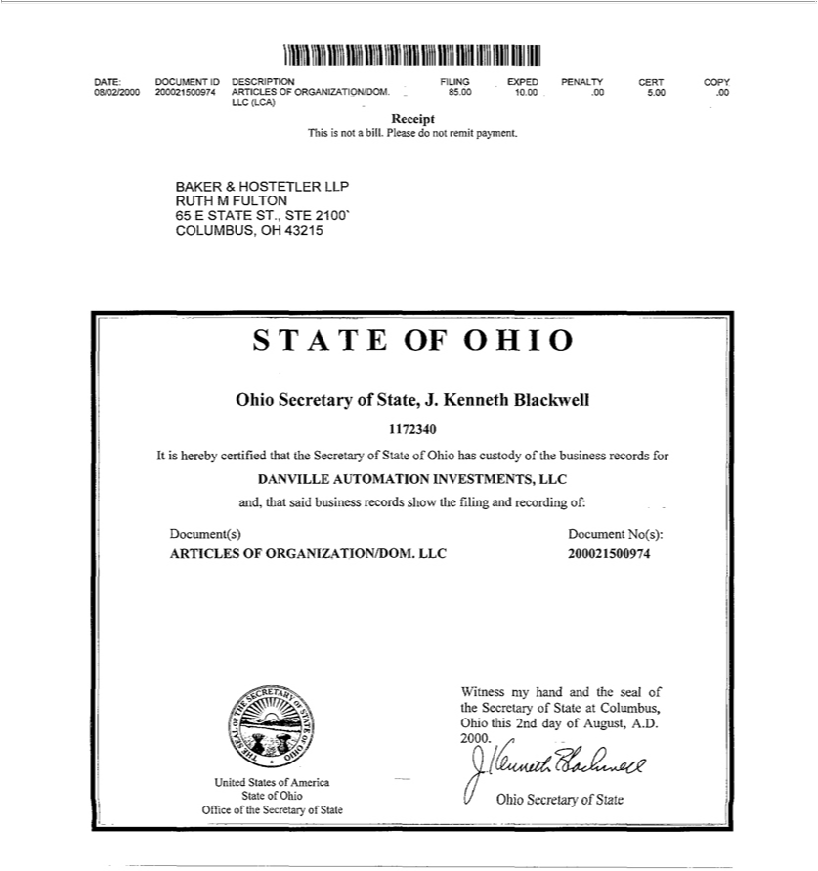

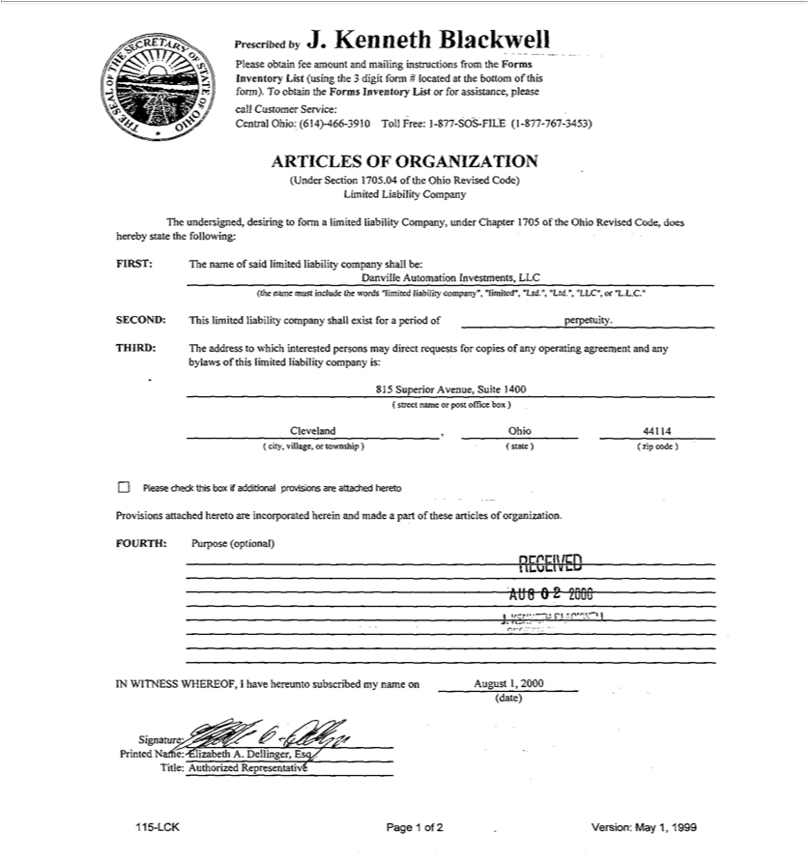

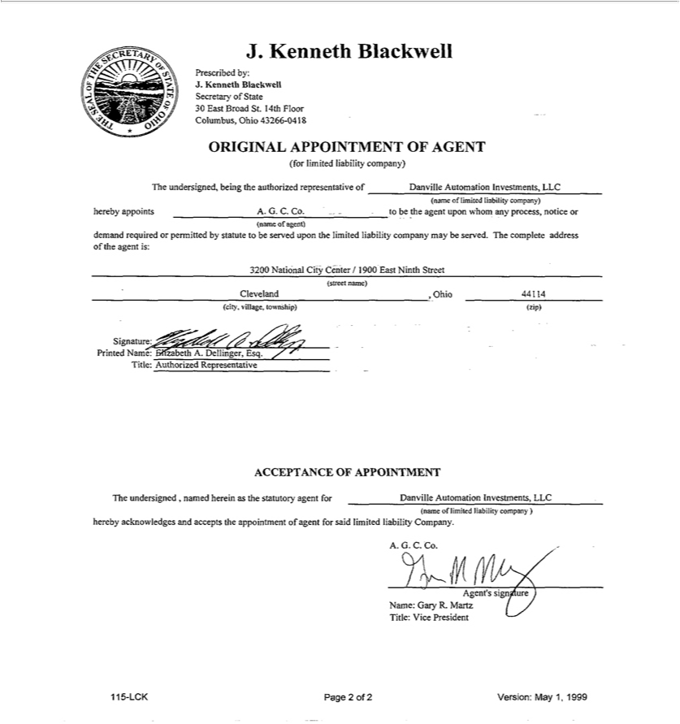


UNITED STATES OF AMERICA,

STATE OF OHIO,

OFFICE OF SECRETARY OF STATE

I, Frank LaRose, Secretary of State of the State of Ohio, do hereby certify that the paper to which this is attached is a true and correct copy from the original record now in my official custody as Secretary of State.

Witness my hand and the seal of the Secretary of State at Columbus, Ohio this 12th day of July, A.D. 2022.

Ohio Secretary of State

Validation Number:

202219303886

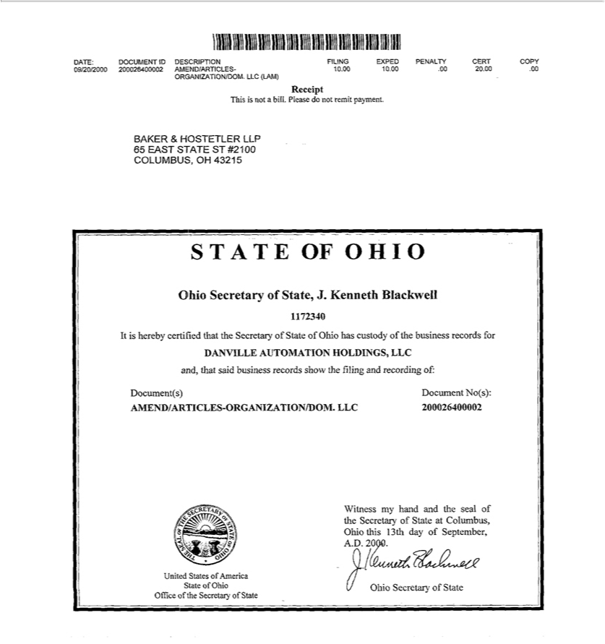

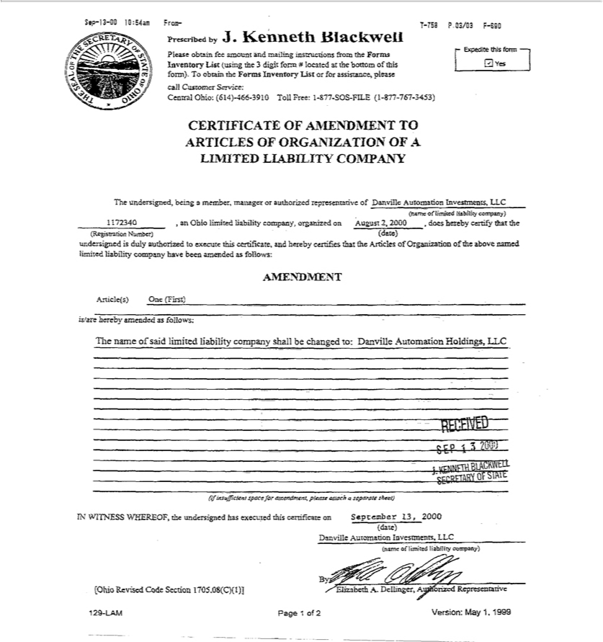

UNITED STATES OF AMERICA,

STATE OF OHIO,

OFFICE OF SECRETARY OF STATE

I, Frank LaRose, Secretary of State of the State of Ohio, do hereby certify that the paper to which this is attached is a true and correct copy from the original record now in my official custody as Secretary of State.

Witness my hand and the seal of the Secretary of State at Columbus, Ohio this 12th day of July, A.D. 2022.

Ohio Secretary of State

Validation Number:

202219303886

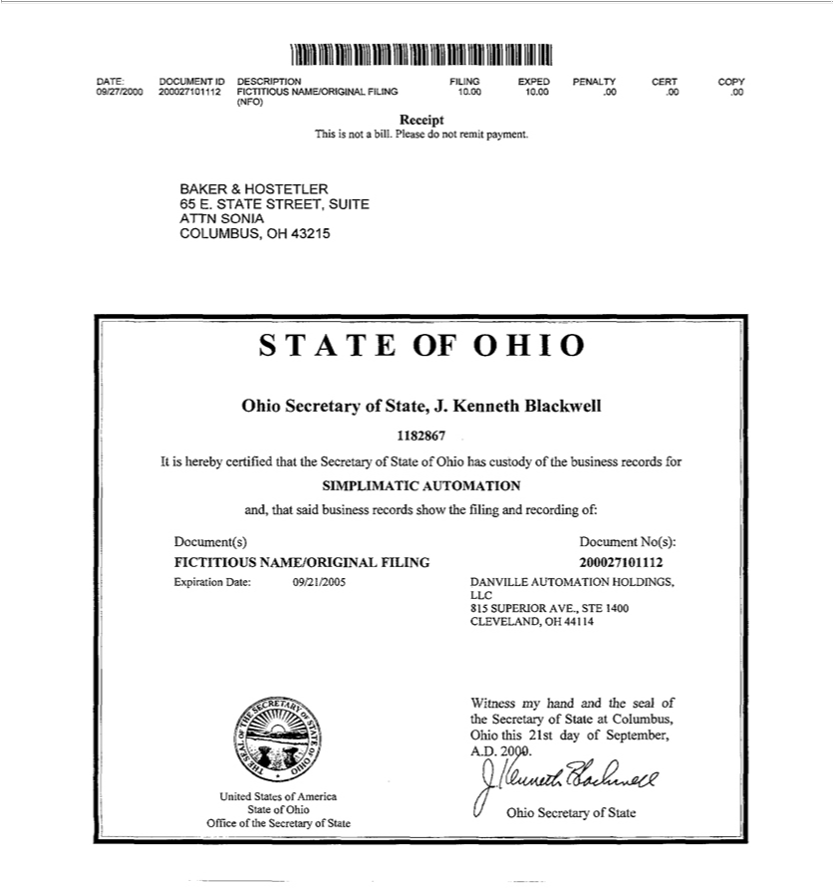

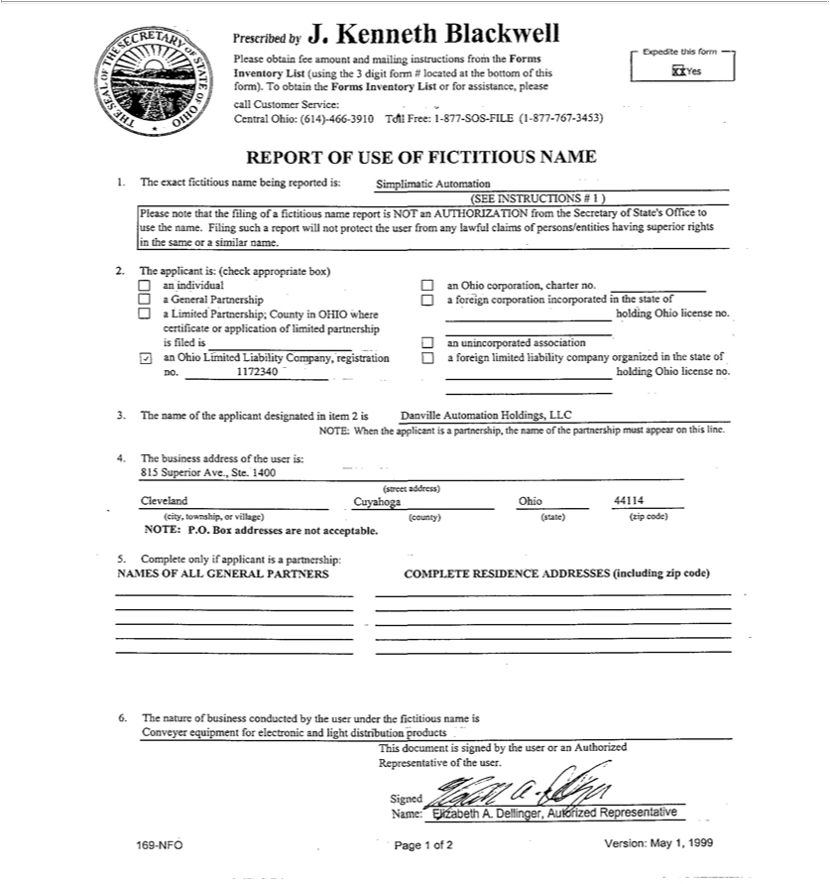


UNITED STATES OF AMERICA,

STATE OF OHIO,

OFFICE OF SECRETARY OF STATE

I, Frank LaRose, Secretary of State of the State of Ohio, do hereby certify that the paper to which this is attached is a true and correct copy from the original record now in my official custody as Secretary of State.

Witness my hand and the seal of the Secretary of State at Columbus, Ohio this 12th day of July, A.D. 2022.

Ohio Secretary of State

Validation Number:

202219303886

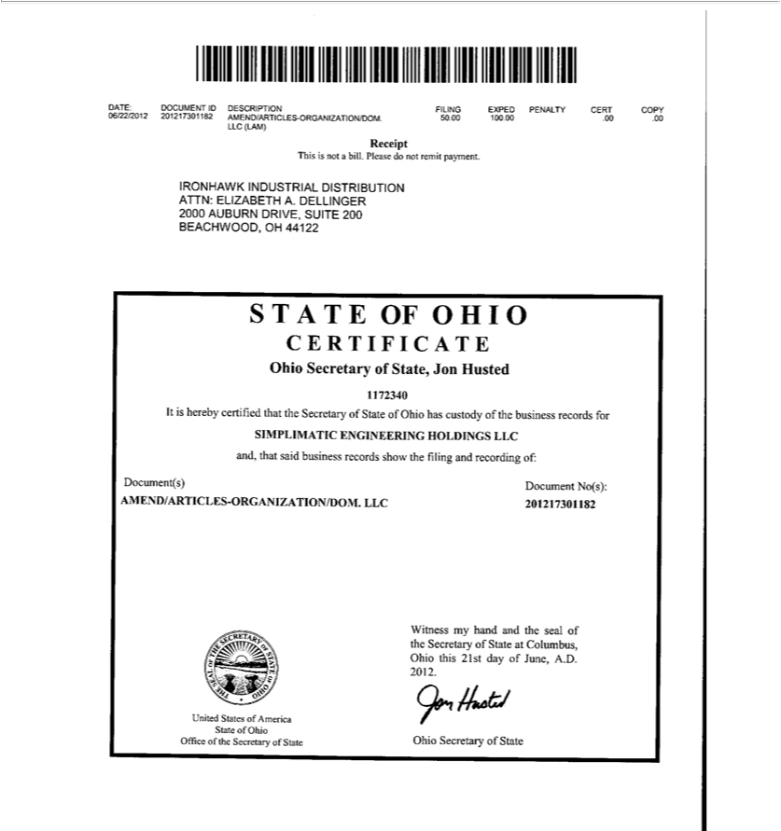

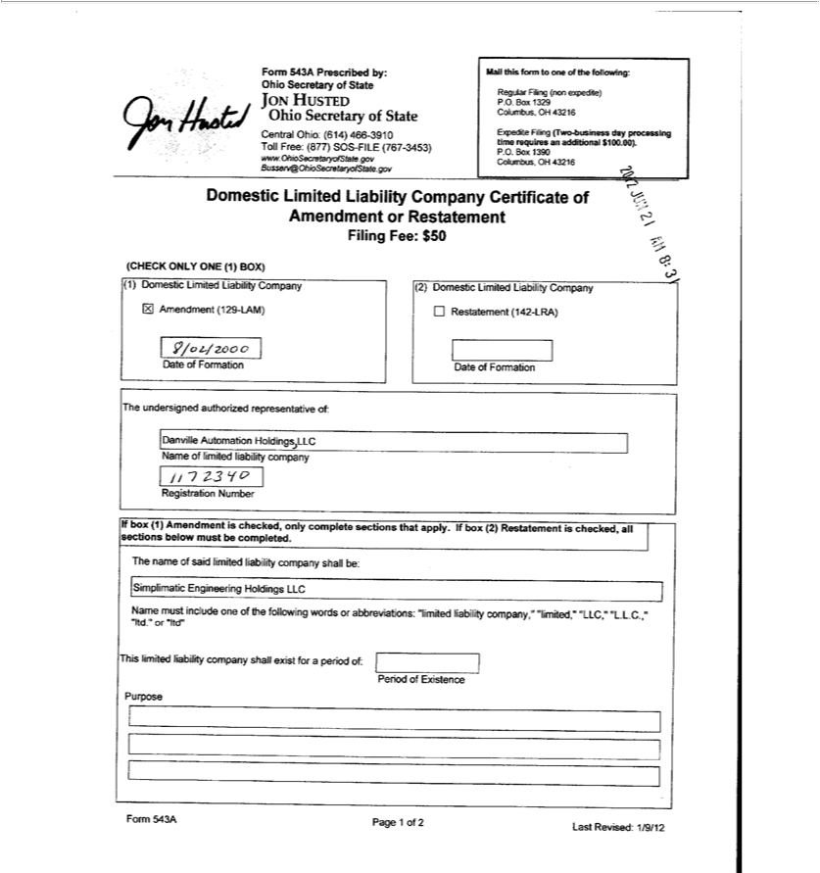

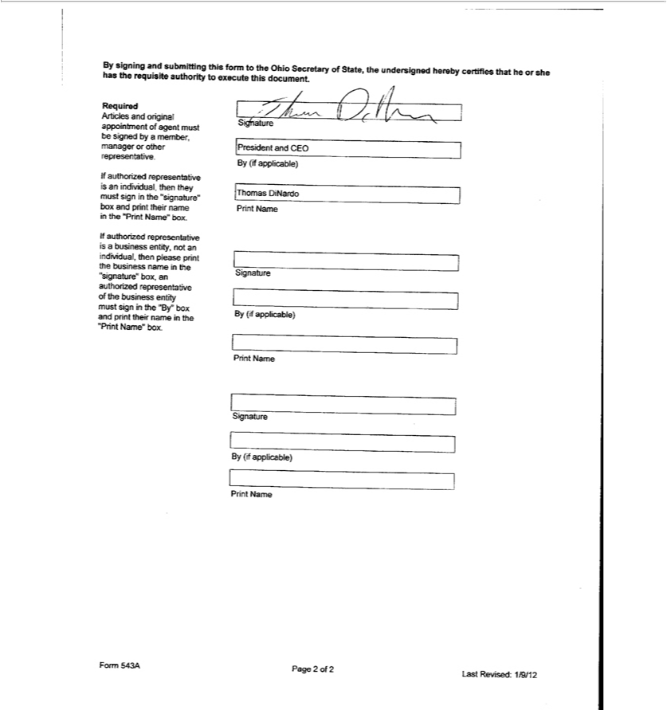


UNITED STATES OF AMERICA,

STATE OF OHIO,

OFFICE OF SECRETARY OF STATE

I, Frank LaRose, Secretary of State of the State of Ohio, do hereby certify that the paper to which this is attached is a true and correct copy from the original record now in my official custody as Secretary of State.

Witness my hand and the seal of the Secretary of State at Columbus, Ohio this 12th day of July, A.D. 2022.

Ohio Secretary of State

Validation Number:

202219303886

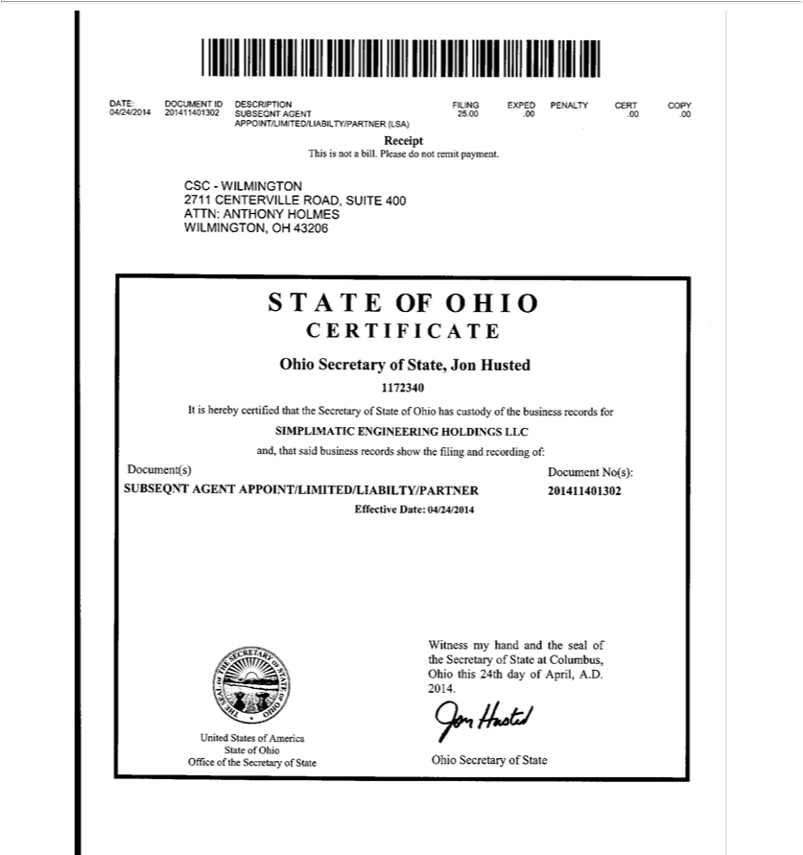

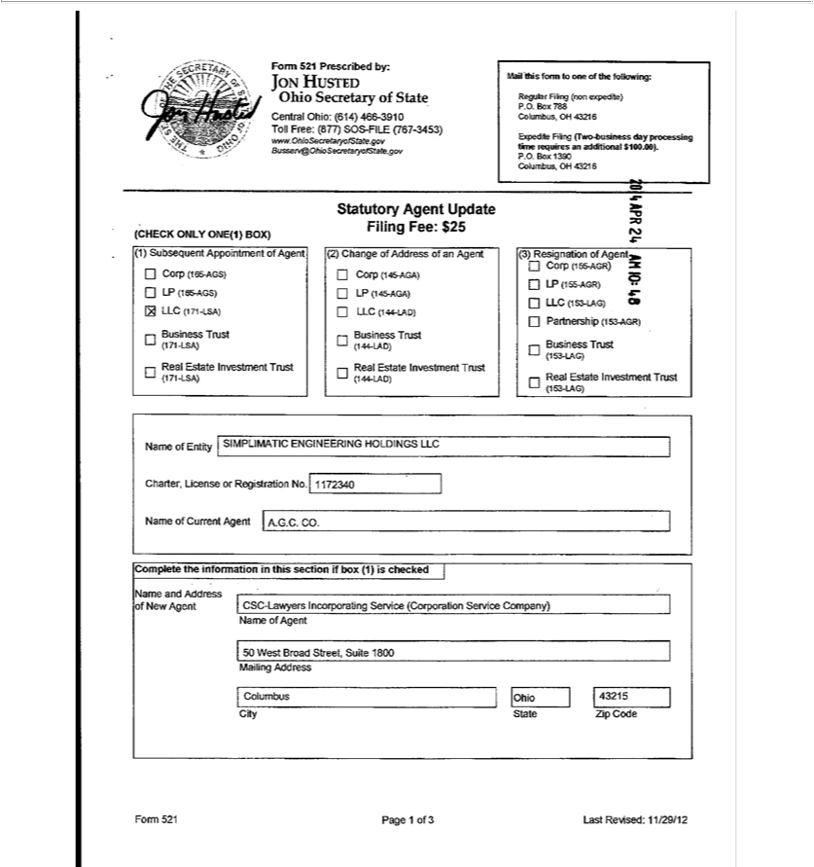

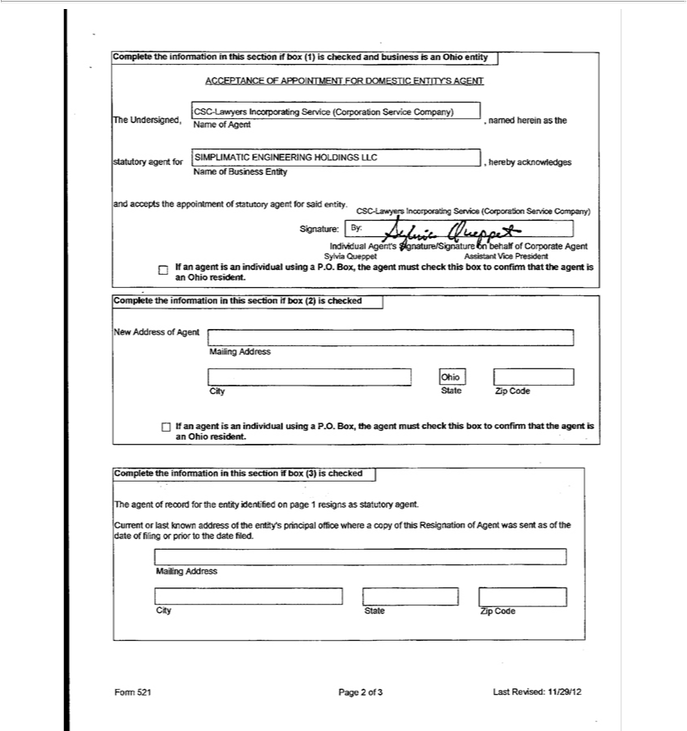

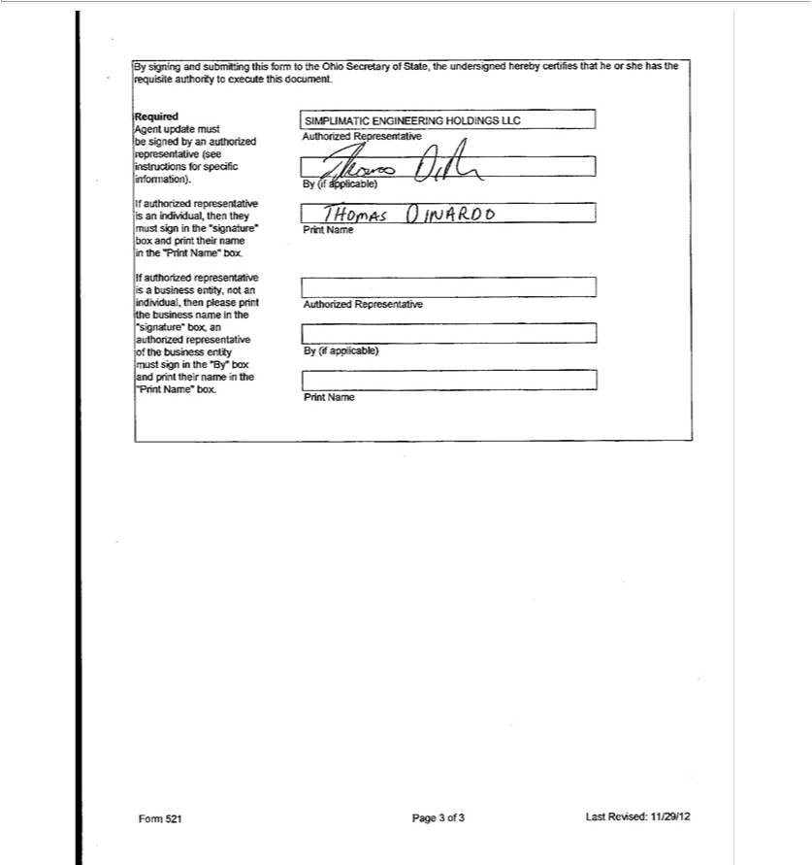


UNITED STATES OF AMERICA,

STATE OF OHIO,

OFFICE OF SECRETARY OF STATE

I, Frank LaRose, Secretary of State of the State of Ohio, do hereby certify that the paper to which this is attached is a true and correct copy from the original record now in my official custody as Secretary of State.

Witness my hand and the seal of the Secretary of State at Columbus, Ohio this 12th day of July, A.D. 2022.

Ohio Secretary of State

Validation Number:

202219303886

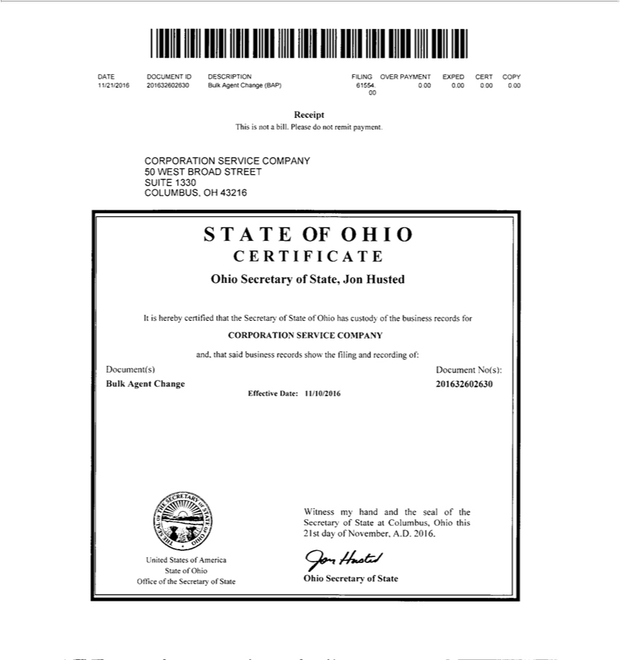

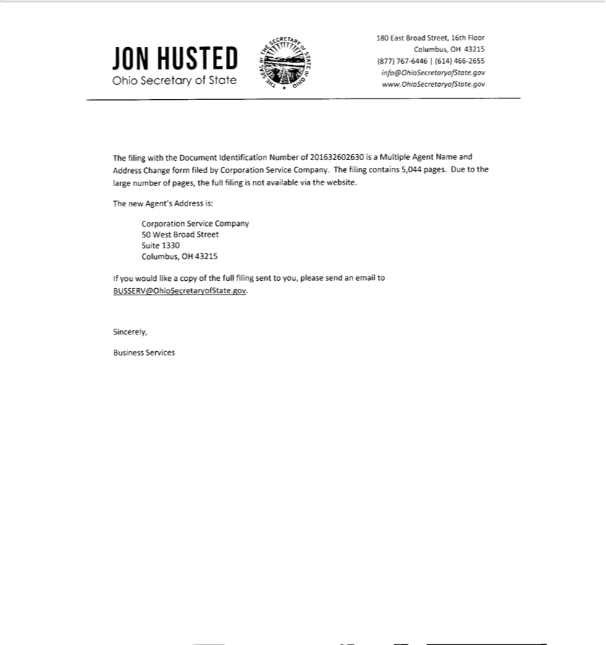


UNITED STATES OF AMERICA,

STATE OF OHIO,

OFFICE OF SECRETARY OF STATE

I, Frank LaRose, Secretary of State of the State of Ohio, do hereby certify that the paper to which this is attached is a true and correct copy from the original record now in my official custody as Secretary of State.

Witness my hand and the seal of the Secretary of State at Columbus, Ohio this 12th day of July, A.D. 2022.

Ohio Secretary of State

Validation Number:

202219303886

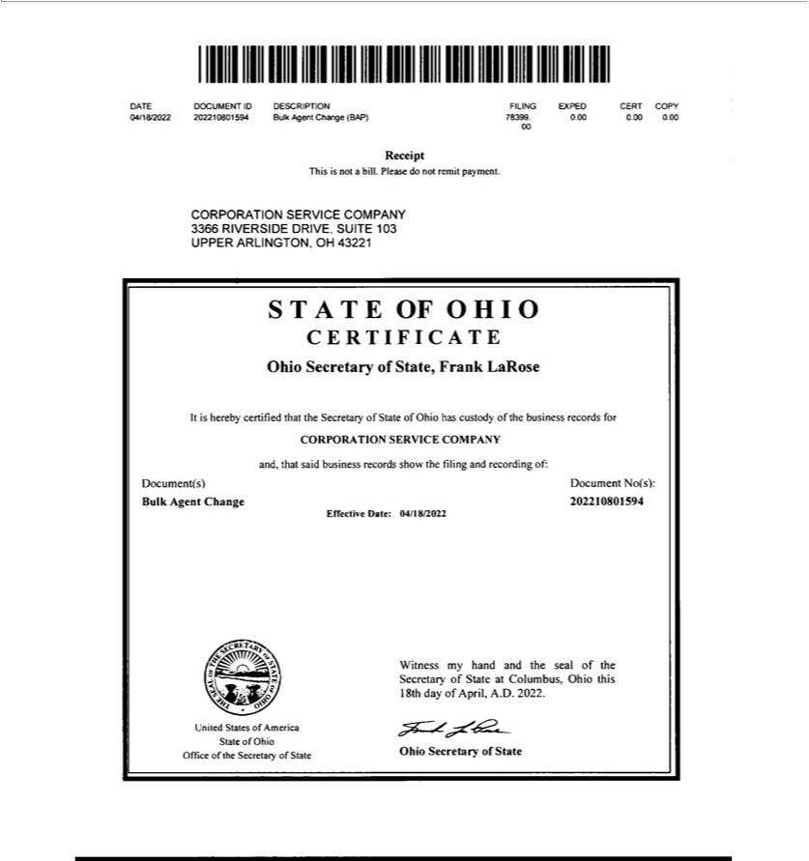

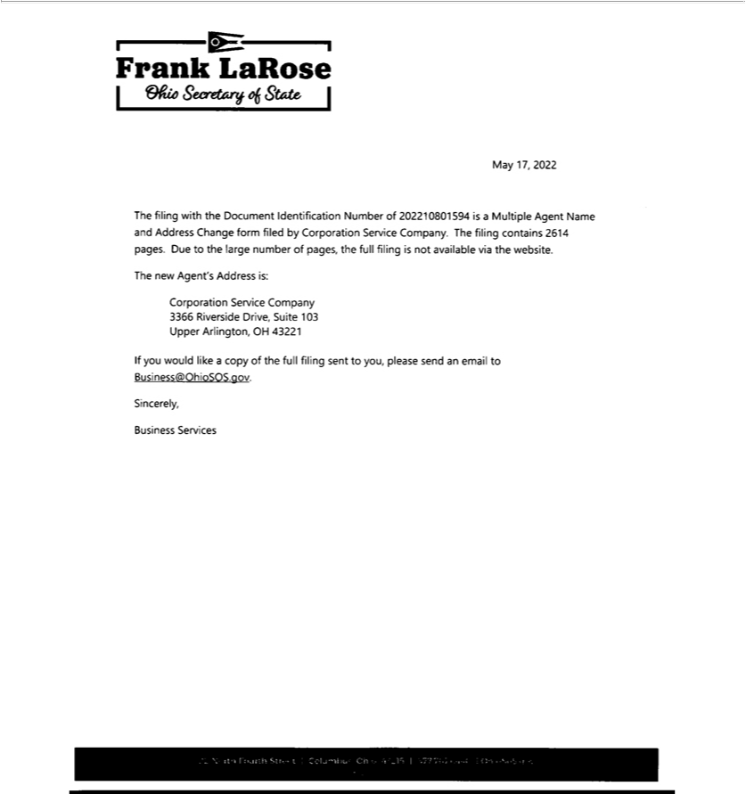


UNITED STATES OF AMERICA,

STATE OF OHIO,

OFFICE OF SECRETARY OF STATE

I, Frank LaRose, Secretary of State of the State of Ohio, do hereby certify that the paper to which this is attached is a true and correct copy from the original record now in my official custody as Secretary of State.

Witness my hand and the seal of the Secretary of State at Columbus, Ohio this 12th day of July, A.D. 2022.

Ohio Secretary of State

Validation Number:

202219303886

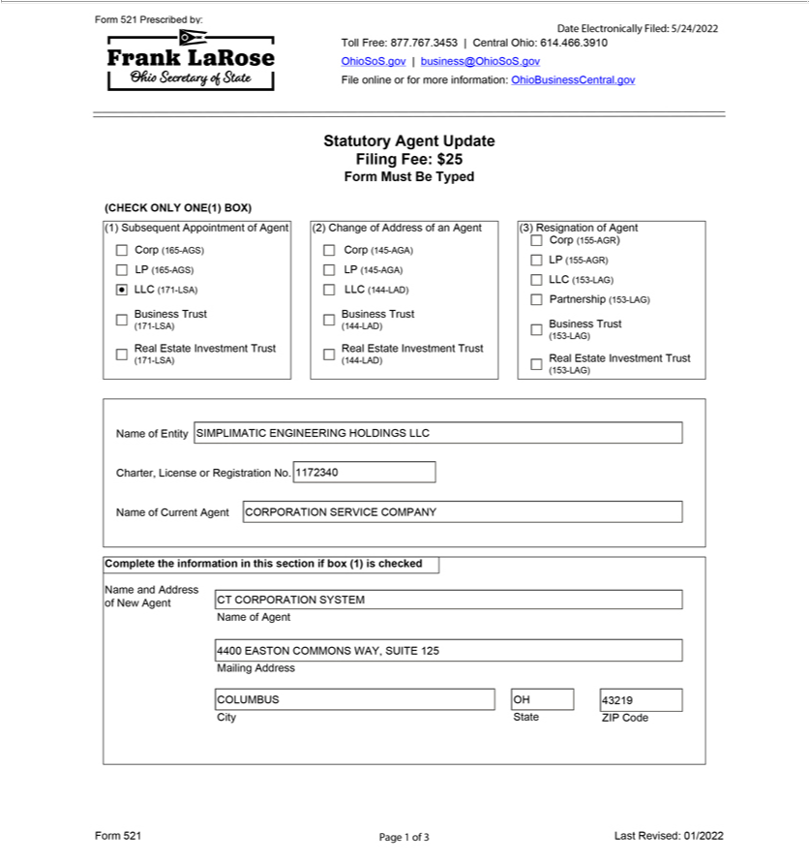

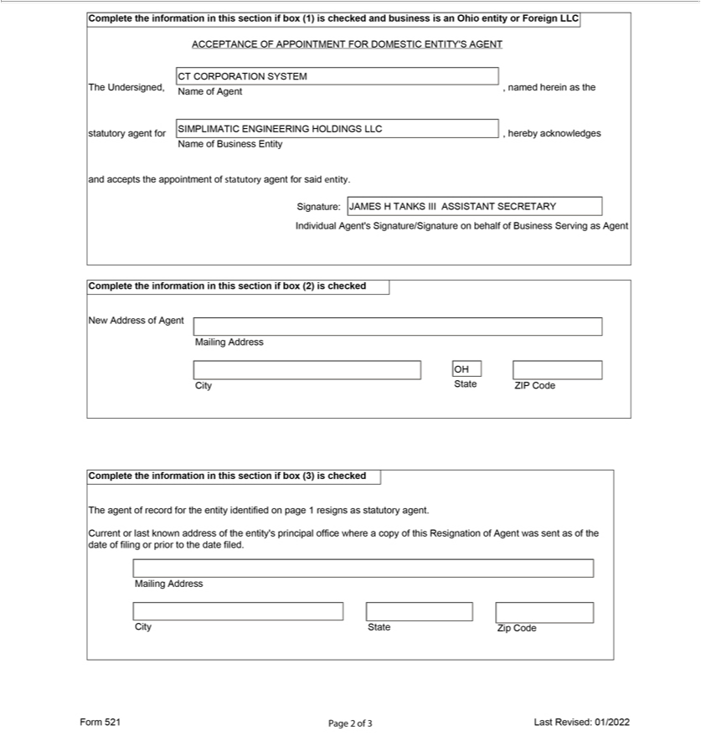

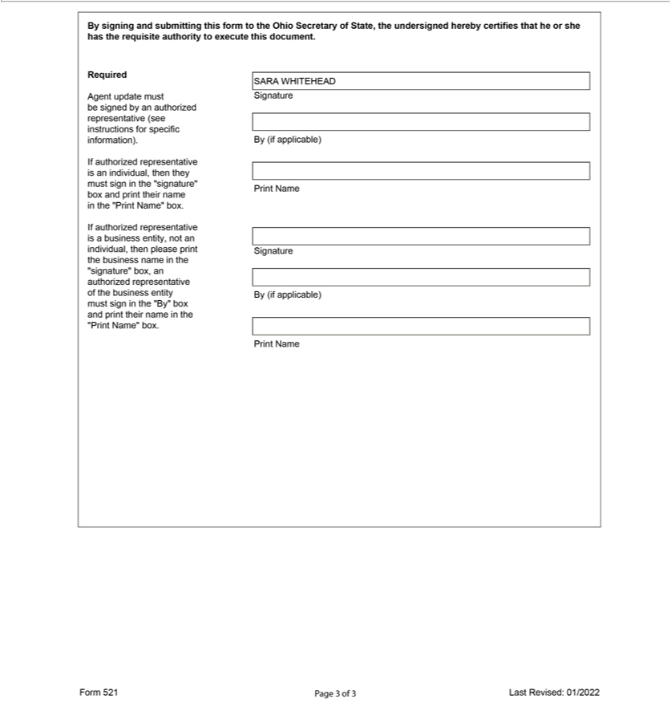

Exhibit 3.nn

EXECUTION COPY

SECOND AMENDED AND RESTATED

OPERATING AGREEMENT OF

SIMPLIMATIC ENGINEERING HOLDINGS LLC

Dated as of August 5, 2022

TABLE OF CONTENTS
ARTICLE I - ORGANIZATION | 2
Section 1.1 Formation | 2
Section 1.2 Name | 2
Section 1.3 Purpose and Powers | 2
Section 1.4 Principal Office | 2
Section 1.5 Registered Office and Registered Agent | 2
Section 1.6 Term | 2
Section 1.7 Names of Managers and Members | 2
Section 1.8 Filing of Certificates | 3
Section 1.9 Records to be Kept | 3
ARTICLE II - CAPITAL CONTRIBUTIONS AND CAPITAL ACCOUNTS | 3
Section 2.1 Initial Capital Contributions | 3
Section 2.2 Additional Capital Contributions | 3
ARTICLE III - ACCOUNTING AND ALLOCATIONS | 4
Section 3.1 Accounting | 4
Section 3.2 Cash Flow | 4
Section 3.3 Allocation of Profits and Losses | 4
ARTICLE IV • THE MANAGERS | 4
Section 4.1 Powers of the Managers | 4
Section 4.2 Limitation on Managers’ Authority | 5
Section 4.3 Duties of Managers | 6
Section 4.4 Reliance on Act of Managers | 6
Section 4.5 Liabilities of Managers | 6
Section 4.6 Indemnification of Managers | 6
Section 4.7 Removal, Resignation, Incapacity or Death of a Manager | 7
Section 4.8 Vacancies | 7
ARTICLE V – OFFICERS | 7
Section 5.1 Officers | 7
Section 5.2 Appointment, Term and Qualification | 7
Section 5.3 Resignation | 7
Section 5.4 Removal | 7
Section 5,5 Vacancy | 7
Section 5.6 Authority and Duties of Officers | 7
ARTICLE VI – RIGHTS AND OBLIGATIONS OF MEMBERS | 8
Section 6.1 Liability of Members; Limited Deficit Restoration | 8
Section 6.2 Voting rights | 8
Section 6.2 Meetings of Members | 8
Section 6.4 Action by Members Without a Meeting | 8
ARTICLE VII – DISSOLUTION OF COMPANY | 8
Section 7.1 Termination | 8
Section 7.2 Winding Up | 9
Section 7.3 Accounting for Dissolution and Liquidation | 9
ARTICLE VIII – TRANSFER OF MEMBERSHIP UNITS; ADMISSION OF MEMBERS | 9
Section 8.1 Member’s Right to Transfer | 9
Section 8.2 Restrictions on Transfer of Membership Units | 10
Section 8.3 Substitute Members; Effect of Substitution and/or Transfer | 10
ARTICLE IX – ACKNOWLEDGEMENT BY MEMBER | 10
Section 9.1 Securities Law | 10
ARTICLE X – MISCELLANEOUS PROVISIONS | 11
Section 10.1 Notice | 11
Section 10.2 Applicable Law | 11
Section 10.3 Further Law | 12
Section 10.4 Entire Agreement; Counterparts | 12
Section 10.5 Amendments | 12
Section 10.6 Titles and Captions | 12
Section 10.7 Benefits | 12
Section 10.8 Severability | 12
Section 10.9 Waiver of Action for Partition | 12
Section 10.10 Power of Attorney | 12
Exhibit A – Definitions | 15
Exhibit B – Duties and Powers of Officers | 18
EXECUTION COPY

SECOND AMENDED AND RESTATED

OPERATING AGREEMENT

OF

SIMPLIMATIC ENGINEERING HOLDINGS LLC

THIS SECOND AMENDED AND RESTATED OPERATING AGREEMENT (the “Agreement”) is made as of August 5, 2022, by Crown International Holdings, Inc., as the sole member of the Company (“Member”), and shall be effective as of March 8, 2022.

RECITALS:

A. Pursuant to Articles of Organization filed with the Ohio Secretary of State on August 2, 2000, the original members formed an Ohio limited liability company under the name and style of “Danville Automation Investments, LLC” (the “Company”) in order to acquire certain assets constituting, directly and through subsidiaries, a material handling business as conducted on the date hereof or such other activities as determined by the Managers (collectively, the “Business”).

B. Pursuant to an amendment to the Articles filed on September 13, 2000, the name of the Company was changed to “Danville Automation

Holdings, LLC”, and the original members entered into an Operating Agreement dated effective as of September 20, 2000 (the “Original Agreement”).

C. The membership interests of certain original members were redeemed in 2006 and the membership interests of certain other original members were redeemed on June 19, 2012; an amendment to the Articles was filed on June 21, 2012 to change the name of the Company to “Simplimatic Engineering Holdings LLC”, and pursuant thereto, the members entered into an Amended and Restated Operating Agreement dated effective June 19, 2012 (the “Amended and Restated Operating Agreement”) thereby amending and restating the Original Agreement in its entirety.

D. On or around March 8, 2022, the Member purchased all existing members’ membership interests in the Company, and thereby became the sole member of the Company.

E. The Member desires to enter into this Agreement in order to amend and restate the Amended and Restated Operating Agreement in its entirety on the terms set forth herein.

F. Certain capitalized terms used herein and in the Exhibits hereto are defined in Exhibit A attached hereto. All other capitalized terms used herein or in any Exhibit shall have the meanings ascribed to them in other parts hereof.

1

AGREEMENTS:

In consideration of the foregoing and the mutual promises herein contained, the undersigned do hereby agree that the Original Agreement is hereby amended and restated in its entirety as follows:

ARTICLE I

Organization

Section 1.1 Formation. The Company was formed as an Ohio limited liability company on August 2, 2000, upon the filing of the Articles with the Ohio Secretary of State pursuant to the provisions of the Act.

Section 1.2 Name. The name of the Company shall be “Simplimatic Engineering Holdings LLC”. The Company may do business under that name and under any other name or names determined by the Managers. If the Company does business under a name other than that set forth in the Articles, the Company shall file a trade name or other certificate as required by law.

Section 1.3 Purpose and Powers. The purposes of the Company and the powers which it may exercise are any and all of the general purposes and powers conferred to limited liability companies by the laws of the State of Ohio, specifically including the following: (a) to acquire, own, operate, expand and ultimately sell the Business; (b) to acquire or lease personal or real property incident to the ownership and operation of the Business; (c) to borrow money and issue evidences of indebtedness, and to secure the same by mortgage, deed of trust, pledge or other lien on any Company Property; and (d) to perform and carry out contracts which are necessary, advisable or convenient to the Business of the Company.

Section 1.4 Principal Office. The address of the principal office of the Company shall be 1046 W. London Park Drive, Forest, VA 24551, or such other location as the Managers may from time to time determine.

Section 1.5 Registered Office and Registered Agent. The name and address of the Company’s current registered agent for service of process in Ohio shall be CT Corporation System, 4400 Easton Commons Way, Suite 125, Columbus, OH 43219. Such registered agent may be changed by the Managers by filing the name and address of the new registered agent with the Ohio Secretary of State.

Section 1.6 Term. The Company shall continue in perpetuity, unless earlier terminated pursuant to the Act or Article VII hereof.

Section 1.7 Names of Managers and Member. The name of the Member as of the date hereof is Crown International Holdings, Inc. The names of the Managers as of the date hereof are set forth in Section 4.1.

2

Section 1.8 Filing of Certificates. The original members have caused to be filed the Articles, and the Managers have caused, or shall cause, to be filed any amendments to the Articles, certificates of authority or certificates of fictitious name as may be required by applicable law in any jurisdiction in which the Company maintains an office, is engaged in business or owns real property, and copies thereof will be maintained with the records of the Company at the principal office referred to in Section 1.4 and made available for inspection pursuant to Section 1.9.

Section 1.9 Records to be Kept. The Managers shall keep or make available at the principal office referred to in Section 1.4 all records required pursuant to this Operating Agreement and the Act. At a minimum, the Company shall keep at its principal office the following records:

- A current list of the full name and last known address of each Manager, Member and Economic Interest Owner;

- Copies of the Company’s federal, state and local income tax returns and financial statements for the three (3) most recent calendar years;

- A copy of the Articles and all amendments thereto, together with executed copies of any powers of attorney pursuant to which the Articles or any amendment have been executed;

- A copy of the Company’s Operating Agreement and all amendments thereto, together with executed copies of any powers of attorney pursuant to which the Operating Agreement or any amendments have been executed; and

- Unless contained in the Operating Agreement, full information regarding the date on which each Member became a member, and the amount of cash and a description and statement of the agreed value of the property or services contributed by each Member, or which each Member has agreed to contribute in the future.

Upon written request by any Member, such Member or its duly authorized representative shall have the right to inspect, and, at such Member’s expense, to copy any Company records described in this Section or the Act, at all reasonable times during business hours.

ARTICLE II

Capital Contributions and Capital Accounts

Section 2.1 Initial Capital Contributions. The capital of the Company is hereby restated as 70,685.529 Membership Units (“Membership Units”).

Section 2.2 Additional Capital Contributions. The Member may, but will not be required to, make any additional Capital Contributions to the Company.

3

ARTICLE III

Accounting and Allocations

Section 3.1 Accounting. The Company’s books shall be kept on the accrual basis and in accordance with (i) tax accounting principles consistently applied and (ii) the determination of Net Profits and Net Losses pursuant to this Agreement (provided that in the event of a conflict between clauses (i) and (ii), clause (ii) shall control). The taxable and fiscal year of the Company shall be the calendar year.

Section 3.2 Cash Flow. Subject to Section 7.2, Cash Flow of the Company shall be determined by the Managers and distributed to the Member at such time or times as the Managers shall determine in their sole discretion.

Section 3.3 Allocation of Profits and Losses. All Net Profits, Net Losses, and other tax or accounting items of the Company will be allocated to the Member.

ARTICLE IV

The Managers

Section 4.1 Powers of the Managers.

- Byron Paul, Keith Heaverlo and Kevin C. Clothier shall be appointed as Managers of the Company. Subject to the provisions of Section 4.2 hereof, the Managers shall have sole and complete authority to manage, control and make all decisions affecting the business and assets of the Company, and shall have (without limiting the generality of the foregoing) the power to authorize or approve all actions in furtherance of the purposes of the Company, including the operation of the Business (either directly or through wholly-owned or majority-owned subsidiaries), the hiring or termination of officers and key employees, the entering into contracts and agreements, borrowing of monies, acquisitions, mergers, real property leases or purchases and dispositions. The Managers shall have such additional rights, authority and powers conferred by law as are necessary, convenient or appropriate to the management and operation of the Business and as are consistent with the purposes of the Company.

- No individual Manager, nor any Member, shall have any power or authority to bind the Company in any way, to pledge its credit or to render it liable for any purpose. The Managers, by proper action taken as provided in this Operating Agreement, shall designate agents, officers or employees of the Company pursuant to Article V hereof with power and authority to bind the Company and manage the day-to-day operations of the Company’s business.

- The Managers shall act with the consent or approval of a majority of the Managers, which may be obtained (i) by action at meeting of the Board of Managers properly convened as provided in this Section 4.1(c), or (ii) by written consent of the majority of the Managers. A meeting of the Board of Managers may be called by any Manager upon three (3) days prior written notice to the other Managers, to be held at a reasonably accessible location or

4

by telephone. Any action by written consent, together with any supporting materials, shall be sent to each Manager for his consent and approval, even though effective with the signature evidencing consent and approval by less than all of the Managers.

Section 4.2 Limitation on Managers’ Authority.

- Notwithstanding anything to the contrary contained herein, the Managers shall have no authority to:

  - Knowingly take any action which is in contravention of this Agreement or the Act, or would make it impossible to carry out the Company purposes;

  - Possess Company Property or use or assign Company Property for other than a Company purpose;

  - Require partition of Company Property; or

  - Take any action that would subject any Member to personal liability without the written consent of such Member.

- The Managers may take the following actions (the “Major Decisions”) only with the Approval of the Member:

  - Lend Company funds to any Person;

  - Effect any merger of the Company or any material acquisition or divestiture of all or substantially all of assets of the Company;

  - Issue new Membership Units other than as contemplated by Article II of this Operating Agreement;

  - Make a voluntary filing or taking any other action by or on behalf of the Company under the United States Bankruptcy Code, or any successor thereto, or any state laws providing for the relief of debtors;

  - Cause the Company to make, execute or deliver any assignment for the benefit of creditors, provided however, that the Managers are authorized to cause the Company to execute and deliver any and all agreements, instruments and other documents related to any financing or refinancing in respect of the Company, the Member or any affiliate of the Member; or

  - Cause the Company to redeem the Membership Units of any Member.

5

Section 4.3 Duties of Managers.

  - The Managers shall maintain the records described in Section 1.9; to cause to be prepared all reports which are required to be furnished by the Company to any Person; and to do all other things and execute and deliver any documents which may be necessary or advisable in order to supervise and manage the affairs and business, and carry out the purposes, of the Company in accordance with this Agreement.

  - Notwithstanding the foregoing, it is expressly understood and agreed that (i) no Manager shall be required to devote his, her or its entire time or attention to the business of the Company; (ii) no Member shall be restricted in any manner from participating in other businesses or activities which may be competitive with the business of the Company (the “Separate Activities”); and (iii) neither the Company nor any Member shall have any right, by virtue of this Operating Agreement, to share or otherwise participate in any Separate Activities of a Member or a Manager.

  - The Managers shall provide the following to the Member within one hundred twenty (120) days after the end of each fiscal year (or as soon thereafter as is reasonably practicable): (i) annual financial statements including a balance sheet, profit and loss statement and cash flow statement; and
- annual tax reporting information.

Section 4.4 Reliance on Act of Managers. No Person dealing with the Managers shall be required to ascertain whether the Managers are acting in accordance with this Agreement, and such Person shall be protected in relying solely upon the deed, transfer, or assurance of, and the execution of any instrument or instruments by, any one of the Managers.

Section 4.5 Liabilities of Managers. Each Manager shall perform his duties in good faith, in a manner he, she or it reasonably believes to be in or not opposed to the best interests of the Company, and with the care that ordinarily prudent persons in a similar position would use under similar circumstances. A Manager who so performs his, her or its duties shall not have any liability by reason of being or having been a Manager. A Manager shall only be liable for willful misconduct, fraud, gross negligence or bad faith.

Section 4.6 Indemnification of Managers. Neither the Member, Managers nor any officer will be liable to the Company by reason of the actions of such person in the conduct of the business of the Company except for fraud, gross negligence or willful misconduct. The Company will, to the fullest extent to which it is empowered to do so by the Ohio law or any other applicable law, indemnify and make advances for expenses to any person who was or is a party, or is threatened to be made a party, to any threatened, pending or completed action, suit or proceeding, whether civil, criminal, administrative or investigative, by reason of the fact that he, she or it is or was a Manager, Member or officer of the Company, against losses, damages, expenses (including attorneys’ fees), judgments, fines and amounts reasonably incurred by him in connection with such action, suit or proceeding; provided, however, that no Person shall be entitled to indemnification hereunder if and to the extent any costs arise as a result of such Person’s bad faith, willful misconduct, fraud, or gross negligence. The termination of any action, suit, or proceeding by judgment, order, settlement or upon a plea of nolo contendere or its equivalent, shall not of itself create a presumption that a Person acted with willful misconduct, fraud, gross negligence or bad faith.

6

Section 4.7 Removal, Resignation, Incapacity or Death of a Manager. A Manager may resign at any time by giving written notice to the Member and the other Managers. The resignation of a Manager shall take effect upon receipt of notice thereof or at such later date specified in such notice; and, unless otherwise specified therein, the acceptance of such resignation shall not be necessary to make it effective. A Manager will hold office until his or her successor is duly appointed and has qualified, or until his or her earlier death, resignation, incapacity or removal in the manner hereinafter provided. The Member may remove any Manager at any time with or without cause.

Section 4.8 Vacancies. The Member may appoint a new Manager in the event of vacancies or reduce the number of Managers.

ARTICLE V

Officers

Section 5.1 Officers. The Company may have a Chief Executive Officer, President, Secretary, and Treasurer. The Company may also have one or more Vice Presidents and such other officers and assistant officers as the Managers may deem necessary. By appointing a Person to serve as an officer of the Company, the Managers shall be deemed to have considered such office necessary and to have established such office in accordance with this Section.

Section 5.2 Appointment, Term and Qualification. The officers shall be appointed by the Managers. Each such officer shall serve until his successor is appointed and qualified, or until his death, resignation or removal.

Section 5.3 Resignation. An officer may resign at any time by giving notice to the Managers. Such notice shall be effective when received by the Managers, unless some other time is specified therein.

Section 5.4 Removal. Any officer may be removed, with or without cause, by the Managers without prejudice to the contract rights of such officer.

Section 5.5 Vacancy. The Managers may fill any vacancy in any office occurring by whatever reason.

Section 5.6 Authority and Duties of Officers. Subject to the foregoing, the officers of the Company shall have such authority and shall perform such duties as are customarily incident to their respective offices, subject always to the directions of the Managers, or as may be specified from time to time by the Managers regardless of whether such authority and duties are customarily incident to such office. Duties and Powers of Officers are described in Exhibit B.

7

ARTICLE VI

Rights and Obligations of the Member

Section 6.1 Liability of the Member. No Member shall be (i) required to make any further contributions to the capital of the Company to discharge any liability of the Company or for any other purpose, or (ii) personally liable for any liabilities of the Company or the Managers.

Section 6.2 Voting Rights. The Member shall have the right to:

- Consent to the Major Decisions pursuant to Section 4.2;

- Remove a Manager pursuant to Section 4.7 and elect a successor Manager pursuant to Section 4.8;

- Consent to dissolve the Company pursuant to Section 7.1(a);

- Approve the Transfer of a Membership Unit pursuant to Section 8.1(a); and

- Consent to the amendment of this Operating Agreement pursuant to Section 10.5.

Section 6.3 Meetings of the Member. Meetings of the Member, for any purpose or purposes, may be called by the Member. The Member may designate any place, either within or outside the State of Ohio, as the place of any meeting of the Member. If no designation is made, the place of meeting will be the principal office of the Company.

Section 6.4 Action by the Member Without a Meeting. Any action required or permitted to be taken at a meeting of the Member may be taken without a meeting if the action is evidenced by written consent describing the action taken, signed by the Member approving such action and delivered to the Managers. Any action taken hereunder is effective when the Member has signed the consent, unless the consent specifies a different effective date.

ARTICLE VII

Dissolution of Company

Section 7.1 Termination. The Company shall be dissolved, liquidated, and terminated upon the occurrence of any of the following (each, a “Liquidating Event”):

- The decision of the Managers with the Approval of the Member;

- Any sale or other disposition of all or substantially all of the Company Property; or

- An entry of a decree of judicial dissolution.

Upon the dissolution and the commencement of the winding up of the Company, a certificate of dissolution shall be filed pursuant to the Act.

8

Section 7.2 Winding Up. Upon the occurrence of a Liquidating Event, the Company shall continue solely for the purposes of winding up its affairs in an orderly manner, liquidating its assets, and satisfying the claims of its creditors, Member, and Economic Interest Owners. No Manager or Member shall take any action that is inconsistent with the winding up of the Company’s business and affairs. The Managers (or, if there is no Manager, any Person elected by the Approval of the Member) shall be responsible for overseeing the winding up and dissolution of the Company and shall take full account of the Company’s liabilities and Company Property and the Company Property shall be liquidated as promptly as is consistent with obtaining the fair value thereof, and the assets of the Company or the proceeds therefrom, to the extent sufficient therefor, shall be applied and distributed in the following order:

- First, to the payment and discharge of all the Company’s debts and liabilities to creditors (including, without limitation, any Member to the extent such Member is a creditor of the Company), including the establishment of any necessary reserves; and

- The balance, if any, to the Member.

Section 7.3 Accounting for Dissolution and Liquidation. The Member shall be furnished with a statement prepared by the Company’s accountants, which shall set forth the assets and liabilities of the Company as of the last day of the month which includes the date of dissolution and shall provide relevant information concerning the application and disposition of all assets and the proceeds thereof.

ARTICLE VIII

Transfer of Membership Units; Admission of Members.

Section 8.1 Member’s Right to Transfer.

- The Member may Transfer a Membership Unit to any Person.

- All Transfers of Membership Units shall be subject to the restrictions set forth in Section 8.2.

- No Transfer of a Membership Unit shall be effective as to the Company until (i) a copy of the duly executed and acknowledged written instrument of Transfer shall have been filed with the Company; and (ii) the assignor and assignee shall have executed and acknowledged such other instruments as the Managers may deem necessary or desirable to effect such substitution, including the written acceptance and adoption by the assignee of the provisions of this Agreement and the assignee’s agreement to indemnify the Managers and the Company against any loss or liability arising out of such Transfer.

- By executing or adopting this Operating Agreement, the Member hereby consents to the admission of substitute Members as provided in this Article VIII. Each Person who becomes a substitute Member shall duly execute this Operating Agreement and shall be deemed, upon such execution, to have ratified and agreed to be bound by all prior action taken by the Company and the Managers.

9

Section 8.2 Restrictions on Transfer of Membership Units. All Transfers of Membership Units shall be subject to the following restrictions:

- No such Transfer shall be made to a minor or incompetent.

- No such Transfer shall be made in violation of any agreement (i) between the Member and the Company or (ii) to which the Company is

subject.

- No such Transfer shall be made if, in the opinion of counsel to the Company, such Transfer may not be effected without registration under the Securities Act of 1933, as amended, or would result in the violation of any applicable state securities laws.

- No Membership Unit or any portion thereof shall be Transferred to the extent that any such Transfer would result in the treatment of the Company as a publicly traded partnership under Code Section 7704, except in the sole discretion of the Member.

- Any Transfer in contravention of the provisions hereof shall be void from inception, shall grant no rights whatsoever to the purported transferee, and shall not bind the Company in any respect.

Section 8.3 Substitute Members., Effect of Substitution and/or Transfer. No Member shall have the right to substitute an assignee as a Member in his, her or its place unless the provisions of Section 8.2 of this Agreement are complied with.

ARTICLE IX

Acknowledgments By Members

Section 9.1 Securities Laws.

- The Member acknowledges that it is purchasing or has purchased its Membership Units for investment only and without a view to resale or distribution thereof.

- Notwithstanding any other provision of this Agreement, no Membership Unit may be offered or sold other than the original offering of the Membership Units, and no transfer of such interest will be made either by the Company or the Members, unless (1) one of the following applies to the proposed transfer of such interest:

  - such Membership Units are registered under the Securities Act of 1933;

  - an opinion of counsel satisfactory to the Company is obtained to the effect that such registration is not necessary; or

  - a “no action letter” from the Securities and Exchange Commission is obtained;

or (2) the Managers waive application of this Section 10.1(b) in their reasonable discretion.

10

- The Member, by signing this Agreement or a counterpart thereof, acknowledges

  - it has received, read and understands this Agreement and the Exhibits attached hereto;

  - it is aware that the ownership and operation of the Company involve certain tax and economic variables and risks which could affect adversely the security of its investment;

  - it has had an opportunity to have his business, tax and/or legal advisors review the documents and information relating to this transaction and advise it as to the merits and risks of this offering;

  - it and/or its advisors (1) have discussed the entire transaction with the Managers and (2) have had ready access to and an opportunity to review any and all documents which they deem relevant to this transaction, and no information, oral or written, requested by them has been withheld by the Managers; and

  - it and/or its advisors has sufficient experience in investment and business matters and recognizes the advantages and disadvantages of an investment of this nature.

ARTICLE X

Miscellaneous Provisions

Section 10.1 Notice. All notices or other communications which may or are required to be given hereunder shall be in writing and shall be sent by facsimile or by electronic mail, delivered by private, overnight delivery service (such as Federal Express), or mailed by registered or certified United States mail, return receipt requested, to the recipient at the facsimile number, e-mail address or mailing address or in any notice of change of the facsimile number, e-mail address or mailing address previously given in writing by the addressee to the addressor. Notices or other communications shall be deemed to have been given on the business day received when sent by facsimile or electronic mail prior to 5:00 p.m. (Eastern time) on a business day or on the first business day thereafter if sent on a day that is not a business day or after 5:00 p.m. (Eastern time), one (1) business day after deposit with an overnight delivery service and three (3) business days after deposit in the United States mail. Any notice sent by electronic mail will be followed up within one (1) business day by one of the other delivery methods provided herein.

Section 10.2 Applicable Law. The rights of the Members and this Agreement shall be governed by, and construed in accordance with, the laws of the State of Ohio. To the extent this Agreement conflicts with the provisions of the Act and to the extent the Act permits this Agreement to supersede the Act, the provisions of this Agreement shall control.

11

Section 10.3 Further Action. The Member shall execute and deliver all documents, provide all information, and take or forebear from all such action as may be necessary or appropriate to achieve the purposes of this Agreement.

Section 10.4 Entire Agreement; Counterparts. This Agreement contains the entire understanding between and among the parties hereto and supersedes any prior understandings and agreements between or among them respecting the subject matter of this Agreement. This Agreement and any amendments hereto may be executed in several counterparts, and all so executed shall constitute one agreement, binding on all parties hereto, notwithstanding that all the parties are not signatory to the original or same counterpart.

Section 10.5 Amendments. This Agreement may not be amended without the Approval of the Member.

Section 10.6 Titles and Captions. All captions are for convenience only, do not form a substantive part of this Agreement, and shall not restrict or enlarge any substantive provisions of this Agreement.

Section 10.7 Benefits. This Agreement shall inure to the benefit of and shall bind the parties hereto, their heirs, legal representatives, successors and permitted assigns. None of the provisions of this Agreement shall be for the benefit of or enforceable by any creditors of the Company.

Section 10.8 Severability. The invalidity or unenforceability of any provision of this Agreement in a particular respect shall not affect the validity and enforceability of any other provisions of this Agreement or of the same provision in any other respect.

Section 10.9 Waiver of Action for Partition. Each Member irrevocably waives during the term of the Company any right that it may have to maintain any action for the partition of the Company Property.

Section 10.10 Power of Attorney

- The Member hereby appoints each Manager as his, her or its agent and attorney-in-fact, to execute on his, her or its behalf and on behalf of the Company the following documents or papers, as deemed necessary or appropriate by such Manager to carry out, on behalf of the Company, any activities or obligations of the Company:

  - any and all agreements amending this Operating Agreement, as now or hereafter amended, that may be appropriate to reflect a change in the name or location of the principal place of business of the Company;

  - such certificates, instruments and documents as may be required or appropriate in connection with the qualification of the Company to do business in any state or jurisdiction and the use of the name of the Company therein;

12

  - such certificates, instruments and documents as may be required or as may be appropriate under the laws of any state or jurisdiction to reflect a change of name or address of a Member; and

  - all conveyances or other instruments and documents necessary to effect the dissolution and termination of the Company, and all other filings with agencies of the Federal government and of the states to carry out the purposes of the Company.

- No Member shall be personally liable with respect to any action taken by the Managers pursuant to the foregoing power of attorney. The foregoing power of attorney shall not be used in any manner inconsistent with the terms of this Agreement, and the characterization and treatment of the Company as a limited liability company.

- It is expressly intended by the Members that the foregoing power of attorney is coupled with an interest, is irrevocable, and shall survive the dissolution or adjudication of bankruptcy or insolvency of any Member.

- The foregoing power of attorney shall survive the delivery of any Transfer of a Membership Unit until such assignee shall have fully complied with the terms hereof, and a similar power of attorney may be one of the instruments which the Managers may require of an assignee under
Section 8.1(c) hereof.

- This power of attorney granted herein shall be in addition to, and not in limitation of, the powers and authority granted to the Managers pursuant to the Act.

13

IN WITNESS WHEREOF, the parties hereto have executed and delivered this Agreement as of the date first above written.

Crown International Holdings, Inc.

By: /s/ David A. Beaver

Name: David A. Beaver

Title: Vice President and Treasurer

[Signature Page to Simplimatic Engineering Holdings LLC Second Amended and Restated Operating Agreement]

EXHIBIT A

CERTAIN DEFINITIONS

Capitalized terms used and not otherwise defined in the Second Amended and Restated Operating Agreement of Simplimatic Engineering Holdings LLC and the Exhibits thereto shall have the meanings set forth below:

“Act” shall mean the Ohio Revised Limited Liability Company Act (being Chapter 1706 of the Ohio Revised Code) or any corresponding provisions of predecessor or successor law.

“Articles” shall mean the Articles of Organization of the Company, as amended from time to time.

“Approval of the Member” or “Approved by the Member” shall mean the approval or written consent of Crown International Holdings, Inc.

“Book Value” shall mean, with respect to any asset of the Company, such asset’s adjusted basis for federal income tax purposes, except as follows:

- The initial Book Value of any asset contributed by the Member to the Company shall be the fair market value as determined by the Managers.

- The Book Value of any Company asset distributed to any Member will be the gross fair market value of the asset, as determined by the Managers, on the date of distribution.

“Business” shall have the meaning set forth in Recital A of the Operating Agreement.

“Capital Contribution” shall mean, with respect to any Member, the amount of cash and the initial Book Value of property (other than money) contributed by such Member to the capital of the Company (excluding any advances or loans).

“Cash Flow” shall mean the cash funds derived by the Company from the operation of the Company’s business and from any other source whatsoever before any deduction for depreciation or amortization and after deduction of:

- all unreimbursed operating expenses including taxes;

- all payments of principal, interest and other charges in respect of any Company indebtedness;

- all expenditures for capital improvements to the Company Property; and

- all reserves, whether for working capital or otherwise, which are required by the Managers in the exercise of their reasonable discretion. 15

“Code” shall mean the Internal Revenue Code of 1986, as heretofore or hereafter amended, and any successor statute thereto.

“Company Property” shall mean all real and personal property acquired by the Company and any improvements thereto, and shall include both tangible and intangible property.

“Economic Interest Owner” shall mean an assignee of an interest in the Company who has not been admitted to the Company as a substituted Member. An Economic Interest Owner shall have the right to receive the transferor Member’s interest in Net Profit and Net Losses and distributions, but shall have no right to consent, vote or otherwise participate in the management of the business and affairs of the Company.

“Liquidating Event” shall have the meaning set forth in Section 7.1 of the Operating Agreement.

“Major Decisions” shall have the meaning set forth in Section 4.2(b) of the Operating Agreement.

“Managers” shall mean Byron Paul, Keith Heaverlo and Kevin C. Clothier or any successor Manager of the Company designated pursuant to Section 4.8 of the Operating Agreement.

“Member” shall mean the party executing this Operating Agreement and any permitted assignee of such Person who is admitted to the Company as a substituted Member. To the extent a Manager holds a Membership Unit, he, she or it shall have all of the rights of a Member in respect of such Membership Unit.

“Membership Unit” shall mean an interest in the Company, including the holder’s interest in the Net Profits, Net Losses and distributions of the Company, and, in the case of a Member, the right to consent, vote or otherwise participate in the management of the business and affairs of the Company.

“Net Profits” and “Net Losses” shall mean, for each fiscal year or other period, an amount equal to the Company’s taxable income or loss for such year or period, with the following adjustments:

- Any income of the Company that is exempt from federal income tax and not otherwise taken into account in computing Net Profits or Net Losses pursuant to this Section shall be added to such taxable income or loss;

- Gain or loss resulting from any disposition of Company Property with respect to which gain or loss is recognized for federal income tax purposes shall be computed by reference to the Book Value of such property disposed of, notwithstanding that the adjusted tax basis of such property differs from its Book Value; and

16

- In lieu of the depreciation, amortization and other cost recovery deductions taken into account in computing such taxable income or loss, there shall be taken into account depreciation for such fiscal year or other period, computed in accordance with the terms of this Operating Agreement.

“Operating Agreement” or “Agreement” shall mean this Second Amended and Restated Operating Agreement, including all Exhibits hereto, as amended from time to time.

“Person” shall mean an individual, estate, trust, corporation, partnership, limited liability company or other business entity.

“Transfer” shall mean to pledge, assign, hypothecate, sell, exchange, gift or otherwise transfer a Membership Unit. Transferred, Transferring, Transferor, and Transferee shall have correlative meanings.

17

EXHIBIT B

DUTIES AND POWERS OF OFFICERS

Chairman. The chairman, if a chairman has been elected and is serving, shall preside at all meetings of the Member. The chairman shall also have power to vote, and execute deeds, mortgages, bonds, contracts and other instruments of the Company except where required or permitted by law to be otherwise executed and except where the Member expressly delegates the execution to some other officer or agent of the Company. The chairman shall perform such other duties and have such other powers as the Member may from time to time assign to him or her.

Chief Executive Officer. The chief executive officer of the Company, in the absence of the chairman, shall preside at all meetings of the Member. The chief executive officer shall have the overall supervision of the business of the Company and shall direct the affairs and policies of the Company, subject to such policies and directions as the Member may provide. The chief executive officer shall have authority to designate the duties and powers of other officers and delegate special powers and duties to specified officers, so long as such designation is not inconsistent with applicable law, this Agreement or action of the Member. The chief executive officer shall also have power to vote the shares or other equity interests of subsidiaries, and execute deeds, mortgages, bonds, contracts and other instruments of the Company except where required or permitted by law to be otherwise executed and except where the Member expressly delegates the execution to some other officer or agent of the Company. The chief executive officer will have general powers of supervision and will be the final arbiter of all differences among officers of the Company, and such decision as to any matter affecting the Company will be final and binding as among the officers of the Company, subject only to the Member. The chief executive officer will have such other powers and perform such duties as are specified in this Agreement and as may from time to time be assigned to him or her by the Member of the Company.

President. The president will be the chief operating officer of the Company in charge of the entire business and all the affairs of the Company and will have the powers and perform the duties incident to that position, including the power to bind the Company in accordance with this Schedule. The president will, in the absence of the chairman and the chief executive officer, preside at all meetings of the Member. The president will have general and active management of the business of the Company and will see that all orders and resolutions of the Member are carried into effect. The president shall also have the power to execute bonds, mortgages and other contracts, except where required or permitted by law to be otherwise signed and executed and except where the signing and execution thereof is expressly delegated by the Member to some other officer or agent of the Company. The president will have such other powers and perform such duties as are specified in this Agreement and as may from time to time be assigned to him or her by the Member of the Company.

Vice Presidents. At the request of the chief executive officer or the president, or in the absence of the chief executive officer and the president or in the event of his or her inability or refusal to act, a vice president (or in the event there be more than one vice president, the vice presidents in the order designated, or in the absence of any designation, then in the order of their

18

election) will perform the duties of the president, and when so acting, will have all the powers of and be subject to all the restrictions upon the president. Any vice president will perform such other duties as from time to time may be assigned to him or her by the chief executive officer, the president or the Member of the Company.

Chief Financial Officer. The chief financial officer of the Company, if there shall be a chief financial officer, shall control, audit and arrange the financial affairs of the Company. He or she shall supervise the receipt and deposit of all monies belonging to the Company and shall, subject to the Member, authorize disbursements of the Company’s monies outside of the ordinary course of business. The chief financial officer shall consult with and advise the Member, the chairman, the chief executive officer, and the president of the Company concerning financial matters pertaining to the Company. The chief financial officer shall also have power to execute deeds, mortgages, bonds, contracts and other instruments of the Company except where required or permitted by law to be otherwise executed and except where the Member expressly shall in general have all other powers and shall perform all other duties which are incident to the chief financial officer of a Company or as may be prescribed by the Member, the chairman, the chief executive officer, or the president from time to time.

Treasurer. The treasurer will: (i) have charge and custody of and be responsible for all funds and securities of the Company; (ii) receive and give receipts for moneys due and payable to the Company from any source whatsoever, and deposit all such monies in the name of the Company in such banks, trust companies or other depositaries as will be selected by the Member; and (iii) in general perform all the duties incident to the office of treasurer and such other duties as from time to time may be assigned to him or her by the Member, the chairman, the chief executive officer, the president, or the chief financial officer. The treasurer will not be required to give a bond for the faithful discharge of his or her duties.

Secretary. The secretary will: (a) keep the minutes of the Member’ meetings in one or more books provided for that purpose; (b) see that all notices are duly given in accordance with the provisions of this Agreement or as required by law; (c) be custodian of Company records; (d) keep a register of the post office address of each Member furnished to the secretary by such Member; (e) certify the resolutions of the Member and other documents of the Company as true and correct; and (f) in general perform all duties incident to the office of secretary and such other duties as from time to time may be assigned to him or her by the chief executive officer, the president, a vice president (as designated by the president) or the Member of the Company.

Assistant Secretaries. Each assistant secretary shall in general assist the secretary and perform all duties incident to the office of assistant secretary and such other duties as from time to time may be assigned to him or her by the president, a vice president (as designated by the chief executive officer or the president), the chief financial officer, the treasurer, the secretary or the Member of the Company.

Assistant Treasurers. Each assistant treasurer shall in general assist the treasurer and perform all duties incident to the office of assistant treasurer and such other duties as from time to time may be assigned to him or her by the chief executive officer, the president, a vice president (as designated by the chief executive officer or the president), the chief financial officer, the treasurer, the secretary or the Member of the Company.

19

Exhibit 3.oo


UNITED STATES OF AMERICA,

STATE OF OHIO,

OFFICE OF SECRETARY OF STATE

I, Frank LaRose, Secretary of State of the State of Ohio, do hereby certify that the paper to which this is attached is a true and correct copy from the original record now in my official custody as Secretary of State.

Witness my hand and the seal of the Secretary of State at Columbus, Ohio this 12th day of July, A.D. 2022.

Ohio Secretary of State

Validation Number:

202219303878

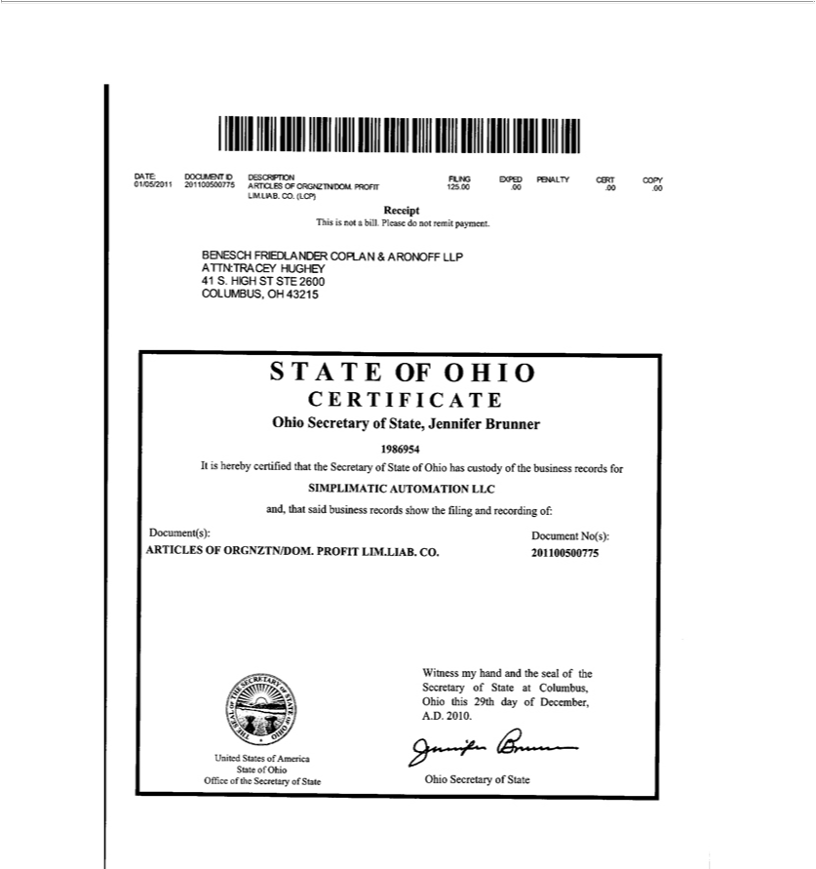

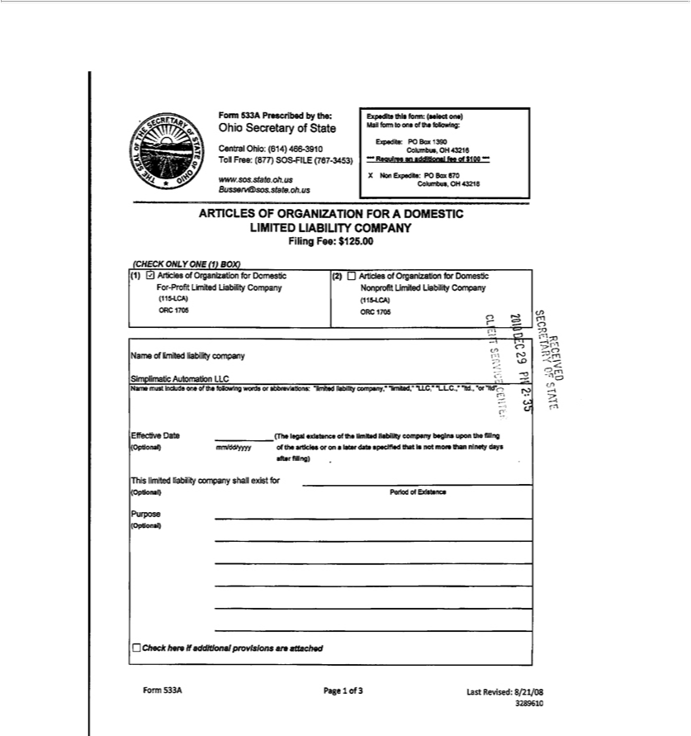

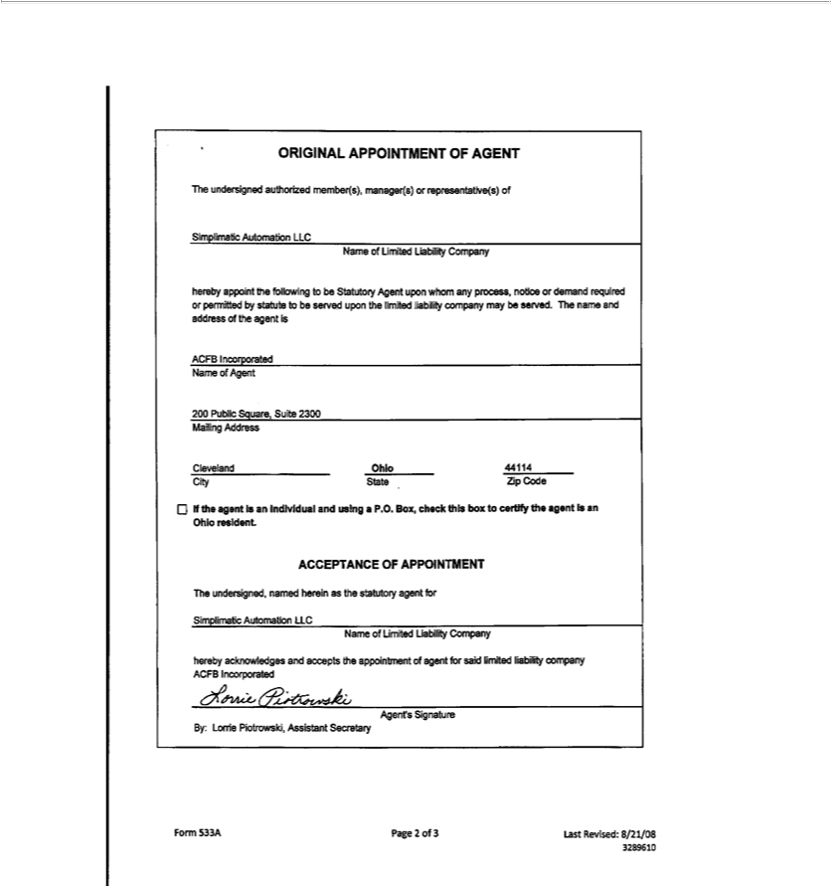

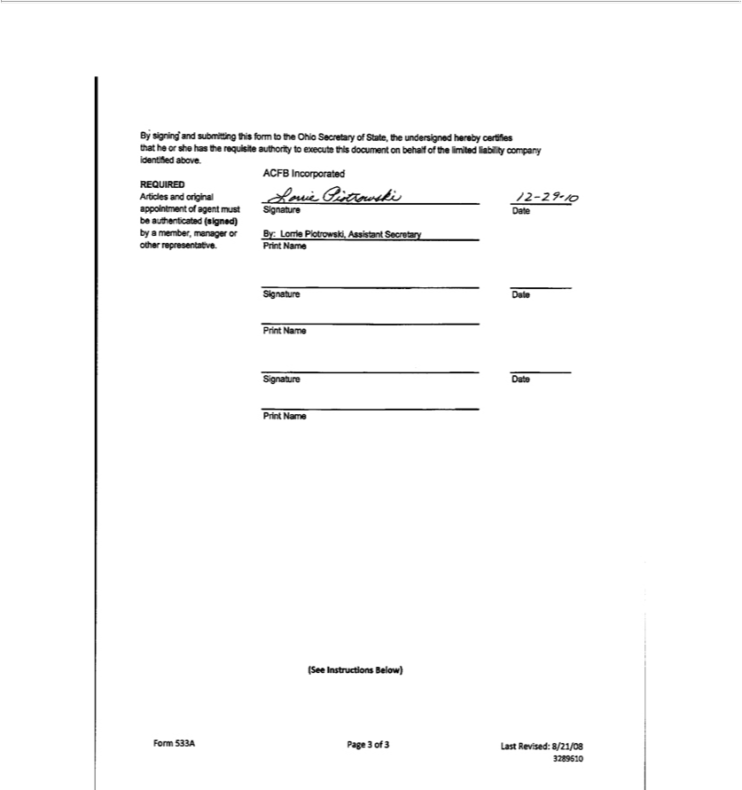


UNITED STATES OF AMERICA,

STATE OF OHIO,

OFFICE OF SECRETARY OF STATE

I, Frank LaRose, Secretary of State of the State of Ohio, do hereby certify that the paper to which this is attached is a true and correct copy from the original record now in my official custody as Secretary of State.

Witness my hand and the seal of the Secretary of State at Columbus, Ohio this 12th day of July, A.D. 2022.

Ohio Secretary of State

Validation Number:

202219303878

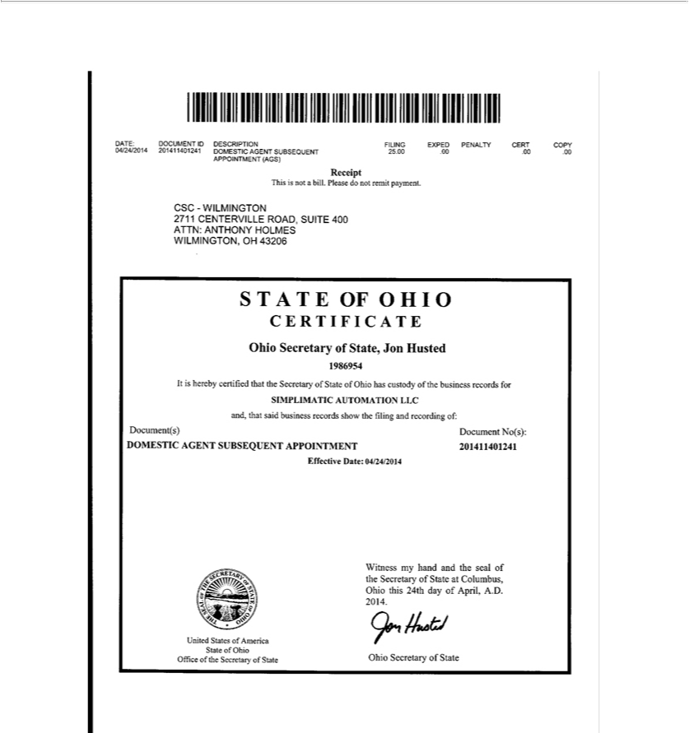

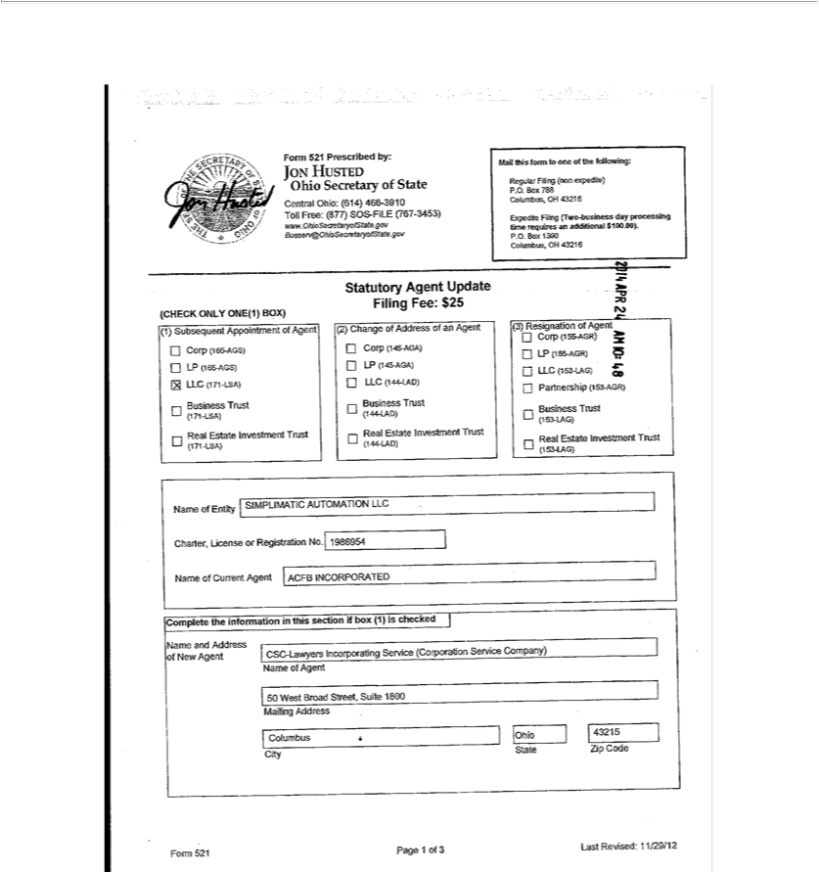

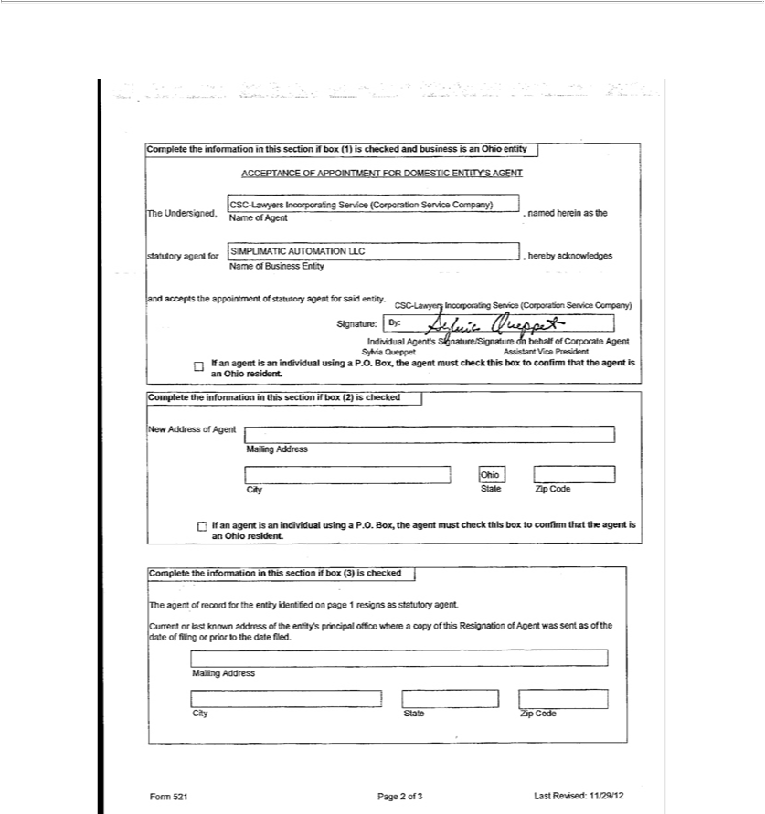

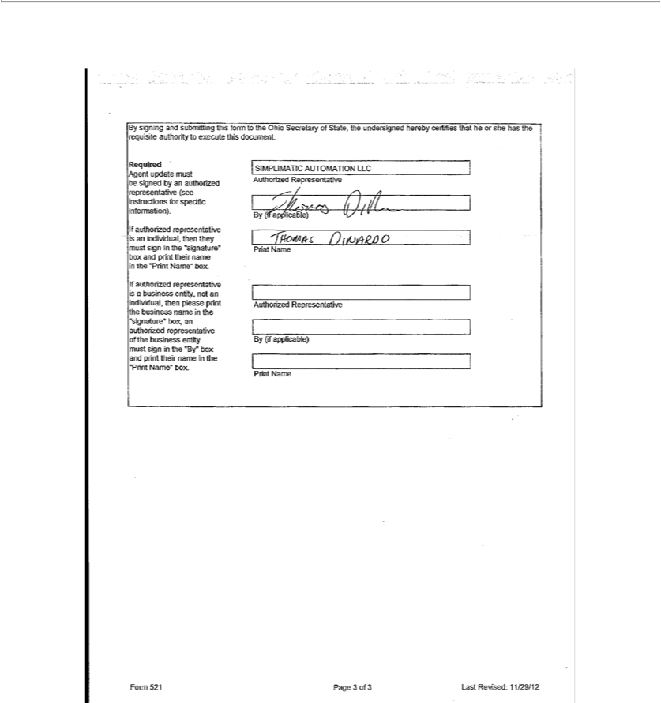

UNITED STATES OF AMERICA,

STATE OF OHIO,

OFFICE OF SECRETARY OF STATE

I, Frank LaRose, Secretary of State of the State of Ohio, do hereby certify that the paper to which this is attached is a true and correct copy from the original record now in my official custody as Secretary of State.

Witness my hand and the seal of the Secretary of State at Columbus, Ohio this 12th day of July, A.D. 2022.

Ohio Secretary of State

Validation Number:

202219303878

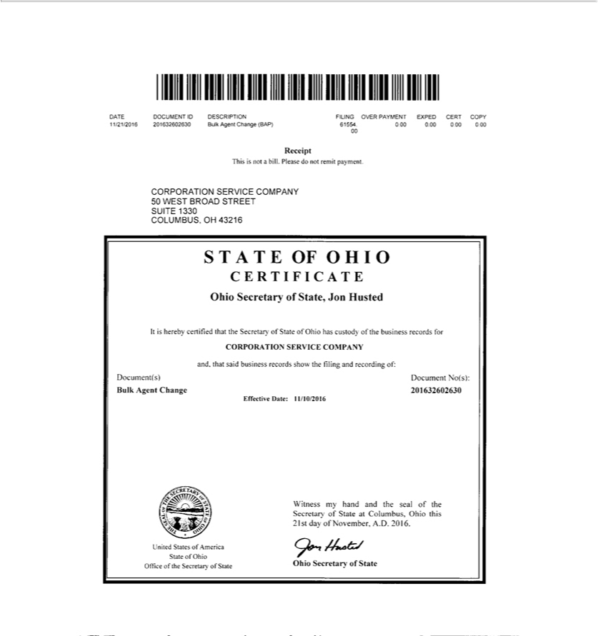

180 East Broad Street, 16th Floor


Columbus, OH 43215

(877) 767-6446 | (614) 466-2655

info@OhioSecretaryofstate.gov

www.OhioSecretaryofstate.gov

The filing with the Document Identification Number of 201632602630 is a Multiple Agent Name and Address Change form filed by Corporation Service Company. The filing contains 5,044 pages. Due to the large number of pages, the full filing is not available via the website.

The new Agent’s Address is:

Corporation Service Company

50 West Broad Street

Suite 1330

Columbus, OH 43215

If you would like a copy of the full filing sent to you, please send an email to BUSSERV@OhioSecretaryofState.gov.

Sincerely,

Business Services


UNITED STATES OF AMERICA,

STATE OF OHIO,

OFFICE OF SECRETARY OF STATE

I, Frank LaRose, Secretary of State of the State of Ohio, do hereby certify that the paper to which this is attached is a true and correct copy from the original record now in my official custody as Secretary of State.

Witness my hand and the seal of the Secretary of State at Columbus, Ohio this 12th day of July, A.D. 2022.

Ohio Secretary of State

Validation Number:

202219303878

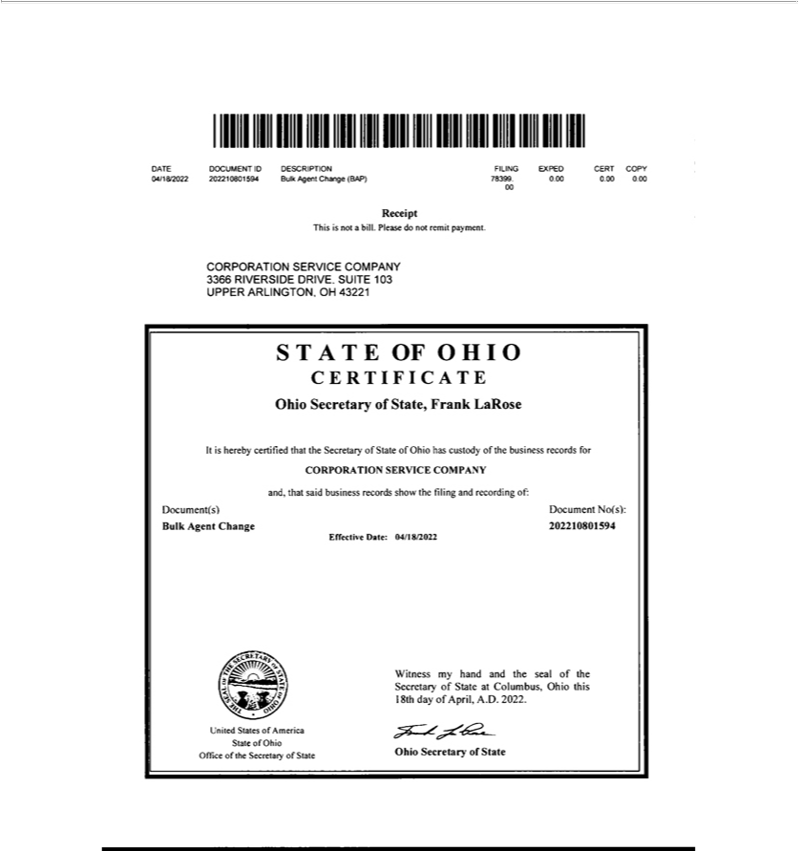

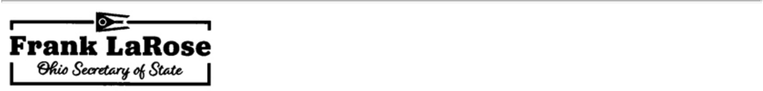
May 17, 2022

The filing with the Document Identification Number of 202210801594 is a Multiple Agent Name and Address Change form filed by Corporation Service Company. The filing contains 2614 pages. Due to the large number of pages, the full filing is not available via the website.

The new Agent’s Address is:

Corporation Service Company

3366 Riverside Drive, Suite 103

Upper Arlington, OH 43221

If you would like a copy of the full filing sent to you, please send an email to Business@OhioSOS.gov.

Sincerely,

Business Services


UNITED STATES OF AMERICA,

STATE OF OHIO,

OFFICE OF SECRETARY OF STATE

I, Frank LaRose, Secretary of State of the State of Ohio, do hereby certify that the paper to which this is attached is a true and correct copy from the original record now in my official custody as Secretary of State.

Witness my hand and the seal of the Secretary of State at Columbus, Ohio this 12th day of July, A.D. 2022.

Ohio Secretary of State

Validation Number:

202219303878

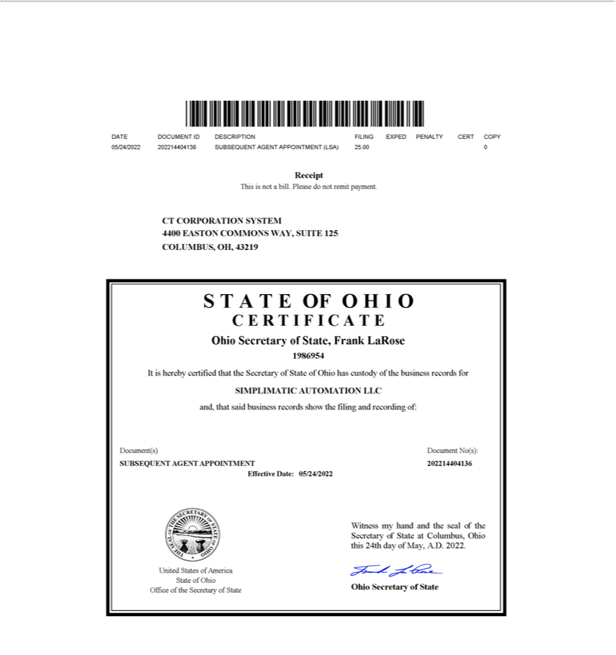

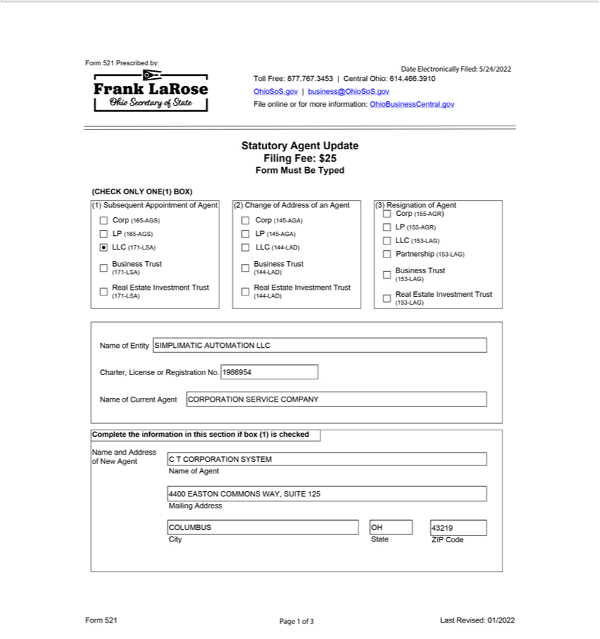

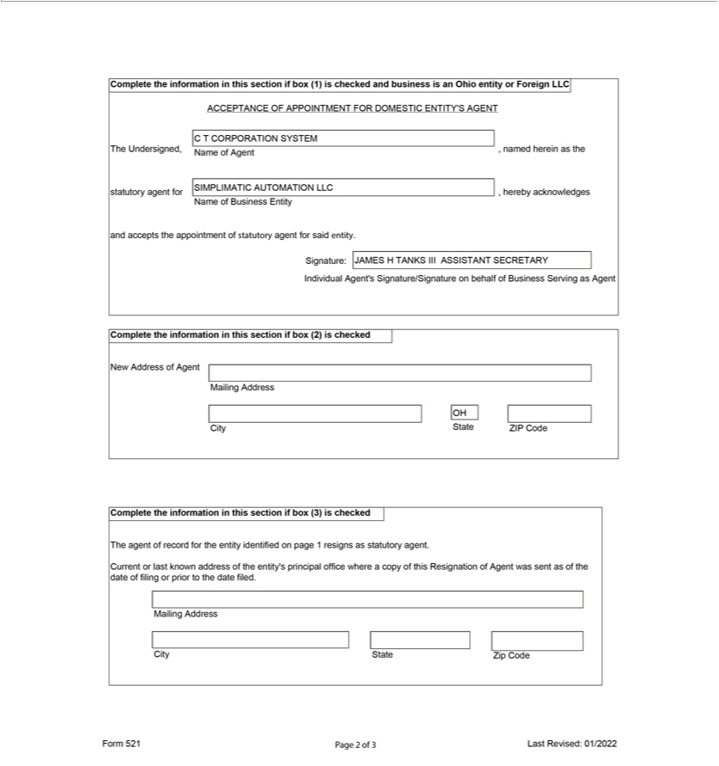

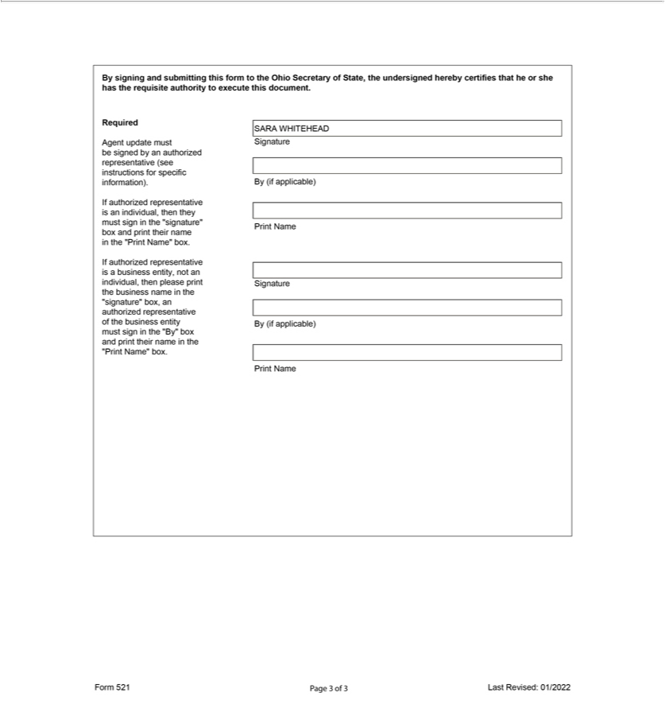

Exhibit 3.pp

FIRST AMENDED AND RESTATED OPERATING AGREEMENT

OF

SIMPLIMATIC AUTOMATION LLC

THIS OPERATING AGREEMENT (“Agreement”), is made and entered into by and between Simplimatic Automation LLC, an Ohio limited liability company (the “Company”), and Simplimatic Engineering Holdings, LLC, an Ohio limited liability company and the sole member of the Company (the “Member”), as of the 30th day of September, 2019.

WHEREAS, the original Operating Agreement of the Company was executed effective December 29, 2010.

WHEREAS, the Member hereby seeks to amend the original Operating Agreement and replace that Operating Agreement in its entirety with this Agreement.

ARTICLE 1

ORGANIZATION

Section 1.1 Formation. Pursuant to the Articles of Organization (the “Articles of Organization”) filed with the Secretary of State of Ohio on December 29, 2010 (the “Commencement Date”), the Company was formed pursuant to the provisions of Chapter 1705 of the Ohio Revised Code (the “Act”). The rights and liabilities of the Member will be as provided in the Act except as otherwise provided in this Agreement. The Member hereby agrees that all actions taken by the authorized representative for filing the Articles of Organization are hereby ratified.

ARTICLE 2

NAME, CHARACTER, PLACE OF

BUSINESS AND TERM OF COMPANY

Section 2.1 Name. The name of the Company as of the date hereof is Simplimatic Automation LLC. The Member may change the Company’s name at any time and from time to time. The Member may also cause the Company to do business at the same time under more than one fictitious name if the Member determines that doing so is in the interest of the Company.

Section 2.2 Character of Business. The business of the Company shall be to engage in any other lawful activity permissible for a limited liability company under the Act.

Section 2.3 Place of Business. The principal office of the Company shall be located at 1046 London Park Drive, Forest, VA 24551, or at such other location as the Member may from time to time determine.

Section 2.4 Location of Records. The Company will maintain, at its principal office, all records pertaining to the Company as required by the

Act.

Section 2.5 Term. The period of duration of the Company shall commence on the Commencement Date and shall continue until dissolved in accordance with the provisions of this Agreement.

Section 2.6 Statutory Agent. The Company from time to time shall appoint a statutory agent in and for the State of Ohio.

ARTICLE 3

CAPITAL CONTRIBUTIONS; FISCAL YEAR

Section 3.1 Capital Contributions. The capital contributions of the Member are set forth on the books and records of the Company. The Member shall not be required to make any additional capital contributions or loans to the Company and no interest shall be paid on the capital contributions of the Member.

Section 3.2 Fiscal Year. The Company shall have the same fiscal year as the Member.

ARTICLE 4

MANAGEMENT OF COMPANY

Section 4.1 Management.

- The business and affairs of the Company will be managed from time to time by the Member.

- The Member is authorized to establish such rules and procedures relating to meetings and notices of meetings as it deems necessary or appropriate.

Section 4.2 Officers. The Member may appoint any person to act as officers of the Company which may include (a) a president; (b) one or more vice presidents; (c) a secretary and/or one or more assistant secretaries; and (d) a treasurer and/or one or more assistant treasurers. The Member may delegate a portion of its day-to-day management responsibilities to any such officers, as determined by the Member from time to time, and such officers will have the authority to contract for, negotiate on behalf of and otherwise represent the interests of the Company as authorized by the Member.

Section 4.3 Reliance on Acts of Member or Officers. No financial institution or any other person, firm or corporation dealing with the Company shall be required to ascertain whether the Member or any officer is acting in accordance with this Agreement but such financial institution or such other person, firm or corporation shall be protected in relying solely upon the deed, transfer or assurance of, and the execution of such instrument or instruments by, the Member or such officer.

ARTICLE 5

DISTRIBUTIONS TO MEMBER

Section 5.1 Distributions of Net Cash Flow and Net Cash Proceeds. Distributions shall be made to the Member at such time as the Member determines.

2

ARTICLE 6

WITHDRAWAL OF A MEMBER; RIGHT TO

CONTINUE THE BUSINESS OF THE COMPANY

Section 6.1 Withdrawal of the Member. The Member shall cease to be a member of the Company upon the occurrence of any of the events of withdrawal as set forth in the Act.

Section 6.2 Right to Continue Business. The Company shall not dissolve upon the withdrawal of the Member by reason of a transfer described in Section 6.1 hereof. Upon the withdrawal of the Member for any other reason, the successors or assigns of the Member may elect to continue the business of the Company within one hundred twenty (120) days after the withdrawal of the Member from the Company pursuant to Section 6.1 hereof.

ARTICLE 7

TRANSFERS OF MEMBERSHIP INTERESTS

Section 7.1 Voluntary Transfers of Membership Interests. The membership interest of the Member may be voluntarily transferred at any time.

ARTICLE 8

DISSOLUTION OF THE COMPANY

Section 8.1 Dissolution. The Company shall be dissolved upon the occurrence of any of the following events:

- If the Member ceases to be a Member of the Company other than by reason of a transfer described in Section 6.1 hereof and the business of the Company is not continued as provided in Section 6.2;

- The sale of substantially all of the Company’s assets;

- The written statement of the sole Member to dissolve the Company; or

- The entry of a decree of judicial dissolution under Section 1705.47 of the Act.

Upon the dissolution of the Company, the Member (or the successor of the Member with respect to the Member’s membership interest) shall proceed, within one hundred eighty (180) days after notice of the event causing dissolution, with the winding up of the Company, and its assets shall be applied and distributed as provided in the Act; provided, however, that nothing in this Agreement shall be deemed to require the Company or any Member to pay any non-recourse debts or obligations of the Company.

Section 8.2 Final Accounting. The Member shall be furnished with a statement prepared by the Company’s accountants, which shall set forth the assets and liabilities of the Company as of the date of the complete liquidation. Upon the compliance by the Member with the foregoing distribution plan, the Member shall cease to be a Member and the Member shall execute and cause to be filed a Certificate of Dissolution of the Company in compliance with the Act and any and all other documents necessary with respect to termination and cancellation.

3

Section 8.3 Reserve. Notwithstanding the provisions of this Section, the Company may retain such amounts as it deems reasonably necessary as a reserve for any contingent liabilities or obligations of the Company. After such reasonable period of time as the Member shall determine, the balance of such reserve shall be distributed to the Member.

ARTICLE 9

INVESTMENT REPRESENTATION

Section 9.1 Investment Purposes. The Member hereby represents and covenants that she is acquiring her membership interest solely for investment purposes and not with a view to the distribution or resale thereof.

ARTICLE 10

INDEMNIFICATION

Section 10.1 Indemnification of Member and Officers. The Company shall indemnify and defend the Member and the officers of the Company, or anyone who was serving as such at the request of the Company on behalf of some other entity (each, an “Indemnified Party”), and hold each of them harmless from and against any and all obligations, losses, damages, penalties, actions, judgments, suits, proceedings, costs, expenses and disbursements of any kind or nature whatsoever that may be imposed on, incurred by or asserted against the Indemnified Party (including, without limitation, all costs and expenses of defense, appeal and settlement) to the fullest extent permitted by the Act. The obligations of the Company under this Section 10.1 shall be satisfied solely from the assets of the Company, and no Member shall have any personal liability on account thereof.

Section 10.2 Insurance. The Company shall have power to purchase and maintain insurance on behalf of any Indemnified Party against any liability asserted against and incurred by such Indemnified Party in such Indemnified Party’s capacity, or arising out of the Indemnified Party’s status as such, whether or not the Company would have the power to indemnify the Indemnified Party against such liability under the provisions of this Section 10.2.

ARTICLE 11

MISCELLANEOUS

Section 11.1 Company Covenants.

- The Company shall maintain its existence as a limited liability company in the State of Ohio and in all other states or jurisdictions where it is required to be qualified to conduct its business.

- The Company shall comply with all obligations under its Articles of Organization, duly adopted by-laws (if any), this Agreement and the

Act.

4

Section 11.2 Governing Law. The Company and this Agreement shall be governed by and construed in accordance with the laws of the State of Ohio, notwithstanding the application of any principles of conflicts of law.

Section 11.3 Entire Agreement. This Agreement, together with the Articles of Organization and any duly adopted by-laws of the Company, as any of the foregoing may be duly amended in writing from time to time, contains the entire agreement or declaration of the Member with respect to the operation of the Company.

Section 11.4 Severability. This Agreement is intended to be performed in accordance with, and only to the extent permitted by, all applicable laws, ordinances, rules and regulations of the jurisdictions in which the Company does business. If any provision of this Agreement, or the application thereof to any person or circumstance shall, for any reason and to any extent, be invalid or unenforceable, the remainder of this Agreement and the application of such provision to other persons or circumstances shall not be affected thereby, but rather shall be enforced to the greatest extent permitted by law.

Section 11.5 Headings and Captions; Variation in Pronouns. The headings and captions used in this Agreement are for convenience of reference only and shall not affect the interpretation or construction of any of the terms and provisions of this Agreement. Except as specifically provided otherwise, all of the terms and words used in this Agreement, regardless of the number and gender in which they are used, shall be deemed and construed to include any other number, singular or plural, and any other gender, masculine, feminine or neuter, as the context or sense of this Agreement or any section or clause herein may require, the same as if such words had been fully and properly written in such number and gender.

Section 11.6 Amendment. This Agreement may be amended by the Member at any time and from time to time. Any such amendment shall be in writing.

5

IN WITNESS WHEREOF, the parties have hereunto set their hand as of the date set forth above.

MEMBER:

SIMPLIMATIC ENGINEERING HOLDINGS, LLC

By: /s/ Sara M. Orange

Name: Sara M. Orange

Title: CFO

COMPANY:

SIMPLIMATIC AUTOMATION LLC

By: /s/ Sara M. Orange

Name: Sara M. Orange

Title: CFO

6

Exhibit 3.qq


I Certify the Following from the Records of the Commission:

The foregoing is a true copy of all business entity documents on file in the Office of the Clerk of the Commission related to SEH Real Estate Holdings LLC, a Virginia limited liability company.

Nothing more is hereby certified.

Signed and Sealed at Richmond on this Date:

July 11, 2022

/s/ Bernard J. Logan

Bernard J. Logan, Clerk of the Commission

1401521205


COMMONWEALTH OF VIRGINIA

STATE CORPORATION COMMISSION

Office of the Clerk

January 15, 2014

THOMAS DINARDO

SIMPLIMATIC

78 CORPORATE WAY

EVINGTON, VA 24550

RECEIPT

RE: SEH Real Estate Holdings LLC

ID: S4872257

DCN: 14-01-15-5394

Dear Customer:

This is your receipt for $100.00 to cover the fee(s) for filing articles of organization for a limited liability company with this office.

The effective date of the filing is January 15, 2014.

If you have any questions, please call (804) 371-9733 or toll-free in Virginia, (866) 722-2551.

Sincerely,

/s/ Joel H. Peck

Joel H. Peck

Clerk of the Commission

RECEIPTLC

LLNCD

CISECOM

P.O. Box 1197, Richmond, VA 23218-1197

Tyler Building, First Floor, 1300 East Main Street, Richmond, VA 23219-3630

Clerk’s Office (804) 371-9733 or (866) 722-2551 (toll-free in Virginia) www.scc.virginia.gov/clk

Telecommunications Device for the Deaf-TDD/Voice: (804) 371-9206

1401521205

COMMONWEALTH OF VIRGINIA

STATE CORPORATION COMMISSION

AT RICHMOND, JANUARY 15, 2014

The State Corporation Commission has found the accompanying articles submitted on behalf of SEH Real Estate Holdings LLC

to comply with the requirements of law, and confirms payment of all required fees. Therefore, it is ORDERED that this CERTIFICATE OF ORGANIZATION

be issued and admitted to record with the articles of organization in the Office of the Clerk of the Commission, effective January 15, 2014.

STATE CORPORATION COMMISSION

By /s/ James C. Dimitri

James C. Dimitri

Commissioner

DLLCACPT

CISECOM

14-01-15-5394

SCC eFile | 1401521205
ARTICLES OF ORGANIZATION

OF

SEH REAL ESTATE HOLDINGS LLC

The undersigned, pursuant to Chapter 12 of Title 13.1 of the Code of Virginia, states as follows:

- The name of the limited liability company is SEH Real Estate Holdings LLC.

- The purpose for which the limited liability company is formed is to engage in any lawful business, purpose or activity for which a limited liability company may be formed under the Virginia Limited Liability Company Act.

- The name of the limited liability company’s initial registered agent is Thomas DiNardo. The initial registered agent is an individual who is a resident of Virginia and a member or manager of the limited liability company.

- The address of the limited liability company’s initial registered office, which is identical to the business office of the initial registered agent, is Simplimatic, 78 Corporate Way, Evington, VA 24550. The initial registered office is located in Campbell County, Virginia.

- The address of the limited liability company’s principal office where the records of the limited liability company are to be kept is 78 Corporate Way, Evington, VA 24550.

ORGANIZER:

Simplimatic Engineering Holdings LLC

By: /s/ Thomas DiNardo Date: January 15, 2014

Thomas DiNardo, Manager

1404550300

COMMONWEALTH OF VIRGINIA

STATE CORPORATION COMMISSION

Office of the Clerk

CORPORATION SERVICE COMPANY

BANK OF AMERICA CENTER, 16TH FLOOR

1111 EAST MAIN STREET

RICHMOND, VA 23219

April 23, 2014

RECEIPT

RE:

SEH Real Estate Holdings LLC

ID:

S4872257

DCN:

1404236087

Dear Customer:

This is to acknowledge the filing of a statement of change of registered office and/or registered agent for the above-referenced limited liability company with this office.

The effective date of the change is April 23, 2014.

If you have any questions about this matter, please contact this office at the addresses or telephone numbers shown below.

Sincerely,

RECEIPT

CISECOM /s/ Joel H. Peck

Joel H. Peck

Clerk of the Commission

P.O. Box 1197, Richmond, VA 23218-1197

Tyler Buildlng, First Floor, 1300 East Main Street, Richmond, VA 23219-3630

Clerk’s Office (804) 371-9733 or (866) 722-2551 (toll-free in Virginia) www.scc.virginia.gov/clk

Telecommunications Device for the Deaf-TDD/Voice: (804) 371-9206

1404550300

COMMONWEALTH OF VIRGINIA


STATE CORPORATION COMMISSION

STATEMENT OF CHANGE OF

REGISTERED OFFICE

AND/OR REGISTERED AGENT CHANGE

- RE: SEH Real Estate Holdings LLC

ID: S4872257

- Current registered agent’s name and registered office address on record (including the jurisdiction in which the registered office is physically located):

THOMAS DINARDO

SIMPLIMATIC

78 CORPORATE WAY

EVINGTON, VA 24550-0000

(CAMPBELL COUNTY)

- The current registered agent is an individual who is a resident of Virginia and a member or manager of the limited liability company.

- The registered agent’s name and registered office address after this statement is filed with the Commission (including the jurisdiction in which the registered office is physically located):

CORPORATION SERVICE COMPANY Bank of America Center, 16th Floor 1111 East Main Street Richmond, VA 23219

(RICHMOND CITY)

- The registered agent named in item 4 is a domestic or foreign stock or nonstock corporation or limited liability company authorized to transact business in Virginia.

- After the foregoing change or changes are made, the limited liability company will be in compliance with the requirements of § 13.1-1015 of the Code of Virginia.

Signed on April 23, 2014, on behalf of SEH Real Estate Holdings LLC

By: Thomas Dinardo, Member

/s/ Thomas Dinardo

1801210002

COMMONWEALTH OF VIRGINIA


STATE CORPORATION COMMISSION

Office of the Clerk

ID:

For Office Use Only

Microfilm Type: | RAC
Charter Fee:
Effective Date: | 1/1/18

Number of All Pages: 871

(Including this page)

1801210002
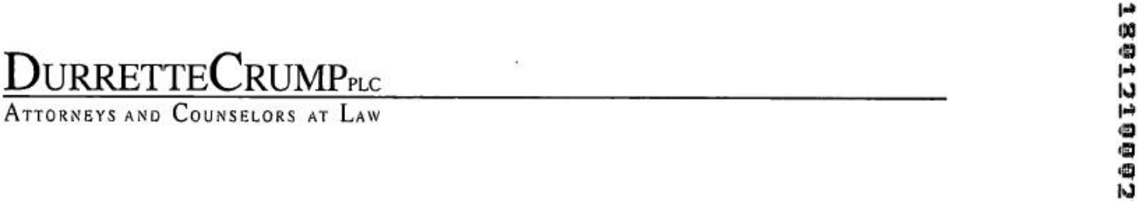

Beverley L. Crump

Direct Dial 804.783.6804

bcrump@durrettecrump.com

December 12, 2017

Ms. Rachel Emerson, Supervisor

State Corporation Commission

17 12 08 0601

Clerk’s Office — 1st Floor

Tyler Building

1300 E. Main Street

P.O. Box 1197

Richmond, VA 23218

By Hand Delivery

RE: Beverley L. Crump, Beverley L Crump, Beverley L. Crump*,

B. L. Crump*, B L Crump*, B L Crump and

Beverly L. Crump

Change of Registered Agent Address - My name as listed

at the Virginia State Corporation Commission

Dear Ms. Emerson:

Effective January 1, 2018, I will relocate my office from its present location at Bank of America Center, 16th Floor, 1111 East Main Street, Richmond, VA 23219 (City of Richmond).

My new office address will be:

100 Shockoe Slip
2nd Floor

Richmond, VA 23219

The new office is located in the City of Richmond.

Accordingly, I would appreciate it if the State Corporation Commission would change the registered office address on all domestic and foreign corporations, limited liability companies, limited partnership and other entities for which my name (as listed in above) as Registered Agent per the attached excel spreadsheet to the above address on January 1, 2018.

The entities listed on the spreadsheet have been notified of this change of Registered Agent address. If you need any further information, please contact me. Thank you for your prompt assistance and cooperation.

Sincerely,

/s/ Beverley L. Crump

Beverley L. Crump

1801210002


December 11, 2017

Ms. Rachel Emerson

Supervisor

State Corporation Commission

Clerk’s Office - 1st Floor

Tyler Building

1300 E. Main Street

P.O. Box 1197

Richmond, VA 23218

Re: Corporation Service Company

Change of Registered Agent Address

Dear Ms. Emerson:

Effective January 1, 2018, Corporation Service Company will relocate its registered office from its present location at Bank of

America Center, 16th Floor, 1111 East Main Street, Richmond, VA 23219 in the City of Richmond. Our new office address will be:

Corporation Service Company

100 Shockoe Slip
2nd Floor

Richmond, VA 23219

The new office is located in the City of Richmond.

Accordingly, we would appreciate it if the State Corporation Commission would change the registered office address of all corporations, limited liability companies and other entities for which Corporation Service Company serves as Registered Agent per the attached excel spreadsheet to the above address on January 1, 2018.

The entities listed on the spreadsheet have been notified of this change at their principal office address. If you need further information or assistance, please contact Anne Grigorakos at 800 927-9801 Ext. 62012 (anne.grigorakos@cscglobal.com). Thank you for your cooperation.

Yours truly,

Corporation Service Company

/s/ George A. Massih III

George A. Massih III

Vice President

1801210002

December 11, 2017

Ms. Rachel Emerson

Supervisor

State Corporation Commission

Clerk’s Office - 1st Floor

Tyler Building

1300 E. Main Street

P.O. Box 1197

Richmond, VA 23218

Re: The Prentice-Hall Corporation System, Inc.

Change of Registered Agent Address

Dear Ms. Emerson:

Effective January 1, 2018, The Prentice-Hall Corporation System, Inc., will relocate its registered office from its present location at Bank of America Center, 16th Floor, 1111 East Main Street, Richmond, VA 23219 in the City of Richmond. Our new office address will be:

The Prentice-Hall Corporation System, Inc.

100 Shockoe Slip
2nd Floor

Richmond, VA 23219

The new office is located in the City of Richmond.

Accordingly, we would appreciate it if the State Corporation Commission would change the registered office address of all corporations, limited liability companies and other entities for which The Prentice-Hall Corporation System, Inc. serves as Registered Agent per the attached excel spreadsheet to the above address on January 1, 2018.

The entities listed on the spreadsheet have been notified of this change at their principal office address. If you need further information or assistance, please contact Anne Grigorakos at 800 927-9801 Ext. 62012 (anne.grigorakos@cscglobal.com). Thank you for your cooperation.

Yours truly,

The Prentice-Hall Corporation System, Inc.

/s/ George A. Massih III

George A. Massih III

Vice President

1801210002

December 11, 2017

Ms. Rachel Emerson

Supervisor

State Corporation Commission

Clerk’s Office - 1st Floor

Tyler Building

1300 E. Main Street

P.O. Box 1197

Richmond, VA 23218

Re: United States Corporation Company

Change of Registered Agent Address

Dear Ms. Emerson:

Effective January 1, 2018, United States Corporation Company will relocate its registered office from its present location at Bank of America Center, 16th Floor, 1111 East Main Street, Richmond, VA 23219 in the City of Richmond. Our new office address will be:

United States Corporation Company

100 Shockoe Slip
2nd Floor

Richmond, VA 23219

The new office is located in the City of Richmond.

Accordingly, we would appreciate it if the State Corporation Commission would change the registered office address of all corporations, limited liability companies and other entities for which United States Corporation Company serves as Registered Agent per the attached excel spreadsheet to the above address on January 1, 2018.

The entities listed on the spreadsheet have been notified of this change at their principal office address. If you need further information or assistance, please contact Anne Grigorakos at 800 927-9801 Ext. 62012 (anne.grigorakos@cscglobal.com). Thank you for your cooperation.

Yours truly,

United States Corporation Company

/s/ George A. Massih III

George A. Massih III

Vice President

COMMONWEALTH OF VIRGINIA


STATE CORPORATION COMMISSION

Office of the Clerk

January 4, 2018

SARA ORANGE

SEH REAL ESTATE HOLDINGS LLC

1046 W LONDON PARK

FOREST, VA 24551

RECEIPT

RE: SEH Real Estate Holdings LLC

ID: S487225 - 7

DCN: 18-01-04-1403

This receipt acknowledges payment of $150.00 to cover the fee for filing an application for reinstatement of the existence of a limited liability company with this office.

This receipt also acknowledges payment of $50.00 to cover the fee for expedited service.

The order of reinstatement was entered on January 4, 2018.

Unless a statement of change was submitted with the reinstatement application, we strongly recommend verifying the registered agent and registered office information on file in the Clerk’s Office by visiting sccefile.scc.virginia.gov or contacting this office.

The next annual registration fee will be due by January 31, 2019.

If you have any questions, please call (804) 371-9733 or toll-free in Virginia, (866) 722-2551.

Sincerely,

/s/ Joel H. Peck

Joel H. Peck

Clerk of the Commission

RECEIPTLC

LLRE

CISJMA

P.O. Box 1197, Richmond, VA 23218-1197

Tyler Building, First Floor, 1300 East Main Street, Richmond, VA 23219-3630

Clerk’s Office (804) 371-9733 or (866) 722-2551 (toll-free in Virginia) www.scc.vlrginia.gov/clk

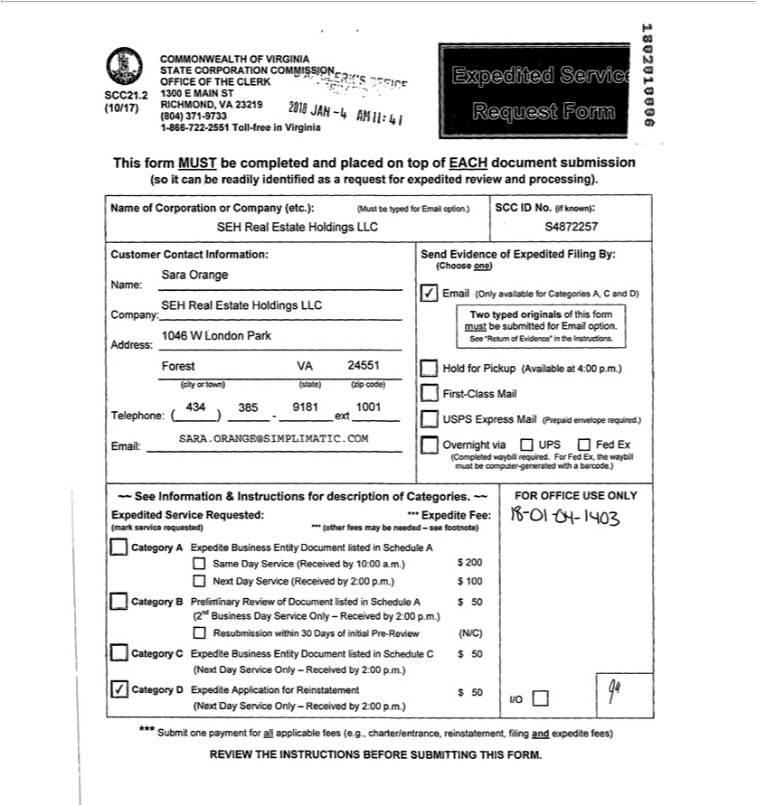

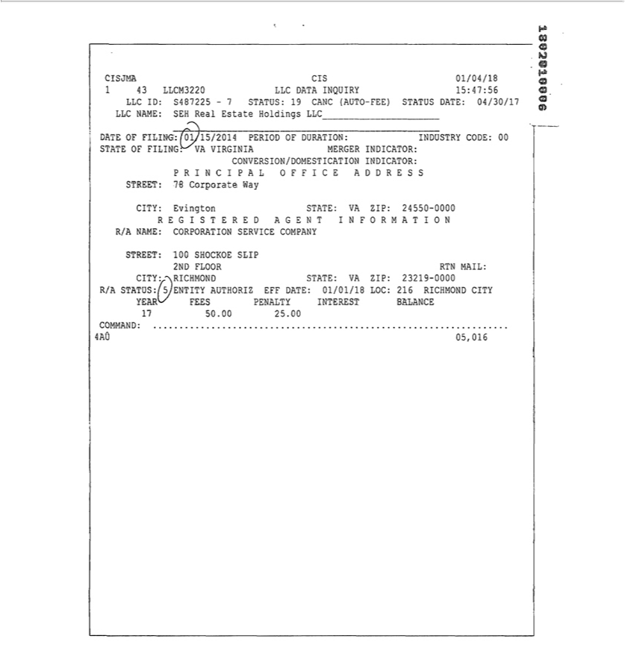

S487225 - 7

COMMONWEALTH OF VIRGINIA

STATE CORPORATION COMMISSION

AT RICHMOND, JANUARY 4, 2018

ORDER OF REINSTATEMENT

The existence of SEN Real Estate Holdings LLC, a domestic limited liability company, was automatically canceled on April 30, 2017. The limited liability company has filed an application for reinstatement and has otherwise complied with the applicable requirements of law.

Therefore, it is ORDERED that the existence of the aforementioned limited liability company is reinstated.

STATE CORPORATION COMMISSION

By /s/ Judith Williams Jagdmann

Judith Williams Jagdmann

Commissioner

- SARA ORANGE

SEH REAL ESTATE HOLDINGS LLC 1046 W LONDON PARK
FOREST, VA 24551

18-01-04-1403

LLREACPT

CISJMA

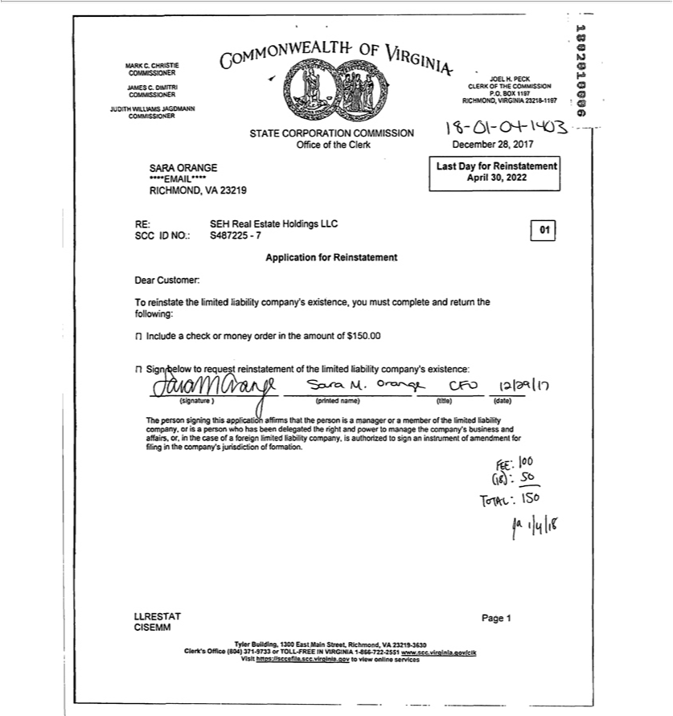

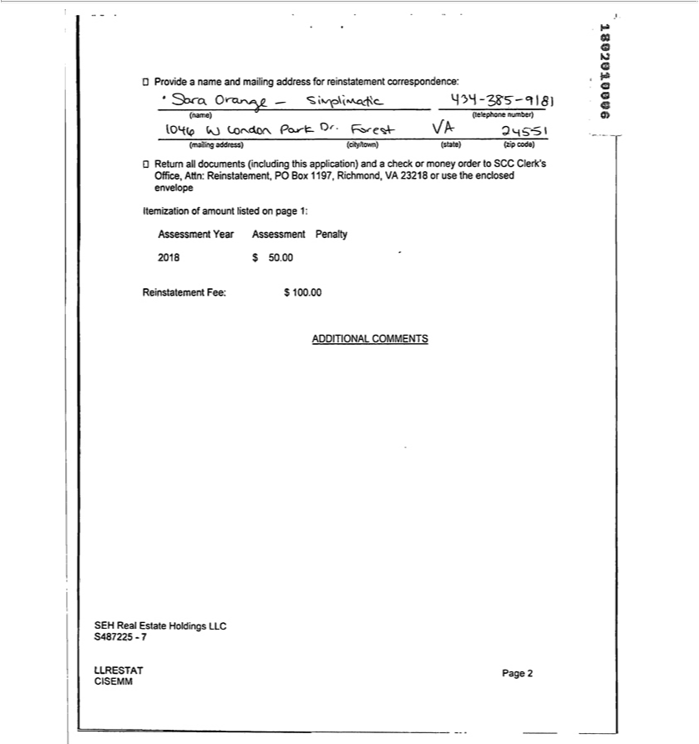

COMMONWEALTH OF VIRGINIA

STATE CORPORATION COMMISSION

Office of the Clerk

June 3, 2019

JULIE MATHER

1046 W LONDON PARK DR

FOREST, VA 24551-4100

RECEIPT

RE: SEH Real Estate Holdings LLC

ID: S487225 -7

DCN: 19-05-29-1507

This receipt acknowledges payment of $175.00 to cover the fee for filing an application for reinstatement of the existence of a limited liability company with this office.

The order of reinstatement was entered on June 3, 2019.

Unless a statement of change was submitted with the reinstatement application, we strongly recommend verifying the registered agent and registered office information on file in the Clerk’s Office by visiting sccefile.scc.virginia.gov or contacting this office.

The next annual registration fee will be due by January 31, 2020.

If you have any questions, please call (804) 371-9733 or toll-free in Virginia, (866) 722-2551.

Sincerely,

/s/ Joel H. Peck

Joel H. Peck

Clerk of the Commission

RECEIPTLC

LLRE

CISBLW

P.O. Box 1197, Richmond, VA 23218-1197

Tyler Building, First Floor, 1300 East Main Street, Richmond, VA 23219-3630

Clerk’s Office (804) 371-9733 or (866) 722-2551 (toll-free in Virginia) www.scc.virginia.gov/clk

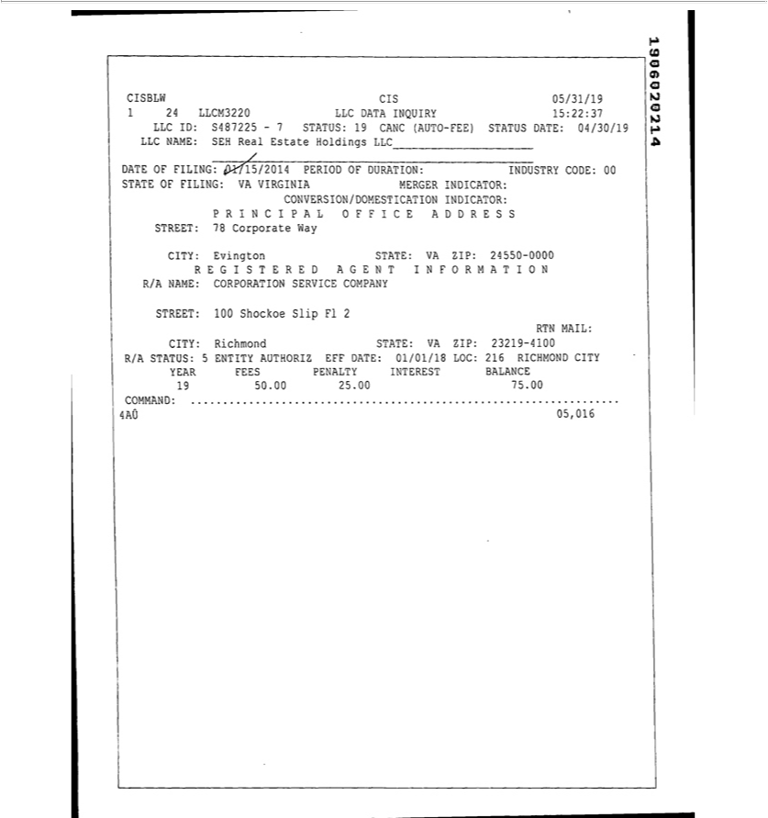

S487225 - 7

COMMONWEALTH OF VIRGINIA

STATE CORPORATION COMMISSION

AT RICHMOND, JUNE 3, 2019

ORDER OF REINSTATEMENT

The existence of SEN Real Estate Holdings LLC, a domestic limited liability company, was automatically canceled on April 30, 2017. The limited liability company has filed an application for reinstatement and has otherwise complied with the applicable requirements of law.

Therefore, it is ORDERED that the existence of the aforementioned limited liability company is reinstated.

STATE CORPORATION COMMISSION

By /s/ Judith Williams Jagdmann

Judith Williams Jagdmann

Commissioner

- JULIE MATHER

1046 W LONDON PARK DR FOREST, VA 24551-4100

19-05-29-1507

LLREACPT

CISBLW

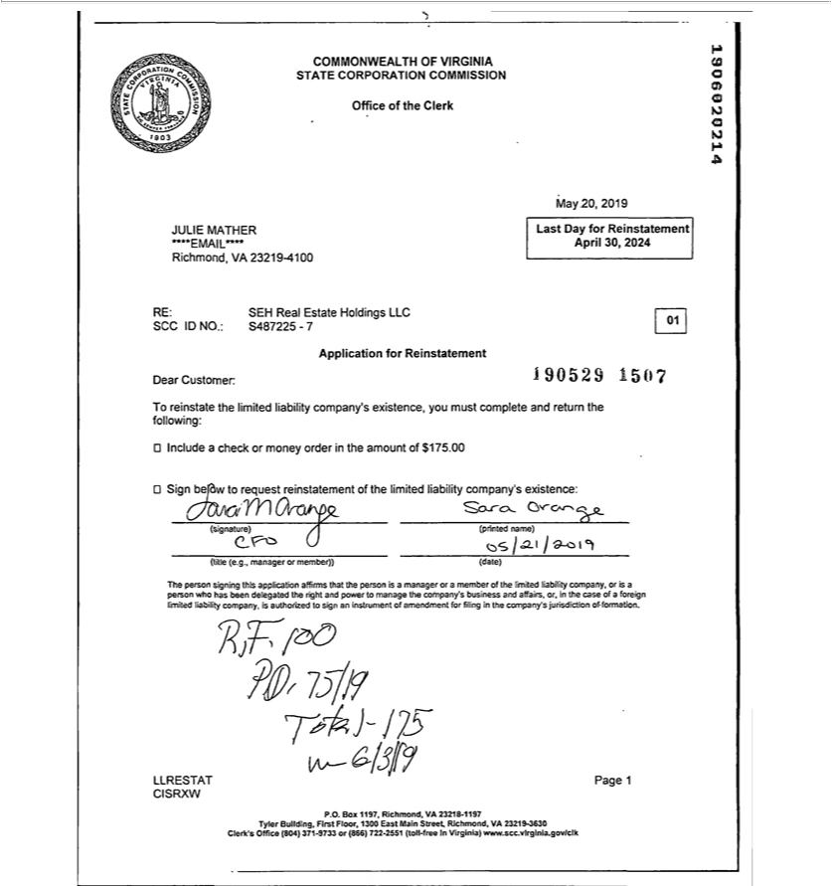

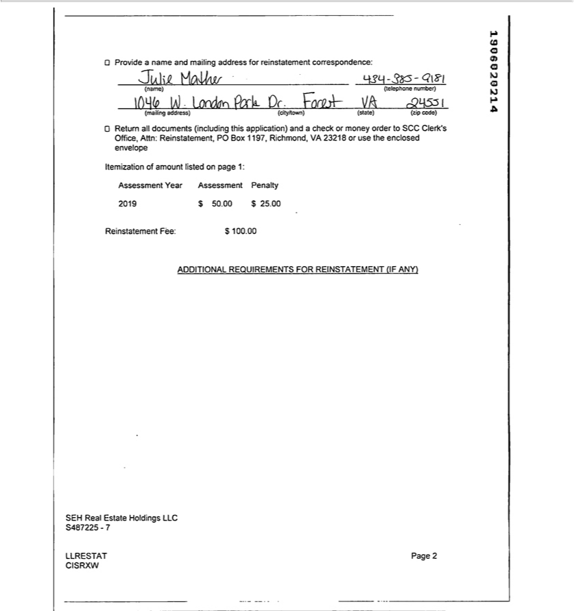

Commonwealth of Virginia

State Corporation Commission

Office of the Clerk

Entity ID: S4872257

Filing Number: 2205264574638

Filing Date/Time: 05/26/2022 09:42 AM

Effective Date/Time: 05/26/2022 09:42 AM


Clerk’s Office

State Corporation Commission

1300 E. Main Street

Richmond, Virginia 23219

Please file the attached documents.

Special Instructions:

Please send evidence to CLS-VAEvidence@wolterskluwer.com.

if there are any problems with the filing, please call us at(804) 217-7255.

Thank you,

/s/ Lauren Phillips

Lauren Phillips

CT Corporation System

Richmond Fulfillment Office

4701 Cox Road

Suite 285

Glen Allen, VA 23060

804-217-7255

CLS-VAEvidence@wolterskluwer.com

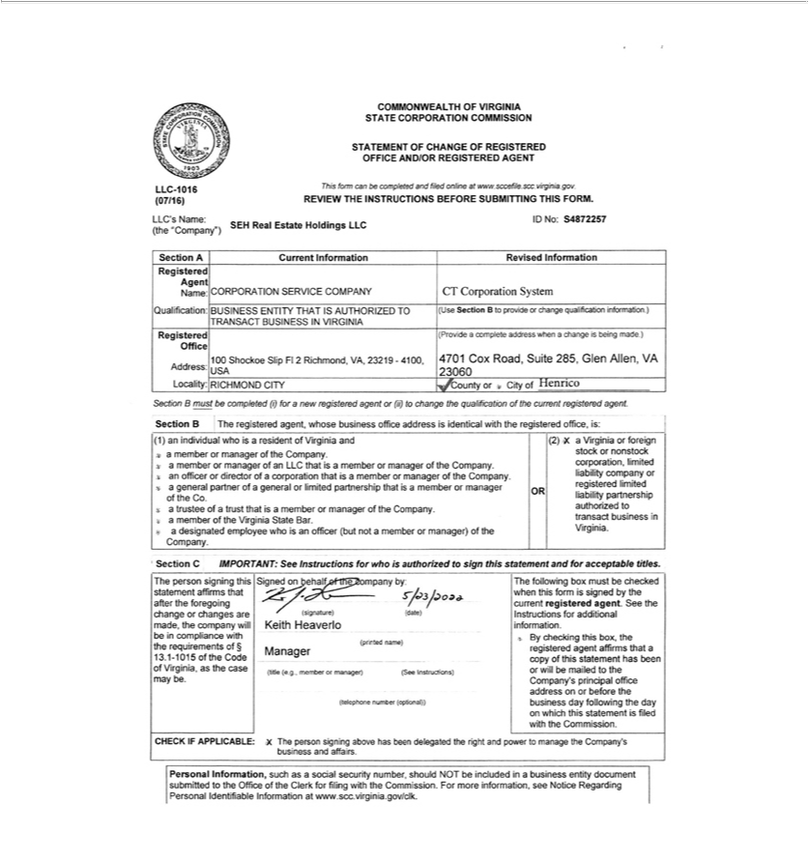

COMMONWEALTH OF VIRGINIA

STATE CORPORATION COMMISSION

Office of the Clerk

July 11, 2022

Marisa Kugelmann

45 School St

Boston, MA, 02108

RECEIPT

RE:

ID:

WORK ORDER NO:

SEH Real Estate Holdings LLC

S4872257

202207112877070

Dear Customer:

This is your receipt for $6.00 to cover the fee for requesting copies with this office.

If you have any questions, please call (804) 371-9733 or toll-free 1-866-722-2551.

Sincerely,

/s/ Bernard J. Logan

Bernard J. Logan

Clerk of the Commission

Delivery Method: Email

TYLER BUILDING, 1300 EAST MAIN STREET, RICHMOND, VA 23219-3630 ☐ WEBSITE: scc.virginia.gov



I Certify the Following from the Records of the Commission:

The foregoing is a true copy of all business entity documents on file in the Office of the Clerk of the Commission related to SEH Real Estate Holdings LLC, a Virginia limited liability company.

Nothing more is hereby certified.


Signed and Sealed at Richmond on this Date:

July 11, 2022

/s/ Bernard J. Logan

Bernard J. Logan, Clerk of the Commission

Exhibit 3.rr

FIRST AMENDED AND RESTATED OPERATING AGREEMENT

OF

SEH REAL ESTATE HOLDINGS LLC

THIS OPERATING AGREEMENT (“Agreement”), is made and entered into by and between SEH Real Estate Holdings LLC, a Virginia limited liability company (the “Company”), and Simplimatic Engineering Holdings, LLC, an Ohio limited liability company and the sole member of the Company (the “Member”), as of the 30111 day of September, 2019.

WHEREAS, the original Operating Agreement of the Company was executed effective January 15, 2014.

WHEREAS, the Member hereby seeks to amend the original Operating Agreement and replace that Operating Agreement in its entirety with this Agreement.

ARTICLE 1

ORGANIZATION

Section 1.1 Formation. Pursuant to the Articles of Organization (the “Articles of Organization”) filed with the Secretary of State of Ohio on January 15, 2014 (the “Commencement Date”), the Company was formed pursuant to the provisions of Virginia Limited Liability Company Act (the “Act”). The rights and liabilities of the Member will be as provided in the Act except as otherwise provided in this Agreement. The Member hereby agrees that all actions taken by the authorized representative for filing the Articles of Organization are hereby ratified.

ARTICLE 2

NAME, CHARACTER, PLACE OF

BUSINESS AND TERM OF COMPANY

Section 2.1 Name. The name of the Company as of the date hereof is SEH Real Estate Holdings LLC. The Member may change the Company’s name at any time and from time to time. The Member may also cause the Company to do business at the same time under more than one fictitious name if the Member determines that doing so is in the interest of the Company.

Section 2.2 Character of Business. The business of the Company shall be to engage in any other lawful activity permissible for a limited liability company under the Act.

Section 2.3 Place of Business. The principal office of the Company shall be located at 1046 London Park Drive, Forest, VA 24551, or at such other location as the Member may from time to time determine.

Section 2.4 Location of Records. The Company will maintain, at its principal office, all records pertaining to the Company as required by the

Act.

Section 2.5 Term. The period of duration of the Company shall commence on the Commencement Date and shall continue until dissolved in accordance with the provisions of this Agreement.

Section 2.6 Statutory Agent. The Company from time to time shall appoint a statutory agent in and for the State of Ohio.

ARTICLE 3

CAPITAL CONTRIBUTIONS; FISCAL YEAR

Section 3.1 Capital Contributions. The capital contributions of the Member are set forth on the books and records of the Company. The Member shall not be required to make any additional capital contributions or loans to the Company and no interest shall be paid on the capital contributions of the Member.

Section 3.2 Fiscal Year. The Company shall have the same fiscal year as the Member.

ARTICLE 4

MANAGEMENT OF COMPANY

Section 4.1 Management.

- The business and affairs of the Company will be managed from time to time by the Member.

- The Member is authorized to establish such rules and procedures relating to meetings and notices of meetings as it deems necessary or appropriate.

Section 4.2 Officers. The Member may appoint any person to act as officers of the Company which may include (a) a president; (b) one or more vice presidents; (c) a secretary and/or one or more assistant secretaries; and (d) a treasurer and/or one or more assistant treasurers. The Member may delegate a portion of its day-to-day management responsibilities to any such officers, as determined by the Member from time to time, and such officers will have the authority to contract for, negotiate on behalf of and otherwise represent the interests of the Company as authorized by the Member.

Section 4.3 Reliance on Acts of Member or Officers. No financial institution or any other person, firm or corporation dealing with the Company shall be required to ascertain whether the Member or any officer is acting in accordance with this Agreement but such financial institution or such other person, firm or corporation shall be protected in relying solely upon the deed, transfer or assurance of, and the execution of such instrument or instruments by, the Member or such officer.

ARTICLE 5

DISTRIBUTIONS TO MEMBER

Section 5.1 Distributions of Net Cash Flow and Net Cash Proceeds. Distributions shall be made to the Member at such time as the Member determines.

2

ARTICLE 6

WITHDRAWAL OF A MEMBER; RIGHT TO

CONTINUE THE BUSINESS OF THE COMPANY

Section 6.1 Withdrawal of the Member. The Member shall cease to be a member of the Company upon the occurrence of any of the events of withdrawal as set forth in the Act.

Section 6.2 Right to Continue Business. The Company shall not dissolve upon the withdrawal of the Member by reason of a transfer described in Section 6.1 hereof. Upon the withdrawal of the Member for any other reason, the successors or assigns of the Member may elect to continue the business of the Company within one hundred twenty (120) days after the withdrawal of the Member from the Company pursuant to Section 6.1 hereof.

ARTICLE 7

TRANSFERS OF MEMBERSHIP INTERESTS

Section 7.1 Voluntary Transfers of Membership Interests. The membership interest of the Member may be voluntarily transferred at any time.

ARTICLES 8

DISSOLUTION OF THE COMPANY

Section 8.1 Dissolution. The Company shall be dissolved upon the occurrence of any of the following events:

- If the Member ceases to be a Member of the Company other than by reason of a transfer described in Section 6.1 hereof and the business of the Company is not continued as provided in Section 6.2;

- The sale of substantially all of the Company’s assets;

- The written statement of the sole Member to dissolve the Company; or

- The entry of a decree of judicial dissolution under Section 1705.47 of the Act.

Upon the dissolution of the Company, the Member (or the successor of the Member with respect to the Member’s membership interest) shall proceed, within one hundred eighty (180) days after notice of the event causing dissolution, with the winding up of the Company, and its assets shall be applied and distributed as provided in the Act; provided, however, that nothing in this Agreement shall be deemed to require the Company or any Member to pay any non-recourse debts or obligations of the Company.

Section 8.2 Final Accounting. The Member shall be furnished with a statement prepared by the Company’s accountants, which shall set forth the assets and liabilities of the Company as of the date of the complete liquidation. Upon the compliance by the Member with the foregoing distribution plan, the Member shall cease to be a Member and the Member shall execute and cause to be filed a Certificate of Dissolution of the Company in compliance with the Act and any and all other documents necessary with respect to termination and cancellation.

3

Section 8.3 Reserve. Notwithstanding the provisions of this Section, the Company may retain such amounts as it deems reasonably necessary as a reserve for any contingent liabilities or obligations of the Company. After such reasonable period of time as the Member shall determine, the balance of such reserve shall be distributed to the Member.

ARTICLE 9

INVESTMENT REPRESENTATION

Section 9.1 Investment Purposes. The Member hereby represents and covenants that she is acquiring her membership interest solely for investment purposes and not with a view to the distribution or resale thereof.

ARTICLE 10

INDEMNIFICATION

Section 10.1 Indemnification of Member and Officers. The Company shall indemnify and defend the Member and the officers of the Company, or anyone who was serving as such at the request of the Company on behalf of some other entity (each, an “Indemnified Party”), and hold each of them harmless from and against any and all obligations, losses, damages, penalties, actions, judgments, suits, proceedings, costs, expenses and disbursements of any kind or nature whatsoever that may be imposed on, incurred by or asserted against the Indemnified Party (including, without limitation, all costs and expenses of defense, appeal and settlement) to the fullest extent permitted by the Act. The obligations of the Company under this Section 10.1 shall be satisfied solely from the assets of the Company, and no Member shall have any personal liability on account thereof.

Section 10.2 Insurance. The Company shall have power to purchase and maintain insurance on behalf of any Indemnified Party against any liability asserted against and incurred by such Indemnified Party in such Indemnified Party’s capacity, or arising out of the Indemnified Party’s status as such, whether or not the Company would have the power to indemnity the Indemnified Party against such liability under the provisions of this Section 10 .2.

ARTICLE 11

MISCELLANEOUS

Section 11.1 Company Covenants.

- The Company shall maintain its existence as a limited liability company in the State of Ohio and in all other states or jurisdictions where it is required to be qualified to conduct its business.

- The Company shall comply with all obligations under its Articles of Organization, duly adopted by-laws (if any), this Agreement and the

Act.

4

Section 11.2 Governing Law. The Company and this Agreement shall be governed by and construed in accordance with the laws of the State of Ohio, notwithstanding the application of any principles of conflicts of law.

Section 11.3 Entire Agreement. This Agreement, together with the Articles of Organization and any duly adopted by-laws of the Company, as any of the foregoing may be duly amended in writing from time to time, contains the entire agreement or declaration of the Member with respect to the operation of the Company.

Section 11.4 Severability. This Agreement is intended to be performed in accordance with, and only to the extent permitted by, all applicable laws, ordinances, rules and regulations of the jurisdictions in which the Company does business. If any provision of this Agreement, or the application thereof to any person or circumstance shall, for any reason and to any extent, be invalid or unenforceable, the remainder of this Agreement and the application of such provision to other persons or circumstances shall not be affected thereby, but rather shall be enforced to the greatest extent permitted by law.

Section 11.5 Headings and Captions; Variation in Pronouns. The headings and captions used in this Agreement are for convenience of reference only and shall not affect the interpretation or construction of any of the terms and provisions of this Agreement. Except as specifically provided otherwise, all of the terms and words used in this Agreement, regardless of the number and gender in which they are used, shall be deemed and construed to include any other number, singular or plural, and any other gender, masculine, feminine or neuter, as the context or sense of this Agreement or any section or clause herein may require, the same as if such words had been fully and properly written in such number and gender.

Section 11.6 Amendment. This Agreement may be amended by the Member at any time and from time to time. Any such amendment shall be in writing.

5

IN WITNESS WHEREOF, the parties have hereunto set their hand as of the date set forth above.

MEMBER:

SIMPLIMATIC ENGINEERING HOLDINGS, LLC

By: /s/ Sara M. Orange

Name: Sara M. Orange

Title: CFO

COMPANY:

SEH REAL ESTATE HOLDINGS LLC

By: /s/ Sara M. Orange

Name: Sara M. Orange

Title: CFO

6

AMENDMENT NO. 1 TO

FIRST AMENDED AND RESTATED OPERATING AGREEMENT

OF

SEH REAL ESTATE HOLDINGS LLC

This AMENDMENT NO. 1 TO FIRST AMENDED AND RESTATED OPERATING AGREEMENT OF SEH REAL ESTATE HOLDINGS LLC (this “Amendment”), dated as of August 5, 2022 (the “Amendment Date”), is made by Simplimatic Engineer Holdings, LLC, an Ohio limited liability company (the “Member”), as the sole member of SEH Real Estate Holdings LLC, a Virginia limited liability company (the “Company”), in accordance with Section 13.1-1023. B of the Code of Virginia.

WHEREAS, reference is made to the First Amended and Restated Operating Agreement of the Company, dated as of January 15, 2014, by the Member (the “Operating Agreement”); and

WHEREAS, the Member wishes to amend the Operating Agreement in certain respects, in accordance with and subject to the terms and conditions set forth herein.

NOW, THEREFORE, for good and valuable consideration, the receipt and sufficiency of which are hereby acknowledged, the Member hereby agrees as follows:

SECTION 1. Definitions. All capitalized terms used, but not otherwise defined, herein, including in the introductory and recital paragraphs above, shall have the meanings assigned thereto in the Operating Agreement, as amended hereby. References in the Operating Agreement to “this Agreement” (and indirect references such as “hereunder”, “hereby”, “herein” and “hereof”) shall each be deemed to be references to the Operating Agreement as amended hereby.

SECTION 2. Amendments to the Operating Agreement.

(a) Section 1.1 of the Operating Agreement is hereby amended to read in full as follows:

Formation. Pursuant to the Articles of Organization (the “Articles of Organization”) filed with the State Corporation Commission of the Commonwealth of Virginia on January 15, 2014 (the “Commencement Date”), the Company was formed pursuant to the provisions of Virginia Limited Liability Company Act (the “Act”). The rights and liabilities of the Member will be as provided in the Act except as otherwise provided in this Agreement. The Member hereby agrees that all actions taken by the authorized representative for filing the Articles of Organization are hereby ratified.

(b) Section 2.6 of the Operating Agreement is hereby amended to read in full as follows:

Statutory Agent. The Company from time to time shall appoint a statutory agent in and for the Commonwealth of Virginia.

- Section 8.1(d) of the Operating Agreement is hereby amended to read in full as follows: The entry of a decree of judicial dissolution under Section 13.1-1047. of the Act.

- Section 11.1(a) of the Operating Agreement is hereby amended to read in full as follows:

The Company shall maintain its existence as a limited liability company in the Commonwealth of Virginia and in all other states or jurisdictions where it is required to be qualified to conduct its business.

(e) Section 11.2 of the Operating Agreement is hereby amended to read in full as follows:

Governing Law. The Company and this Agreement shall be governed by and construed in accordance with the laws of the Commonwealth of Virginia, notwithstanding the application of any principles of conflicts of law.

SECTION 3. Miscellaneous.

a. Effectiveness; Limited Effect. The Member hereby agrees that this Amendment shall be effective as of the Amendment Date. The amendments provided in Section 2 hereof shall be applicable solely with respect to those matters expressly provided therein and no other amendments, waivers or consents may be construed or implied. Except as expressly provided herein, the Operating Agreement is and shall remain unchanged and in full force and effect and nothing contained in this Amendment shall abrogate, prejudice, diminish or otherwise affect any powers, rights, remedies or obligations of any person arising before the date of this Amendment.

b. Entire Agreement. This Amendment constitutes the entire agreement of the Member with respect to the subject matter hereof.

c. Governing Law. This Amendment shall be governed by, and construed under, the laws of the Commonwealth of Virginia (without regard to conflict of laws principles), all rights and remedies being governed by said laws.

IN WITNESS WHEREOF, the undersigned, intending to be legally bound hereby, has duly executed this Amendment as of the Amendment Date.

SIMPLIMATIC ENGINEERING HOLDINGS LLC

By: /s/ David A. Beaver

Name: David A. Beaver

Title: Vice President

[Signature Page to Amendment No. 1 of First A&R Operating Agreement]

Exhibit 3.ss
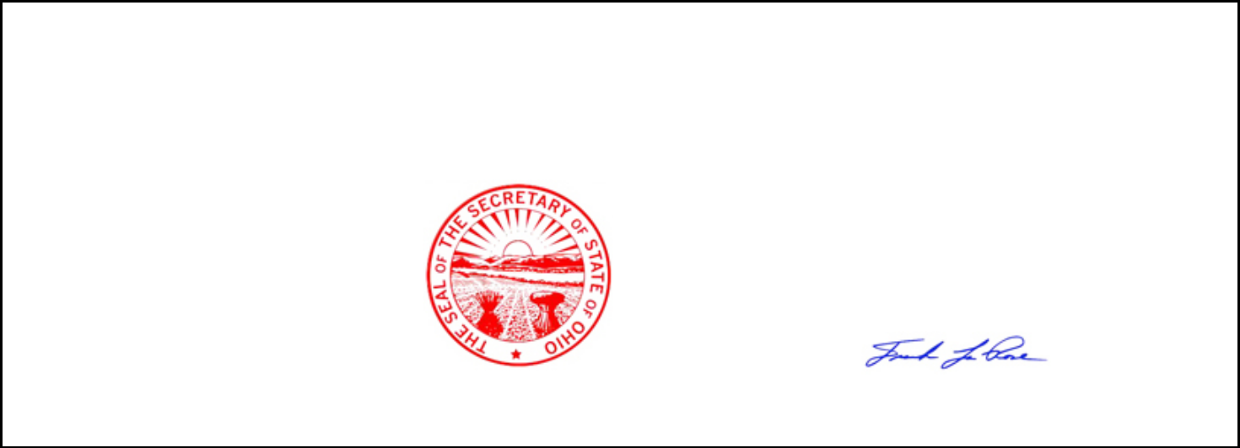

UNITED STATES OF AMERICA,

STATE OF OHIO,

OFFICE OF SECRETARY OF STATE

I, Frank LaRose, Secretary of State of the State of Ohio, do hereby certify that the paper to which this is attached is a true and correct copy from the original record now in my official custody as Secretary of State.

Witness my hand and the seal of the Secretary of State at Columbus, Ohio this 12th day of July, A.D. 2022.

Ohio Secretary of State

Validation Number:

202219303850

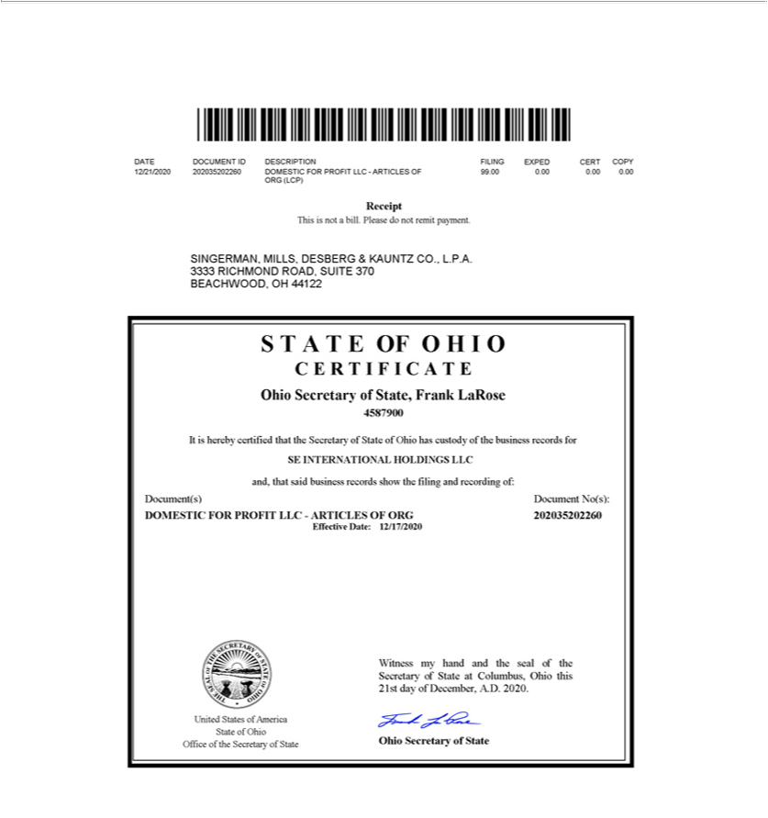

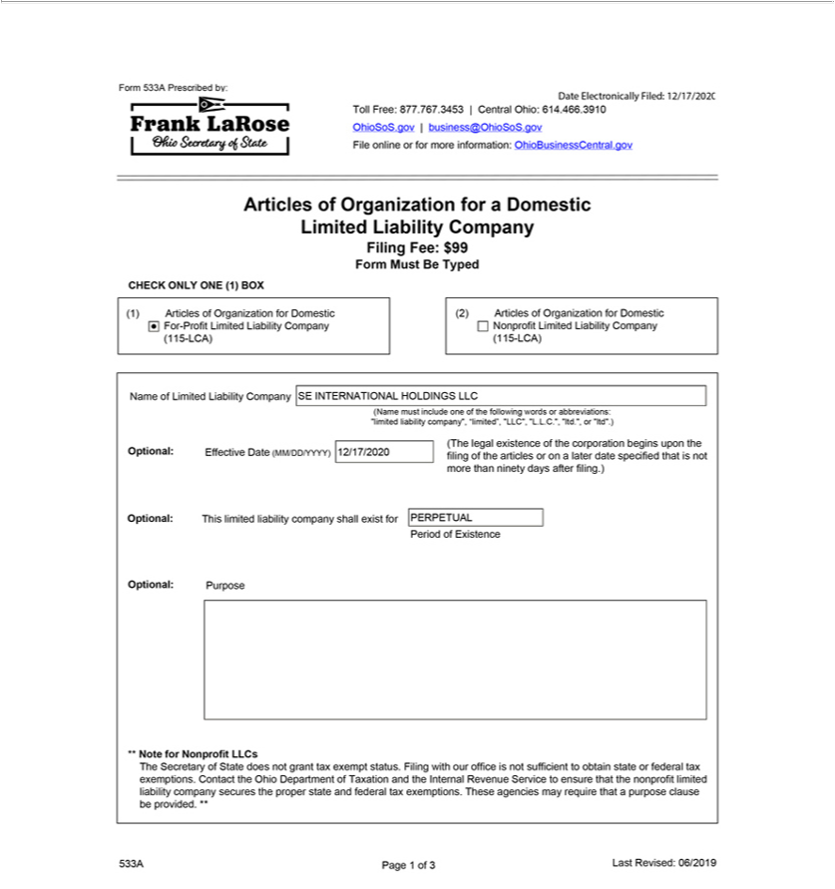

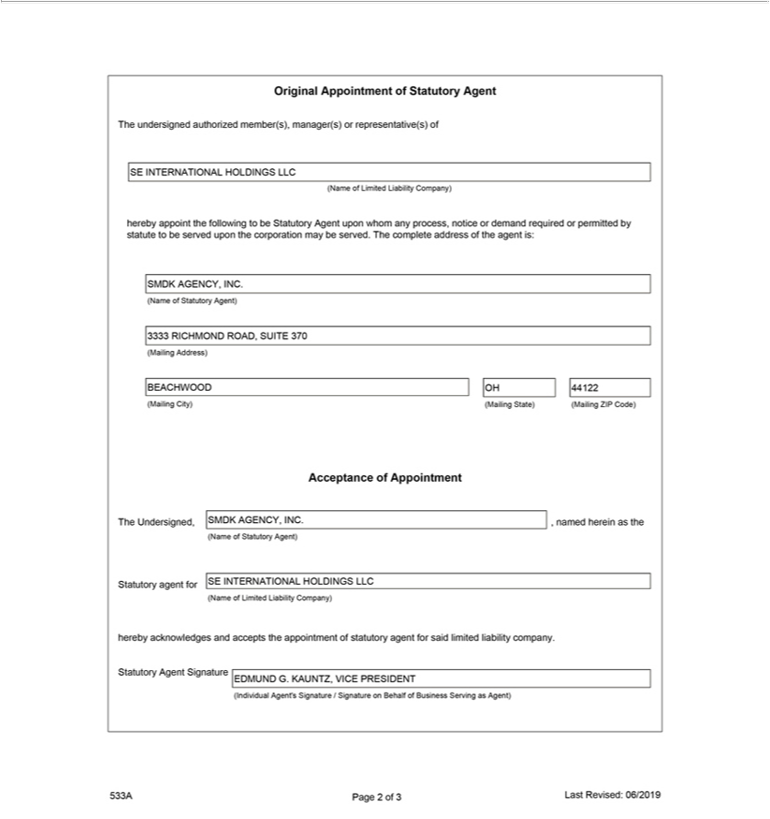

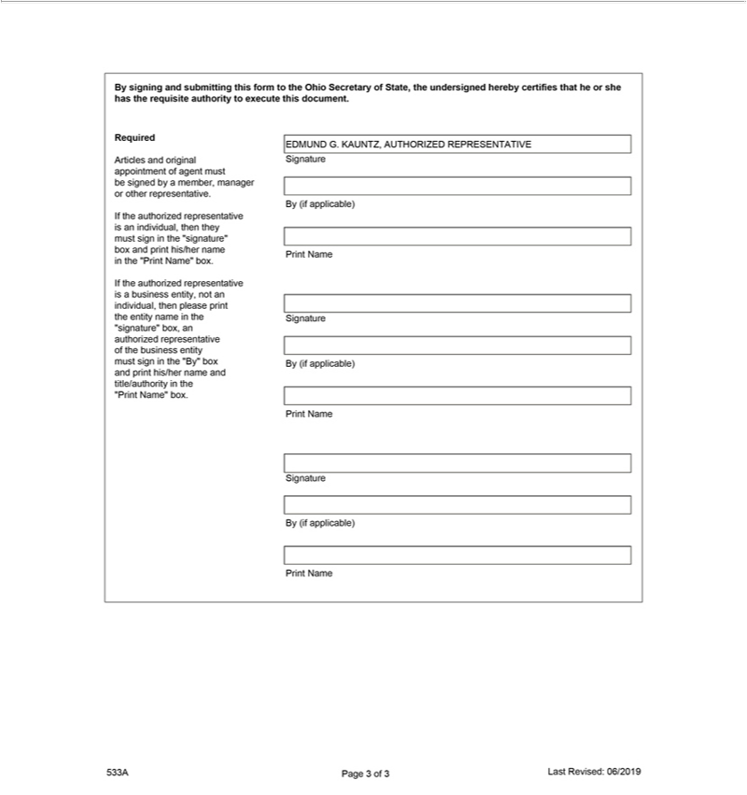


UNITED STATES OF AMERICA,

STATE OF OHIO,

OFFICE OF SECRETARY OF STATE

I, Frank LaRose, Secretary of State of the State of Ohio, do hereby certify that the paper to which this is attached is a true and correct copy from the original record now in my official custody as Secretary of State.

Witness my hand and the seal of the Secretary of State at Columbus, Ohio this 12th day of July, A.D. 2022.

Ohio Secretary of State

Validation Number:

202219303850

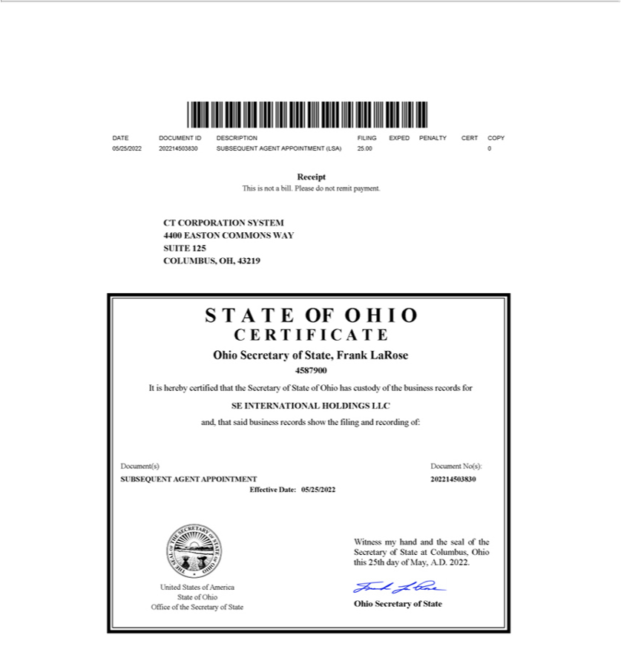

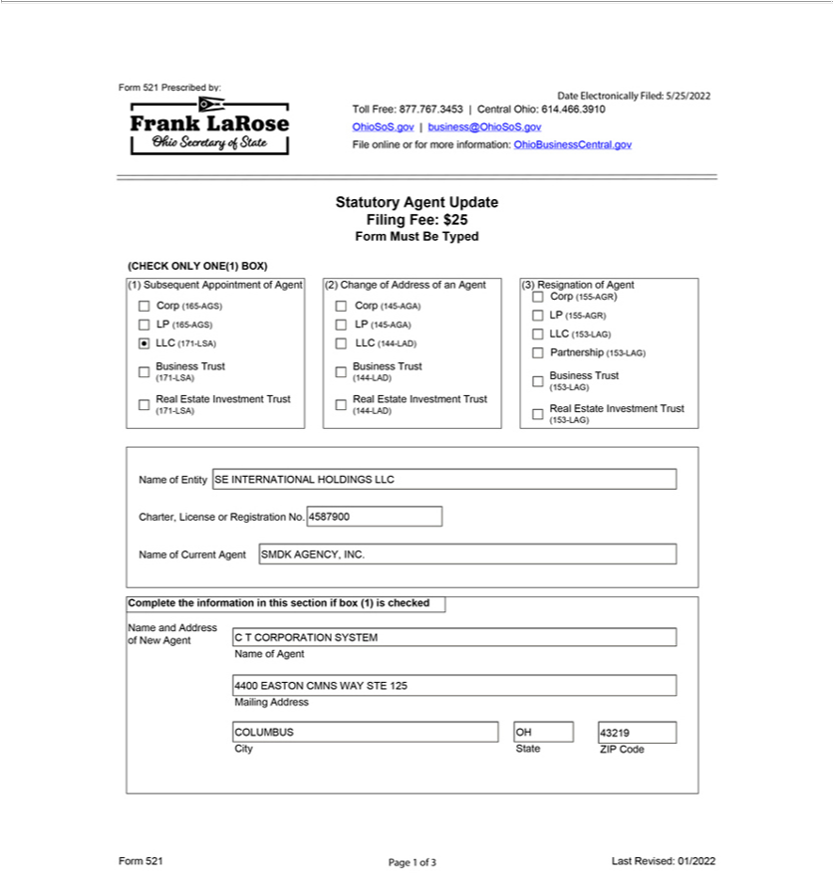

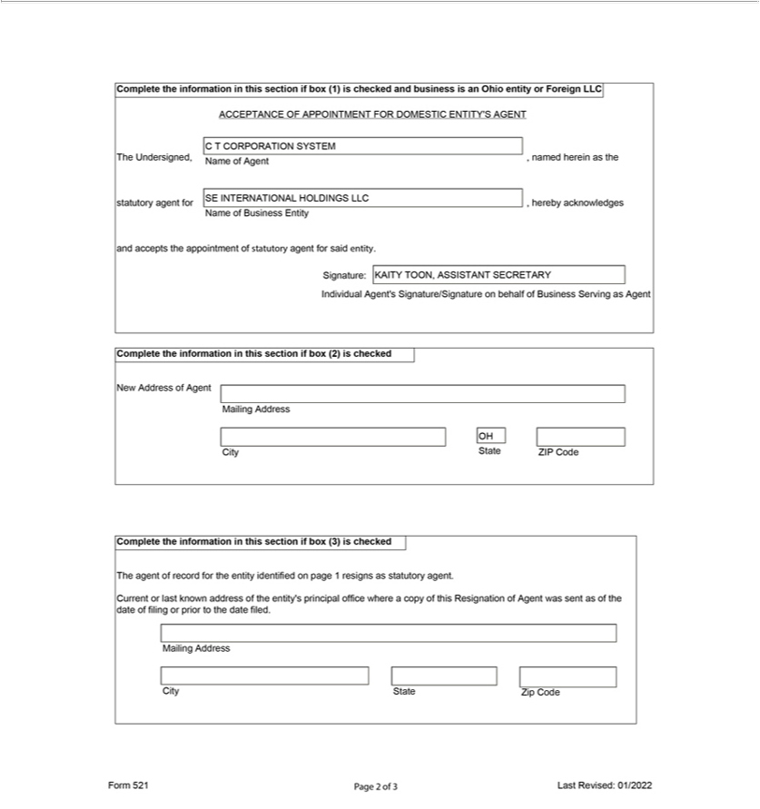

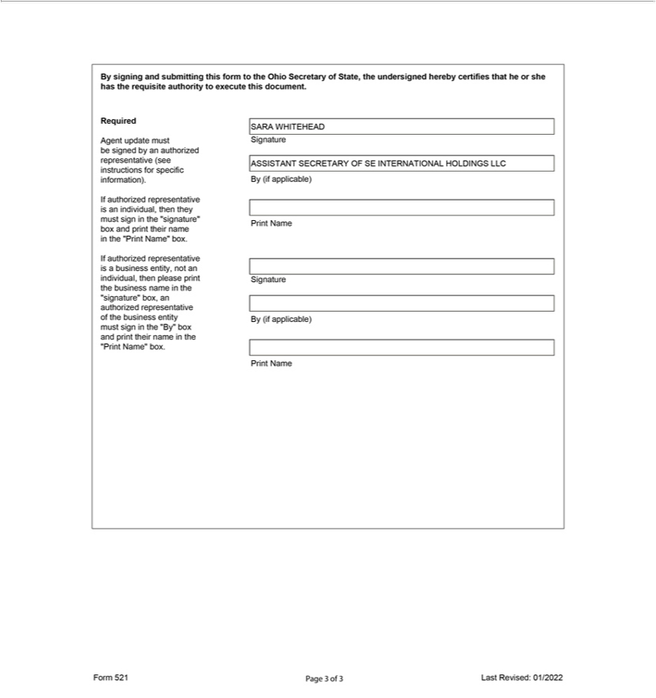

Exhibit 3.tt

DECLARATION OF AFFAIRS AND ORGANIZATIONAL ACTION

FOR

SE INTERNATIONAL HOLDINGS LLC

The undersigned, being the sole member of SE INTERNATIONAL HOLDINGS LLC (the “Company”), hereby makes the following declarations (the “Declaration”) and takes the following actions by its written consent:

- STATEMENT OF PURPOSE.

The Company has been formed for the purpose of engaging in any lawful act or activity for which a limited liability company may be formed under Sections 1705.01 to 1705.58, inclusive, of the Ohio Revised Code (the “Act”), including, without limiting the generality of the foregoing, the following purposes:

  - to engage in the business (the “Business”) of (i) owning, managing and ultimately disposing of ownership interests in corporations, partnerships, limited liability companies or other legal entities engaged in furthering the business of the Member in foreign countries (the “International Subsidiaries”); and (ii) contributing capital to, loaning funds to, and receiving distributions or loan payments from, the International Subsidiaries;

  - to borrow money and issue evidences of indebtedness for purposes of the Business or otherwise and to secure the same by mortgage, pledge or other lien on any property of the Company; and

  - to enter into any kind of activity, and to perform and carry out contracts of any kind, incident or appropriate to the business of the Company.

- CAPITAL CONTRIBUTION.

SIMPLIMATIC ENGINEERING HOLDINGS LLC, an Ohio limited liability company (the “Member”), shall contribute One Hundred Dollars

($100) to the capital of the Company in exchange for one hundred percent of the membership interests in the Company.

- ADDITIONAL CAPITAL CONTRIBUTIONS.

The Member shall have the right (but not the obligation) to make additional capital contributions to the Company from time to time as necessary to meet the working capital needs of the Company.

IV. RETURN OF CAPITAL.

The Company shall have the right from time to time to make distributions to the Member that include a return of all or any pa11 of the capital contribution of the Member.

- MEMBER LOANS.

  - The Member shall have the right (but not the obligation) to make loans to the Company from time to time as necessary to meet the working capital needs of the Company. In the event that the Member advances funds to the Company, such advance shall be deemed to be a loan to the Company unless the Member expressly designates such advance as a capital contribution.

  - Unless otherwise provided in writing in respect of any specific loan, all loans made by the Member shall be payable upon demand and shall bear interest at a per annum rate equal to two percent (2.0%) in excess of the prime rate as announced from time to time by the bank in which the Company maintains its principal operating account.

  - Loans made by the Member to the Company may (but need not be) evidenced by a promissory note or other written agreement.

VI. DISSOLUTION OF THE COMPANY.

- The existence of the Company shall continue perpetually unless the Member determines to dissolve the Company and wind up its affairs. None of the events described in Section 1705.15 (C) through (J) of the Act shall be deemed to be an event of withdrawal in respect of the Company, and the existence of the Company shall continue notwithstanding the occurrence of any such event.

- Upon the dissolution of the Company and the commencement of the winding up of the Company, a Certificate of Dissolution shall be filed pursuant to the Act.

- Upon the dissolution of the Company, the Company shall continue solely for the purpose of winding up its affairs in an orderly manner, liquidating its assets and satisfying the claims of its creditors and the Member. The Member (or any person or persons designated by the Member) shall be responsible for overseeing the winding up and dissolution of the Company and shall take full account of the Company’s assets and liabilities, shall liquidate the Company’s assets as promptly as is consistent with obtaining fair value thereof and shall apply the proceeds of such liquidation, to the extent sufficient therefor, to the following:

  - First, to the payment and discharge of all of the Company’s debts and liabilities to its creditors (including, without limitation, the Member, to the extent the Member is a creditor), including the establishment of any necessary reserves; and

  - The balance, if any, to the Member.

VII. BY-LAWS.

The By-Laws attached hereto as Exhibit A are hereby adopted as the By-Laws of the Company.

2

VIII. DESIGNATION OF OFFICERS.

The Member may appoint a President, Vice President, Treasurer and/or Secretary of the Company to serve in such capacities until such time as their successors shall be designated by the Member. The Member hereby appoints the following officers for the Company:

Thomas DiNardo

Sara M. Orange

President

Chief Financial Officer, Treasurer and Secretary

IX. BANKING.

The Company shall transact banking at such banks as the Member may from time to time designate. The officers of the Company are hereby authorized to execute and deliver to the designated banks their customary forms of banking resolutions and to attach copies of such resolutions to this Declaration. Any such resolutions shall be deemed to have been adopted by the Member in the same manner and with the same effect as if fully set forth herein.

- NO THIRD-PARTY BENEFICIARY.

The provisions of this Declaration are for the benefit of the Member and the Company only and are not for, nor shall they inure to the benefit of creditors of the Company nor anyone asserting a claim against the Company.

XI. GENERAL MATTERS.

- The appointment by the Company of SMDK Agency, Inc. to act as agent for the Company in the State of Ohio upon whom any process, notice, or demand required or permitted by statute to be served upon the Company may be served is hereby ratified, confirmed, and approved.

- The actions of Singerman, Mills, Desberg & Kauntz Co., L.P.A. in connection with the formation of the Company, including, without limitation, the filing of the Articles of Organization of the Company with the Ohio Secretary of State are hereby ratified, confi1med and approved.

- The address of the principal office of the Company shall be 1046 W. London Park Drive, Forest, Virginia 24551.

3

IN WI1NESS WHEREOF, the undersigned, being the sole member of the Company, has executed this Declaration of Affairs and Organizational Action as of the 17th day of December, 2020.

SIMPLIMATIC ENGINEERING HOLDINGS LLC

By: /s/ Thomas DiNardo

Thomas DiNardo, President

[Signature page for SE International Holdings LLC Declaration of Affairs]

EXHIBIT “A”

BY-LAWS OF

SE INTERNATIONAL HOLDINGS LLC

CHAPTER I

MEMBERSHIP INTERESTS

1.01 Transfer and Registration of Membership Interests. The membership interests in the Company shall not be represented by certificates unless the member by written action determines to provide for the issuance of certificates. The membership interests shall be registered and transferred on the books of the Company. If the member by written action provides for the issuance of certificates, the member shall have the right to make such rules and regulations as the member deems expedient concerning the issuance, transfer and registration of such certificates and the membership interest represented thereby and may appoint transfer agents and registrars thereof.

CHAPTER II

OFFICERS

2.01 Officers. The Company may have a President, a Secretary, and a Treasurer. The Company may also have one or more Vice Presidents and such other officers and assistant officers as the member may deem necessary. By designating a person to serve as an officer of the Company, the member shall be deemed to have considered such office necessary and to have established such office in accordance with this Section.

2.02 Resignation. An officer may resign at any time by giving notice to the member, the President or the Secretary. Such notice shall be effective when received by the person or persons to whom directed, unless some other time is specified therein.

2.03 Removal. Any officer may be removed, with or without cause, by the member without prejudice to the contract rights of such officer.

2.04 Vacancy. The member may fill any vacancy in any office occurring by whatever reason.

2.05 Compensation. Compensation of all officers shall be fixed by the member, and no officer shall be prevented from receiving such compensation by virtue of the fact that he or she is also a member of the Company.

2.06 The President. The president shall be the chief executive officer of the Company; shall have general and active management of the business of the Company; and shall see that all orders and resolutions of the member are carried into effect. The president shall execute bonds, mortgages and other contracts of the Company, except where required or permitted by law to be otherwise signed and executed and except where the signing and execution thereof shall be expressly delegated by the member to some other officer or agent of the Company.

i

2.07 Vice Presidents. The vice-president, if any, or if there shall be more than one, the vice-presidents in the order determined by the member, shall, in the absence or disability of the president, perform the duties and exercise the powers of the president and shall perform such other duties and have such other powers as the member may, from time to time, determine or these By-Laws may prescribe.

2.08 The Secretary and Assistant Secretaries. The secretary shall keep a record of all the proceedings of the member of the Company; shall have custody of the seal of the Company, if any, and the secretary, or an assistant secretary, shall have authority to affix the same to any instrument requiring it and when so affixed, it may be attested by his or her signature or by the signature of such assistant secretary. The member may give general authority to any other officer to affix the seal of the Company and to attest the affixing by his or her signature. The assistant secretary, or if there be more than one, the assistant secretaries in the order determined by the member, shall, in the absence or disability of the secretary, perform the duties and exercise the powers of the secretary and shall perform such other duties and have such other powers as the member may from time to time prescribe.

2.09 The Treasurer and the Assistant Treasurer. The treasurer shall have the custody of the Company’s funds and securities; shall keep full and accurate accounts or receipts and disbursements in books belonging to the Company; shall deposit all monies and other valuable effects in the name and to the credit of the Company as may be ordered by the member, taking proper vouchers for such disbursements; and shall render to the president and the member an account of the Company upon request. If required by the member, the treasurer shall give the Company a bond (which shall be renewed every six years) in such sums and with such surety or sureties as shall be satisfactory to the member for the faithful performance of the duties of the office of treasurer and for the restoration to the Company, in case of death, resignation, retirement, or removal from office, of all books, papers, vouchers, money, and other property of whatever kind in the possession or under the control of the treasurer belonging to the Company. The assistant treasurer, or if there shall be more than one, the assistant treasurers in the order determined by the member, shall, in the absence or disability of the treasurer, perform the duties and exercise the powers of the treasurer and shall perform such other duties and have such other powers as the member may from time to time prescribe.

2.10 Other Officers, Assistant Officers and Agents. Officers, assistant officers and agents, if any, other than those whose duties are provided for in these By-Laws, shall have such authority and perform such duties as may from time to time be prescribed by resolution of the member.

ii

CHAPTER III

INDEMNIFICATION

3.01 Indemnification. The Company shall indemnify and defend (subject to the provisions of Section 3.02), to the full extent then permitted by law, any person who was or is a patty or is threatened to be made a party to any threatened, pending or completed action, suit or proceeding, whether civil, criminal, administrative or investigative, by reason of the fact that he is or was an officer, employee or agent of the Company, or is or was serving at the request of the Company as a director, trustee, officer, employee or agent of a corporation, domestic or foreign, non-profit or for profit, partnership, joint venture, trust, or other enterprise, provided, however, that the Company shall indemnify any such agent (as opposed to any officer or employee) of the Company to an extent greater than that required by law only if and to the extent that the member may, in its discretion, so determine.

3.02 Advance Payment of Expenses. Expenses, including attorney’s fees, incurred in defending any action, suit or proceeding referred to in Section 3.01 of this Chapter may be paid by the Company in advance of the final disposition of such action, suit or proceeding as authorized by the member in the specific case upon receipt of an undertaking by or on behalf of the officer, employee or agent to repay such amount, unless it shall ultimately be dete1mined that he is entitled to be indemnified by the Company as authorized in this Chapter.

3.03 Non-Exclusive. The indemnification provided in this Chapter shall not be deemed exclusive of any other rights to which those seeking indemnification may be entitled under any law, the Articles of Organization, these By-Laws, or any agreement, or act of the member or otherwise, both as to action in official capacities and as to action in another capacity while he is an officer, employee or agent, and shall continue as to a person who has ceased to be an officer, employee or agent and shall inure to the benefit of heirs, executors and administrators of each such person.

3.04 Insurance. The Company may, to the full extent then permitted by law, purchase and maintain insurance on behalf of any person who is or was an officer, employee or agent of the Company or is or was serving at the request of the Company as a Director, trustee, officer, employee or agent of a corporation, domestic or foreign, non-profit or for profit, partnership, joint venture, trust, or other enterprise against any liability asserted against him and incurred by him in any such capacity, or arising out of his status as such, whether or not the Company would have the power to indemnify him against such liability.

CHAPTER IV

MISCELLANEOUS

4.01 Fiscal Year. The fiscal year of the Company shall be the calendar year or as otherwise may be determined from time to time by the member.

4.02 Voting Upon Shares Held by the Company. Unless otherwise ordered by the member, the President in person or by proxy or proxies appointed by him or her shall have full power and authority on behalf of the Company to vote, act and consent with respect to any shares or interests issued by other entities which the Company may own, which may be held in the Company’s name or as to which the Company may otherwise have the right to vote, act or consent.

iii

4.03 Checks, Drafts, etc. All checks, drafts, or other orders for the payment of money, notes, or other evidence of indebtedness issued in the name of the Company shall be signed by such officer or officers, agent or agents of the Company and in such manner as the member may determine.

CHAPTER V

ADDITIONAL MEMBERS

5.01 Additional Members. In the event that at any time the Company has more than one member, the actions required or permitted to be taken by the member hereunder shall be taken with the approval of members holding a majority of the percentage interests in the Company.

CHAPTER VI

AMENDMENTS

6.01 Amendment of By-Laws. These By-Laws may be amended or repealed and new amendments may be adopted by written action of the Member.

iv

Exhibit 3.uu


UNITED STATES OF AMERICA,

STATE OF OHIO,

OFFICE OF SECRETARY OF STATE

I, Frank LaRose, Secretary of State of the State of Ohio, do hereby certify that the paper to which this is attached is a true and correct copy from the original record now in my official custody as Secretary of State.

Witness my hand and the seal of the Secretary of State at Columbus, Ohio this 12th day of July, A.D. 2022.

Ohio Secretary of State

Validation Number:

202219303874

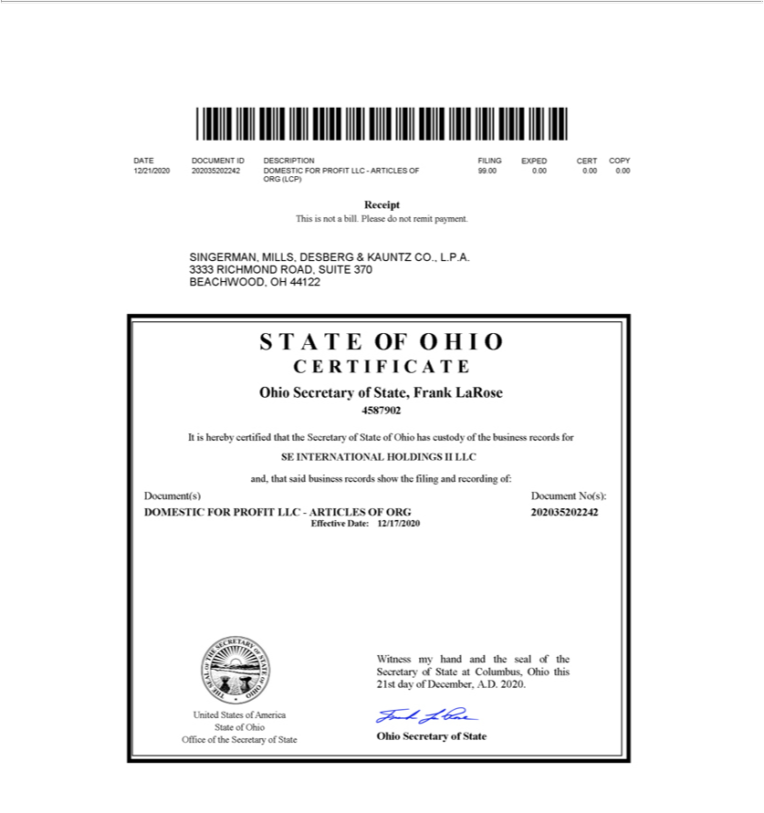

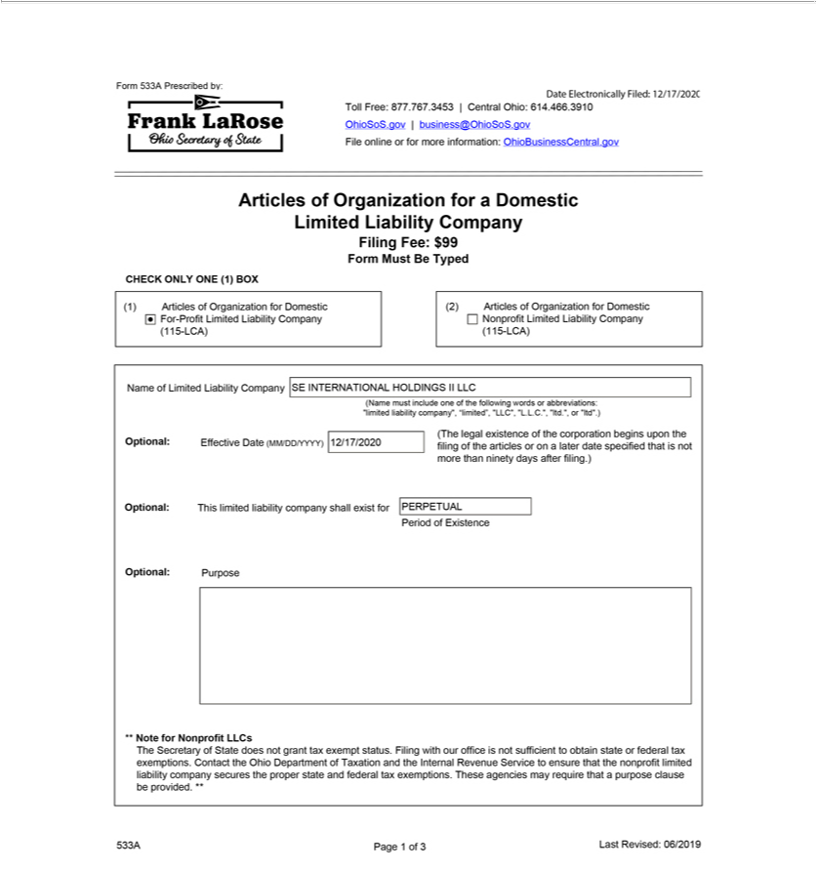

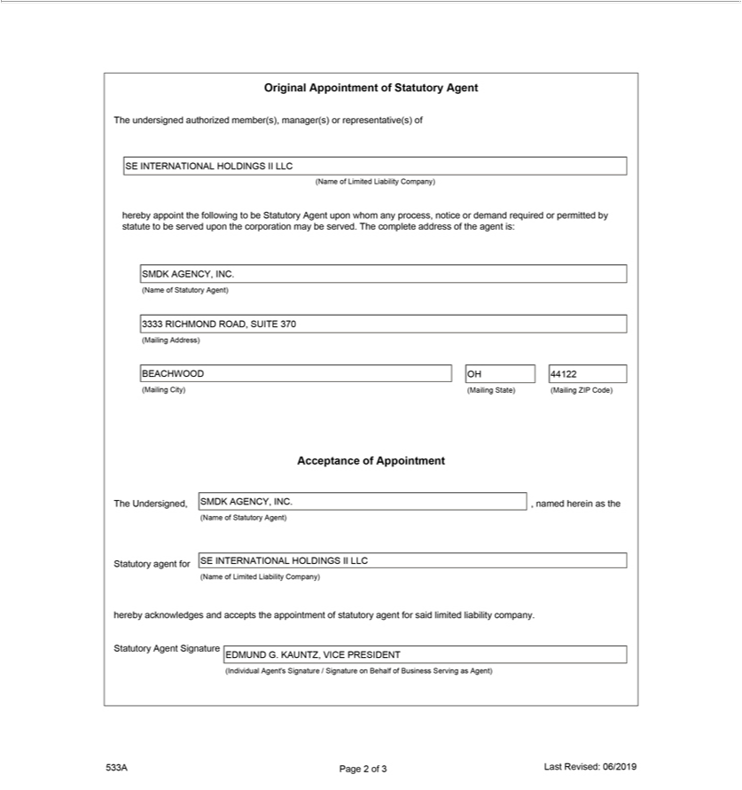

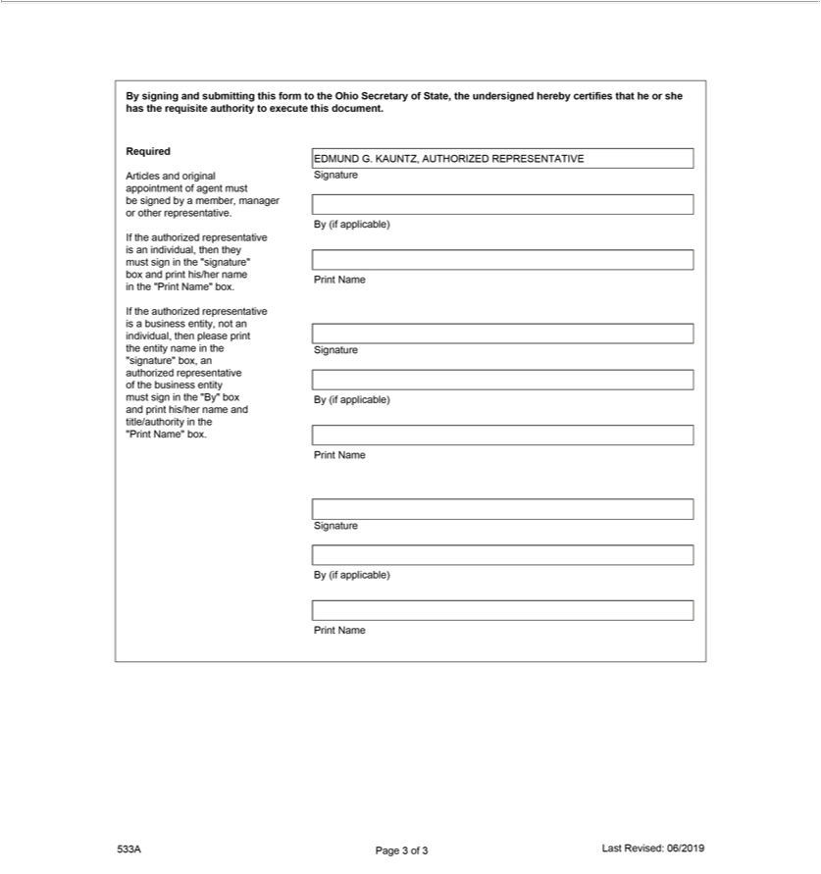


UNITED STATES OF AMERICA,

STATE OF OHIO,

OFFICE OF SECRETARY OF STATE

I, Frank LaRose, Secretary of State of the State of Ohio, do hereby certify that the paper to which this is attached is a true and correct copy from the original record now in my official custody as Secretary of State .

Witness my hand and the seal of the Secretary of State at

Columbus, Ohio this 12th day of July, A.D. 2022.

Ohio Secretary of State

Validation Number:

202219303874

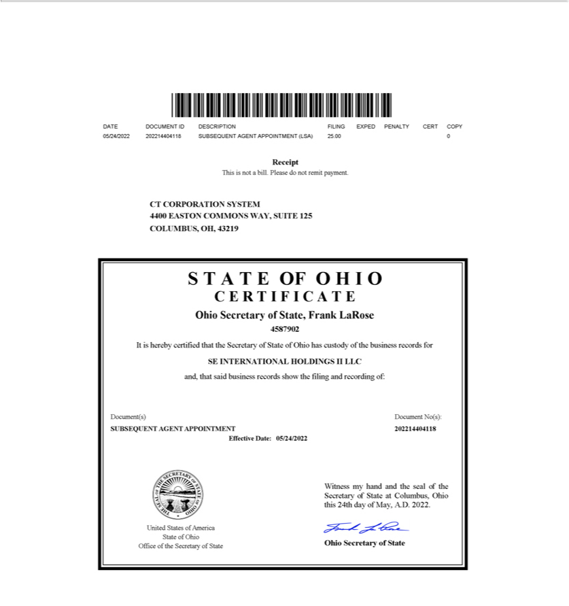

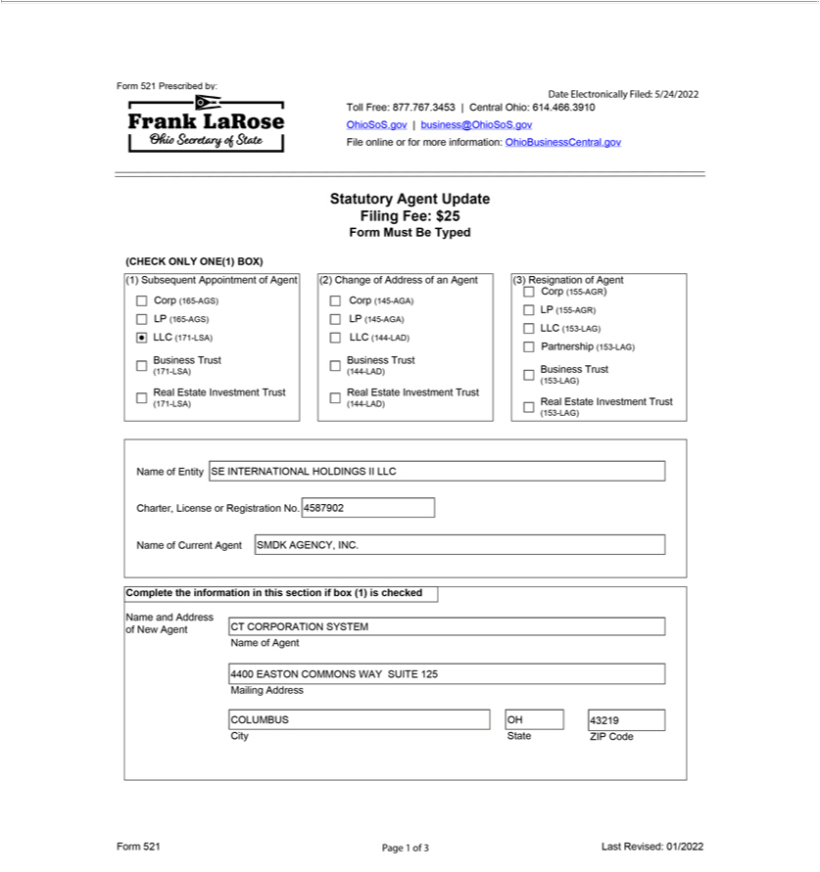

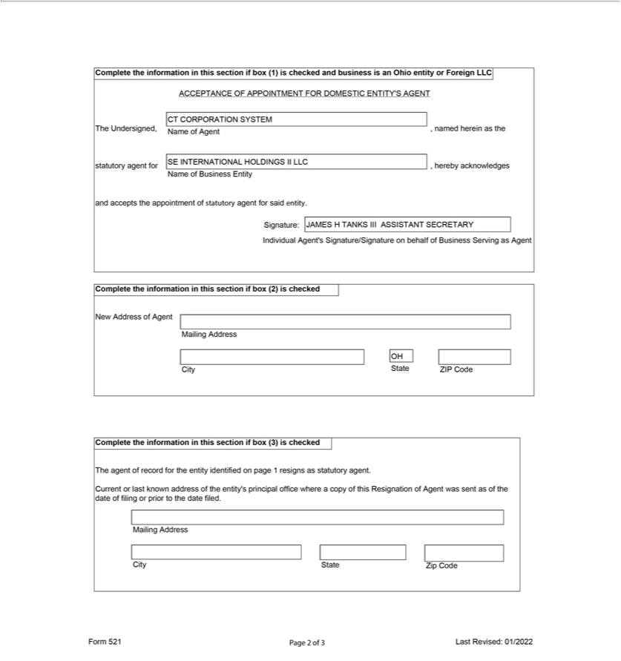

Exhibit 3.vv

DECLARATION OF AFFAIRS AND ORGANIZATIONAL ACTION

FOR

SE INTERNATIONAL HOLDINGS II LLC

The undersigned, being the sole member of SE INTERNATIONAL HOLDINGS II LLC (the “Company”), hereby makes the following declarations (the “Declaration”) and takes the following actions by its written consent:

- STATEMENT OF PURPOSE.

The Company has been formed for the purpose of engaging in any lawful act or activity for which a limited liability company may be formed under Sections 1705.01 to 1705.58, inclusive, of the Ohio Revised Code (the “Act”), including, without limiting the generality of the foregoing, the following purposes:

  - to engage in the business (the “Business”) of (i) owning, managing and ultimately disposing of ownership interests in corporations, partnerships, limited liability companies or other legal entities engaged in furthering the business of the Member in foreign countries (the “International Subsidiaries”); and (ii) contributing capital to, loaning funds to, and receiving distributions or loan payments from, the International Subsidiaries;

  - to borrow money and issue evidences of indebtedness for purposes of the Business or otherwise and to secure the same by mortgage, pledge or other lien on any property of the Company; and

  - to enter into any kind of activity, and to perform and carry out contracts of any kind, incident or appropriate to the business of the Company.

- CAPITAL CONTRIBUTION.

SIMPLIMATIC ENGINEERING HOLDINGS LLC, an Ohio limited liability company (the “Member”), shall contribute One Hundred Dollars

($100) to the capital of the Company in exchange for one hundred percent of the membership interests in the Company.

- ADDITIONAL CAPITAL CONTRIBUTIONS.

The Member shall have the right (but not the obligation) to make additional capital contributions to the Company from time to time as necessary to meet the working capital needs of the Company.

IV. RETURN OF CAPITAL.

The Company shall have the right from time to time to make distributions to the Member that include a return of all or any part of the capital contribution of the Member.

1

- MEMBER LOANS.

  - The Member shall have the right (but not the obligation) to make loans to the Company from time to time as necessary to meet the working capital needs of the Company. In the event that the Member advances funds to the Company, such advance shall be deemed to be a loan to the Company unless the Member expressly designates such advance as a capital contribution.

  - Unless otherwise provided in writing in respect of any specific loan, all loans made by the Member shall be payable upon demand and shall bear interest at a per annum rate equal to two percent (2.0%) in excess of the prime rate as announced from time to time by the bank in which the Company maintains its principal operating account.

  - Loans made by the Member to the Company may (but need not be) evidenced by a promissory note or other written agreement.

VI. DISSOLUTION OF THE COMPANY.

- The existence of the Company shall continue perpetually unless the Member determines to dissolve the Company and wind up its affairs. None of the events described in Section 1705.15 (C) through (J) of the Act shall be deemed to be an event of withdrawal in respect of the Company, and the existence of the Company shall continue notwithstanding the occurrence of any such event.

- Upon the dissolution of the Company and the commencement of the winding up of the Company, a Certificate of Dissolution shall be filed pursuant to the Act.

- Upon the dissolution of the Company, the Company shall continue solely for the purpose of winding up its affairs in an orderly manner, liquidating its assets and satisfying the claims of its creditors and the Member. The Member (or any person or persons designated by the Member) shall be responsible for overseeing the winding up and dissolution of the Company and shall take full account of the Company’s assets and liabilities, shall liquidate the Company’s assets as promptly as is consistent with obtaining fair value thereof and shall apply the proceeds of such liquidation, to the extent sufficient therefor, to the following:

  - First, to the payment and discharge of all of the Company’s debts and liabilities to its creditors (including, without limitation, the Member, to the extent the Member is a creditor), including the establishment of any necessary reserves; and

  - The balance, if any, to the Member.

VII. BY-LAWS.

The By-Laws attached hereto as Exhibit A are hereby adopted as the By-Laws of the Company.

2

VIII. DESIGNATION OF OFFICERS.

The Member may appoint a President, Vice President, Treasurer and/or Secretary of the Company to serve in such capacities until such time as their successors shall be designated by the Member. The Member hereby appoints the following officers for the Company:

Thomas DiNardo

Sara M. Orange

President

Chief Financial Officer, Treasurer and Secretary

IX. BANKING.

The Company shall transact banking at such banks as the Member may from time to time designate. The officers of the Company are hereby authorized to execute and deliver to the designated banks their customary forms of banking resolutions and to attach copies of such resolutions to this Declaration. Any such resolutions shall be deemed to have been adopted by the Member in the same manner and with the same effect as if fully set forth herein.

- NO THIRD-PARTY BENEFICIARY.

The provisions of this Declaration are for the benefit of the Member and the Company only and are not for, nor shall they inure to the benefit of creditors of the Company nor anyone asserting a claim against the Company.

XI GENERAL MATTERS.

- The appointment by the Company of SMDK Agency, Inc. to act as agent for the Company in the State of Ohio upon whom any process, notice, or demand required or permitted by statute to be served upon the Company may be served is hereby ratified, confirmed, and approved.

- The actions of Singerman, Mills, Desberg & Kauntz Co., L.P.A. in connection with the formation of the Company, including, without limitation, the filing of the Articles of Organization of the Company with the Ohio Secretary of State are hereby ratified, confirmed and approved.

- The address of the principal office of the Company shall be 1046 W. London Park Drive, Forest, Virginia 24551.

3

IN WITNESS WHEREOF, the undersigned, being the sole member of the Company, has executed this Declaration of Affairs and Organizational Action as of the 17th day of December, 2020.

SIMPLIMATIC ENGINEERING HOLDINGS LLC

By: /s/ Thomas DiNardo, President

Thomas DiNardo, President

[Signature page for SE International Holdings II LLC Declaration of Affairs]

EXHIBIT “A”

BY-LAWS OF

SE INTERNATIONAL HOLDINGS II LLC

CHAPTER I

MEMBERSHIP INTERESTS

1.01 Transfer and Registration of Membership Interests. The membership interests in the Company shall not be represented by certificates unless the member by written action determines to provide for the issuance of certificates. The membership interests shall be registered and transferred on the books of the Company. If the member by written action provides for the issuance of certificates, the member shall have the right to make such rules and regulations as the member deems expedient concerning the issuance, transfer and registration of such certificates and the membership interest represented thereby and may appoint transfer agents and registrars thereof.

CHAPTER II

OFFICERS

2.01 Officers. The Company may have a President, a Secretary, and a Treasurer. The Company may also have one or more Vice Presidents and such other officers and assistant officers as the member may deem necessary. By designating a person to serve as an officer of the Company, the member shall be deemed to have considered such office necessary and to have established such office in accordance with this Section.

2.02 Resignation. An officer may resign at any time by giving notice to the member, the President or the Secretary. Such notice shall be effective when received by the person or persons to whom directed, unless some other time is specified therein.

2.03 Removal. Any officer may be removed, with or without cause, by the member without prejudice to the contract rights of such officer.

2.04 Vacancy. The member may fill any vacancy in any office occurring by whatever reason.

2.05 Compensation. Compensation of all officers shall be fixed by the member, and no officer shall be prevented from receiving such compensation by virtue of the fact that he or she is also a member of the Company.

2.06 The President. The president shall be the chief executive officer of the Company; shall have general and active management of the business of the Company; and shall see that all orders and resolutions of the member are carried into effect. The president shall execute bonds, mortgages and other contracts of the Company, except where required or permitted by law to be otherwise signed and executed and except where the signing and execution thereof shall be expressly delegated by the member to some other officer or agent of the Company.

i

2.07 Vice Presidents. The vice-president, if any, or if there shall be more than one, the vice-presidents in the order determined by the member, shall, in the absence or disability of the president, perform the duties and exercise the powers of the president and shall perform such other duties and have such other powers as the member may, from time to time, determine or these By-Laws may prescribe.

2.08 The Secretary and Assistant Secretaries. The secretary shall keep a record of all the proceedings of the member of the Company; shall have custody of the seal of the Company, if any, and the secretary, or an assistant secretary, shall have authority to affix the same to any instrument requiring it and when so affixed, it may be attested by his or her signature or by the signature of such assistant secretary. The member may give general authority to any other officer to affix the seal of the Company and to attest the affixing by his or her signature. The assistant secretary, or if there be more than one, the assistant secretaries in the order determined by the member, shall, in the absence or disability of the secretary, perform the duties and exercise the powers of the secretary and shall perform such other duties and have such other powers as the member may from time to time prescribe.

2.09 The Treasurer and the Assistant Treasurer. The treasurer shall have the custody of the Company’s funds and securities; shall keep full and accurate accounts or receipts and disbursements in books belonging to the Company; shall deposit all monies and other valuable effects in the name and to the credit of the Company as may be ordered by the member, taking proper vouchers for such disbursements; and shall render to the president and the member an account of the Company upon request. If required by the member, the treasurer shall give the Company a bond (which shall be renewed every six years) in such sums and with such surety or sureties as shall be satisfactory to the member for the faithful performance of the duties of the office of treasurer and for the restoration to the Company, in case of death, resignation, retirement, or removal from office, of all books, papers, vouchers, money, and other property of whatever kind in the possession or under the control of the treasurer belonging to the Company. The assistant treasurer, or if there shall be more than one, the assistant treasurers in the order determined by the member, shall, in the absence or disability of the treasurer, perform the duties and exercise the powers of the treasurer and shall perform such other duties and have such other powers as the member may from time to time prescribe.

2.10 Other Officers, Assistant Officers and Agents. Officers, assistant officers and agents, if any, other than those whose duties are provided for in these By-Laws, shall have such authority and perform such duties as may from time to time be prescribed by resolution of the member.

ii

CHAPTER III

INDEMNIFICATION

3.01 Indemnification. The Company shall indemnify and defend (subject to the provisions of Section 3.02), to the full extent then permitted by law, any person who was or is a party or is threatened to be made a party to any threatened, pending or completed action, suit or proceeding, whether civil, criminal, administrative or investigative, by reason of the fact that he is or was an officer, employee or agent of the Company, or is or was serving at the request of the Company as a director, trustee, officer, employee or agent of a corporation, domestic or foreign, non-profit or for profit, partnership, joint venture, trust, or other enterprise, provided, however, that the Company shall indemnify any such agent (as opposed to any officer or employee) of the Company to an extent greater than that required by law only if and to the extent that the member may, in its discretion, so determine.

3.02 Advance Payment of Expenses. Expenses, including attorney’s fees, incurred in defending any action, suit or proceeding referred to in Section 3.01 of this Chapter may be paid by the Company in advance of the final disposition of such action, suit or proceeding as authorized by the member in the specific case upon receipt of an undertaking by or on behalf of the officer, employee or agent to repay such amount, unless it shall ultimately be determined that he is entitled to be indemnified by the Company as authorized in this Chapter.

3.03 Non-Exclusive. The indemnification provided in this Chapter shall not be deemed exclusive of any other rights to which those seeking indemnification may be entitled under any law, the Articles of Organization, these By-Laws, or any agreement, or act of the member or otherwise, both as to action in official capacities and as to action in another capacity while he is an officer, employee or agent, and shall continue as to a person who has ceased to be an officer, employee or agent and shall inure to the benefit of heirs, executors and administrators of each such person.

3.04 Insurance. The Company may, to the full extent then permitted by law, purchase and maintain insurance on behalf of any person who is or was an officer, employee or agent of the Company or is or was serving at the request of the Company as a Director, trustee, officer, employee or agent of a corporation, domestic or foreign, non-profit or for profit, partnership, joint venture, trust, or other enterprise against any liability asserted against him and incurred by him in any such capacity, or arising out of his status as such, whether or not the Company would have the power to indemnify him against such liability.

CHAPTER IV

MISCELLANEOUS

4.01 Fiscal Year. The fiscal year of the Company shall be the calendar year or as otherwise may be determined from time to time by the member.

4.02 Voting Upon Shares Held by the Company. Unless otherwise ordered by the member, the President in person or by proxy or proxies appointed by him or her shall have full power and authority on behalf of the Company to vote, act and consent with respect to any shares or interests issued by other entities which the Company may own, which may be held in the Company’s name or as to which the Company may otherwise have the right to vote, act or consent.

iii

4.03 Checks, Drafts, etc. All checks, drafts, or other orders for the payment of money, notes, or other evidence of indebtedness issued in the name of the Company shall be signed by such officer or officers, agent or agents of the Company and in such manner as the member may determine.

CHAPTER V

ADDITIONAL MEMBERS

5.01 Additional Members. In the event that at any time the Company has more than one member, the actions required or permitted to be taken by the member hereunder shall be taken with the approval of members holding a majority of the percentage interests in the Company.

CHAPTER VI

AMENDMENTS

6.01 Amendment of By-Laws. These By-Laws may be amended or repealed and new amendments may be adopted by written action of the Member.

iv

Exhibit 5

Cira Centre


2929 Arch Street

Philadelphia, PA 19104-2808

+1 215 994 4000 Main

+1 215 994 2222 Fax

www.dechert.com

November 14, 2022

Crown Holdings, Inc.

770 Township Line Road

Yardley, PA 19067

Crown Americas LLC

c/o Crown Holdings, Inc.

770 Township Line Road

Yardley, PA 19067

Guarantors listed on Schedule A

c/o Crown Holdings, Inc.

770 Township Line Road

Yardley, PA 19067

Re: Form S-4 Registration Statement (Reg. No. 333-)

Ladies and Gentlemen:

We have acted as special counsel to Crown Holdings, Inc., a Pennsylvania corporation (the “Company”), Crown Americas LLC, a Pennsylvania

limited liability company (the “Issuer”), and the guarantors listed on Schedule A hereto (together with the Company, the “Guarantors”) in connection

with the preparation and filing of the Registration Statement on Form S-4 (Registration No. 333- ) filed by the Issuers and the Guarantors on the date

hereof with the Securities and Exchange Commission (the “Commission”) under the Securities Act of 1933, as amended (the “Securities Act”), and the

Trust Indenture Act of 1939, as amended (the “Trust Indenture Act”), as amended (the “Registration Statement”). Upon the effectiveness of the

Registration Statement, the Issuer and the Guarantors propose to offer to exchange (the “Exchange Offer”) an aggregate principal amount of up to

$500,000,000 of the Issuer’s 5.250% Senior Notes due 2030 (the “New Notes”), and the guarantees thereof by the Guarantors (the “New Guarantees”),

registered under the Securities Act for an equal aggregate principal amount of the Issuer’s outstanding 5.250% Senior Notes due 2030 (the “Old Notes”),

and the guarantees thereof by the Guarantors (the “Old Guarantees”). The New Notes and the New Guarantees are to be issued pursuant to the terms of

the Indenture, dated as of March 17, 2022, by and among the Issuer, the Guarantors and U.S. Bank Trust Company, National Association (as successor

to U.S. Bank National Association), as trustee (the “Trustee”), incorporated by reference as Exhibit 4.k to the Registration Statement (the “Indenture”).

This opinion is being furnished to the Issuer and the Guarantors in accordance with the requirements of Item 601(b)(5) of Regulation S-K of the Securities Act, and no opinion is expressed herein as to any matter other than as to the legality of the New Notes and the New Guarantees.

We have participated in the preparation of the Registration Statement and have made such legal and factual examination and inquiry as we have deemed advisable for the rendering of this opinion. In making our examination we have assumed the genuineness of all signatures, the authenticity of all documents submitted to us as originals and the conformity to all authentic original documents of all documents submitted to us as copies.

In rendering the opinions expressed below, we have assumed that (a) the Indenture has been duly authorized, executed and delivered by the Trustee and constitutes a legal, valid and binding agreement of the Trustee, (b) the Registration Statement will have been declared effective by the Commission, (c) the Indenture will have been qualified under the Trust Indenture Act, and (d) the Old Notes have been, and the New Notes will have

been, duly authenticated and delivered by the Trustee in accordance with the terms of the Indenture. In addition, we have assumed that there will be no changes in applicable law between the date of this opinion and the date of issuance and delivery of the New Notes and the New Guarantees.

Based upon the foregoing and subject to the assumptions, limitations and qualifications stated herein, we are of the opinion that:

- When the New Notes have been duly executed, authenticated, issued and delivered by or on behalf of the Issuer in exchange for the Old Notes in the manner contemplated by the prospectus included in the Registration Statement, then the New Notes will constitute valid and binding obligations of the Issuer, enforceable against the Issuer in accordance with their terms.

- When the New Notes have been duly executed, authenticated, issued and delivered by or on behalf of the Issuer in exchange for the Old Notes in the manner contemplated by the prospectus included in the Registration Statement, and when the New Guarantees have been duly executed in accordance with the terms of the Indenture, then the New Guarantees will constitute valid and binding obligations of each Guarantor enforceable against each Guarantor in accordance with their terms.

The opinions rendered above are limited by principles of equity (regardless of whether considered in a proceeding in equity or at law) that may limit the availability of certain rights and remedies and do not reflect the effect of bankruptcy (including preferences), insolvency, fraudulent conveyance, moratorium, receivership, reorganization and other similar laws or decisions relating to or affecting creditors’ rights generally or debtors’ obligations generally.

We express no opinion as to the validity, binding effect or enforceability of any provision in any agreement or instrument that (a) requires or relates to payment of any interest at a rate or in an amount that a court would determine in the circumstances under applicable law to be commercially unreasonable or a penalty or forfeiture, (b) relates to governing law and submission by the parties to the jurisdiction of one or more particular courts or (c) relates to waivers of rights or defenses or any indemnification or contribution provisions.

The opinions expressed herein are limited to the General Corporation Law of the State of Delaware and the laws of the United States, the Commonwealth of Pennsylvania and the State of New York that are applicable to securities of the type contemplated by the Indenture, and we express no opinion with respect to the applicability or effect of the laws of any other jurisdiction (including without limitation the effect of such laws on the enforceability of the New Notes or the New Guarantees). We are not members of the bar of the State of Delaware, nor do we purport to be experts in the laws of the State of Delaware.

The opinions expressed herein are rendered to the Company and the Guarantors in connection with the filing of the Registration Statement and for no other purpose.

We hereby consent to the filing of this opinion letter as Exhibit 5 to the Registration Statement and to the use of our name in the prospectus contained therein under the caption “Legal Matters.” In giving such consent we do not thereby admit that we come within the category of persons whose consent is required under Section 7 of the Securities Act or the rules and regulations of the Commission promulgated thereunder.

Very truly yours,

/s/ Dechert LLP

2

Schedule A

Guarantors:

CROWN Beverage Packaging Puerto Rico, Inc.

Crown Consultants, Inc.

Crown Cork & Seal Company (DE), LLC

Crown Cork & Seal Company, Inc.

Crown Financial Corporation

Crown International Holdings, Inc.

CROWN Packaging Technology, Inc.

Foreign Manufacturers Finance Corporation

CROWN Cork & Seal USA, Inc.

CR USA, Inc.

Crown Beverage Packaging, LLC

Crown Beverage Holdings, Inc.

Signode Industrial Group LLC

Signode Pickling Holding LLC

Signode US IP Holdings LLC

Signode Industrial Group US Inc.

Signode Industrial Group Holdings US Inc.

Signode International IP Holdings LLC

Simplimatic Engineering Holdings, LLC

Simplimatic Automation LLC

SEH Real Estate Holdings LLC

SE International Holdings LLC

SE International Holdings II LLC

3

Exhibit 23.a

CONSENT OF INDEPENDENT REGISTERED PUBLIC ACCOUNTING FIRM

We hereby consent to the incorporation by reference in this Registration Statement on Form S-4 of Crown Holdings, Inc. of our report dated February 28, 2022, relating to the financial statements, financial statement schedule, and the effectiveness of internal control over financial reporting, which appears in Crown Holdings, Inc.’s Annual Report on Form 10-K for the year ended December 31, 2021. We also consent to the reference to us under the heading “Experts” in such Registration Statement.

/s/ PricewaterhouseCoopers LLP

Philadelphia, Pennsylvania

November 14, 2022

Exhibit 25

SECURITIES AND EXCHANGE COMMISSION

Washington, D.C. 20549

FORM T-1

STATEMENT OF ELIGIBILITY UNDER THE TRUST INDENTURE ACT OF 1939 OF A CORPORATION DESIGNATED TO ACT AS TRUSTEE

- Check if an Application to Determine Eligibility of a Trustee Pursuant to Section 305(b)(2)

U.S. BANK TRUST COMPANY, NATIONAL ASSOCIATION

(Exact name of Trustee as specified in its charter)

91-1821036
 | I.R.S. Employer Identification No.
800 Nicollet Mall
Minneapolis, Minnesota |  |  | 55402
(Address of principal executive offices) |  |  | (Zip Code)
 | Michael Judge
U.S. Bank National Association
50 South 16th Street, Suite 2000
 | Philadelphia, PA 19102
(215) 761-9326
(Name, address and telephone number of agent for service)
 | Crown Americas LLC
 | (Issuer with respect to the Securities)
Pennsylvania |  |  | 23-1526444
(State or other jurisdiction of |  |  | (I.R.S. Employer
incorporation or organization) |  |  | Identification No.)
770 Township Line Road
Yardley, PA |  |  | 19067
(Address of Principal Executive Offices) |  |  | (Zip Code)
5.250% Senior Notes due 2030
 | (Title of the Indenture Securities)

FORM T-1

Item 1. GENERAL INFORMATION. Furnish the following information as to the Trustee.

- Name and address of each examining or supervising authority to which it is subject. Comptroller of the Currency

Washington, D.C.

- Whether it is authorized to exercise corporate trust powers.

Yes

Item 2. AFFILIATIONS WITH THE OBLIGOR. If the obligor is an affiliate of the Trustee, describe each such affiliation. None

Items 3-15 Items 3-15 are not applicable because to the best of the Trustee’s knowledge, the obligor is not in default under any Indenture for which the Trustee acts as Trustee.

Item 16. LIST OF EXHIBITS: List below all exhibits filed as a part of this statement of eligibility and qualification.

- A copy of the Articles of Association of the Trustee, attached as Exhibit 1.

- A copy of the certificate of authority of the Trustee to commence business and exercise corporate trust powers, attached as Exhibit 2.

- A copy of the existing bylaws of the Trustee, attached as Exhibit 3.

- A copy of each Indenture referred to in Item 4. Not applicable.

- The consent of the Trustee required by Section 321(b) of the Trust Indenture Act of 1939, attached as Exhibit 5.

- Report of Condition of the Trustee as of September 30, 2022, published pursuant to law or the requirements of its supervising or examining authority, attached as Exhibit 6.

SIGNATURE

Pursuant to the requirements of the Trust Indenture Act of 1939, as amended, the Trustee, U.S. BANK TRUST COMPANY, NATIONAL ASSOCIATION, a national banking association organized and existing under the laws of the United States of America, has duly caused this statement of eligibility and qualification to be signed on its behalf by the undersigned, thereunto duly authorized, all in the City of Philadelphia, State of Pennsylvania on the 14th of November, 2022.

By: /s/ Michael Judge

Michael Judge

Vice President

Exhibit 1

ARTICLES OF ASSOCIATION

OF

U. S. BANK TRUST COMPANY, NATIONAL ASSOCIATION

For the purpose of organizing an association (the “Association) to perform any lawful activities of national banks, the undersigned enter into the following Articles of Association:

FIRST. The title of this Association shall be U. S. Bank Trust Company, National Association.

SECOND. The main office of the Association shall be in the city of Portland, county of Multnomah, state of Oregon. The business of the Association will be limited to fiduciary powers and the support of activities incidental to the exercise of those powers. The Association may not expand or alter its business beyond that stated in this article without the prior approval of the Comptroller of the Currency.

THIRD. The board of directors of the Association shall consist of not less than five nor more than twenty-five persons, the exact number to be fixed and determined from time to time by resolution of a majority of the full board of directors or by resolution of a majority of the shareholders at any annual or special meeting thereof. Each director shall own common or preferred stock of the Association or of a holding company owning the Association, with an aggregate par, fair market, or equity value of not less than $1,000, as of either (i) the date of purchase, (ii) the date the person became a director, or

- the date of that person’s most recent election to the board of directors, whichever is more recent. Any combination of common or preferred stock of the Association or holding company may be used.

Any vacancy in the board of directors may be filled by action of a majority of the remaining directors between meetings of shareholders. The board of directors may increase the number of directors up to the maximum permitted by law. Terms of directors, including directors selected to fill vacancies, shall expire at the next regular meeting of shareholders at which directors are elected, unless the directors resign or are removed from office. Despite the expiration of a director’s term, the director shall continue to serve until his or her successor is elected and qualified or until there is a decrease in the number of directors and his or her position is eliminated.

Honorary or advisory members of the board of directors, without voting power or power of final decision in matters concerning the business of the Association, may be appointed by resolution of a majority of the full board of directors, or by resolution of shareholders at any annual or special meeting. Honorary or advisory directors shall not be counted to determined the number of directors of the Association or the presence of a quorum in connection with any board action, and shall not be required to own qualifying shares.

FOURTH. There shall be an annual meeting of the shareholders to elect directors and transact whatever other business may be brought before the meeting. It shall be held at the main office or any other convenient place the board of directors may designate, on the day of each year specified therefor in the Bylaws, or if that day falls on a legal holiday in the state in which the

-1-

Association is located, on the next following banking day. If no election is held on the day fixed or in the event of a legal holiday on the following banking day, an election may be held on any subsequent day within 60 days of the day fixed, to be designated by the board of directors, or, if the directors fail to fix the day, by shareholders representing two-thirds of the shares issued and outstanding. In all cases, at least 10 days’ advance notice of the meeting shall be given to the shareholders by first-class mail.

In all elections of directors, the number of votes each common shareholder may cast will be determined by multiplying the number of shares he or she owns by the number of directors to be elected. Those votes may be cumulated and cast for a single candidate or may be distributed among two or more candidates in the manner selected by the shareholder. On all other questions, each common shareholder shall be entitled to one vote for each share of stock held by him or her.

A director may resign at any time by delivering written notice to the board of directors, its chairperson, or to the Association, which resignation shall be effective when the notice is delivered unless the notice specifies a later effective date.

A director may be removed by the shareholders at a meeting called to remove him or her, when notice of the meeting stating that the purpose or one of the purposes is to remove him or her is provided, if there is a failure to fulfill one of the affirmative requirements for qualification, or for cause; provided, however, that a director may not be removed if the number of votes sufficient to elect him or her under cumulative voting is voted against his or her removal.

FIFTH. The authorized amount of capital stock of the Association shall be 1,000,000 shares of common stock of the par value of ten dollars ($10) each; but said capital stock may be increased or decreased from time to time, according to the provisions of the laws of the United States. The Association shall have only one class of capital stock.

No holder of shares of the capital stock of any class of the Association shall have any preemptive or preferential right of subscription to any shares of any class of stock of the Association, whether now or hereafter authorized, or to any obligations convertible into stock of the Association, issued, or sold, nor any right of subscription to any thereof other than such, if any, as the board of directors, in its discretion, may from time to time determine and at such price as the board of directors may from time to time fix.

Transfers of the Association’s stock are subject to the prior written approval of a federal depository institution regulatory agency. If no other agency approval is required, the approval of the Comptroller of the Currency must be obtained prior to any such transfers.

Unless otherwise specified in the Articles of Association or required by law, (1) all matters requiring shareholder action, including amendments to the Articles of Association must be approved by shareholders owning a majority voting interest in the outstanding voting stock, and (2) each shareholder shall be entitled to one vote per share.

-2-

Unless otherwise specified in the Articles of Association or required by law, all shares of voting stock shall be voted together as a class, on any matters requiring shareholder approval.

Unless otherwise provided in the Bylaws, the record date for determining shareholders entitled to notice of and to vote at any meeting is the close of business on the day before the first notice is mailed or otherwise sent to the shareholders, provided that in no event may a record date be more than 70 days before the meeting.

The Association, at any time and from time to time, may authorize and issue debt obligations, whether subordinated, without the approval of the shareholders. Obligations classified as debt, whether subordinated, which may be issued by the Association without the approval of shareholders, do not carry voting rights on any issue, including an increase or decrease in the aggregate number of the securities, or the exchange or reclassification of all or part of securities into securities of another class or series.

SIXTH. The board of directors shall appoint one of its members president of this Association and one of its members chairperson of the board and shall have the power to appoint one or more vice presidents, a secretary who shall keep minutes of the directors’ and shareholders’ meetings and be responsible for authenticating the records of the Association, and such other officers and employees as may be required to transact the business of this Association. A duly appointed officer may appoint one or more officers or assistant officers if authorized by the board of directors in accordance with the Bylaws.

The board of directors shall have the power to:

- Define the duties of the officers, employees, and agents of the Association.

- Delegate the performance of its duties, but not the responsibility for its duties, to the officers, employees, and agents of the Association.

- Fix the compensation and enter employment contracts with its officers and employees upon reasonable terms and conditions consistent with applicable law.

- Dismiss officers and employees.

- Require bonds from officers and employees and to fix the penalty thereof.

- Ratify written policies authorized by the Association’s management or committees of the board.

- Regulate the manner any increase or decrease of the capital of the Association shall be made; provided that nothing herein shall restrict the power of shareholders to increase or decrease the capital of the Association in accordance with law, and nothing shall raise or lower from two-thirds the percentage required for shareholder approval to increase or reduce the capital.

-3-

- Manage and administer the business and affairs of the Association.

- Adopt initial Bylaws, not inconsistent with law or the Articles of Association, for managing the business and regulating the affairs of the Association.

- Amend or repeal Bylaws, except to the extent that the Articles of Association reserve this power in whole or in part to the shareholders.

- Make contracts.

- Generally perform all acts that are legal for a board of directors to perform.

SEVENTH. The board of directors shall have the power to change the location of the main office to any authorized branch within the limits of the city of Portland, Oregon, without the approval of the shareholders, or with a vote of shareholders owning two-thirds of the stock of the Association for a location outside such limits and upon receipt of a certificate of approval from the Comptroller of the Currency, to any other location within or outside the limits of the city of Portland, Oregon, but not more than thirty miles beyond such limits. The board of directors shall have the power to establish or change the location of any office or offices of the Association to any other location permitted under applicable law, without approval of shareholders, subject to approval by the Comptroller of the Currency.

EIGHTH. The corporate existence of this Association shall continue until termination according to the laws of the United States.

NINTH. The board of directors of the Association, or any shareholder owning, in the aggregate, not less than 25 percent of the stock of the Association, may call a special meeting of shareholders at any time. Unless otherwise provided by the Bylaws or the laws of the United States, or waived by shareholders, a notice of the time, place, and purpose of every annual and special meeting of the shareholders shall be given by first-class mail, postage prepaid, mailed at least 10, and no more than 60, days prior to the date of the meeting to each shareholder of record at his/her address as shown upon the books of the Association. Unless otherwise provided by the Bylaws, any action requiring approval of shareholders must be effected at a duly called annual or special meeting.

TENTH. These Articles of Association may be amended at any regular or special meeting of the shareholders by the affirmative vote of the holders of a majority of the stock of the Association, unless the vote of the holders of a greater amount of stock is required by law, and in that case by the vote of the holders of such greater amount; provided, that the scope of the Association’s activities and services may not be expanded without the prior written approval of the Comptroller of the Currency. The Association’s board of directors may propose one or more amendments to the Articles of Association for submission to the shareholders.

-4-

In witness whereof, we have hereunto set our hands this 11th of June, 1997.

/s/ Jeffrey T. Grubb

Jeffrey T. Grubb

/s/ Robert D. Sznewajs

Robert D. Sznewajs

/s/ Dwight V. Board

Dwight V. Board

/s/ P. K. Chatterjee

P. K. Chatterjee

/s/ Robert Lane

Robert Lane

Exhibit 2


Office of the Comptroller of the Currency

Washington, DC 20219

CERTIFICATE OF CORPORATE EXISTENCE AND FIDUCIARY POWERS

I, Michael J. Hsu, Acting Comptroller of the Currency, do hereby certify that:

- The Comptroller of the Currency, pursuant to Revised Statutes 324, et seq, as amended, and 12 USC 1, et seq, as amended, has possession, custody, and control of all records pertaining to the chartering, regulation, and supervision of all national banking associations.

- “U.S. Bank Trust Company, National Association,” Portland, Oregon (Charter No. 23412), is a national banking association formed under the laws of the United States and is authorized thereunder to transact the business of banking and exercise fiduciary powers on the date of this certificate.

IN TESTIMONY WHEREOF, today, November 1, 2022, I have hereunto subscribed my name and caused my seal of office to be affixed to these presents at the U.S. Department of the Treasury, in the City of Washington, District of Columbia.

/s/ Michael J. Hsu

Acting Comptroller of the Currency


2023-00118-C

Exhibit 3

U.S. BANK TRUST COMPANY, NATIONAL ASSOCIATION

AMENDED AND RESTATED BYLAWS

ARTICLE I

Meetings of Shareholders

Section 1.1. Annual Meeting. The annual meeting of the shareholders, for the election of directors and the transaction of any other proper business, shall be held at a time and place as the Chairman or President may designate. Notice of such meeting shall be given not less than ten (10) days or more than sixty (60) days prior to the date thereof, to each shareholder of the Association, unless the Office of the Comptroller of the Currency (the “OCC”) determines that an emergency circumstance exists. In accordance with applicable law, the sole shareholder of the Association is permitted to waive notice of the meeting. If, for any reason, an election of directors is not made on the designated day, the election shall be held on some subsequent day, as soon thereafter as practicable, with prior notice thereof. Failure to hold an annual meeting as required by these Bylaws shall not affect the validity of any corporate action or work a forfeiture or dissolution of the Association.

Section 1.2. Special Meetings. Except as otherwise specially provided by law, special meetings of the shareholders may be called for any purpose, at any time by a majority of the board of directors (the “Board”), or by any shareholder or group of shareholders owning at least ten percent of the outstanding stock. Every such special meeting, unless otherwise provided by law, shall be called upon not less than ten (10) days nor more than sixty (60) days prior notice stating the purpose of the meeting.

Section 1.3. Nominations for Directors. Nominations for election to the Board may be made by the Board or by any shareholder.

Section 1.4. Proxies. Shareholders may vote at any meeting of the shareholders by proxies duly authorized in writing. Proxies shall be valid only for one meeting and any adjournments of such meeting and shall be filed with the records of the meeting.

Section 1.5. Record Date. The record date for determining shareholders entitled to notice and to vote at any meeting will be thirty days before the date of such meeting, unless otherwise determined by the Board.

Section 1.6. Quorum and Voting. A majority of the outstanding capital stock, represented in person or by proxy, shall constitute a quorum at any meeting of shareholders, unless otherwise provided by law, but less than a quorum may adjourn any meeting, from time to time, and the meeting may be held as adjourned without further notice. A majority of the votes cast shall decide every question or matter submitted to the shareholders at any meeting, unless otherwise provided by law or by the Articles of Association.

Section 1.7. Inspectors. The Board may, and in the event of its failure so to do, the Chairman of the Board may appoint Inspectors of Election who shall determine the presence of quorum, the validity of proxies, and the results of all elections and all other matters voted upon by shareholders at all annual and special meetings of shareholders.

Section 1.8. Waiver and Consent. The shareholders may act without notice or a meeting by a unanimous written consent by all shareholders.

Section 1.9. Remote Meetings. The Board shall have the right to determine that a shareholder meeting not be held at a place, but instead be held solely by means of remote communication in the manner and to the extent permitted by the General Corporation Law of the State of Delaware.

ARTICLE II

Directors

Section 2.1. Board of Directors. The Board shall have the power to manage and administer the business and affairs of the Association. Except as expressly limited by law, all corporate powers of the Association shall be vested in and may be exercised by the Board.

Section 2.2. Term of Office. The directors of this Association shall hold office for one year and until their successors are duly elected and qualified, or until their earlier resignation or removal.

Section 2.3. Powers. In addition to the foregoing, the Board shall have and may exercise all of the powers granted to or conferred upon it by the Articles of Association, the Bylaws and by law.

Section 2.4. Number. As provided in the Articles of Association, the Board of this Association shall consist of no less than five nor more than twenty-five members, unless the OCC has exempted the Association from the twenty-five- member limit. The Board shall consist of a number of members to be fixed and determined from time to time by resolution of the Board or the shareholders at any meeting thereof, in accordance with the Articles of Association. Between meetings of the shareholders held for the purpose of electing directors, the Board

by a majority vote of the full Board may increase the size of the Board but not to more than a total of twenty-five directors, and fill any vacancy so created in the Board; provided that the Board may increase the number of directors only by up to two directors, when the number of directors last elected by shareholders was fifteen or fewer, and by up to four directors, when the number of directors last elected by shareholders was sixteen or more. Each director shall own a qualifying equity interest in the Association or a company that has control of the Association in each case as required by applicable law. Each director shall own such qualifying equity interest in his or her own right and meet any minimum threshold ownership required by applicable law.

Section 2.5. Organization Meeting. The newly elected Board shall meet for the purpose of organizing the new Board and electing and appointing such officers of the Association as may be appropriate. Such meeting shall be held on the day of the election or as soon thereafter as practicable, and, in any event, within thirty days thereafter, at such time and place as the Chairman or President may designate. If, at the time fixed for such meeting, there shall not be a quorum present, the directors present may adjourn the meeting until a quorum is obtained.

Section 2.6. Regular Meetings. The regular meetings of the Board shall be held, without notice, as the Chairman or President may designate and deem suitable.

Section 2.7. Special Meetings. Special meetings of the Board may be called at any time, at any place and for any purpose by the Chairman of the Board or the President of the Association, or upon the request of a majority of the entire Board. Notice of every special meeting of the Board shall be given to the directors at their usual places of business, or at such other addresses as shall have been furnished by them for the purpose. Such notice shall be given at least twelve hours (three hours if meeting is to be conducted by conference telephone) before the meeting by telephone or by being personally delivered, mailed, or electronically delivered. Such notice need not include a statement of the business to be transacted at, or the purpose of, any such meeting.

Section 2.8. Quorum and Necessary Vote. A majority of the directors shall constitute a quorum at any meeting of the Board, except when otherwise provided by law; but less than a quorum may adjourn any meeting, from time to time, and the meeting may be held as adjourned without further notice. Unless otherwise provided by law or the Articles or Bylaws of this Association, once a quorum is established, any act by a majority of those directors present and voting shall be the act of the Board.

Section 2.9. Written Consent. Except as otherwise required by applicable laws and regulations, the Board may act without a meeting by a unanimous written consent by all directors, to be filed with the Secretary of the Association as part of the corporate records.

Section 2.10. Remote Meetings. Members of the Board, or of any committee thereof, may participate in a meeting of such Board or committee by means of conference telephone, video or similar communications equipment by means of which all persons participating in the meeting can hear each other and such participation shall constitute presence in person at such meeting.

Section 2.11. Vacancies. When any vacancy occurs among the directors, the remaining members of the Board may appoint a director to fill such vacancy at any regular meeting of the Board, or at a special meeting called for that purpose.

ARTICLE III

Committees

Section 3.1. Advisory Board of Directors. The Board may appoint persons, who need not be directors, to serve as advisory directors on an advisory board of directors established with respect to the business affairs of either this Association alone or the business affairs of a group of affiliated organizations of which this Association is one. Advisory directors shall have such powers and duties as may be determined by the Board, provided, that the Board’s responsibility for the business and affairs of this Association shall in no respect be delegated or diminished.

Section 3.2. Trust Audit Committee. At least once during each calendar year, the Association shall arrange for a suitable audit (by internal or external auditors) of all significant fiduciary activities under the direction of its trust audit committee, a function that will be fulfilled by the Audit Committee of the financial holding company that is the ultimate parent of this Association. The Association shall note the results of the audit (including significant actions taken as a result of the audit) in the minutes of the Board. In lieu of annual audits, the Association may adopt a continuous audit system in accordance with 12 C.F.R. § 9.9(b).

The Audit Committee of the financial holding company that is the ultimate parent of this Association, fulfilling the function of the trust audit committee:

- Must not include any officers of the Association or an affiliate who participate significantly in the administration of the Association’s fiduciary activities; and

- Must consist of a majority of members who are not also members of any committee to which the Board has delegated power to manage and control the fiduciary activities of the Association.

Section 3.3. Executive Committee. The Board may appoint an Executive Committee which shall consist of at least three directors and which shall have, and may exercise, to the extent permitted by applicable law, all the powers of the Board between meetings of the Board or otherwise when the Board is not meeting.

Section 3.4. Trust Management Committee. The Board of this Association shall appoint a Trust Management Committee to provide oversight of the fiduciary activities of the Association. The Trust Management Committee shall determine policies governing fiduciary activities. The Trust Management Committee or such sub-committees, officers or others as may be duly designated by the Trust Management Committee shall oversee the processes related to fiduciary activities to assure conformity with fiduciary policies it establishes, including ratifying the acceptance and the closing out or relinquishment of all trusts. The Trust Management Committee will provide regular reports of its activities to the Board.

Section 3.5. Other Committees. The Board may appoint, from time to time, committees of one or more persons who need not be directors, for such purposes and with such powers as the Board may determine; however, the Board will not delegate to any committee any powers or responsibilities that it is prohibited from delegating under any law or regulation. In addition, either the Chairman or the President may appoint, from time to time, committees of one or more officers, employees, agents or other persons, for such purposes and with such powers as either the Chairman or the President deems appropriate and proper. Whether appointed by the Board, the Chairman, or the President, any such committee shall at all times be subject to the direction and control of the Board.

Section 3.6. Meetings, Minutes and Rules. An advisory board of directors and/or committee shall meet as necessary in consideration of the purpose of the advisory board of directors or committee, and shall maintain minutes in sufficient detail to indicate actions taken or recommendations made; unless required by the members, discussions, votes or other specific details need not be reported. An advisory board of directors or a committee may, in consideration of its purpose, adopt its own rules for the exercise of any of its functions or authority.

ARTICLE IV

Officers

Section 4.1. Chairman of the Board. The Board may appoint one of its members to be Chairman of the Board to serve at the pleasure of the Board. The Chairman shall supervise the carrying out of the policies adopted or approved by the Board; shall have general executive powers, as well as the specific powers conferred by these Bylaws; and shall also have and may exercise such powers and duties as from time to time may be conferred upon or assigned by the Board.

Section 4.2. President. The Board may appoint one of its members to be President of the Association. In the absence of the Chairman, the President shall preside at any meeting of the Board. The President shall have general executive powers, and shall have and may exercise any and all other powers and duties pertaining by law, regulation or practice, to the office of President, or imposed by these Bylaws. The President shall also have and may exercise such powers and duties as from time to time may be conferred or assigned by the Board.

Section 4.3. Vice President. The Board may appoint one or more Vice Presidents who shall have such powers and duties as may be assigned by the Board and to perform the duties of the President on those occasions when the President is absent, including presiding at any meeting of the Board in the absence of both the Chairman and President.

Section 4.4. Secretary. The Board shall appoint a Secretary, or other designated officer who shall be Secretary of the Board and of the Association, and shall keep accurate minutes of all meetings. The Secretary shall attend to the giving of all notices required by these Bylaws to be given; shall be custodian of the corporate seal, records, documents and papers of the Association; shall provide for the keeping of proper records of all transactions of the Association; shall, upon request, authenticate any records of the Association; shall have and may exercise any and all other powers and duties pertaining by law, regulation or practice, to the Secretary, or imposed by these Bylaws; and shall also perform such other duties as may be assigned from time to time by the Board. The Board may appoint one or more Assistant Secretaries with such powers and duties as the Board, the President or the Secretary shall from time to time determine.

Section 4.5. Other Officers. The Board may appoint, and may authorize the Chairman, the President or any other officer to appoint, any officer as from time to time may appear to the Board, the Chairman, the President or such other officer to be required or desirable to transact the business of the Association. Such officers shall exercise such powers and perform such duties as pertain to their several offices, or as may be conferred upon or assigned to them by these Bylaws, the Board, the Chairman, the President or such other authorized officer. Any person may hold two offices.

Section 4.6. Tenure of Office. The Chairman or the President and all other officers shall hold office until their respective successors are elected and qualified or until their earlier death, resignation, retirement, disqualification or removal from office, subject to the right of the Board or authorized officer to discharge any officer at any time.

ARTICLE V

Stock

Section 5.1. The Board may authorize the issuance of stock either in certificated or in uncertificated form. Certificates for shares of stock shall be in such form as the Board may from time to time prescribe. If the Board issues certificated stock, the certificate shall be signed by the President, Secretary or any other such officer as the Board so determines. Shares of stock shall be transferable on the books of the Association, and a transfer book shall be kept in which all transfers of stock shall be recorded. Every person becoming a shareholder by such transfer shall, in proportion to such person’s shares, succeed to all rights of the prior holder of such shares. Each certificate of stock shall recite on its face that the stock represented thereby is transferable only upon the books of the Association properly endorsed. The Board may impose conditions upon the transfer of the stock reasonably calculated to simplify the work of the Association for stock transfers, voting at shareholder meetings, and related matters, and to protect it against fraudulent transfers.

ARTICLE VI

Corporate Seal

Section 6.1. The Association shall have no corporate seal; provided, however, that if the use of a seal is required by, or is otherwise convenient or advisable pursuant to, the laws or regulations of any jurisdiction, the following seal may be used, and the Chairman, the President, the Secretary and any Assistant Secretary shall have the authority to affix such seal:

ARTICLE VII

Miscellaneous Provisions

Section 7.1. Execution of Instruments. All agreements, checks, drafts, orders, indentures, notes, mortgages, deeds, conveyances, transfers, endorsements, assignments, certificates, declarations, receipts, discharges, releases, satisfactions, settlements, petitions, schedules, accounts, affidavits, bonds, undertakings, guarantees, proxies and other instruments or documents may be signed, countersigned, executed, acknowledged, endorsed, verified, delivered or accepted on behalf of the Association, whether in a fiduciary capacity or otherwise, by any officer of the Association, or such employee or agent as may be designated from time to time by the Board by resolution, or by the Chairman or the President by written instrument, which resolution or instrument shall be certified as in effect by the Secretary or an Assistant Secretary of the Association. The provisions of this section are supplementary to any other provision of the Articles of Association or Bylaws.

Section 7.2. Records. The Articles of Association, the Bylaws as revised or amended from time to time and the proceedings of all meetings of the shareholders, the Board, and standing committees of the Board, shall be recorded in appropriate minute books provided for the purpose. The minutes of each meeting shall be signed by the Secretary, or other officer appointed to act as Secretary of the meeting.

Section 7.3. Trust Files. There shall be maintained in the Association files all fiduciary records necessary to assure that its fiduciary responsibilities have been properly undertaken and discharged.

Section 7.4. Trust Investments. Funds held in a fiduciary capacity shall be invested according to the instrument establishing the fiduciary relationship and according to law. Where such instrument does not specify the character and class of investments to be made and does not vest in the Association a discretion in the matter, funds held pursuant to such instrument shall be invested in investments in which corporate fiduciaries may invest under law.

Section 7.5. Notice. Whenever notice is required by the Articles of Association, the Bylaws or law, such notice shall be by mail, postage prepaid, e- mail, in person, or by any other means by which such notice can reasonably be expected to be received, using the address of the person to receive such notice, or such other personal data, as may appear on the records of the Association. Except where specified otherwise in these Bylaws, prior notice shall be proper if given not more than 30 days nor less than 10 days prior to the event for which notice is given.

ARTICLE VIII

Indemnification

Section 8.1. The Association shall indemnify such persons for such liabilities in such manner under such circumstances and to such extent as permitted by Section 145 of the Delaware General Corporation Law, as now enacted or hereafter amended. The Board may authorize the purchase and maintenance of insurance and/or the execution of individual agreements for the purpose of such indemnification, and the Association shall advance all reasonable costs and expenses (including attorneys’ fees) incurred in defending any action, suit or proceeding to all persons entitled to indemnification under this Section 8.1. Such insurance shall be consistent with the requirements of 12 C.F.R. § 7.2014 and shall exclude coverage of liability for a formal order assessing civil money penalties against an institution-affiliated party, as defined at 12 U.S.C. § 1813(u).

Section 8.2. Notwithstanding Section 8.1, however, (a) any indemnification payments to an institution-affiliated party, as defined at 12 U.S.C. § 1813(u), for an administrative proceeding or civil action initiated by a federal banking agency, shall be reasonable and consistent with the requirements of 12 U.S.C. § 1828(k) and the implementing regulations thereunder; and (b) any indemnification payments and advancement of costs and expenses to an institution-affiliated party, as defined at 12 U.S.C. § 1813(u), in cases involving an administrative proceeding or civil action not initiated by a federal banking agency, shall be in accordance with Delaware General Corporation Law and consistent with safe and sound banking practices.

ARTICLE IX

Bylaws: Interpretation and Amendment

Section 9.1. These Bylaws shall be interpreted in accordance with and subject to appropriate provisions of law, and may be added to, altered, amended, or repealed, at any regular or special meeting of the Board.

Section 9.2. A copy of the Bylaws and all amendments shall at all times be kept in a convenient place at the principal office of the Association, and shall be open for inspection to all shareholders during Association hours.

ARTICLE X

Miscellaneous Provisions

Section 10.1. Fiscal Year. The fiscal year of the Association shall begin on the first day of January in each year and shall end on the thirty-first day of December following.

Section 10.2. Governing Law. This Association designates the Delaware General Corporation Law, as amended from time to time, as the governing law for its corporate governance procedures, to the extent not inconsistent with Federal banking statutes and regulations or bank safety and soundness.

***

(February 8, 2021)

Exhibit 5

CONSENT

In accordance with Section 321(b) of the Trust Indenture Act of 1939, the undersigned, U.S. BANK TRUST COMPANY, NATIONAL ASSOCIATION hereby consents that reports of examination of the undersigned by Federal, State, Territorial or District authorities may be furnished by such authorities to the Securities and Exchange Commission upon its request therefor.

Dated: November 14, 2022

By: /s/ Michael Judge

Michael Judge

Vice President

 |  | Exhibit 6
 | U.S. Bank Trust Company, National Association
 | Statement of Financial Condition
 | as of 9/30/2022
 |  | ($000’s)
 |  |  |  |  | 9/30/2022
Assets
Cash and Balances Due From | $ |  |  |  | 668,095
Depository Institutions
Securities |  |  |  |  | 4,281
Federal Funds |  |  |  |  | 0
Loans & Lease Financing Receivables |  |  |  |  | 0
Fixed Assets |  |  |  |  | 2,441
Intangible Assets |  |  |  |  | 581,868
Other Assets |  |  |  |  | 121,947
Total Assets |  |  |  | $ | 1,378,632
Liabilities
Deposits | $ |  |  |  | 0
Fed Funds |  |  |  |  | 0
Treasury Demand Notes |  |  |  |  | 0
Trading Liabilities |  |  |  |  | 0
Other Borrowed Money |  |  |  |  | 0
Acceptances |  |  |  |  | 0
Subordinated Notes and Debentures |  |  |  |  | 0
Other Liabilities |  |  |  |  | 94,169
Total Liabilities |  |  |  | $ | 94,169
Equity
Common and Preferred Stock |  |  |  |  | 200
Surplus |  |  |  |  | 1,171,635
Undivided Profits |  |  |  |  | 112,628
Minority Interest in Subsidiaries |  |  |  |  | 0
Total Equity Capital |  |  |  | $ | 1,284,463
Total Liabilities and Equity Capital | $ |  |  |  | 1,378,632
Exhibit 99.a


CROWN AMERICAS LLC

LETTER OF TRANSMITTAL

for

OFFER TO EXCHANGE

all outstanding 5.250% Senior Notes Due 2030

for

5.250% Senior Notes Due 2030

that have been registered under the Securities Act of 1933

144A CUSIP Number: U20330 AA1

Regulation S CUSIP Number: U20330 AA1

THE EXCHANGE OFFER WILL EXPIRE AT 5:00 P.M., NEW YORK CITY TIME, ON 2022, UNLESS EXTENDED (THE “EXPIRATION DATE”). TENDERS OF OLD NOTES MAY BE WITHDRAWN AT ANY TIME PRIOR TO 5:00 P.M. ON THE EXPIRATION DATE.

Deliver to the Exchange Agent:

By Mail, Overnight Courier or Hand:

U.S. Bank Trust Company, National Association

111 Fillmore Avenue

St. Paul, MN 55107-1402

Attention: Specialized Finance

Telephone: (800) 934-6802

DELIVERY OF THIS INSTRUMENT TO AN ADDRESS OTHER THAN AS SET FORTH ABOVE OR TRANSMISSION OF INSTRUCTIONS VIA A FACSIMILE NUMBER OTHER THAN THE ONE LISTED ABOVE WILL NOT CONSTITUTE A VALID DELIVERY.

THE INSTRUCTIONS ACCOMPANYING THIS LETTER OF TRANSMITTAL SHOULD BE READ CAREFULLY BEFORE THIS LETTER OF TRANSMITTAL IS COMPLETED.

HOLDERS WHO WISH TO BE ELIGIBLE TO RECEIVE NEW NOTES FOR THEIR OLD NOTES PURSUANT TO THE EXCHANGE OFFER MUST VALIDLY TENDER (AND NOT WITHDRAW)THEIR OLD NOTES TO THE EXCHANGE AGENT PRIOR TO THE EXPIRATION DATE.

The undersigned acknowledges receipt of the Prospectus dated , 2022 (the “Prospectus”) of Crown Americas LLC (the “Company”) and this Letter of Transmittal (the “Letter of Transmittal”), which together constitute the Company’s offer to exchange (the “Exchange Offer”), upon the terms and conditions set forth in the Prospectus and this Letter of Transmittal, each $1,000 principal amount of their 5.250% Senior Notes due 2030 (the “New Notes”) that have been registered under the Securities Act of 1933, as amended (the “Securities Act”), pursuant to a registration statement (the “Registration Statement”) of which the Prospectus is a part, for each $1,000 principal amount of their outstanding 5.250% Senior Notes due 2030 (the “Old Notes”), of which $500 million aggregate principal amount is outstanding. Other capitalized terms used but not defined herein have the meaning given to them in the Prospectus.

Interest on the New Notes will accrue from and including the issue date of the Old Notes surrendered in exchange therefor. Holders (as hereinafter defined) of Old Notes accepted for exchange will be deemed to have waived the right to receive any other payments or accrued interest on the Old Notes. The Company reserves the

right, at any time or from time to time, to extend the Exchange Offer in their discretion, in which event the term “Expiration Date” shall mean the latest time and date to which the Exchange Offer is extended. The Company shall notify Holders of the Old Notes of any extension by means of a press release or other public announcement prior to 9:00 A.M., New York City time, on the next business day after the previously scheduled Expiration Date. In addition, if the Company materially amends the terms of the Exchange Offer, the Company will as promptly as practicable distribute a prospectus supplement to the Holders of the Old Notes disclosing the change and extend the Exchange Offer for a period of five to ten business days, depending upon the significance of the amendment and the manner of disclosure to the registered Holders, if the Exchange Offer would otherwise expire during the five to ten business day period.

This letter of transmittal is to be completed by a Holder of Old Notes either if (a) a tender of Old Notes is to be made by delivering physical certificates for such Old Notes to the Exchange Agent or (b) a tender of Old Notes is to be made by book-entry transfer to the account of the Exchange Agent for the Exchange Offer at The Depository Trust Company (“DTC”) pursuant to the procedures set forth under “The Exchange Offer—Procedures for Tendering Old Notes—DTC Book-Entry Transfers” in the Prospectus. Certificates or book-entry confirmation of the transfer of Old Notes into the Exchange Agent’s account at DTC, as the case may be, as well as this Letter of Transmittal or a facsimile hereof, properly completed and duly executed, with any required signature guarantees, and any other documents required by this Letter of Transmittal, must be received by the Exchange Agent at its address set forth herein on or prior to the Expiration Date.

Tenders by book-entry transfer may also be made by delivering an agent’s message in lieu of this Letter of Transmittal. The term “book-entry confirmation” means a confirmation of a book-entry transfer of Old Notes into the Exchange Agent’s account at DTC. The term “agent’s message” means a message to the Exchange Agent, transmitted by DTC through DTC’s Automated Tender Offer Program system, which states that such facility has received an express acknowledgment that the Holder agrees to be bound by the Letter of Transmittal and that the Company may enforce the Letter of Transmittal against such Holder. The agent’s message forms a part of a book-entry transfer.

YOUR BANK OR BROKER CAN ASSIST YOU IN COMPLETING THIS FORM. THE INSTRUCTIONS INCLUDED WITH THIS LETTER OF TRANSMITTAL MUST BE FOLLOWED. QUESTIONS AND REQUESTS FOR ASSISTANCE OR FOR ADDITIONAL COPIES OF THE PROSPECTUS AND THIS LETTER OF TRANSMITTAL MAY BE DIRECTED TO THE EXCHANGE AGENT.

List below the notes to which this Letter of Transmittal relates. If the space indicated below is inadequate, the Certificate or Registration Numbers and Principal Amounts should be listed on a separately signed schedule affixed hereto.

DESCRIPTION OF 5.250% SENIOR NOTES DUE 2030 TENDERED HEREBY*

Name(s) and Address(es) of
Registered Owner(s) |  | Certificate or | Aggregate Principal Amount |  | Principal Amount
(Please fill in) | Registration Numbers |  |  | Represented by Old Notes |  | Tendered**

Total:

- If Note(s) have been lost, destroyed or stolen, please check this box and see Instruction 7.

Please fill out remainder of this Letter of Transmittal and indicate here the number of lost, destroyed or stolen Notes:

- Need not be completed by book-entry Holders.

- Unless otherwise indicated, the Holder will be deemed to have tendered the full aggregate principal amount represented by such Old Notes. All tenders of Notes must be in denominations of $2,000 and any integral multiple of $1,000 in excess thereof.

2

This Letter of Transmittal is to be used by Holders if certificates representing Old Notes are to be physically delivered to the Exchange Agent herewith by Holders. Delivery of documents to a book-entry transfer facility does not constitute delivery to the Exchange Agent.

The term “Holder” with respect to the Exchange Offer means any person in whose name Old Notes are registered on the books of the Company or any other person who has obtained a properly completed bond power from the registered Holder.

The undersigned has completed, executed and delivered this Letter of Transmittal to indicate the action the undersigned desires to take with respect to the Exchange Offer. Holders who wish to tender their Old Notes must complete this Letter of Transmittal in its entirety. Please read this entire Letter of Transmittal carefully before checking any box below.

- CHECK HERE IF TENDERED OLD NOTES ARE BEING DELIVERED BY BOOK-ENTRY TRANSFER MADE TO AN ACCOUNT MAINTAINED BY THE EXCHANGE AGENT WITH DTC AND COMPLETE THE FOLLOWING:

Name of Tendering Institution Account Number Transaction Code Number

- CHECK HERE IF YOU ARE A BROKER-DEALER AND WISH TO RECEIVE TEN ADDITIONAL COPIES OF THE PROSPECTUS AND TEN COPIES OF ANY AMENDMENTS OR SUPPLEMENTS THERETO.

Name Address
3

Ladies and Gentlemen:

Upon the terms and subject to the conditions of the Exchange Offer, the undersigned hereby tenders to the Company the principal amount of the Old Notes indicated above. Subject to, and effective upon, the acceptance for exchange of such Old Notes tendered hereby, the undersigned hereby exchanges, assigns and transfers to, or upon the order of, the Company all right, title and interest in and to such Old Notes as are being tendered hereby, in full satisfaction of all obligations owing to the undersigned arising out of or relating to the Old Notes, including all rights to accrued and unpaid interest thereon as of the Expiration Date. The undersigned hereby irrevocably constitutes and appoints the Exchange Agent the true and lawful agent and attorney-in-fact of the undersigned (with full knowledge that said Exchange Agent acts as the agent of the Company in connection with the Exchange Offer) to cause the Old Notes to be assigned, transferred and exchanged. The undersigned represents and warrants that it has full power and authority to tender, exchange, assign and transfer the Old Notes and to acquire New Notes issuable upon the exchange of such tendered Old Notes, and that when the same are accepted for exchange, the Company will acquire good and unencumbered title to the tendered Old Notes, free and clear of all liens, restrictions, charges and encumbrances and not subject to any adverse claim.

If the undersigned is not a Broker-Dealer, the undersigned represents that it acquired the New Notes in the ordinary course of its business, it is not engaged in, and does not intend to engage in, a distribution of New Notes and it has no arrangements or understandings with any Person to participate in a distribution of the New Notes. If the undersigned is a Broker-Dealer that will receive New Notes for its own account in exchange for Old Notes, it represents that the Old Notes to be exchanged for New Notes were acquired by it as a result of market-making activities or other trading activities and acknowledges that it will deliver a prospectus in connection with any resale of such New Notes; however, by so acknowledging and by delivering a prospectus, the undersigned will not be deemed to admit that it is an “underwriter” within the meaning of the Securities Act. The undersigned and any such other person acknowledge that, if they are participating in the Exchange Offer for the purpose of distributing the New Notes, (i) they must comply with the registration and prospectus delivery requirements of the Securities Act in connection with the resale transaction and (ii) failure to comply with such requirements in such instance could result in the undersigned or any such other person incurring liability under the Securities Act for which such persons are not indemnified by the Company. If the undersigned or the person receiving the New Notes covered by this letter is an affiliate (as defined under Rule 405 of the Securities Act) of the Company, the undersigned represents to the Company that the undersigned understands and acknowledges that such New Notes may not be offered for resale, resold or otherwise transferred by the undersigned or such other person without registration under the Securities Act or an exemption therefrom.

The undersigned also warrants that it will, upon request, execute and deliver any additional documents deemed by the Exchange Agent or the Company to be necessary or desirable to complete the exchange, assignment and transfer of tendered Old Notes or transfer ownership of such Old Notes on the account books maintained by a book-entry transfer facility.

The Exchange Offer is subject to certain conditions set forth in the Prospectus under the caption “The Exchange Offer—Terms of the Exchange Offer.” The undersigned recognizes that as a result of these conditions (which may be waived, in whole or in part, by the Company), as more particularly set forth in the Prospectus, the Company may not be required to exchange any of the Old Notes tendered hereby and, in such event, the Old Notes not exchanged will be returned to the undersigned at the address shown below the signature of the undersigned.

All authority herein conferred or agreed to be conferred shall survive the death, incapacity or dissolution of the undersigned and every obligation of the undersigned hereunder shall be binding upon the heirs, personal representatives, successors, assigns, trustees in bankruptcy or other legal representatives of the undersigned. This tender may be withdrawn only in accordance with the procedures set forth in “The Exchange Offer— Withdrawal Rights” section of the Prospectus.

Unless otherwise indicated in the box entitled “Special Registration Instructions” or the box entitled “Special Delivery Instructions” in this Letter of Transmittal, certificates for all New Notes delivered in exchange for tendered Old Notes, and any Old Notes delivered herewith but not exchanged, will be registered in the name of the undersigned and shall be delivered to the undersigned at the address shown below the signature of the undersigned. If a New Note is to be issued to a person other than the person(s) signing this Letter of Transmittal, or if a New Note

4

is to be mailed to someone other than the person(s) signing this Letter of Transmittal or to the person(s) signing this Letter of Transmittal at an address different than the address shown on this Letter of Transmittal, the appropriate boxes of this Letter of Transmittal should be completed. If Old Notes are surrendered by Holder(s) that have completed either the box entitled “Special Registration Instructions” or the box entitled “Special Delivery Instructions” in this Letter of Transmittal, signature(s) on this Letter of Transmittal must be guaranteed by an Eligible Institution (defined in Instruction 3).

For purposes of the Exchange Offer, the Company shall be deemed to have accepted validly tendered Old Notes when, as and if the Company has given oral or written notice thereof to the Exchange Agent.

The undersigned understands that tenders of Old Notes pursuant to the procedures described under the caption “The Exchange Offer—Procedures for Tendering Old Notes” in the Prospectus and in the instructions hereto will, upon the Company’s acceptance for exchange of such tendered Old Notes, constitute a binding agreement between the undersigned and the Company upon the terms and subject to the conditions of the Exchange Offer and that the tendering Holder will be deemed to have waived the right to receive any payment in respect of interest or otherwise on such Old Notes accrued up to the date of issuance of the New Notes. The undersigned recognizes that, under certain circumstances set forth in the Prospectus, the Company may not be required to accept for exchange any of the Old Notes tendered hereby.

5

SPECIAL REGISTRATION INSTRUCTIONS

To be completed ONLY if the Old Notes are to be issued in the name of someone other than the undersigned.

Name

Address

Book-Entry Transfer Facility Account:

Employer Identification or Social Security Number:

(Please print or type)

SPECIAL DELIVERY INSTRUCTIONS

To be completed ONLY if the Old Notes are to be sent to someone other than the undersigned, or to the undersigned at an address other than that shown under “Description of 5.250% Senior Notes due 2030 Tendered Hereby.”

Name

Address

Book-Entry Transfer Facility Account:

Employer Identification or Social Security Number:

(Please print or type)

REGISTERED HOLDER(S) OF OLD NOTES SIGN HERE

(In addition, complete the attached Form W-9)

X

X

Dated: , [2022]

6

Must be signed by registered Holder(s) exactly as name(s) appear(s) on the Old Notes or on a security position listing as the owner of the Old Notes or by person(s) authorized to become registered Holder(s) by properly completed bond powers transmitted herewith. If signature is by attorney-in-fact, trustee, executor, administrator, guardian, officer of a corporation or other person acting in a fiduciary capacity, please provide the following information. (Please print or type:)

Name and Capacity (full title)

Address (including zip code)

(Area Code and Telephone Number)

(Taxpayer Identification or Social Security No.)

Dated: , [2022]

SIGNATURE GUARANTEE

(If Required—See Instruction 4)

(Signature of Representative of Signature Guarantor)

(Name and Title)

(Name of Plan)

(Area Code and Telephone Number)

Dated: , [2022]

7

INSTRUCTIONS

Forming Part of the Terms and Conditions of the Exchange Offer

- Delivery of this Letter of Transmittal and Certificates. All physically delivered Old Notes or confirmation of any book-entry transfer, as well as a properly completed and duly executed copy of this Letter of Transmittal or facsimile thereof, and any other documents required by this Letter of Transmittal, must be received by the Exchange Agent at its address set forth herein on or prior to expiration of the Exchange Offer (the “Expiration Date”). The method of delivery of this Letter of Transmittal, the Old Notes and any other required documents is at the election and risk of the Holder, and except as otherwise provided below, the delivery will be deemed made only when actually received by the Exchange Agent. If such delivery is by mail, it is suggested that registered mail with return receipt requested, properly insured, be used.

No alternative, conditional, irregular or contingent tenders will be accepted. All tendering Holders, by execution of this Letter of Transmittal (or facsimile thereof) or otherwise complying with the tender procedures set forth in the Prospectus, shall waive any right to receive notice of the acceptance of the Old Notes for exchange.

Delivery to an address other than as set forth herein, or instructions via a facsimile number other than the ones set forth herein, will not constitute a valid delivery.

- Partial Tenders; Withdrawals. If less than the entire principal amount of Old Notes evidenced by a submitted certificate is tendered, the tendering Holder should fill in the principal amount tendered in the column entitled “Principal Amount Tendered” in the box entitled “Description of 5.250% Senior Notes due 2030 Tendered Hereby”. A newly issued Old Note for the principal amount of Old Notes submitted but not tendered will be sent to such Holder as soon as practicable after the Expiration Date. All Old Notes delivered to the Exchange Agent will be deemed to have been tendered in full unless otherwise indicated.

Old Notes tendered pursuant to the Exchange Offer may be withdrawn at any time prior to the Expiration Date, after which tenders of Old Notes are irrevocable. To be effective, a written, telegraphic or facsimile transmission notice of withdrawal must be timely received by the Exchange Agent or the Holder must otherwise comply with the withdrawal procedures of DTC as described in the Prospectus. Any such notice of withdrawal must

- specify the name of the person having deposited the Old Notes to be withdrawn (the “Depositor”), (ii) identify the Old Notes to be withdrawn (including the registration number(s) and principal amount of such Old Notes, or, in the case of Old Notes transferred by book-entry transfer, the name and number of the account at DTC to be credited), (iii) be signed by the Holder in the same manner as the original signature on this Letter of Transmittal (including any required signature guarantees) or be accompanied by documents of transfer sufficient to have the Trustee with respect to the Old Notes register the transfer of such Old Notes into the name of the person withdrawing the tender and (iv) specify the name in which any such Old Notes are to be registered, if different from that of the Depositor. All questions as to the validity, form and eligibility (including time of receipt) of such notices will be determined by the Company, whose determination shall be final and binding on all parties. Any Old Notes so withdrawn will be deemed not to have been validly tendered for purposes of the Exchange Offer and no New Notes will be issued with respect thereto unless the Old Notes so withdrawn are validly retendered. Any Old Notes which have been tendered but which are not accepted for exchange will be returned to the Holder thereof without cost to such Holder as soon as practicable after withdrawal, rejection of tender or termination of the Exchange Offer.

  - Signature on this Letter of Transmittal; Written Instruments and Endorsements; Guarantee of Signatures. If this Letter of Transmittal is signed by the registered Holder(s) of the Old Notes tendered hereby, the signature must correspond with the name(s) as written on the face of the certificates without alteration or any change whatsoever. If this Letter of Transmittal is signed by a participant in DTC, the signature must correspond with the name as it appears on the security position listing as the owner of the Old Notes.

If any of the Old Notes tendered hereby are owned of record by two or more joint owners, all such owners must sign this Letter of Transmittal. 8

If a number of Old Notes registered in different names are tendered, it will be necessary to complete, sign and submit as many separate copies of this Letter of Transmittal as there are different registrations of Old Notes.

Signatures on this Letter of Transmittal or a notice of withdrawal, as the case may be, must be guaranteed by an “eligible guarantor institution” within the meaning of Rule 17Ad-15 under the Exchange Act (an “Eligible Institution”), unless the Old Notes tendered hereby are tendered (i) by a registered Holder who has not completed the box entitled “Special Registration Instructions” or “Special Delivery Instructions” on the Letter of Transmittal or (ii) for the account of an Eligible Institution.

If this Letter of Transmittal is signed by the registered Holder or Holders of Old Notes (which term, for the purposes described herein, shall include a participant in DTC whose name appears on a security listing as the owner of the Old Notes) listed and tendered hereby, no endorsements of the tendered Old Notes or separate written instruments of transfer or exchange are required. In any other case, the registered Holder (or acting Holder) must either properly endorse the Old Notes or transmit properly completed bond powers with this Letter of Transmittal (in either case, executed exactly as the name(s) of the registered Holder(s) appear(s) on the Old Notes, and, with respect to a participant in DTC whose name appears on a security position listing as the owner of Old Notes, exactly as the name of the participant appears on such security position listing), with the signature on the Old Notes or bond power guaranteed by an Eligible Institution (except where the Old Notes are tendered for the account of an Eligible Institution).

If this Letter of Transmittal, any certificates or separate written instruments of transfer or exchange are signed by trustees, executors, administrators, guardians, attorneys-in-fact, officers of corporations or others acting in a fiduciary or representative capacity, such persons should so indicate when signing, and, unless waived by the Company, proper evidence satisfactory to the Company of their authority to so act must be submitted.

- Special Registration and Delivery Instructions. Tendering Holders should indicate, in the applicable box, the name and address (or account at DTC, as applicable) in which the New Notes or substitute Old Notes for principal amounts not tendered or not accepted for exchange are to be issued (or deposited), if different from the names and addresses or accounts of the person signing this Letter of Transmittal. In the case of issuance in a different name, the employer identification number or social security number of the person named must also be indicated and the tendering Holder should complete the applicable box.

If no instructions are given, the New Notes (and any Old Notes not tendered or not accepted) will be issued in the name of and sent to the acting Holder of the Old Notes or deposited at such Holder’s account at DTC, as applicable.

- Transfer Taxes. The Company shall pay all transfer taxes, if any, applicable to the transfer and exchange of Old Notes to them or their order pursuant to the Exchange Offer. If a transfer tax is imposed for any reason other than the transfer and exchange of Old Notes to the Company or its order pursuant to the Exchange Offer, the amount of any such transfer taxes (whether imposed on the registered Holder or any other person) will be payable by the tendering Holder.

Except as provided in this Instruction 5, it will not be necessary for transfer tax stamps to be affixed to the Old Notes listed in this Letter of Transmittal.

- Waiver of Conditions. The Company reserves the right, in its reasonable judgment, to waive, in whole or in part, any of the conditions to the Exchange Offer set forth in the Prospectus.

- Mutilated, Lost, Stolen or Destroyed Old Notes. If a Holder’s Old Note(s) has (have) been mutilated, lost, stolen or destroyed, such fact should be indicated on the face of the Letter of Transmittal. In such event, you may be required to complete a lost share affidavit and any additional documentation and instructions that may be required by the Exchange Agent and the Company and provide indemnity satisfactory to the Exchange Agent and the Company in order to effectively surrender such mutilated, lost, stolen or destroyed Old Notes.

9

- Requests for Assistance or Additional Copies. Questions relating to the procedure for tendering, as well as requests for additional copies of the Prospectus and this Letter of Transmittal, may be directed to the Exchange Agent at the address and telephone number(s) set forth above.

- Validity and Form. All questions as to the validity, form, eligibility (including time of receipt), acceptance of tendered Old Notes and withdrawal of tendered Old Notes will be determined by the Company, which determination will be final and binding. The Company reserves the absolute right to reject any and all Old Notes not properly tendered or any Old Notes the Company’s acceptance of which would, in the opinion of counsel for the Company, be unlawful. The Company also reserves the right, in its reasonable judgment, to waive any defects, irregularities or conditions of tender as to particular Old Notes. The Company’s interpretation of the terms and conditions of the Exchange Offer (including the instructions in this Letter of Transmittal) will be final and binding on all parties. Unless waived, any defects or irregularities in connection with tenders of Old Notes must be cured within such time as the Company shall determine. Although the Company intends to notify Holders of defects or irregularities with respect to tenders of Old Notes, neither the Company, the Exchange Agent nor any other person shall incur any liability for failure to give such notification. Tenders of Old Notes will not be deemed to have been made until such defects or irregularities have been cured or waived. Any Old Notes received by the Exchange Agent that are not properly tendered and as to which the defects or irregularities have not been cured or waived will be returned by the Exchange Agent to the tendering Holder as soon as practicable following the Expiration Date.

10

IMPORTANT TAX INFORMATION

Under current United States federal income tax law, a Holder tendering Old Notes is required to provide the Exchange Agent with such Holder’s correct taxpayer identification number (“TIN”) (generally, a social security number, individual taxpayer identification number, or employer identification number) on the attached Form W-9, and to certify whether the Holder is subject to federal backup withholding and that the Holder is a United States person (as defined under the Internal Revenue Code of 1986, as amended (the “Code”)). If the Exchange Agent is not provided with the correct TIN, the Holder may be subject to a $50 penalty imposed by the IRS. In addition, if (a) the Holder does not furnish the Exchange Agent with a TIN in the required manner, (b) the IRS notifies the Exchange Agent that the TIN provided is incorrect, or (c) the Holder is required but fails to certify that the Holder is not subject to backup withholding, federal backup withholding will apply. If federal backup withholding applies, the Exchange Agent or other payer is required to withhold a percentage (currently 24%) of any reportable payment made to a Holder of Old Notes pursuant to this tender offer as well as any future reportable payment that may be made to a Holder of New Notes. Backup withholding is not an additional federal income tax. Rather, the federal income tax liability of persons subject to backup withholding will be reduced by the amount of tax withheld. If withholding results in an overpayment of taxes, a refund may be obtained from the IRS.

If the Holder has not been issued a TIN and has applied for a TIN or intends to apply for a TIN in the near future, such Holder should write “Applied For” in the space provided for the TIN in Part I of the attached Form W-9, sign and date the Form W-9, and complete the Certificate of Awaiting Taxpayer Identification Number below. If “Applied For” is written in Part I and the Exchange Agent is not provided with a TIN within 60 days, the Exchange Agent will remit any previously withheld amounts to the IRS as backup withholding and will withhold a percentage (currently 24%) of all future reportable payments due to the Holder until the Holder furnishes its TIN to the Exchange Agent.

Certain Holders (including, among others, all corporations and certain non-United States persons) are not subject to these federal backup withholding requirements. Exempt Holders other than non-United States persons (as defined under the Code) should indicate their exempt status on Form W-9 by furnishing their TIN, writing “Exempt” on the face of the form, and signing and dating the form. A non-United States person must provide certification of foreign status as set forth below. See the enclosed Guidelines for Certification of Taxpayer Identification Number on Form W-9 below for additional instructions.

A non-United States person, unless the income or gain earned is effectively connected with a trade or business conducted in the United States by such non-United States person, may qualify as an exempt recipient by submitting to the Exchange Agent a properly completed IRS Form W-8BEN or W-8BEN-E (or other applicable form) signed under penalty of perjury, certifying that the person is a non-United States person and is the beneficial owner of any payment received. Only the beneficial owner of a reportable payment subject to federal backup withholding should use Form W-8BEN or W-8BEN-E (or other applicable form). In general, a person is not a beneficial owner of income if the person is receiving the income as nominee, agent, or custodian, or to the extent the person is a conduit whose participation in the transaction is disregarded. Certain other foreign persons, such as a withholding foreign partnership, withholding foreign trust, or an intermediary, should also not use Form W-8BEN or W-8BEN-E (or other applicable form), but should use an alternate form of a Form W-8. Consult your tax advisor for more information on these alternative forms. Failure to provide Form W-8BEN or W-8BEN-E (or other applicable form) may result in withholding at a 30% rate (foreign person withholding) or federal backup withholding (currently 24%). A Form W-8BEN or W-8BEN-E (or other applicable form) can be obtained from the Exchange Agent or from the IRS website at www.irs.gov.

11

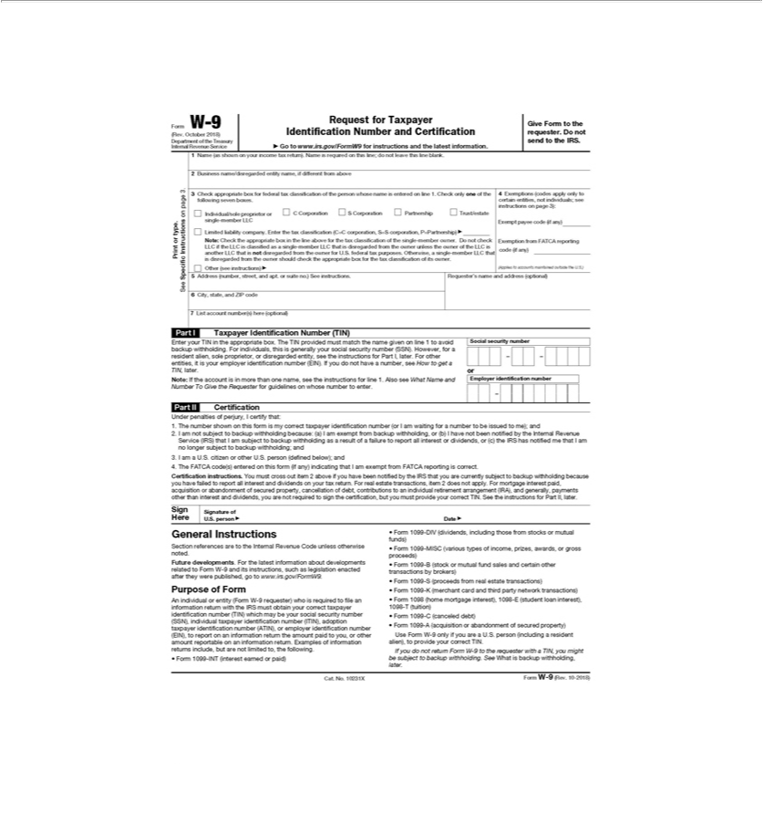

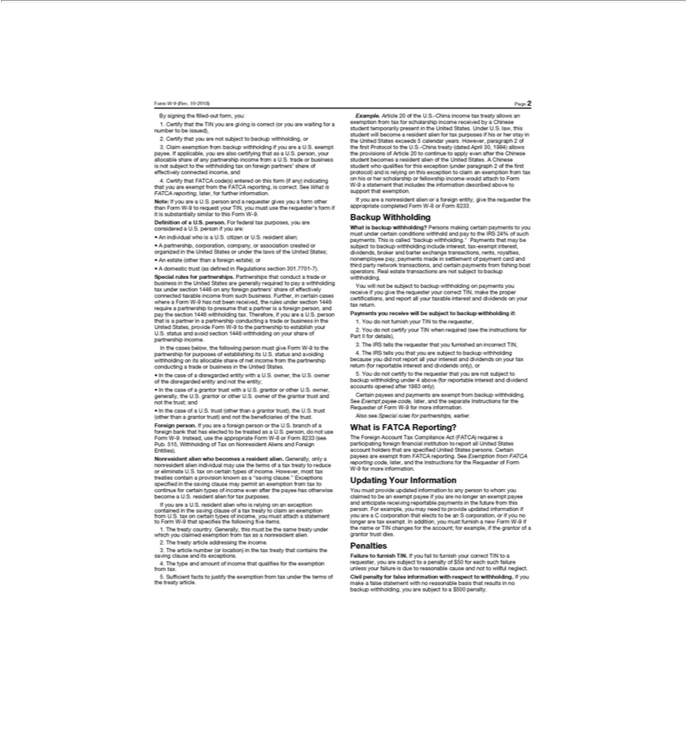

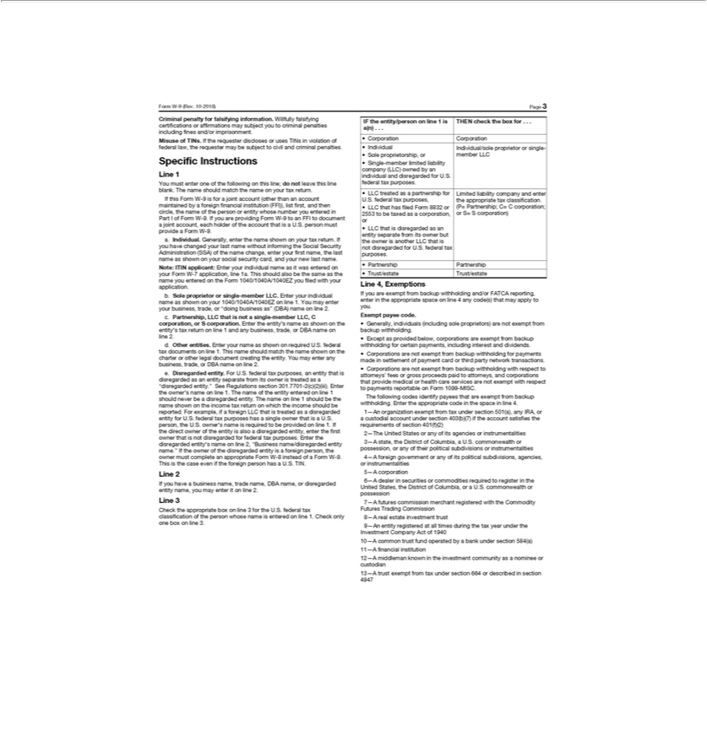

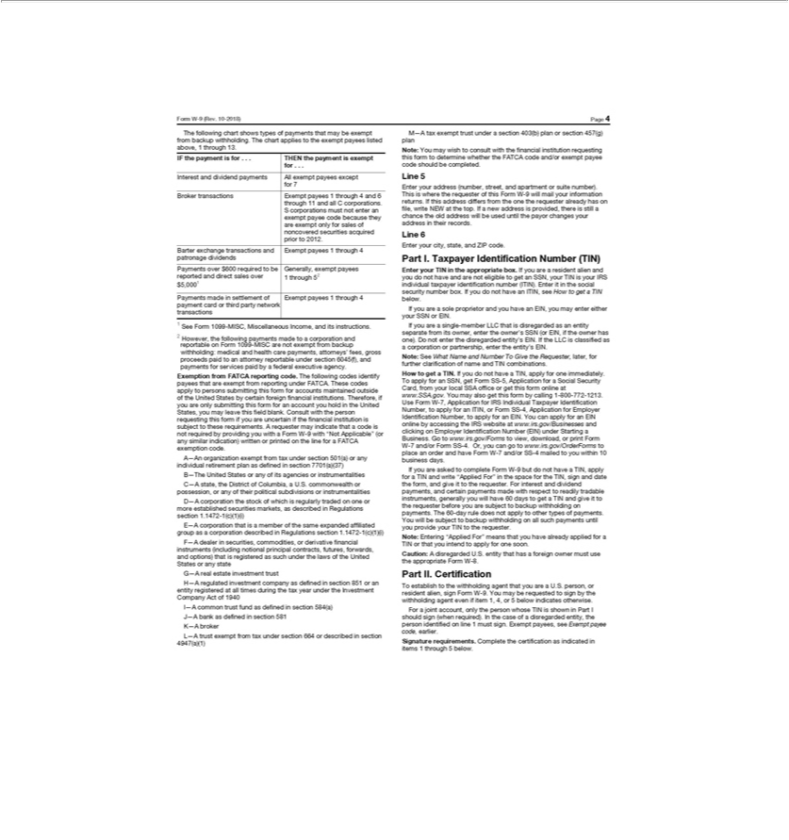

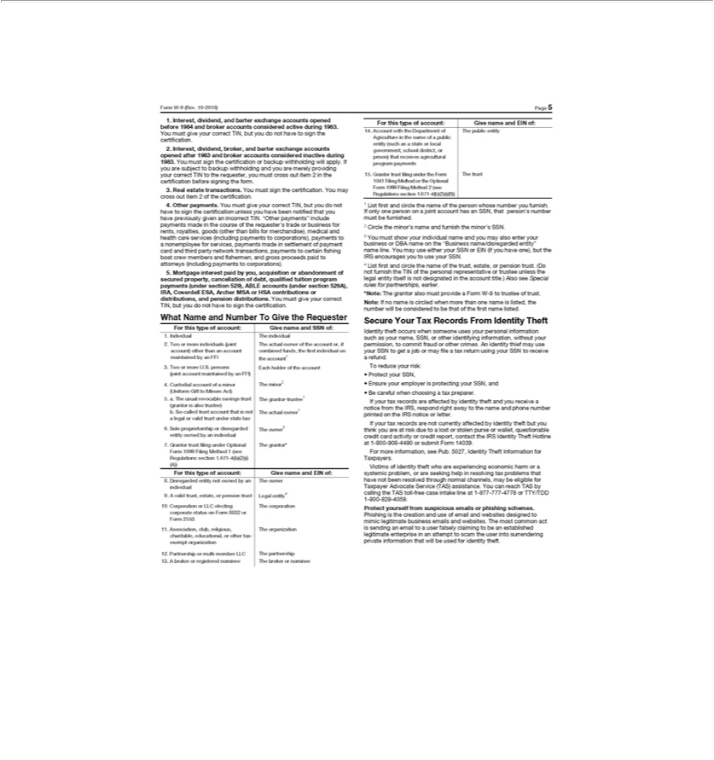

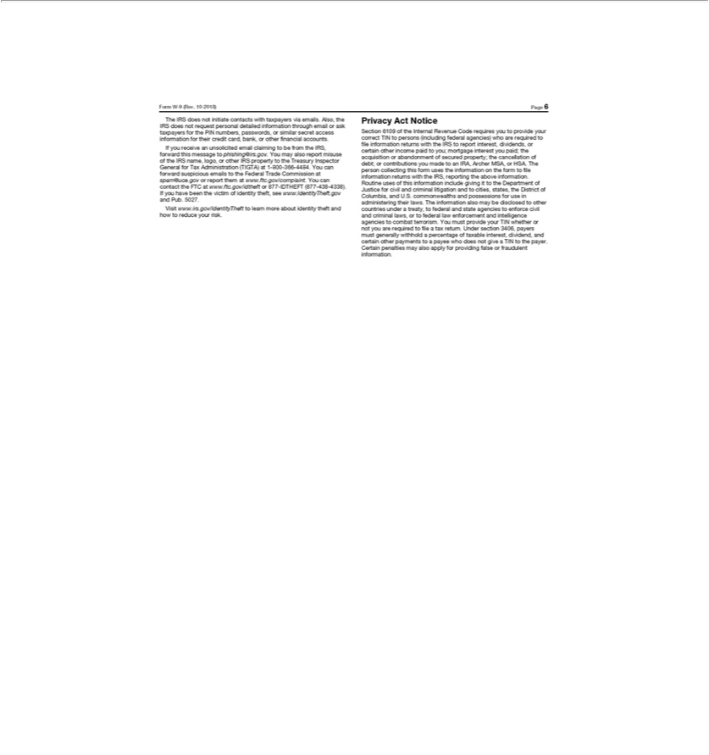

Exhibit 99.b


CROWN AMERICAS LLC
LETTER TO HOLDERS
To Holders of 5.250% Senior Notes due 2030:
Crown Americas LLC (the “Company”) is offering, upon and subject to the terms and conditions set forth in the Prospectus, dated | , 2022
(the “Prospectus”), and the enclosed Letter of Transmittal (the “Letter of Transmittal”), to exchange (the “Exchange Offer”) (i) each $1,000 principal

amount of their 5.250% Senior Notes due 2030 (the “New Notes”) that have been registered under the Securities Act of 1933, as amended (the

“Securities Act”), pursuant to a registration statement (the “Registration Statement”) of which the Prospectus is a part, for each $1,000 principal amount

of their outstanding 5.250% Senior Notes due 2030 (the “Old Notes”), of which $500,000,000 aggregate principal amount is outstanding. The Exchange

Offer is being made in order to satisfy certain obligations of the Companies contained in that certain Registration Rights Agreement, dated as of

March 17, 2022, Crown Holdings, Inc., the Company, each of Citigroup Global Markets Inc., BNP Paribas Securities Corp. and Mizuho Securities USA

LLC as representatives of the initial purchasers, and the Guarantors (as defined therein), relating to the $500 million 5.250% Senior Notes due 2030.

Briefly, you may either:

- Tender all or some of your Old Notes, along with a completed and executed Letter of Transmittal, and receive New Notes in exchange; or

- Retain your Old Notes.

All tendered Existing Notes must be received on or prior to the accompanying Prospectus.

2022 at 5:00 p.m., New York City Time (the “Expiration Date”), as shown in

Please review the enclosed Letter of Transmittal and Prospectus carefully. If you have any questions on the terms of the Exchange Offer or questions regarding the appropriate procedures for tendering your Existing Notes and the Letter of Transmittal, please call (800) 934-6802 or write:

U.S. Bank Trust Company, National Association

111 Fillmore Avenue

St. Paul, MN 55107-1402

Attn: Specialized Finance

Exhibit 99.c

CROWN AMERICAS LLC
LETTER TO BROKERS, DEALERS AND OTHER NOMINEES
for
OFFER TO EXCHANGE
all outstanding 5.250% Senior Notes Due 2030
for
5.250% Senior Notes Due 2030
that have been registered under the Securities Act of 1933
144A CUSIP Number: U20330 AA1
Regulation S CUSIP Number: U20330 AA1
To: Brokers, Dealers, Commercial Banks, Trust Companies and Other Nominees:
Crown Americas LLC (the “Company”) is offering, upon and subject to the terms and conditions set forth in the Prospectus, dated | 2022
(the “Prospectus”), and the enclosed Letter of Transmittal (the “Letter of Transmittal”), to exchange (the “Exchange Offer”) each $1,000 principal amount of their 5.250% Senior Notes due 2030 that have been registered under the Securities Act of 1933, as amended (the “Securities Act”), pursuant to a registration statement (the “Registration Statement”) of which the Prospectus is a part, for each $1,000 principal amount of their outstanding

5.250% Senior Notes due 2030 (the “Old Notes”), of which $500 million aggregate principal amount is outstanding. The Exchange Offer is being made in order to satisfy certain obligations of the Company contained in that certain Registration Rights Agreement, dated as of March 17, 2022, Crown Holdings, Inc., the Company, each of Citigroup Global Markets Inc., BNP Paribas Securities Corp. and Mizuho Securities USA LLC as representatives of the initial purchasers, and the Guarantors (as defined therein), relating to the $500 million 5.250% Senior Notes due 2030.

We are asking you to contact your clients for whom you hold Old Notes registered in your name or in the name of your nominee. In addition, we ask you to contact your clients who, to your knowledge, hold Old Notes registered in their own name.

Enclosed are copies of the following documents:

- the Prospectus;

- a Letter of Transmittal for your use in connection with the exchange of Old Notes and for the information of your clients (facsimile copies of the Letter of Transmittal may be used to exchange Old Notes);

- a form of letter that may be sent to your clients for whose accounts you hold Old Notes registered in your name or the name of your nominee, with space provided for obtaining the clients’ instructions with regard to the Exchange Offer;

- guidelines of the Internal Revenue Service for Certification of Taxpayer Identification Number on Substitute Form W-9; and

- a return envelope addressed to U.S. Bank National Association, the Exchange Agent.

YOUR PROMPT ACTION IS REQUESTED. THE EXCHANGE OFFER WILL EXPIRE AT 5:00 P.M., NEW YORK CITY TIME, ON 2022, UNLESS EXTENDED (THE “EXPIRATION DATE”). OLD NOTES TENDERED PURSUANT TO THE EXCHANGE OFFER MAY BE WITHDRAWN, SUBJECT TO THE PROCEDURES DESCRIBED IN THE PROSPECTUS, AT ANY TIME PRIOR TO THE EXPIRATION DATE.

To tender Old Notes, certificates for Old Notes or a book-entry confirmation (see “The Exchange Offer” in the Prospectus), a duly executed and properly completed Letter of Transmittal or a facsimile thereof or electronic instructions sent to the Depository Trust Company, and any other required documents, must be received by the Exchange Agent as provided in the Prospectus and the Letter of Transmittal.

The Company will not pay any fees or commissions to any broker, dealer or other person in connection with the solicitation of tenders pursuant to the Exchange Offer. The Company will, however, upon request, reimburse brokers, dealers, commercial banks and trust companies for reasonable and necessary costs and expenses incurred by them in forwarding the Prospectus and the related documents to the beneficial owners of Existing Notes held by them as nominee or in a fiduciary capacity. The Company will pay or cause to be paid all stock transfer taxes, if any, applicable to the exchange of Existing Notes pursuant to the Exchange Offer, except as otherwise provided in the Prospectus and the Letter of Transmittal.

Questions and requests for assistance with respect to the Exchange Offer or requests for additional copies of the enclosed material may be directed to the Exchange Agent at its address and phone number set forth on the front of the Letter of Transmittal.

Very truly yours,

CROWN AMERICAS LLC

NOTHING CONTAINED HEREIN OR IN THE ENCLOSED DOCUMENTS SHALL CONSTITUTE YOU OR ANY OTHER PERSON AS AN AGENT OF CROWN AMERICAS LLC OR THE EXCHANGE AGENT, OR ANY AFFILIATE THEREOF, OR AUTHORIZE YOU OR ANY OTHER PERSON TO MAKE ANY STATEMENTS OR USE ANY DOCUMENT ON BEHALF OF ANY OF THEM WITH RESPECT TO THE EXCHANGE OFFER, EXCEPT FOR THE ENCLOSED DOCUMENTS AND THE STATEMENTS EXPRESSLY MADE IN THE PROSPECTUS AND THE LETTER OF TRANSMITTAL.

2

Exhibit 99.d

CROWN AMERICAS LLC

LETTER TO CLIENTS

for

OFFER TO EXCHANGE

all outstanding 5.250% Senior Notes Due 2030

for

5.250% Senior Notes Due 2030

that have been registered under the Securities Act of 1933

144A CUSIP Number: U20330 AA1; Regulation S CUSIP Number: U20330 AA1

To Our Clients:

Enclosed for your consideration is a Prospectus, dated 2022 (the “Prospectus”), and the related Letter of Transmittal (the “Letter of Transmittal”), relating to the offer (the “Exchange Offer”) of Crown Americas LLC (the “Company”) to exchange each $1,000 principal amount of their 5.250% Senior Notes due 2030 (the “New Notes”) that have been registered under the Securities Act of 1933, as amended (the “Securities Act”), pursuant to a registration statement (the “Registration Statement”) of which the Prospectus is a part, for each $1,000 principal amount of their outstanding 5.250% Senior Notes due 2030 (the “Old Notes”), of which $500 million aggregate principal amount is outstanding. The Exchange Offer is being made in order to satisfy certain obligations of the Company contained in that certain Registration Rights Agreement, dated as of March 17, 2022, by and among Crown Holdings, Inc., the Company, each of Citigroup Global Markets Inc., BNP Paribas Securities Corp. and Mizuho Securities USA LLC as representatives of the initial purchasers, and the Guarantors (as defined therein), relating to the $500 million 5.250% Senior Notes due 2030.

The material is being forwarded to you as the beneficial owner of Old Notes carried by us for your account or benefit but not registered in your name. A tender of any Old Notes may be made only by us as the registered holder and pursuant to your instructions. Therefore, the Company urges beneficial owners of Old Notes registered in the name of a broker, dealer, commercial bank, trust company or other nominee to contact such registered holder promptly if they wish to tender Old Notes in the Exchange Offer.

Accordingly, we request instructions as to whether you wish us to tender any or all of the Old Notes held by us for your account, pursuant to the terms and conditions set forth in the Prospectus and Letter of Transmittal. We urge you to read carefully the Prospectus and the Letter of Transmittal before instructing us to tender your Old Notes.

Your instructions to us should be forwarded to us as promptly as possible in order to permit us to tender Old Notes on your behalf in accordance

with the provisions of the Exchange Offer. The Exchange Offer will expire at 5:00 p.m., New York City time, on 2022, unless extended (the “Expiration Date”). Old Notes tendered pursuant to the Exchange Offer may be withdrawn, subject to the procedures described in the Prospectus, at any time prior to the Expiration Date.

Your attention is directed to the following:

- The Exchange Offer is for the exchange of $1,000 principal amount at maturity of the New Notes for each $1,000 principal amount at maturity of the Old Notes. The terms of the New Notes are substantially identical (including principal amount, interest rate, maturity, security and ranking) to the terms of the Old Notes, except that the New Notes are freely transferable by holders thereof (except as provided in the Prospectus).

- THE EXCHANGE OFFER IS SUBJECT TO CERTAIN CONDITIONS. SEE “THE EXCHANGE OFFER—TERMS OF THE EXCHANGE OFFER” IN THE PROSPECTUS.

3. The Exchange Offer and withdrawal rights will expire at 5:00 p.m., New York City time, on 2022, unless extended.

- Any transfer taxes incident to the transfer of Old Notes from the holder to the Company will be paid by the Company, except as otherwise provided in the Prospectus and the Letter of Transmittal.

The Exchange Offer is not being made to, nor will exchange be accepted from or on behalf of, holders of Old Notes in any jurisdiction in which the making of the Exchange Offer or the acceptance thereof would not be in compliance with the laws of such jurisdiction.

If you wish to have us tender any or all of your Old Notes held by us for your account or benefit, please so instruct us by completing, executing and returning to us the instruction form that appears below. The accompanying Letter of Transmittal is furnished to you for informational purposes only and may not be used by you to tender Old Notes held by us and registered in our name for your account or benefit.

INSTRUCTIONS

The undersigned acknowledge(s) receipt of your letter and the enclosed material referred to therein in connection with the Exchange Offer of Crown Americas LLC with respect to their Old Notes, including the Prospectus and the Letter of Transmittal.

This form will instruct you to exchange the aggregate principal amount of Old Notes indicated below (or, if no aggregate principal amount is indicated below, all Old Notes) held by you for the account or benefit of the undersigned, pursuant to the terms and conditions set forth in the Prospectus and Letter of Transmittal.

If the undersigned instructs you to tender Old Notes held by you for the account of the undersigned, it is understood that you are authorized to make, on behalf of the undersigned (and the undersigned, by its signature below, hereby makes to you), the representations and warranties contained in the Letter of Transmittal that are to be made with respect to the undersigned as a beneficial owner, including but not limited to the representations, that

- any New Notes acquired pursuant to the Exchange Offer will be obtained in the ordinary course of business of the person receiving such New Notes, whether or not such person is the registered holder, (ii) neither the holder of Old Notes nor any other person has an arrangement or understanding with any person to participate in the distribution of such New Notes, (iii) if the holder is not a broker-dealer, or is a broker-dealer but will not receive New Notes for its own account in exchange for Old Notes, neither the holder nor any such other person is engaged in or intends to participate in the distribution of such New Notes and (iv) neither the holder nor any such other person is an “affiliate” of the Company within the meaning of Rule 405 of the Securities Act or, if such holder is an affiliate, that such holder will comply with the registration and prospectus delivery requirements of the Securities Act to the extent applicable. By so acknowledging that it will deliver and by delivering a prospectus meeting the requirements of the Securities Act in connection with any resale of such New Notes, the undersigned is not deemed to admit that it is an “underwriter” within the meaning of the Securities Act.

2

Please tender the Old Notes held by you for my (our) account as indicated below:

Aggregate Principal Amount of Old Notes to be Exchanged*

- I (we) understand that if I (we) sign these instruction forms without indicating an aggregate principal amount of Old Notes in the spaces above, all Old Notes held by you for my (our) account will be exchanged.

PLEASE SIGN HERE

Signature(s):

Date: ,

Name(s) (please print):

Capacity (full title), if signing in a fiduciary or representative capacity:

Address (including zip code):

Area Code and Telephone Number:

Taxpayer Identification or Social Security No.:

Exhibit 107.a

Calculation of Filing Fee Tables

FORM S–4

(Form type)

CROWN HOLDINGS, INC.

(Exact name of registrant as specified in its charter)

Table 1: Newly Registered and Carry Forward Securities

CALCULATION OF REGISTRATION FEE

 | Amount | Proposed | Proposed
Title of each class of | Amount | maximum | maximum | Amount of
Title of each class of | to be | offering price | aggregate | Amount of
securities to be registered | registered | per share | offering price (1) | registration fee (2)
5.250% Senior Notes due 2030 | $500,000,000 | 100% | $500,000,000 | $55,100
Guarantees of 5.250% Senior Notes due 2030 | N/A | N/A | N/A | N/A ⁽³⁾

- Estimated solely for the purpose of calculating the registration fee in accordance with Rule 457(f) of the Securities Act.

- The registration fee has been calculated pursuant to Rule 457(f) under the Securities Act.

- No additional consideration is being received for the guarantees, and, therefore no additional fee is required.

